Eddie Gurnee

Homework 2
SQL
Total points: 40

1. (10 pts.) Database creation and querying exercise.
advisor table:
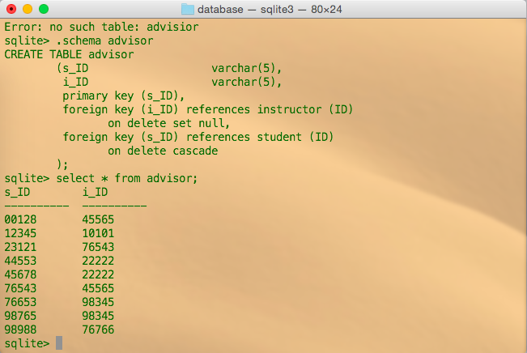
classroom table:
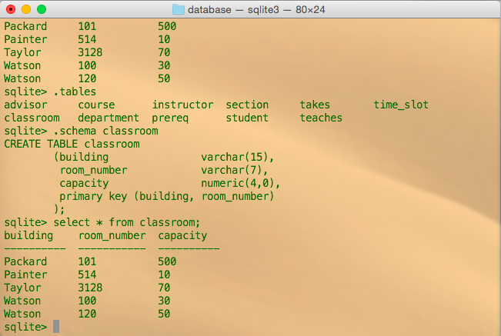
course table:
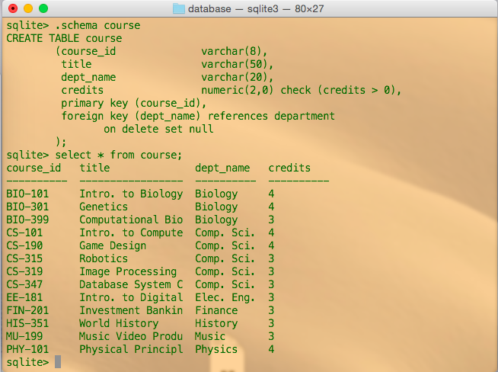
department table:
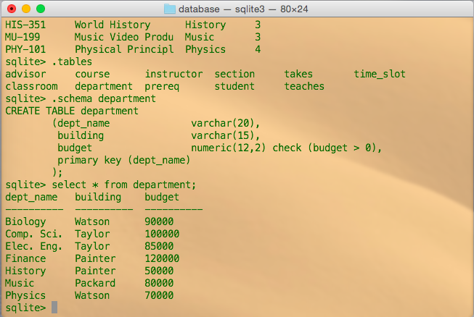
instructor table:
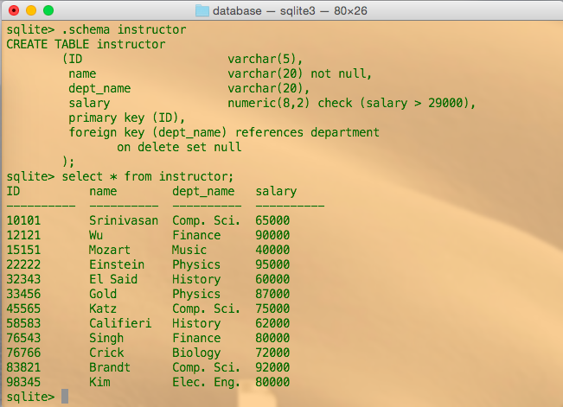
prereq table:
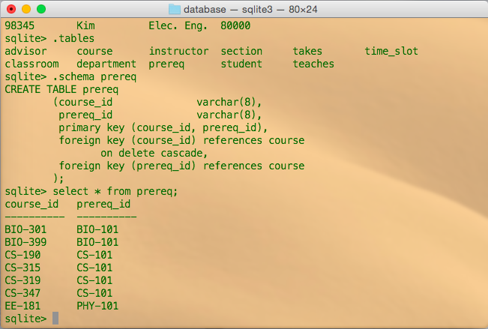
section table:
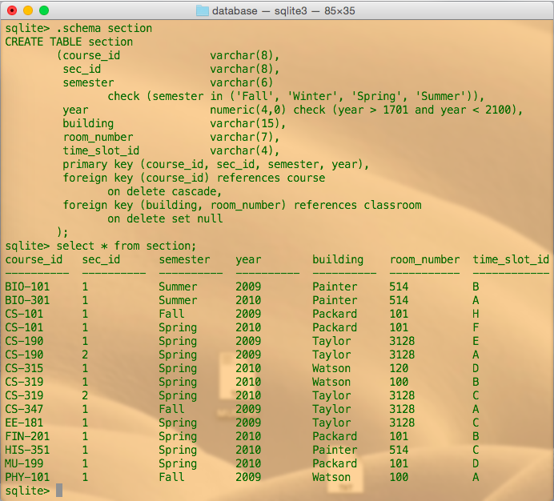
student table:
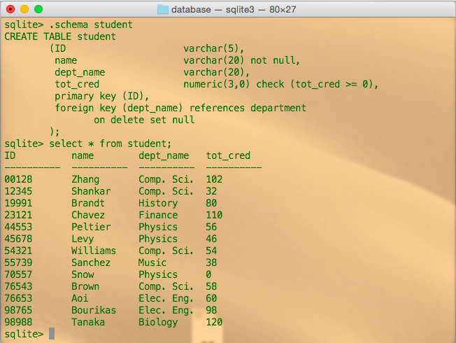
takes table:
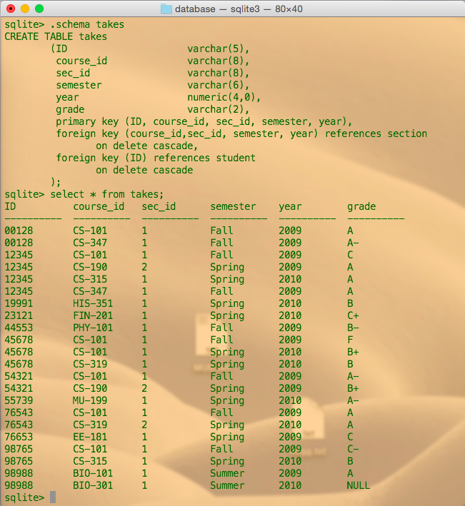
teaches table:
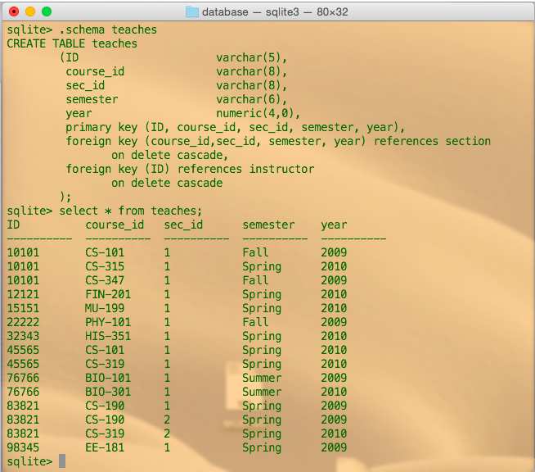
time_slot table:
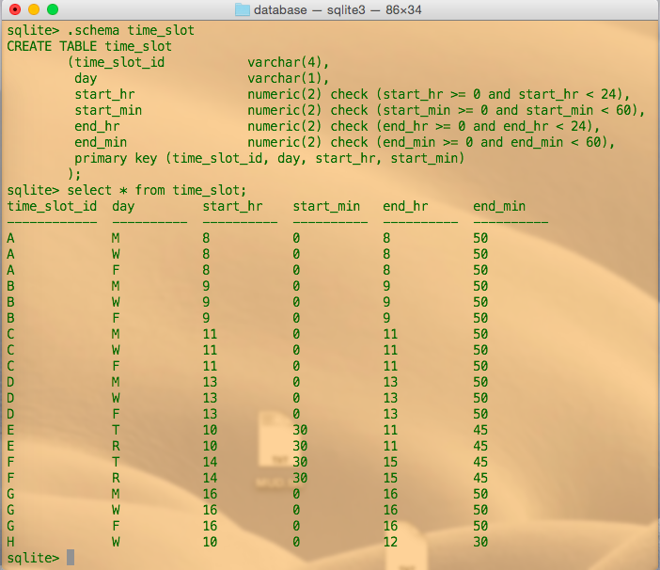
2. (10 pts.) Run the following queries on the university database you just created.
a. List all students.
Response:
select *
from student;

ID name dept_name tot_cred
---------- ---------- ---------- ----------
00128 Zhang Comp. Sci. 102
12345 Shankar Comp. Sci. 32
19991 Brandt History 80
23121 Chavez Finance 110
44553 Peltier Physics 56
45678 Levy Physics 46
54321 Williams Comp. Sci. 54
55739 Sanchez Music 38
70557 Snow Physics 0
76543 Brown Comp. Sci. 58
76653 Aoi Elec. Eng. 60
98765 Bourikas Elec. Eng. 98
98988 Tanaka Biology 120

b. List only course_ids of courses that are offered in Spring 2009.
Response:
select course_id
from section
where year=2009 and semester='Spring';

course_id
----------
CS-190
CS-190
EE-181

c. List only student names and how many more credits they have to take to complete their degree. Assume that the degree completion requirement is 124 credits for all students.
Response:
select name,
(124 - tot_cred) as credit_remaining
from student;

name credit_remaining
---------- ----------------
Zhang 22
Shankar 92
Brandt 44
Chavez 14
Peltier 68
Levy 78
Williams 70
Sanchez 86
Snow 124
Brown 66
Aoi 64
Bourikas 26
Tanaka 4

d. Find the total number of instructors and their average salary.
Response:
select count(ID) as num_instructors,
avg(salary) as average_salary
from instructor;

num_instructors average_salary
--------------- ----------------
12 74833.3333333333

e. List only course_ids of all courses that are either offered in Spring or Summer.
Response:
select course_id
from section
where semester='Spring' or semester='Summer';

course_id
----------
BIO-101
BIO-301
CS-101
CS-190
CS-190
CS-315
CS-319
CS-319
EE-181
FIN-201
HIS-351
MU-199

f. List all rooms that have a capacity of at least 50 and utmost 100.
Response:
select *
from classroom
where capacity>=50 and capacity<=100;

building room_number capacity
---------- ----------- ----------
Taylor 3128 70
Watson 120 50

g. List all instructors who have a name that begins with K.
Response:
select *
from instructor
where name like 'K%';

ID name dept_name salary
---------- ---------- ---------- ----------
45565 Katz Comp. Sci. 75000
98345 Kim Elec. Eng. 80000

h. List only student_ids of students who have received a grade of A, A-, or B+ in any course.
Response:
select ID as student_id
from takes
where grade like 'A%' or grade='B+';

student_id
----------
00128
00128
12345
12345
12345
45678
54321
54321
55739
76543
76543
98988

3. (8 pts.) Run these queries on the university database you have created.
a. Find the names of all students who have taken at least one Comp. Sci. course; make sure there are no duplicate names in the result.
Response:
select distinct name
from student, takes
where course_id like 'CS%';

name
----------
Zhang
Shankar
Brandt
Chavez
Peltier
Levy
Williams
Sanchez
Snow
Brown
Aoi
Bourikas
Tanaka

b. Find the IDs and names of all students who have not taken any course offering before Spring 2009.
Response:
select distinct student.ID, name
from student, takes
where takes.ID = student.ID
and (year>2009 or (year=2009 and semester<>'Winter'));

ID name
---------- ----------
00128 Zhang
12345 Shankar
19991 Brandt
23121 Chavez
44553 Peltier
45678 Levy
54321 Williams
55739 Sanchez
70557 Snow
76543 Brown
76653 Aoi
98765 Bourikas
98988 Tanaka

c. For each department, find the maximum salary of instructors in that department. You may assume that every department has at least one instructor.
Response:
select instructor.dept_name, max(salary)
from instructor, department
group by instructor.dept_name;

dept_name max(salary)
---------- -----------
Biology 72000
Comp. Sci. 92000
Elec. Eng. 80000
Finance 90000
History 62000
Music 40000
Physics 95000

d. Find the lowest, across all departments, of the per-department maximum salary computed by the preceding query.
Response:
select dept_name, min(max_salary)
from (
select instructor.dept_name, max(salary) as max_salary
from instructor, department
group by instructor.dept_name);

dept_name min(max_salary)
---------- ---------------
Music 40000

4. (4 pts.) Exercise 3.15 – parts b and c only.
Consider the bank database of Figure 3.19, where the primary keys are underlined. Construct the following SQL queries for this relational database:
a. Find all customers who have an account at all the branches located in “Brooklyn”.
b. Find out the total sum of all loan amounts in the bank.
c. Find the names of all branches that have assets greater than those of at least one branch located in “Brooklyn”.
Response:
b. select sum(amount)
from loan;
c. select distinct branch_name
from branch
where asset > (
select min(assets)
from branch
where branch_name='Brooklyn');

5. (4 pts.) Exercise 3.21 – parts a and c only.
Consider the library database of Figure 3.21. Write the following queries in SQL:
a. Print the names of members who have borrowed any book published by “McGraw-Hill”.
b. Print the names of members who have borrowed all books published by “McGraw-Hill”.
c. For each publisher, print the names of members who have borrowed more than five books of that publisher.
d. Print the average number of books borrowed per member. Take into account that if a member does not borrow any books, then that member does not appear in the borrowed relation at all.
Response:
a. select distinct member.name
from member, borrowed, book
where book.publisher='McGraw-Hill';
c. select member.name
from member, (
select publisher,
count(borrowed.isbn),
borrowed.memb_no as borrow_count
from book, borrowed
group by publisher) as publisher_count
where borrow_count > 5;

6. (2 pts.) Exercise 4.14
Show how to define a view tot_credits (year, num_credits), giving the total number of credits taken by students in each year.
Response:
create view tot_credits as
select year, sum(credits)
from course, section
group by year;

7. (2 pts.) Exercise 5.12
Consider the following relations for a company database:
• emp(ename, dname, salary)
• mgr(ename, mname) and the Java code in Figure 5.26, which uses the JDBC API. Assume that the userid, password, machine name, etc. are all okay. Describe in concise English what the Java program does. (That is, produce an English sentence like “It finds the manager of the toy department,” not a line-by-line description of what each Java statement does.)

Response: This program travels up the employee hierarchy, displaying a managers name, then the name of who manages them, then who manages them, until an employee without a manager is reached.

