Using Dia to draw ER diagrams

1. Download Dia from dia-installer.de. You will need X-Windows to run this software on Macs.

2. Open Dia.

3. Choose ER toolbox, from the drop-down list on the left hand side of the screen.

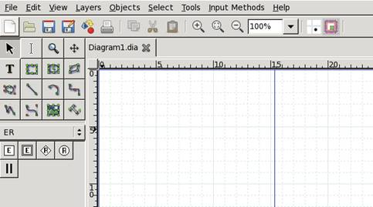

4. Drag and drop an entity (single-lined squares) on to the page. Double-clicking will let you change the name and set other properties of an entity.

5. Drag and drop attributes (Circles). Double-clicking will let you change the name of an attribute and set it as a key, derived, and/or multi-valued attribute.

6. Drag and drop links (undirected line) between attributes and entities. Make sure the lines are anchored to the entities and attributes. Otherwise, these links do not stay intact if you were to move the objects on the screen.

7. Drag and drop relationships (diamond) between entities. Double-clicking will let you set the cardinality and participation constraints on the relationship. Use either arrows or cardinalities to specify cardinality constraints. See the picture below and pick one option and use throughout your diagram.

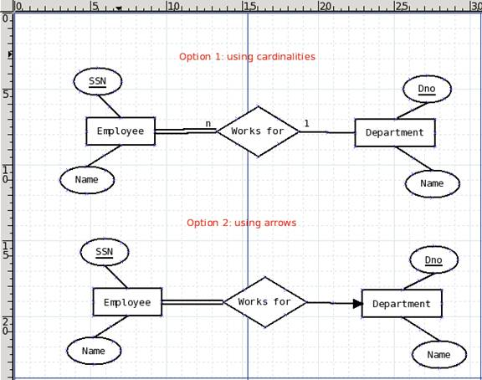

8. Add any assumptions you made in a text box at the bottom of the design.

9. Use double-lined squares to represent weak entities (attribute setting in the entity properties box).

10. Use double-lined diamonds to represent identifying relationships (attribute setting in the relationship properties box).

11. You can draw EER diagrams too with Dia. Just pick the right tools from other toolboxes, such as flowchart.

12. When you are done with the diagram save as a *.dia file to be able to modify the design later. Submit a jpeg file for grading purposes.

