Eddie Gurnee
COSC 571
3/11/15
Homework #3

1.
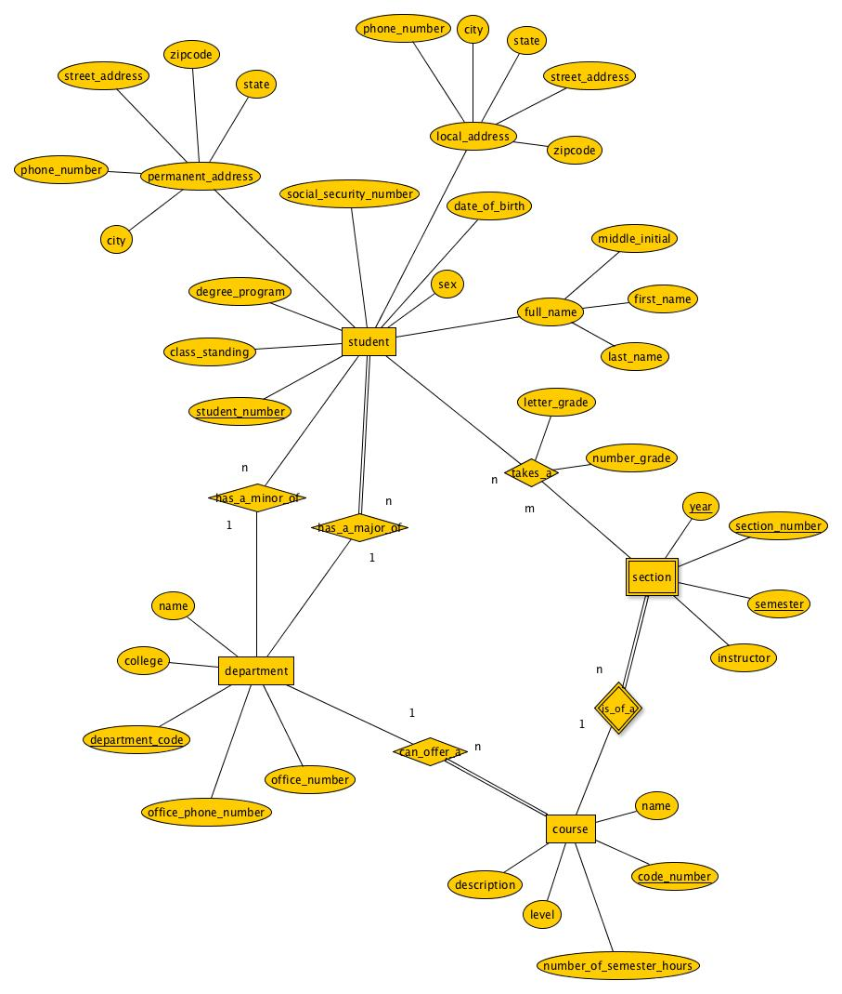
Assumptions/Explanations:
- While both social security number and student number are unique for a student, only one is needed for the primary key and student number is chosen.
- Students are only allowed to have one major and one minor and not all students are required to have a minor.
- Courses can only be offered through one department, no courses will be co-chaired.
- Multiple sections of the same course can be offered at the same time, so the section number is needed for a unique identifier. All of the underlined in section are partial keys, I just can't figure out how to dotted underline in yEd yet.
- The only information needed on an instructor is their name, so no other information is stored.
- A student gets a grade when they take a section.

2.
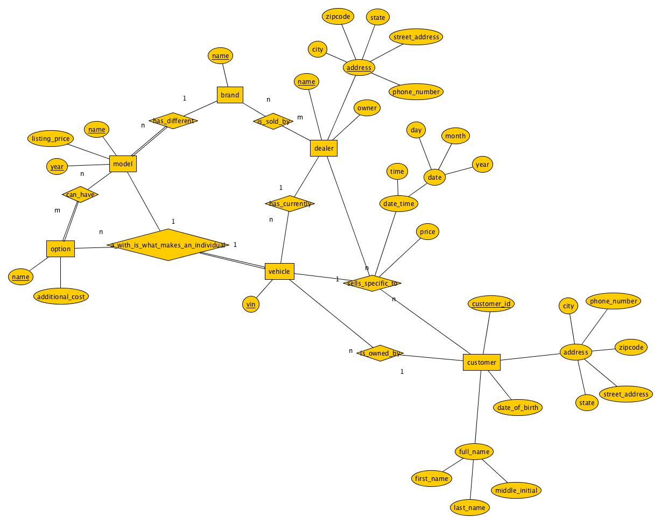
Assumptions/Explanations:
- A car dealership can sell a number of brands and a brand are sold in many different dealerships.
- A dealership can be a chain, so the address is included to guarantee uniqueness.
- The information on what cars a customer owns is important to predict buying trends, so that information is stored even if it was not sold by a particular dealer.
- A vehicle is unique through a combination of its model and the options chosen.
- The cost of an option depends only on what the option is, not on the model; i.e. installing a sunroof costs the same regardless of what vehicle it is installed in.

3.
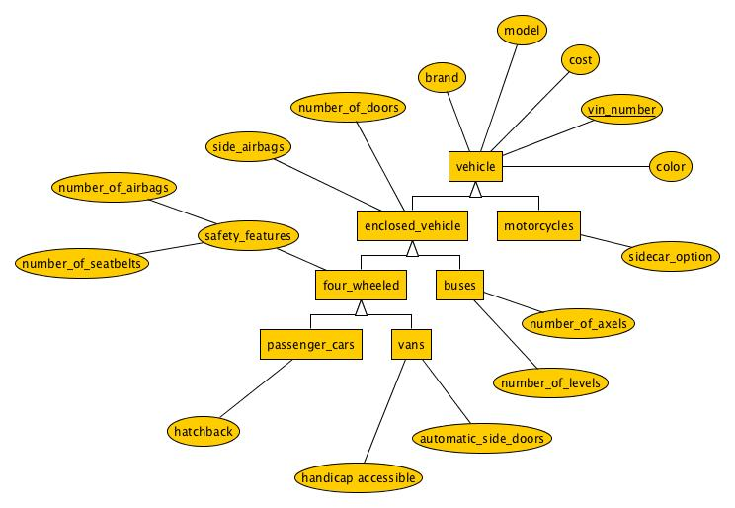
Assumptions/Explanations:
- The only safety feature that buses have the potential of having are side airbags; they all have one seatbelt for the drive but nothing else.
- Motorcycles have no doors (the existence of a door on the sidecar is not considered).
- Personal vehicles (not buses or motorcycles) are designed for individual use with safety as a primary concern, therefore the number of people who can travel in it depends on the number of seat belts.
- Only cars have the possibility for hatchbacks.

4.
employee(number, name)
mechanic(employee_number)
does(employee_number, repair_job_number)
repair_job(car_license, number, description, cost_parts, cost_work)
car(license, manufacturer, model, year)
salesman(employee_number)
buys(employee_number, license, client_id, price, date, value)
sells(employee_number, license, client_id, date, commission)
client(id, name, address)
client_phone(phone_number, client_id)

Assumptions/Explanations:
- Mechanic and Salesman use their employee_number when being referred to, not any contrived mechanic or salesman numbers, as that information isn't helpful to be stored.
- The derived attribute 'value' from the sells relation is not stored as it is derived.
- The multi-value attribute phone from client has become its own table to store multiples.

5.
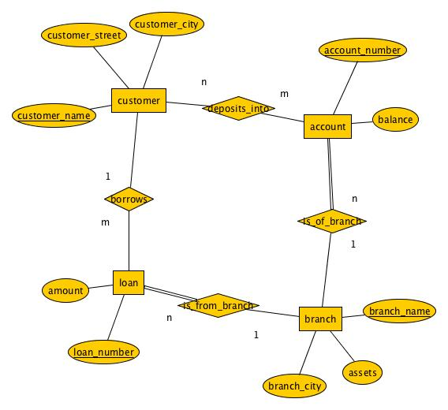
Assumptions/Explanations:
- Loan numbers are unique across all branches.
- Any customer can deposit into any account of a given branch.
- Accounts can exist without an associated customer, but always belong to a specific branch.
- Loans can exist without customers; it just represents money that is owed to the bank, yet is unavailable.

