Eddie Gurnee
COSC 592
Operating Systems
Chapter 7 & 8 Reading Questions:

Chapter 7

Exercise 1: Consider the situation of cars attempting to use a single lane bridge (see the diagram below).

- Show that the four required conditions for deadlock hold in this example.
- State a simple rule that could preclude deadlocks in this system.
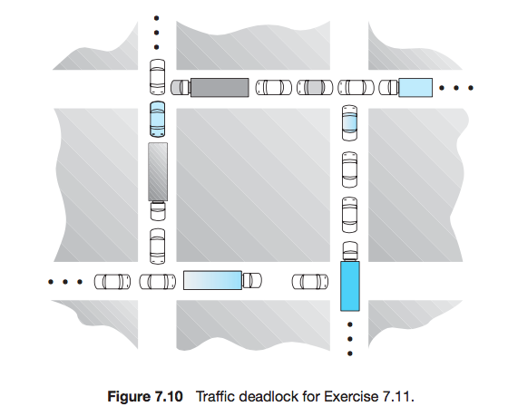
Response:

Exercise 2: The Java API for the Thread class contains a method destroy that has been deprecated. Consulting the API (you can find it), explain why the method was deprecated. Provide an example where the use of destroy might possibly lead to a deadlock.

Response:

Exercise 3: Consider the following snapshot of a system:

 | Allocation |  |  |  | Max |  |  |  | Available
 | A | B | C | D | A | B | C | D | A | B | C | D
P0 | 1 | 2 | 3 | 4 | 3 | 5 | 6 | 6 | 3 | 1 | 2 | 3
P1 | 3 | 1 | 2 | 1 | 5 | 2 | 5 | 2
P2 | 2 | 3 | 0 | 1 | 2 | 6 | 1 | 3
P3 | 1 | 2 | 1 | 3 | 1 | 4 | 2 | 4
P4 | 2 | 1 | 0 | 0 | 4 | 2 | 1 | 2

Answer the following questions using the banker’s algorithm:

- Illustrate that the system is in a safe state by demonstrating an order in which the processes may complete.
- If a request from process P1 arrives for (1,0,0,1), can the request be granted immediately?
- If a request from process P0 arrives for (0,0,2,0), can the request be granted immediately?

Response:

Chapter 8

Exercise 4: Consider a logical address space of 256 pages of 4,096 words each, mapped onto a physical memory of 128 frames.
- How many bits are there in a logical address?
- How many bits are there in a physical address?

Response:

Exercise 5: Given six memory partitions of 200 KB, 600 KB, 350 KB, 300 KB, 750 KB, and 125 KB (in order), how would the ﬁrst-ﬁt, best-ﬁt, and worst-ﬁt algorithms place processes of size 358 KB, 500 KB, 150 KB, 125 KB, and 375 KB (in order)? Rank the algorithms in terms of how efﬁciently they use memory in this case.

Response:

Exercise 6: Assuming a 1-KB page size, what are the page numbers and offsets for the following address references (provided as decimal numbers):

- 4123
- 28224
- 206928
- 516000

Response:

