Eddie Gurnee
COSC 592
Operating Systems
Chapter 3 Reading Questions:

3.8) Describe the differences among short-term, medium-term, and long-term scheduling.

3.9) Describe the actions taken by a kernel to context-switch between processes.

3.14) Using the program in Figure 3.34, identify the values of pid at lines A, B, C, and D. (Assume that the actual pids of the parent and child are 2600 and 2603, respectively.)
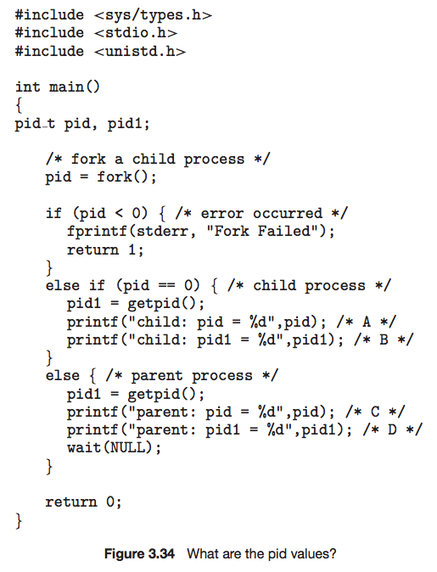

3.17) Using the program shown in Figure 3.35, explain what the output will be at lines X and Y.

