Eddie Philip Gurnee

Tyler Charles Hoffman

2015-03-06

COSC 571

Best Buy Books Project

Phase 2 – ER diagram and Three Screens

**ER Diagram**

Available at <http://db2.emich.edu/~201501_cosc471_group04/admin/data/ER_Diagram.pdf>

**Justifications:**

Customer:

One_Click_Buying – Customers should be allowed to click on the "Buy It Now" button to immediately create an order of the item selected using the default destination and default pay method.

Date_Of_Birth – Customers should recieve an e-mail wishing them a happy birthday and giving them a coupon.

Prime_Member – Customers that are prime members do not need to pay for shipping and sometimes recieve coupons.

Loyalty_Points – Earned when books are purchased.

Customers can have mutiple credit cards stored, but credit cards are associated with only one customer.

Customers have a wishlist that they can add books to.

Credit Card:

Default_Card – A customer's card to be used in One-Click buying.

Name_On_Card – If the name on a card is different than the stored customer name, that needs to be stored.

Type – If the card is debit or credit.

Still_Valid – indicates whether the date the card is being use is before the expiration date.

Customer uses a specific credit card to place any number of orders.

Order:

Delivery_Status – The current state of delivery based on the date was created, the date the order is viewed, and the length of the delivery to the order's location.

Based on a location, it'll take an order a specific amount of time to get there and will cost a certain amount of money to ship.

Delivery_Location:

Default_Location – A customer's address to be used in One-Click buying.

Phone_Contact – Any phone number and carrier of someone to contact if issues occur or when the delivery arrives.

Customers can have two delivery locations stored; one for their home and another for a commonly used location.

Multiple accounts can order deliveries to the same address.

Coupon:

Customers can receive coupons that have a dollar value that can be applied to some orders to reduce cost.

Only up to three coupons can be applied to an order.

Book:

Books can be in a series with other books (trilogy, nonology, duology, etc), as well as being similar to other books, though only the five most similar books are stored.

Books need to have a genre and can have up to three (to accomodate teen paranormal romance).

Genre:

Each genres has a most popular book, and keeps track of how many were purchased so far this month.

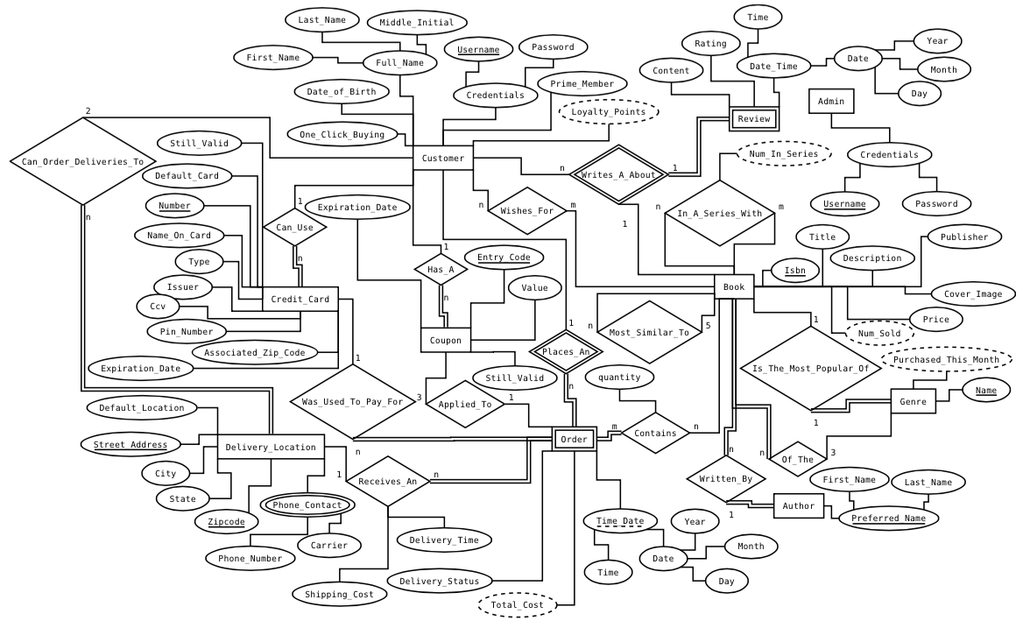

**Links to Functional Pages**

Main page

<http://db2.emich.edu/~201501_cosc471_group04/>

Search

<http://db2.emich.edu/~201501_cosc471_group04/search.php>

Results – This was a search for Absolute Java

<http://db2.emich.edu/~201501_cosc471_group04/search.php?query=Absolute+Java>

Feel free to search for anything written by H.P. Lovecraft, i.e. Call of Cthulhu, The Shadow Over Innsmouth, The Dunwich Horror, etc.