AquaVend
Automated Water Vending Machine System

Submitted by:

Paulo Heyman- code
Cris Dale Noay – hardware
Cedrick Masculino - hardware
Jicel Crisostomo – manuscript

March 31, 2026

Table of Contents
Table of Contents
Project Overview 3
Project Description 3
Problem Statement 3
Objectives 3
General Objective 3
Scope and Limitations 4
Scope of the Study 4
Limitations of the Study 4
System Architecture 5
Architecture Description 5
Data Flow 6
Hardware Components 8
Software Components 8
Functional Requirements 8
Non-Functional Requirements 9
Database Design (Sample Fields) 10
System Operation Procedure 10
Gantt Chart 11
Expected Output 11
Development Period 12
Proof of System Functionality 13
Source Code 13

Project Overview

Project Description
This project presents AquaVend, an automated coin-operated water vending machine powered by an ESP32 microcontroller. The system is designed to provide an easy and convenient way of dispensing drinking water using coins. It offers two types of water, which are regular water and cold water with different prices. A cooling system using a Peltier module is included to provide chilled water for users. The system uses a timed pump to ensure that the correct amount of water is dispensed in every transaction. It also uses a Finite State Machine (FSM) to manage the operation of the system smoothly. The machine can detect coins and process them accurately using sensor input. All transactions are recorded in a database for monitoring and tracking purposes. If the internet connection is lost, the system can store data locally and sync it later when the connection is restored. Overall, the system aims to provide a low-cost, efficient, and reliable water vending solution.

Problem Statement
Traditional water dispensing systems often lack automation, accuracy, and monitoring capabilities. Many existing systems are inefficient and require manual operation, which can lead to errors and inconvenience for users.
The study aims to address the following problems:
- Inconsistent Water Dispensing
Water vending machines sometimes provide unequal amounts of water per transaction, causing customer dissatisfaction.
- Lack of Automation and Control
Many systems do not use intelligent control, resulting in inefficient and unreliable operations.
- No Transaction Monitoring System
Most machines do not record transactions, making it difficult to track usage and sales.
- Network Dependency Issues
Some systems rely heavily on internet connection, and failure can stop the system from working properly.
- Poor User Feedback
Users are not properly informed about system status such as coin detection or water availability.

High Cost of Commercial Machines
Existing vending machines are expensive, making them inaccessible for small businesses or schools.

Objectives
General Objective
To design and develop a reliable and low-cost coin-operated water vending machine that provides accurate dispensing, cooling functionality, and transaction monitoring.

Specific Objectives
The study aims to achieve the following:
- To implement a Finite State Machine (FSM) for structured system control
- To accurately detect and process coin pulses using interrupt-based input
- To support dual pricing (₱3 regular / ₱5 cold water)
- To control water dispensing using timed pump activation with safety timeout
- To integrate a Peltier cooling system for cold water selection
- To display system status using a 16x2 I2C LCD
- To implement offline transaction storage and automatic synchronization
- To ensure system reliability through non-blocking logic (millis-based timing)

Scope and Limitations

Scope of the Study
This study focuses on the design, construction, and controlled evaluation of a single AquaVend prototype.
Specifically, the scope of the study includes the following:
- ESP32-based embedded system
- Coin-operated input using pulse detection
- FSM-based control system
- Timer-based water dispensing mechanism
- LCD-based user interface
- Peltier-based cooling system (on/off control)
- WiFi-based cloud logging using Firebase Firestore
- Offline transaction queue with auto-sync
- Cup count tracking system with reset functionality.
The study excludes large-scale production, long-term field deployment, advanced payment systems, and IoT integration.

Limitations of the Study
Despite its intended functionality, the proposed system has several limitations that should be acknowledged.
Specifically, the limitation of the study includes the following:
- Requires stable electrical power supply
- No integrated water level sensor (uses estimated cup count only)
- No built-in water purification system
- Limited to water dispensing only
- Mobile payment systems are not supported
- Security for cloud API is limited (API key-based access)
- Testing conducted in controlled environments only
- Long-term durability and hardware wear not evaluated

System Architecture

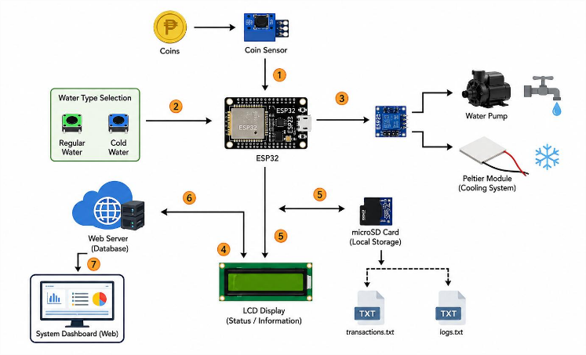

Figure 1: System Architecture

Architecture Description
The AquaVend system follows a modular embedded architecture centered on the ESP32 microcontroller and controlled using a Finite State Machine.

1. Input Module
The process begins when a user inserts a coin into the machine. The coin slot generates pulse signals corresponding to the value of the inserted coin. These signals are detected and sent to the ESP32 microcontroller using interrupt-based input processing. This method ensures accurate and real-time detection of coin insertion without manual input.
2. Processing Unit (ESP32)
Upon receiving the coin signal, the ESP32 processes the input using a Finite State Machine (FSM). The system operates through different states such as IDLE, ACCEPTING_COINS, DISPENSING, and OUT_OF_WATER. The ESP32 validates the inserted amount, manages transitions between states, and controls the overall system flow. This structured logic ensures stable and predictable system behavior.

3.User Selection Interface
The system includes push buttons that allow users to select between regular water and cold water. An additional reset option is also available. The ESP32 reads the button inputs and determines the corresponding operation based on the selected option and available balance.
4. Water Dispensing System
Once the payment is validated, the ESP32 activates the water pump through a MOSFET control circuit. The pump operates based on a timer to ensure that a fixed and accurate volume of water is dispensed. A safety timeout mechanism is also implemented to prevent overuse or hardware damage.
5. Cooling System
If the user selects cold water, the ESP32 activates the Peltier module to cool the water before dispensing. The cooling system is digitally controlled and operates without a temperature feedback loop. This provides a simple and cost-effective solution for chilled water dispensing.
6. Display System (LCD Interface)
The system uses a 16x2 LCD with I2C interface to display important information. This includes user instructions, inserted coin value, selected water type, system status, and error messages. The display helps guide users and improves overall usability
7. Data Storage and Cloud Logging
The system records all transactions using a cloud-based database such as Firebase Firestore. Stored data include the inserted amount, selected water type, and timestamp of each transaction. In case of internet disconnection, the system temporarily stores data in a local queue. Once the connection is restored, the stored data are automatically synchronized with the cloud database.
The architecture integrates user input control, flow sensing, and automated water dispensing within a single microcontroller-based device. This design reduces system complexity, minimizes dependency on manual operation, and ensures accurate and consistent water dispensing. It also enables efficient control and monitoring within a standalone system setup.

Data Flow
The data flow of the AquaVend water vending machine describes how information moves through the system, from user interaction to processing, execution, and transaction recording. Understanding this flow helps explain how the system ensures accurate dispensing, proper validation, and real-time system feedback.
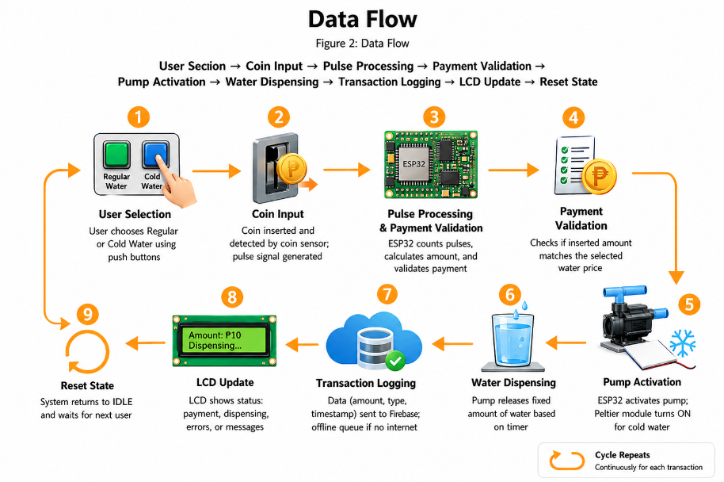

Figure 2: Data Flow
The data flow of the system follows a clear and structured path:
User Selection → Coin Input → Processing and Validation → Dispensing → Data Logging → Display Update → System Reset.
This organized flow ensures accuracy, reliability, and smooth operation while maintaining a simple and efficient embedded system design as follows:

1. User Selection
The data flow begins when the user selects a type of water (regular or cold) using push buttons. After selection, the user inserts coins into the machine. The coin sensor detects the inserted coins and generates pulse signals corresponding to the coin value. This process is automatic and reduces the need for manual input.
2. Coin Input
Once the coin pulses are generated, they are transmitted to the ESP32 microcontroller through input pins. At this stage, the data consist of raw pulse signals that represent the inserted amount but have not yet been processed or validated.
3. Pulse Processing
The ESP32 processes the incoming pulse signals using interrupt-based logic. It counts and converts these pulses into a monetary value. The system also reads the selected water type and prepares the necessary conditions for validation.
4. Payment Validation
The ESP32 compares the total inserted amount with the required price of the selected water type. If the amount is sufficient, the system proceeds to the next step. If not, the system remains in the current state and waits for additional coin input.
5. Pump Activation
Once payment is validated, the ESP32 activates the water pump through a control circuit. The pump operates for a specific duration using a timer to ensure a fixed volume of water is dispensed. If cold water is selected, the cooling system (Peltier module) is also activated.

6. Transaction Logging
After dispensing, the system generates a transaction record that includes the inserted amount, selected water type, and timestamp. This data is sent to a cloud database such as Firebase Firestore. If the internet connection is unavailable, the data are temporarily stored in a local queue and uploaded later when connectivity is restored.

7. Data Presentation (LCD Output)
The system updates the LCD display to show relevant information such as payment status, selected option, dispensing confirmation, and system messages. This provides real-time feedback to the user and improves interaction with the machine.

8. Continuous System Cycle (Reset State)
After completing the transaction, the system resets to its initial state (IDLE). It clears temporary data and prepares for the next user. The data flow continues in a cycle, ensuring that each new transaction is processed accurately and efficiently.

\

Hardware Components
Component | Description
ESP32 | Main controller
Coin Slot | Pulse-based coin detection
Water Pump (12V DC) | Dispenses water
MOSFET (IRF250N) | Controls pump and cooler
Peltier Module (TEC12706) | Cooling system
LCD 16x2 (I2C) | User interface
Push Buttons | User input
Power Supply (12V 5A) | Main power
Buck Converter | Voltage regulation
Water Hose & Faucet | Output system

Software Components
Software | Purpose
Arduino IDE | Development environment
Embedded C++ | Firmware programming
Firebase Firestore | Cloud database
WiFi Library | Network connectivity
HTTPClient | API communication
Table 2: Software Components

Functional Requirements
This section discusses the core functional requirements of the automated water vending system. Each requirement defines a specific function that the system must perform to ensure accurate, reliable, and efficient water dispensing and transaction management.

1. The system shall accept and process coin inputs using pulse signals
The system must detect and process coin inputs through pulse signals generated by the coin acceptor module. Each inserted coin produces a specific number of pulses that the system interprets as monetary value. This function allows the machine to accurately recognize payments in a fast and automated manner without manual intervention.

2. The system shall allow user selection between cold and regular water
The system must provide an option for users to choose between cold water and regular water. This selection is done through input buttons or a control interface before dispensing begins. This requirement ensures user preference is considered and properly processed by the system.
3. The system shall validate payment before dispensing
The system must verify that the inserted amount is sufficient before allowing water dispensing. If the required payment is not met, the system must prevent activation of the dispensing mechanism. This ensures that only fully paid transactions are processed.
4. The system shall activate the pump for a fixed duration
Once payment is validated, the system must activate the water pump for a predefined amount of time. The dispensing duration corresponds to a standard cup volume. This ensures consistent and controlled water output for every transaction.
5. The system shall control the cooling system for cold water
When cold water is selected, the system must activate the cooling mechanism to maintain the desired water temperature. The cooling system operates automatically based on user selection, ensuring proper temperature control before dispensing.
6. The system shall display system status via LCD
The system must provide real-time feedback using an LCD screen. It displays important information such as payment status, selected water type, dispensing progress, and system alerts. This improves user interaction and system transparency.
8. The system shall store transactions offline when WiFi is unavailable
If internet connectivity is lost, the system must temporarily store transaction data in local memory. This ensures that no data is lost during network interruptions.
9. The system shall automatically sync offline data when reconnected
Once internet connection is restored, the system must automatically upload all stored offline transactions to Firebase. This ensures data consistency between local storage and the cloud database.
10. The system shall track the number of cups dispensed
The system must keep a running count of all cups dispensed. This feature helps monitor machine usage and supports maintenance and reporting purposes.
11. The system shall provide system reset functionality
The system must include a reset function that restores default settings and clears temporary data when needed. This ensures the system can recover from errors or prepare for new operations.

Together, these functional requirements define the core operations of the system—from payment processing and user selection to dispensing, storage, and monitoring. By fulfilling these requirements, the system ensures an automated, efficient, and reliable water vending process.

Non-Functional Requirements
This section discusses the non-functional requirements of the automated water vending system. These requirements define the quality attributes of the system and describe how well the system performs its functions rather than what functions it performs.
1. Performance
The system is required to respond immediately to coin insertion and button inputs. This requirement ensures that user actions such as payment detection and water selection are processed without noticeable delay. Fast system response improves user experience and allows smooth and efficient operation, especially during continuous usage.
2. Reliability
The system must ensure accurate and consistent water dispensing for every completed transaction. It must also remain stable during intermittent or unstable network conditions without affecting core dispensing functions. This requirement ensures that the system operates correctly even when connectivity issues occur.
3. Safety
The system must include pump timeout protection to prevent hardware damage. The pump should automatically turn off after a fixed duration or when no valid transaction is detected. This ensures that the hardware components are protected from overuse and operational errors.
4. Maintainability
The system must be designed with a modular code structure where functions are separated based on their purpose. This allows easier debugging, upgrading, and maintenance of both software and hardware components. The design should also support quick replacement of faulty parts without affecting the entire system.
5. Scalability
The system must be capable of future expansion without significant redesign. It should support possible enhancements such as mobile payment integration, water level and temperature sensors, and IoT-based dashboards. This requirement ensures that the system can adapt to new technologies and increased user demand over time.
The non-functional requirements define the system’s expected performance quality, reliability, safety measures, maintainability, and scalability. Meeting these requirements ensures that the automated water vending system operates efficiently, safely, and can be improved or expanded in the future.

System Operation Procedure
This section describes the step-by-step procedure for operating the automated water vending system. The procedure outlines the normal sequence of actions required to ensure proper system functionality from device startup to transaction completion.
Step 1: Power On the System
Power On the System

The system is powered on using a stable power source. Upon startup, the ESP32 microcontroller initializes all hardware components, including the LCD display, WiFi module, coin acceptor, pump system, and control buttons. This step prepares the system for operation.
Step 2: System Initialization and Idle State
System Initialization and Idle State

After initialization, the system enters idle mode. The LCD displays the message “Select Water,” indicating that the system is ready for user interaction. At this stage, the system waits for user input.
Step 3: User Selection
User Selection

The user selects the desired water type by pressing the corresponding button for either cold water or regular water. The system records this selection and prepares the appropriate dispensing configuration.
Step 4: Coin Insertion
Coin Insertion

The user inserts coins into the coin acceptor. The system detects coin pulses through interrupt signals, which are sent to the microcontroller for processing.
Step 5: Payment Processing
Payment Processing

The detected pulses are grouped and converted into their equivalent monetary value. The system continuously updates the total inserted amount until the required payment is met.
Step 6: Payment Validation
Payment Validation

The system checks whether the inserted amount is sufficient based on the selected water type. If the payment is insufficient, the system continues to accept coins. If the payment is valid, the system proceeds to dispensing.

Step 6: Payment Validation
Payment Validation

The system checks whether the inserted amount is sufficient based on the selected water type. If the payment is insufficient, the system continues to accept coins. If the payment is valid, the system proceeds to dispensing.
Step 7: Water Dispensing
Water Dispensing

Once payment is validated, the system activates the water pump. Water is dispensed for a fixed duration corresponding to one serving or cup. If cold water is selected, the cooling system is also activated during dispensing.
Step 8: Transaction Logging
Transaction Logging

After dispensing, the system logs the transaction details, including water type, amount paid, and timestamp. If the system is connected to WiFi, the data is sent to Firebase. If offline, the data is temporarily stored locally for later synchronization.
Step 9: Completion and Reset
Completion and Reset

After dispensing is completed, the pump is turned off. The system then resets and returns to idle mode, ready for the next transaction. If a fault condition such as low water level occurs, the system may enter an “OUT_OF_WATER” state.

The system operation procedure ensures a smooth, automated, and reliable water dispensing process. By following these steps, transactions are accurately processed, securely recorded, and efficiently managed through the system.

Paulo Heyman Gantt Chart
Task / Phase | Week 1 | 2 | 3 | 4 | 5 | 6 | 7 | 8
Project Planning & Proposal | ███ | ███
Requirements Analysis |  | ███ | ███
System Architecture Design |  | ███ | ███
Hardware Setup & Wiring |  |  |  | ███
Firmware Development (ESP32) |  |  |  |  | ███
RFID Integration |  |  |  |  | ███ | ███
Web Server & Dashboard Development
Data Storage Configuration
System Integration
Testing & Debugging
Documentation Writing
Final Evaluation & Submission

Cris Dale Noay Gantt Chart
Task / Phase | Week 1 | 2 | 3 | 4 | 5 | 6 | 7 | 8
Project Planning & Proposal | ███ | ███
Requirements Analysis |  | ███ | ███
System Architecture Design |  | ███ | ███
Hardware Setup & Wiring |  |  |  | ███
Firmware Development (ESP32) |  |  |  |  | ███
RFID Integration |  |  |  |  | ███ | ███
Web Server & Dashboard Development
Data Storage Configuration
System Integration
Testing & Debugging
Documentation Writing
Final Evaluation & Submission

Cedrick Masculino Gantt Chart
Task / Phase | Week 1 | 2 | 3 | 4 | 5 | 6 | 7 | 8
Project Planning & Proposal | ███ | ███
Requirements Analysis |  | ███ | ███
System Architecture Design |  | ███ | ███
Hardware Setup & Wiring |  |  |  | ███
Firmware Development (ESP32) |  |  |  |  | ███
RFID Integration |  |  |  |  | ███ | ███
Web Server & Dashboard Development
Data Storage Configuration
System Integration
Testing & Debugging
Documentation Writing
Final Evaluation & Submission

Jicel Crisostomo Gantt Chart
Task / Phase | Week 1 | 2 | 3 | 4 | 5 | 6 | 7 | 8
Project Planning & Proposal | ███ | ███
Requirements Analysis |  | ███ | ███
System Architecture Design |  | ███ | ███
Hardware Setup & Wiring |  |  |  | ███
Firmware Development (ESP32) |  |  |  |  | ███
RFID Integration |  |  |  |  | ███ | ███
Web Server & Dashboard Development
Data Storage Configuration
System Integration
Testing & Debugging
Documentation Writing
Final Evaluation & Submission

Expected Output
The expected outputs of the automated water vending system are the following:
1. Fully Functional Automated Water Vending System
The system is expected to operate as a complete automated water dispensing machine. It should handle coin input, user selection, payment validation, and water dispensing without manual intervention.
2. Accurate and Consistent Water Dispensing
The system must dispense water in a consistent and controlled manner for every successful transaction. This ensures that each user receives the correct and equal amount of water based on the system configuration.
3. Real-Time and Offline-Capable Transaction Logging
The system is expected to record all transactions in real time when an internet connection is available. In cases of network interruption, the system should store data locally and automatically sync once the connection is restored.
4. User-Friendly LCD Interface
The system must provide a clear and easy-to-understand LCD display that shows system status, user prompts, payment progress, and transaction results. This improves user interaction and system usability.
5. Reliable FSM-Based System Behavior
The system is expected to follow a reliable Finite State Machine (FSM) logic to manage its different states such as idle, payment processing, dispensing, and reset. This ensures stable and predictable system operation.
6. Dual-Mode Water Selection (Cold and Regular)
The system must support two water options: cold water and regular water. Users should be able to select their preferred option before payment, and the system should adjust operation accordingly.

Development Period
Pictures During Development (Documentation Evidence)
Pictures serve as visual proof of system development and implementation. These images should be captured during actual development, not only after project completion.

Recommended Development Photos
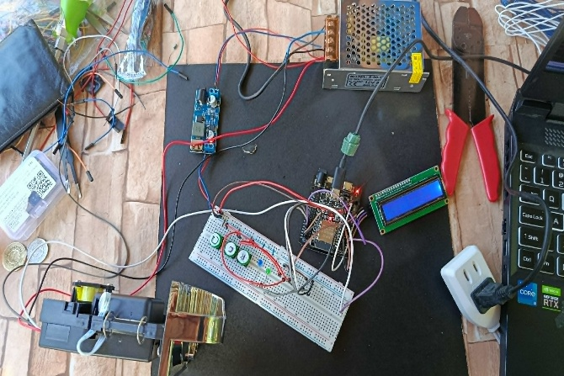
- Hardware Assembly Photos
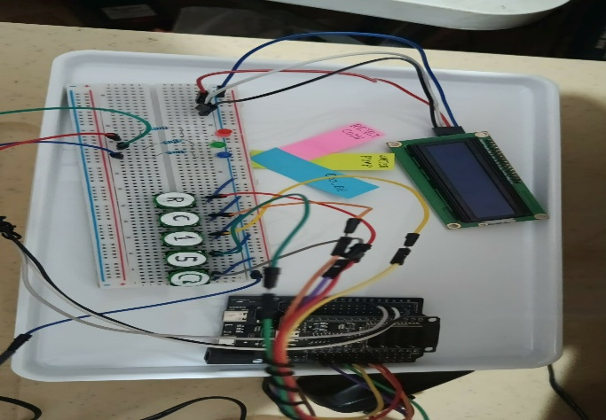

- Programming and Configuration Photos
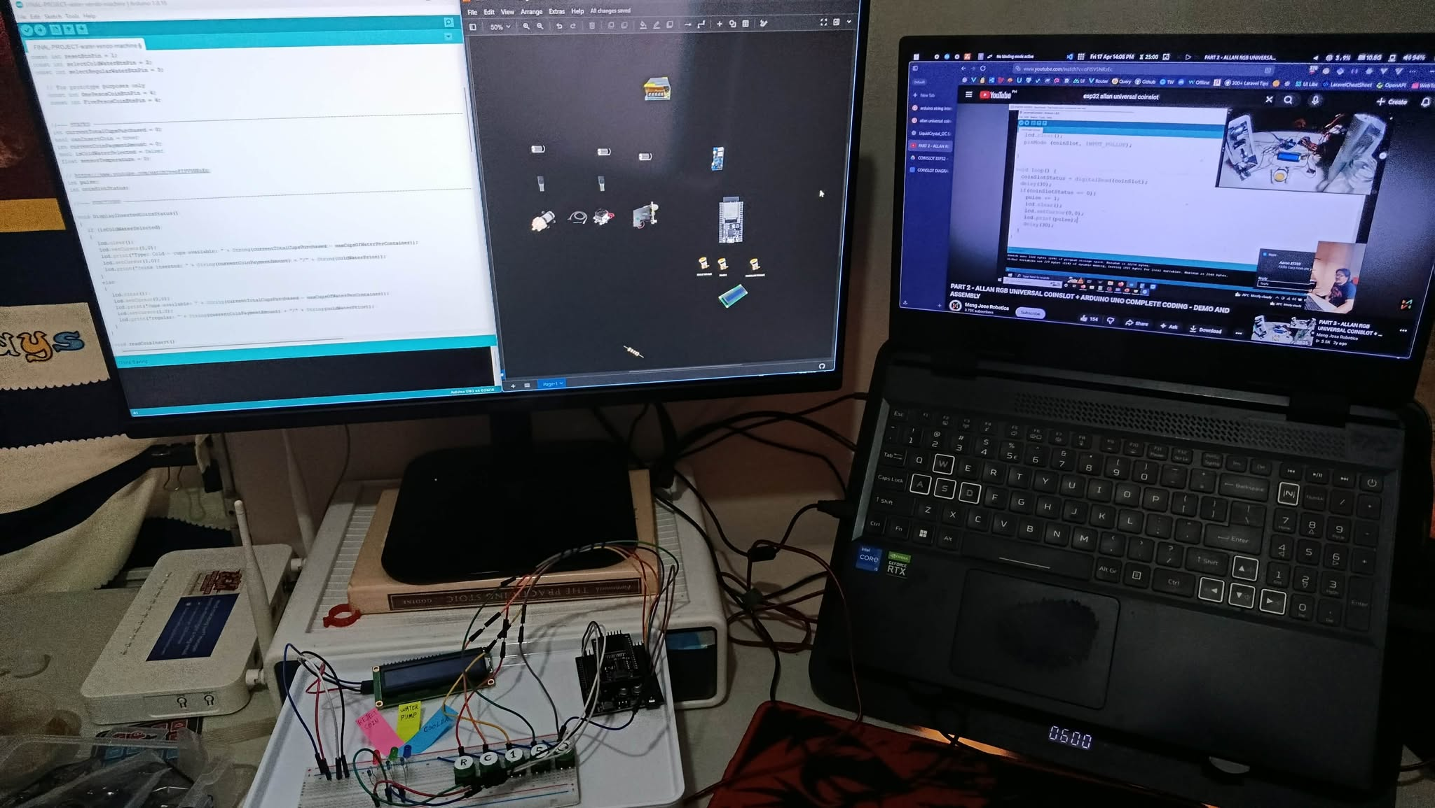
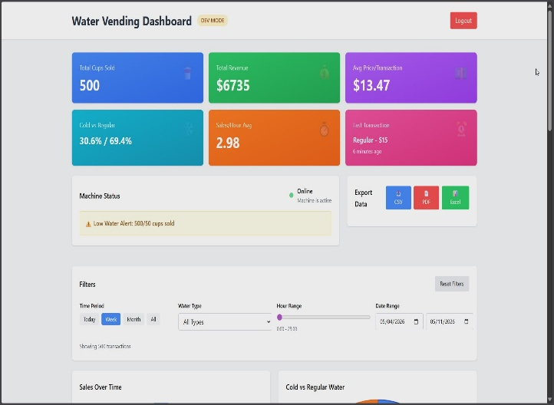
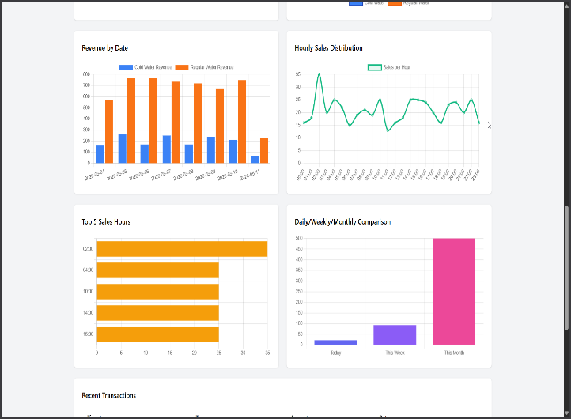
- Web Dashboard Screenshots
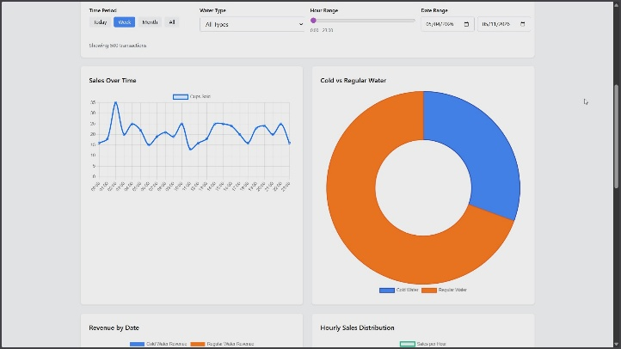

Source Code
#include <WiFi.h>
#include <HTTPClient.h>
#include <LiquidCrystal_I2C.h>
#include <Wire.h>
#include <time.h>
#include <Preferences.h>
#include <string.h>

// -------------------- LCD --------------------
LiquidCrystal_I2C lcd(0x27, 16, 2);

// -------------------- WIFI --------------------
#define WIFI_SSID "YOUR_WIFI_SSID"
#define WIFI_PASSWORD "YOUR_WIFI_PASSWORD"

// true = WiFi + Firebase enabled
// false = full offline mode, logs saved locally only
#define WIFI_ENABLED false

// -------------------- FIREBASE --------------------
#define FIREBASE_PROJECT_ID "YOUR_FIREBASE_PROJECT_ID"
#define FIREBASE_API_KEY "YOUR_FIREBASE_API_KEY"

// -------------------- DEBUG --------------------
#define COIN_DEBUG true
#define LCD_DEBUG_PULSES false

// -------------------- VENDING UX --------------------
// false = one cup per selection, keeps remaining balance
// true = auto-dispense as many cups as balance allows
#define AUTO_MULTI_CUP false

// -------------------- ESP32 30-PIN SAFE PINS --------------------
#define SDA_PIN 21
#define SCL_PIN 22

#define coinSlotPin 34 // GPIO34 needs external 10k pull-up to 3.3V
#define pumpPin 26
#define coolerPin 27

#define btnCold 18
#define btnRegular 19
#define resetBtn 23

// -------------------- CONSTANTS --------------------
const int maxCups = 50;

const int regularPrice = 3;
const int coldPrice = 5;

const unsigned long pumpDuration = 11500;
const unsigned long pumpTimeout = 20000;
const unsigned long cupGapDuration = 700;

// New: cooler runs first for 10 seconds before pump starts
const unsigned long coldPreCoolDuration = 10000;

const int coinPulseTimeout = 300;
const unsigned long coinRejectedDisplayTime = 1500;

#define MAX_OFFLINE_LOGS 100

// -------------------- COIN RULES --------------------
struct CoinRule {
const char *label;
int minPulse;
int maxPulse;
int value;
};

CoinRule coinRules[] = {
{"1 PESO", 1, 2, 1},
{"5 PESO", 4, 10, 5},
{"10 PESO", 15, 20, 10}
};

const int coinRuleCount = sizeof(coinRules) / sizeof(coinRules[0]);

// -------------------- FSM --------------------
enum State {
IDLE,
ACCEPTING_COINS,
PRE_COOLING,
DISPENSING,
CUP_GAP,
COIN_REJECTED,
OUT_OF_WATER,
ERROR_STATE
};

State currentState = ERROR_STATE;
State lastDisplayedState = ERROR_STATE;
State resumeAfterMessage = IDLE;

// -------------------- BUTTON --------------------
struct ButtonState {
uint8_t pin;
int last;
int current;
bool pressed;
};

ButtonState coldButton = {btnCold, HIGH, HIGH, false};
ButtonState regularButton = {btnRegular, HIGH, HIGH, false};
ButtonState resetButton = {resetBtn, HIGH, HIGH, false};

// -------------------- OFFLINE TRANSACTION --------------------
struct TransactionLog {
int amount;
bool coldSelected;
bool timeSynced;
uint32_t uptimeMs;
char timestamp[25];
};

TransactionLog offlineQueue[MAX_OFFLINE_LOGS];
int offlineCount = 0;

// -------------------- GLOBAL VARIABLES --------------------
Preferences prefs;
bool prefsReady = false;

volatile int pulseBuffer = 0;
volatile bool coinInputEnabled = false;

int coinPulseCount = 0;
unsigned long coinLastPulseTime = 0;
unsigned long coinDebugTimer = 0;

int currentCoins = 0;
int cupsToDispense = 0;
int cupsSold = 0;

uint32_t totalSales = 0;
uint32_t lostLogCount = 0;

bool isCold = false;
bool wifiConnected = false;
bool timeIsSynced = false;
bool flushPending = false;

unsigned long pumpStartTime = 0;
unsigned long preCoolStartTime = 0;
unsigned long cupGapStartTime = 0;
unsigned long lastButtonCheckTime = 0;
unsigned long lastWifiCheckTime = 0;
unsigned long messageStartTime = 0;

int lastRejectedPulseCount = 0;
char errorMessage[17] = "System Error";

// LCD cache
int lastDisplayedCoins = -9999;
int lastDisplayedCupsToDispense = -9999;
int lastDisplayedCupsSold = -9999;
int lastDisplayedPulseCount = -9999;
int lastDisplayedRejectedPulse = -9999;
int lastDisplayedPreCoolSeconds = -9999;

// -------------------- FUNCTION DECLARATIONS --------------------
void setState(State newState);
void resetCoinDetector();
void forceLCDRefresh();
void saveRuntimeState();
bool addOfflineTransaction(const TransactionLog &tx);
void flushOfflineQueue();
bool syncTime(unsigned long timeoutMs);
void validatePayment();
void beginWaterCycle();
void beginPreCooling();
void beginDispensing();
void handlePreCooling();

// -------------------- ISR --------------------
void IRAM_ATTR coinISR() {
if (!coinInputEnabled) return;

static unsigned long lastInterruptTime = 0;
unsigned long now = millis();

if (now - lastInterruptTime > 5) {
pulseBuffer++;
}

lastInterruptTime = now;
}

// -------------------- STATE NAME --------------------
const char *stateName(State state) {
switch (state) {
case IDLE: return "IDLE";
case ACCEPTING_COINS: return "ACCEPTING_COINS";
case PRE_COOLING: return "PRE_COOLING";
case DISPENSING: return "DISPENSING";
case CUP_GAP: return "CUP_GAP";
case COIN_REJECTED: return "COIN_REJECTED";
case OUT_OF_WATER: return "OUT_OF_WATER";
case ERROR_STATE: return "ERROR_STATE";
default: return "UNKNOWN";
}
}

// -------------------- LCD HELPERS --------------------
void printLCDLine(int row, const char *text) {
char buffer[17];

strncpy(buffer, text, 16);
buffer[16] = '\0';

lcd.setCursor(0, row);
lcd.print(buffer);

int len = strlen(buffer);
for (int i = len; i < 16; i++) {
lcd.print(' ');
}
}

void forceLCDRefresh() {
lastDisplayedState = ERROR_STATE;
lastDisplayedCoins = -9999;
lastDisplayedCupsToDispense = -9999;
lastDisplayedCupsSold = -9999;
lastDisplayedPulseCount = -9999;
lastDisplayedRejectedPulse = -9999;
lastDisplayedPreCoolSeconds = -9999;
}

// -------------------- COIN DETECTOR RESET --------------------
void resetCoinDetector() {
noInterrupts();
pulseBuffer = 0;
interrupts();

coinPulseCount = 0;
coinLastPulseTime = 0;
}

// -------------------- CENTRALIZED STATE TRANSITION --------------------
void setState(State newState) {
if (currentState == newState) {
forceLCDRefresh();
return;
}

State oldState = currentState;

// Exit actions
coinInputEnabled = false;
resetCoinDetector();

// Keep outputs active only during PRE_COOLING or DISPENSING.
// PRE_COOLING: cooler ON, pump OFF
// DISPENSING: pump ON, cooler ON only if cold
if (newState != DISPENSING && newState != PRE_COOLING) {
digitalWrite(pumpPin, LOW);
digitalWrite(coolerPin, LOW);
}

currentState = newState;

// Entry actions
if (newState == IDLE || newState == ACCEPTING_COINS) {
resetCoinDetector();
coinInputEnabled = true;
} else {
coinInputEnabled = false;
}

if (COIN_DEBUG) {
Serial.print("STATE: ");
Serial.print(stateName(oldState));
Serial.print(" -> ");
Serial.println(stateName(newState));
}

forceLCDRefresh();
}

// -------------------- PREFERENCES --------------------
void saveRuntimeState() {
if (!prefsReady) return;

prefs.putInt("balance", currentCoins);
prefs.putInt("cupsSold", cupsSold);
prefs.putUInt("totalSales", totalSales);
prefs.putUInt("lostLogs", lostLogCount);
}

void persistOfflineQueue() {
if (!prefsReady) return;

prefs.putInt("offCount", offlineCount);

if (offlineCount > 0) {
prefs.putBytes("offQueue", offlineQueue, sizeof(TransactionLog) * offlineCount);
} else {
prefs.remove("offQueue");
}
}

void loadPersistentData() {
prefsReady = prefs.begin("vendo", false);

if (!prefsReady) {
Serial.println("Preferences failed");
return;
}

currentCoins = prefs.getInt("balance", 0);
cupsSold = prefs.getInt("cupsSold", 0);
totalSales = prefs.getUInt("totalSales", 0);
lostLogCount = prefs.getUInt("lostLogs", 0);

offlineCount = prefs.getInt("offCount", 0);

if (offlineCount < 0 || offlineCount > MAX_OFFLINE_LOGS) {
offlineCount = 0;
}

size_t loadedBytes = prefs.getBytes("offQueue", offlineQueue, sizeof(offlineQueue));
int loadedItems = loadedBytes / sizeof(TransactionLog);

if (loadedItems < offlineCount) {
offlineCount = loadedItems;
}

Serial.print("Loaded balance: ");
Serial.println(currentCoins);

Serial.print("Loaded cups sold: ");
Serial.println(cupsSold);

Serial.print("Loaded offline logs: ");
Serial.println(offlineCount);
}

// -------------------- TIME --------------------
bool getISOTime(char *buffer, size_t bufferSize) {
time_t now;
time(&now);

if (now < 1700000000) {
strncpy(buffer, "1970-01-01T00:00:00Z", bufferSize);
buffer[bufferSize - 1] = '\0';
return false;
}

struct tm timeInfo;
gmtime_r(&now, &timeInfo);

strftime(buffer, bufferSize, "%Y-%m-%dT%H:%M:%SZ", &timeInfo);
return true;
}

bool syncTime(unsigned long timeoutMs) {
if (!WIFI_ENABLED || !wifiConnected) return false;

Serial.println("Syncing NTP time...");

configTime(0, 0, "pool.ntp.org", "time.nist.gov");

unsigned long start = millis();

while (millis() - start < timeoutMs) {
time_t now;
time(&now);

if (now > 1700000000) {
timeIsSynced = true;
Serial.println("Time synced");
return true;
}

delay(200);
}

timeIsSynced = false;
Serial.println("Time sync failed");
return false;
}

// -------------------- WIFI --------------------
void connectWiFi() {
if (!WIFI_ENABLED) {
Serial.println("WiFi disabled");
wifiConnected = false;
return;
}

Serial.println("Connecting to WiFi...");
WiFi.begin(WIFI_SSID, WIFI_PASSWORD);

int attempts = 0;

while (WiFi.status() != WL_CONNECTED && attempts < 10) {
delay(500);
Serial.print(".");
attempts++;
}

wifiConnected = (WiFi.status() == WL_CONNECTED);

if (wifiConnected) {
Serial.println("\nWiFi connected");
syncTime(10000);
flushPending = true;
} else {
Serial.println("\nWiFi failed");
}
}

void checkWifiStatus() {
if (!WIFI_ENABLED) return;

if (millis() - lastWifiCheckTime > 10000) {
lastWifiCheckTime = millis();

bool previous = wifiConnected;
wifiConnected = (WiFi.status() == WL_CONNECTED);

if (!wifiConnected) {
WiFi.begin(WIFI_SSID, WIFI_PASSWORD);
}

if (!previous && wifiConnected) {
Serial.println("WiFi reconnected");
syncTime(5000);
flushPending = true;
}
}
}

void maybeFlushOfflineQueue() {
if (!WIFI_ENABLED) return;
if (!wifiConnected) return;
if (!flushPending && offlineCount == 0) return;
if (currentState != IDLE) return;

flushPending = false;
flushOfflineQueue();
}

// -------------------- FIREBASE --------------------
TransactionLog makeTransaction(int amount, bool coldSelected) {
TransactionLog tx;

tx.amount = amount;
tx.coldSelected = coldSelected;
tx.uptimeMs = millis();
tx.timeSynced = getISOTime(tx.timestamp, sizeof(tx.timestamp));

return tx;
}

bool postTransactionToFirebase(const TransactionLog &tx) {
if (!WIFI_ENABLED || !wifiConnected) return false;

char url[300];

snprintf(
url,
sizeof(url),
"https://firestore.googleapis.com/v1/projects/%s/databases/(default)/documents/waterLogs?key=%s",
FIREBASE_PROJECT_ID,
FIREBASE_API_KEY
);

char json[600];

snprintf(
json,
sizeof(json),
"{"
"\"fields\":{"
"\"amount\":{\"integerValue\":\"%d\"},"
"\"isCold\":{\"booleanValue\":%s},"
"\"timestamp\":{\"timestampValue\":\"%s\"},"
"\"timeSynced\":{\"booleanValue\":%s},"
"\"clientUptimeMs\":{\"integerValue\":\"%lu\"}"
"}"
"}",
tx.amount,
tx.coldSelected ? "true" : "false",
tx.timestamp,
tx.timeSynced ? "true" : "false",
(unsigned long)tx.uptimeMs
);

HTTPClient http;
http.setTimeout(5000);

http.begin(url);
http.addHeader("Content-Type", "application/json");

int code = http.POST((uint8_t *)json, strlen(json));

http.end();

Serial.print("Firebase HTTP code: ");
Serial.println(code);

return (code >= 200 && code < 300);
}

bool addOfflineTransaction(const TransactionLog &tx) {
if (offlineCount >= MAX_OFFLINE_LOGS) {
lostLogCount++;
saveRuntimeState();

Serial.println("Offline queue full");
return false;
}

offlineQueue[offlineCount] = tx;
offlineCount++;

persistOfflineQueue();

Serial.print("Saved offline transaction. Queue: ");
Serial.println(offlineCount);

return true;
}

void flushOfflineQueue() {
if (!WIFI_ENABLED || !wifiConnected || offlineCount == 0) return;

Serial.println("Flushing offline queue...");

int sent = 0;

while (sent < offlineCount) {
if (!postTransactionToFirebase(offlineQueue[sent])) {
break;
}

sent++;
}

if (sent > 0) {
for (int i = sent; i < offlineCount; i++) {
offlineQueue[i - sent] = offlineQueue[i];
}

offlineCount -= sent;
persistOfflineQueue();
}

Serial.print("Offline queue remaining: ");
Serial.println(offlineCount);
}

bool recordTransaction(int price, bool coldSelected) {
if (WIFI_ENABLED && wifiConnected && !timeIsSynced) {
syncTime(3000);
}

TransactionLog tx = makeTransaction(price, coldSelected);

totalSales += price;
saveRuntimeState();

if (WIFI_ENABLED && wifiConnected) {
if (postTransactionToFirebase(tx)) {
flushPending = true;
return true;
}
}

return addOfflineTransaction(tx);
}

// -------------------- LCD UPDATE --------------------
void updateLCD() {
int preCoolSecondsRemaining = -1;

if (currentState == PRE_COOLING) {
unsigned long elapsed = millis() - preCoolStartTime;

if (elapsed >= coldPreCoolDuration) {
preCoolSecondsRemaining = 0;
} else {
preCoolSecondsRemaining = (coldPreCoolDuration - elapsed + 999) / 1000;
}
}

if (
currentState == lastDisplayedState &&
currentCoins == lastDisplayedCoins &&
cupsToDispense == lastDisplayedCupsToDispense &&
cupsSold == lastDisplayedCupsSold &&
coinPulseCount == lastDisplayedPulseCount &&
lastRejectedPulseCount == lastDisplayedRejectedPulse &&
preCoolSecondsRemaining == lastDisplayedPreCoolSeconds
) {
return;
}

lastDisplayedState = currentState;
lastDisplayedCoins = currentCoins;
lastDisplayedCupsToDispense = cupsToDispense;
lastDisplayedCupsSold = cupsSold;
lastDisplayedPulseCount = coinPulseCount;
lastDisplayedRejectedPulse = lastRejectedPulseCount;
lastDisplayedPreCoolSeconds = preCoolSecondsRemaining;

char line[17];

if (currentState == IDLE) {
if (currentCoins > 0) {
snprintf(line, sizeof(line), "Balance: P%d", currentCoins);
printLCDLine(0, line);
printLCDLine(1, "Select Water");
} else {
printLCDLine(0, "Insert/Select");
printLCDLine(1, "Cold | Regular");
}
}

else if (currentState == ACCEPTING_COINS) {
int price = isCold ? coldPrice : regularPrice;

snprintf(line, sizeof(line), "%s P%d", isCold ? "Cold" : "Regular", price);
printLCDLine(0, line);

if (LCD_DEBUG_PULSES && coinPulseCount > 0) {
snprintf(line, sizeof(line), "Pulse: %d", coinPulseCount);
} else {
snprintf(line, sizeof(line), "Paid: %d/%d", currentCoins, price);
}

printLCDLine(1, line);
}

else if (currentState == PRE_COOLING) {
printLCDLine(0, "Cooling water...");
snprintf(line, sizeof(line), "Pump in: %ds", preCoolSecondsRemaining);
printLCDLine(1, line);
}

else if (currentState == DISPENSING) {
printLCDLine(0, "Dispensing...");
snprintf(line, sizeof(line), "Left:%d Bal:%d", cupsToDispense, currentCoins);
printLCDLine(1, line);
}

else if (currentState == CUP_GAP) {
printLCDLine(0, "Next cup...");
snprintf(line, sizeof(line), "Left: %d", cupsToDispense);
printLCDLine(1, line);
}

else if (currentState == COIN_REJECTED) {
printLCDLine(0, "Invalid Coin");
snprintf(line, sizeof(line), "Pulse: %d", lastRejectedPulseCount);
printLCDLine(1, line);
}

else if (currentState == OUT_OF_WATER) {
printLCDLine(0, "OUT OF WATER");
printLCDLine(1, "Press RESET");
}

else if (currentState == ERROR_STATE) {
printLCDLine(0, "SYSTEM ERROR");
printLCDLine(1, errorMessage);
}
}

// -------------------- COIN CLASSIFIER --------------------
bool classifyCoin(int pulseCount, int &coinValue, const char *&coinLabel) {
for (int i = 0; i < coinRuleCount; i++) {
if (
pulseCount >= coinRules[i].minPulse &&
pulseCount <= coinRules[i].maxPulse
) {
coinValue = coinRules[i].value;
coinLabel = coinRules[i].label;
return true;
}
}

coinValue = 0;
coinLabel = "UNKNOWN";
return false;
}

void enterCoinRejected(int pulseCount) {
lastRejectedPulseCount = pulseCount;
messageStartTime = millis();

if (currentState == ACCEPTING_COINS) {
resumeAfterMessage = ACCEPTING_COINS;
} else {
resumeAfterMessage = IDLE;
}

setState(COIN_REJECTED);
}

void processCoins() {
if (currentState != IDLE && currentState != ACCEPTING_COINS) {
resetCoinDetector();
return;
}

unsigned long now = millis();

noInterrupts();
int detected = pulseBuffer;
pulseBuffer = 0;
interrupts();

if (detected > 0) {
coinPulseCount += detected;
coinLastPulseTime = now;

if (COIN_DEBUG) {
Serial.print("RAW PULSE: ");
Serial.print(detected);
Serial.print(" | TOTAL: ");
Serial.println(coinPulseCount);
}
}

if (coinPulseCount > 0 && (now - coinLastPulseTime > coinPulseTimeout)) {
int coinValue = 0;
const char *coinLabel = "UNKNOWN";

bool validCoin = classifyCoin(coinPulseCount, coinValue, coinLabel);

if (COIN_DEBUG) {
Serial.println("------ COIN ANALYSIS ------");
Serial.print("Final Pulse Count: ");
Serial.println(coinPulseCount);
}

if (validCoin) {
currentCoins += coinValue;
saveRuntimeState();

if (COIN_DEBUG) {
Serial.print("VALID: ");
Serial.println(coinLabel);
Serial.print("ADDED: ");
Serial.println(coinValue);
Serial.print("BALANCE: ");
Serial.println(currentCoins);
}

resetCoinDetector();
} else {
if (COIN_DEBUG) {
Serial.println("INVALID COIN / UNKNOWN RANGE");
}

int rejectedPulse = coinPulseCount;
resetCoinDetector();
enterCoinRejected(rejectedPulse);
}

if (COIN_DEBUG) {
Serial.println("---------------------------");
}
}

if (COIN_DEBUG && millis() - coinDebugTimer > 5000) {
coinDebugTimer = millis();

Serial.print("STATE: ");
Serial.print(stateName(currentState));
Serial.print(" | BALANCE: ");
Serial.print(currentCoins);
Serial.print(" | OFFLINE LOGS: ");
Serial.println(offlineCount);
}
}

// -------------------- PAYMENT --------------------
void beginPreCooling() {
setState(PRE_COOLING);

preCoolStartTime = millis();

digitalWrite(pumpPin, LOW);
digitalWrite(coolerPin, HIGH);

Serial.println("Cold pre-cooling started");
Serial.println("Cooler: ON | Pump: OFF");
}

void beginDispensing() {
setState(DISPENSING);

pumpStartTime = millis();

digitalWrite(pumpPin, HIGH);

if (isCold) {
digitalWrite(coolerPin, HIGH);
Serial.println("Cold dispensing started");
Serial.println("Cooler: ON | Pump: ON");
} else {
digitalWrite(coolerPin, LOW);
Serial.println("Regular dispensing started");
Serial.println("Cooler: OFF | Pump: ON");
}
}

void beginWaterCycle() {
if (isCold) {
beginPreCooling();
} else {
beginDispensing();
}
}

void validatePayment() {
if (currentState != ACCEPTING_COINS) return;

if (cupsSold >= maxCups) {
setState(OUT_OF_WATER);
return;
}

int price = isCold ? coldPrice : regularPrice;

if (currentCoins < price) return;

int capacityRemaining = maxCups - cupsSold;

if (capacityRemaining <= 0) {
setState(OUT_OF_WATER);
return;
}

if (AUTO_MULTI_CUP) {
int affordableCups = currentCoins / price;

if (affordableCups > capacityRemaining) {
affordableCups = capacityRemaining;
}

cupsToDispense = affordableCups;
currentCoins -= cupsToDispense * price;
} else {
cupsToDispense = 1;
currentCoins -= price;
}

saveRuntimeState();

Serial.print("Payment accepted. Cups queued: ");
Serial.println(cupsToDispense);

beginWaterCycle();
}

// -------------------- DISPENSING --------------------
void enterError(const char *message) {
strncpy(errorMessage, message, 16);
errorMessage[16] = '\0';

setState(ERROR_STATE);
}

void handlePreCooling() {
unsigned long elapsed = millis() - preCoolStartTime;

if (elapsed >= coldPreCoolDuration) {
Serial.println("Pre-cooling finished");
Serial.println("Starting pump now");

beginDispensing();
}
}

void handleDispensing() {
unsigned long elapsed = millis() - pumpStartTime;

if (elapsed >= pumpTimeout) {
digitalWrite(pumpPin, LOW);
digitalWrite(coolerPin, LOW);

enterError("Pump Timeout");
return;
}

if (elapsed >= pumpDuration) {
digitalWrite(pumpPin, LOW);
digitalWrite(coolerPin, LOW);

int price = isCold ? coldPrice : regularPrice;

cupsSold++;
cupsToDispense--;

saveRuntimeState();

Serial.print("Cup dispensed. Cups sold: ");
Serial.println(cupsSold);

if (!recordTransaction(price, isCold)) {
enterError("Log Queue Full");
return;
}

if (cupsSold >= maxCups) {
setState(OUT_OF_WATER);
return;
}

if (AUTO_MULTI_CUP && cupsToDispense > 0) {
cupGapStartTime = millis();
setState(CUP_GAP);
} else {
cupsToDispense = 0;
setState(IDLE);
}
}
}

void handleCupGap() {
if (millis() - cupGapStartTime >= cupGapDuration) {
beginWaterCycle();
}
}

void handleCoinRejected() {
if (millis() - messageStartTime >= coinRejectedDisplayTime) {
setState(resumeAfterMessage);
}
}

// -------------------- BUTTONS --------------------
void updateButton(ButtonState &button) {
button.current = digitalRead(button.pin);
button.pressed = (button.last == HIGH && button.current == LOW);
button.last = button.current;
}

void selectWater(bool coldSelected) {
isCold = coldSelected;

if (currentState != ACCEPTING_COINS) {
setState(ACCEPTING_COINS);
} else {
forceLCDRefresh();
}

Serial.println(coldSelected ? "Cold selected" : "Regular selected");

validatePayment();
}

void handleResetButton() {
Serial.println("Reset pressed");

digitalWrite(pumpPin, LOW);
digitalWrite(coolerPin, LOW);

currentCoins = 0;
cupsToDispense = 0;
cupsSold = 0;

resetCoinDetector();
saveRuntimeState();

setState(IDLE);
}

void readButtons() {
if (millis() - lastButtonCheckTime < 50) return;
lastButtonCheckTime = millis();

updateButton(coldButton);
updateButton(regularButton);
updateButton(resetButton);

if (resetButton.pressed) {
handleResetButton();
return;
}

if (
currentState == IDLE ||
currentState == ACCEPTING_COINS
) {
if (coldButton.pressed) {
selectWater(true);
}

if (regularButton.pressed) {
selectWater(false);
}
}
}

// -------------------- SETUP --------------------
void setup() {
Serial.begin(115200);
Serial.println("=== WATER VENDO SYSTEM START ===");

Wire.begin(SDA_PIN, SCL_PIN);

lcd.init();
lcd.backlight();

printLCDLine(0, "System Starting");
printLCDLine(1, "Please wait...");

pinMode(coinSlotPin, INPUT); // GPIO34 requires external 10k pull-up

pinMode(pumpPin, OUTPUT);
pinMode(coolerPin, OUTPUT);

pinMode(btnCold, INPUT_PULLUP);
pinMode(btnRegular, INPUT_PULLUP);
pinMode(resetBtn, INPUT_PULLUP);

digitalWrite(pumpPin, LOW);
digitalWrite(coolerPin, LOW);

loadPersistentData();

attachInterrupt(digitalPinToInterrupt(coinSlotPin), coinISR, FALLING);

connectWiFi();

if (cupsSold >= maxCups) {
setState(OUT_OF_WATER);
} else {
setState(IDLE);
}

updateLCD();
}

// -------------------- LOOP --------------------
void loop() {
readButtons();
checkWifiStatus();

switch (currentState) {
case IDLE:
processCoins();
break;

case ACCEPTING_COINS:
processCoins();
validatePayment();
break;

case PRE_COOLING:
handlePreCooling();
break;

case DISPENSING:
handleDispensing();
break;

case CUP_GAP:
handleCupGap();
break;

case COIN_REJECTED:
handleCoinRejected();
break;

case OUT_OF_WATER:
break;

case ERROR_STATE:
break;
}

maybeFlushOfflineQueue();
updateLCD();
}

