Relativity

In a tennis game, suppose a player faces a ball at 80 km/h, and hits it so as to reverse its velocity.

If she is on a ship moving at 10 km/h, someone on the wharf will see the ball coming at 90 km/h and returned at 70 km/h

The change in velocity is the same, whoever observes it: 160 km/h.

So the acceleration is the same, and the force applied (mass times acceleration) is also the same. So everyone agrees F = ma.

-Newtonian machanics satisfies the principle of relativity
- the laws of nature do not depend on the choice of reference frame

A 19th Century or Newtonian view: “That's O.K. for mechanics. But an experiment with light should tell us our absolute speed.” (?)

Oersted
moving electric field → magnetic field

Faraday induction:
moving magnetic field → electric field

Maxwell
moving electric field → moving magnetic field → moving electric field …electromagnetic wave: light travels in any direction at

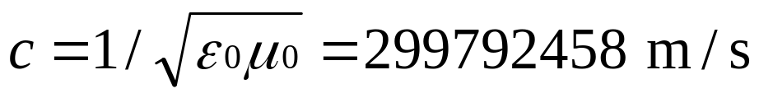

If speeds add as we change frame, the speed of light must change (?) We could explain this by saying the medium is moving, but light goes through a vacuum.

Einstein's misgivings
- What would a light beam look like to someone who was travelling beside it at the same speed?
- What was wrong with Faraday’s and Maxwell’s E&M theory in a different frame?
- But Faraday’s experiments worked in any frame; the relative motion of magnet and wire was enough to specify the voltage.
- The principle of relativity says that no experiment within a capsule can find how fast it is moving
- Experiments like Fizeau’s tell us that adding speeds is wrong for light

So relativity holds for optics :
The speed of light is the same for all steadily moving observers

The 1887 Michelson-Morley experiment measured the difference between light speeds in two directions at right angles.

Shouldn't the differences in light speed cancel since it goes both ways before detection? Putting the same question in different terms: If you drive from Christchurch to Arthur's Pass (say 150 km) at an average speed of 70 km/h, and return at an average of 50 km/h, isn't the average on the to-and-fro journey 60 km/h? (To answer this: how many hours would 150 km need at 70 km/h? at 50 km/h? And how many hours would 300 km need at 60 km/h? Does this tally?)

Thursday, 11 May 2000: The speed of light is independent of the speed of the light source to within one part in 10²⁰. Kenneth Brecher, Boston University studied gamma radiation arriving from distant gamma ray bursters (GRBs).
How do we know what the time is “there”?

(a): Move a nice stable clock gently

(b) Get the pips on the radio/TV

Distance is measured by bouncing a light signal from one end to the other, measuring time on one clock. Given the speed of light, that fixes the distance, by a purely local (one-clock) set of measurements.

Then synchronise the clocks by noting its arrival, and check their rates by repeating it all. This sets up a set of observers in a coordinate frame.

Can everyone agree that “the train was hit by lightning at each end at the same time''?
- Guard and driver both struck by lightning

- passenger Bev in the middle of the train saw the lightning bolts at the same time on her clock

- Andy on the ground opposite Bev will agree the bolts arrive together,

- since Bev is in the middle, she calculates that they left at the same time

- Andy calculates that the two bolts came different distances, and so did not leave at the same time.

In Newtonian days there was no time problem- the speeds of the light signals were not the same to Andy and to Bev.
Do they agree on the tick rate of a clock?
Take a light clock, where light bounces between two parallel mirrors. If the mirrors are L metres apart for Bev, one half-tick takes 2L/c seconds.

Andy sees a clock tick with the light signal on a slanting path with speed c.

So it took a longer time.

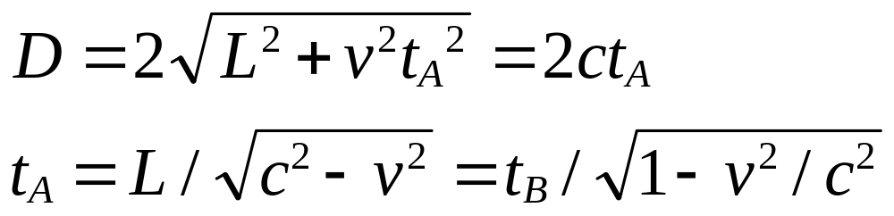 So he sees Bev's clock as running slow. -- time dilation

Kaivola et al, Phys. Rev. Lett. 54, 255 (1985), quote a test of time dilation to 1 part in 10⁵

Frisch & Smith Am J Phys 1963 On each clock ‘tick’ - 1.5 μs - half the remaining radioactive muons from space decay.
Given 600 muons at time 0, there will be approx. 300 1.5 μs later, and 150 at 3 μs.
A muon detector on Mt Washington (1910 m) was gated to count particles at 99.50 to 99.54% of c. They counted typically 568 muons per hour at the top.
It takes 6.4 μs for a fast muon to fly to the bottom. This is 4 half-lives; we'd expect 568/2⁴ or 32 muons per hour at the bottom. However, they counted 412 per hour (approx.) at ground level!
Time dilation explains this. The inbuilt clock of the muon runs slow, as seen by an external observer, and so it decays more slowly and lives longer.
Length contraction

The muon sees Mt Washington fly past it at (their common relative speed) 99.5 of the speed of light, in less than 1.5 μs (the half life). So it claims that Mt Washington has an apparent height of 450 m, not 1910 m!

Twin paradox

Andy stays on earth. Bev (let's suppose her to be his twin) goes to α Centauri by spaceship. When she gets there, she reverses her rocket, and returns home.

Andy sees her clock running slow in both directions. The turnround takes negligible time in comparison.

So Andy thinks she comes home younger than he is. She has aged less.
Is it all a matter of perspective, with nothing really happening?

No. Physics is different. The muons really live longer than expected.

Will all clocks such as their heartbeats be affected too?

If not, they can measure their speed in their own frame by comparing their clocks – contrary to relativity
All clocks obey Maxwellian physics for this purpose. Matter including biological tissue is electromechanical as far as we know.

What really happens to speed addition?
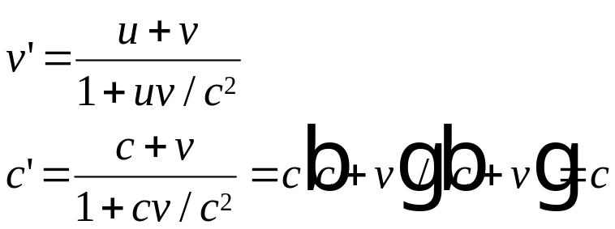
Mass and energy

Mass is:
(a) Something an object always has
(b) Something whose total is always the same before and after a collision.
(c) Something, which when multiplied by speed gives the momentum conserved in a collision.
Why (b)?
- it is needed for (a)
- it is energy conservation
Why (c)?
- it is needed for isolated system to have no overall acceleration
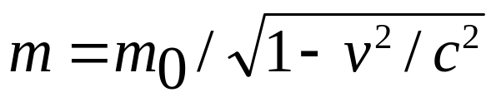So we insist on (b) and (c) still being true in relativity. Since speeds are no longer what they were, (a) cannot be kept as well.

A hotter body weighs more. Its atoms are moving faster, excited by the heat.
The increase in mass is the energy supplied (as work going into kinetic energy, or by way of heating, say, as in the above problem), divided by c²: E=mc²

Einstein made a leap of faith: this equation should apply to m₀ as well, whatever the source. (It includes kinetic energy – heat!) So every kilogram of matter contains 9 x 10¹⁶ J of energy. Hence the historic realisation that chemical energy is peanuts.

Piantala bene wert 4barratp5



