EE201C

Homework 1

Name: Peidong Chen UID: 204432674

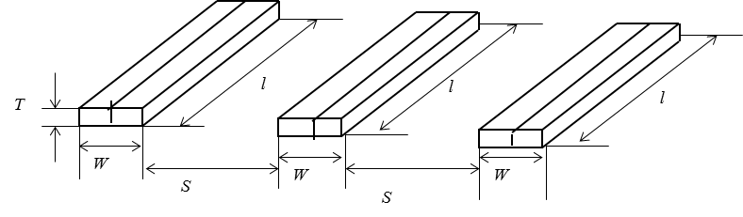

Discretize 3 wires into 6 filaments.

For each filament, calculate its self-inductance with:

For each pair of filament, calculate the mutual inductance with:

We can get the inductance matrix for 6 filaments:

Calculate the matrix of inductance with Matlab code:

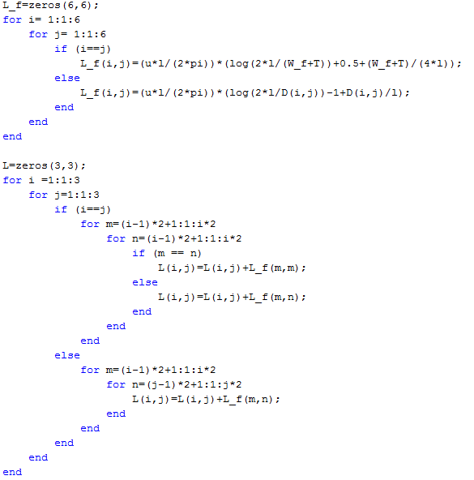

Calculate inductance matrix of three wires with:



We can get the inductance matrix for 3 wires:

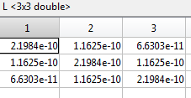

Capacitance calculation:

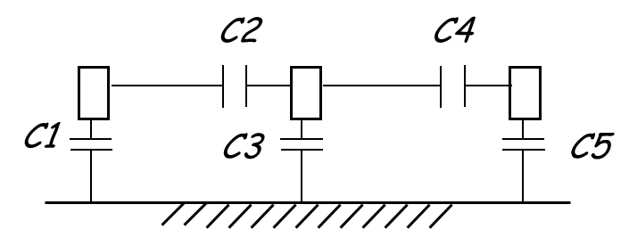









Resistance calculation:



Simulation:

Layout with Cadence:

RC circuit model:

Rising time = 20ps

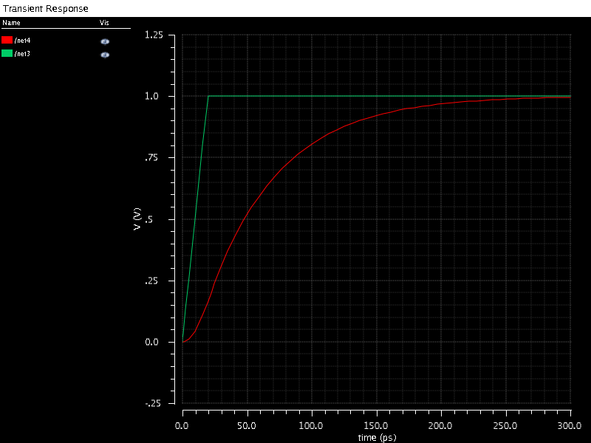

RCL circuit model:

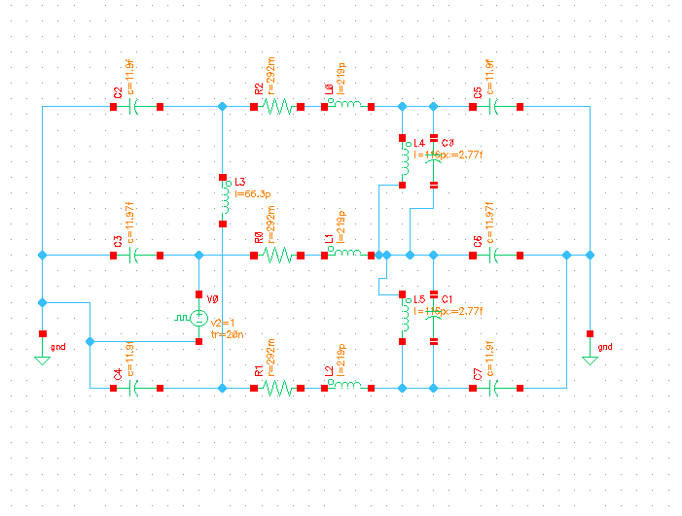

Rising time = 20ps

