**EE201C HW#2**

Problem#1

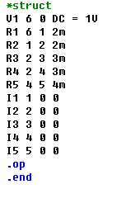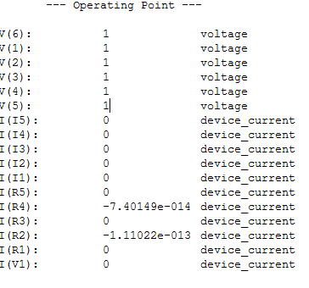

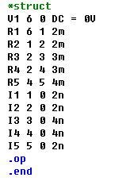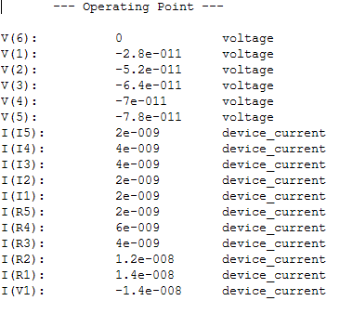

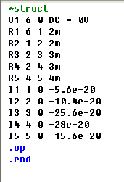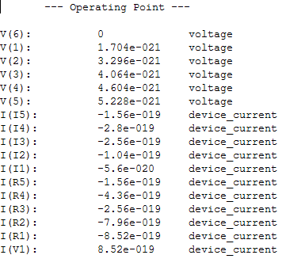

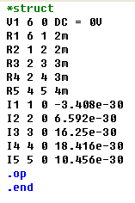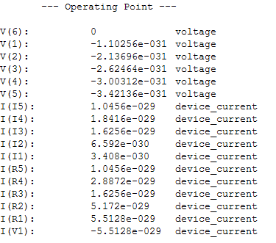

Thus the zero to 3rd moments are mo = 1, m1 = -7e-11, m2 = 4.064e-21, m3 = -3.00312e-31

m4 = 1.95481e-41

From the S2P paper, we get

Matlab code:

m0 = 1;  
m1 = -7e-11;  
m2 = 4.604e-21;  
m3 = -3.00312e-31;  
m4 = 1.95467e-41;  
a1 = (m2*m3 - m1*m4) / (m1*m3 - m2*m2);  
a2 = (m2*m4 - m3*m3) / (m1*m3 - m2*m2);  
p1 = (-a1 + sqrt(a1*a1 - 4*a2))/(2*a2);  
p2 = (-a1 - sqrt(a1*a1 - 4*a2))/(2*a2);  
k2 = p2 * (m0/p1 - m1) / (1/p2 - 1/p1);  
k1 = (-m0 - k2/p2) * p1;

syms s t;  
ilaplace ((k1/(s - p1) + k2/(s-p2))/s, s, t);  
t=0:0.01e-10:0.5e-9;   
y = 2117821015315835./(20472632681851984*exp((3838618627847247*t)/65536)) - 8895143536189541./(8061237224801257*exp((8061237224801257*t)/524288)) + 165034748664628021125615370894749/165034748664628002923815091143888  
plot(t,y);

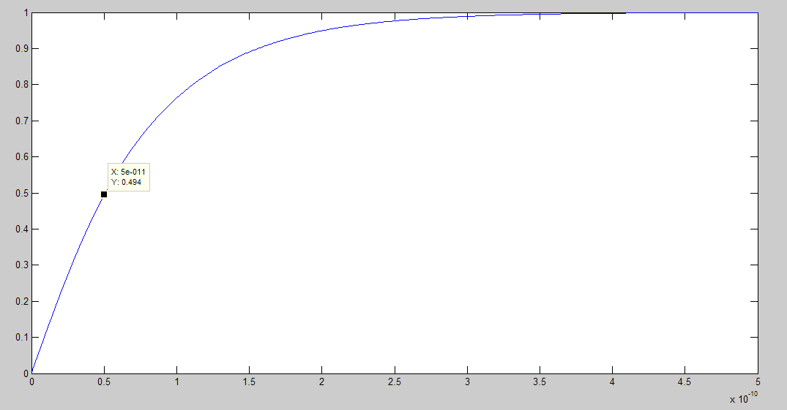

From the plot, we could see the delay at node4 is about 50ps.

Then we do a spice simulation.

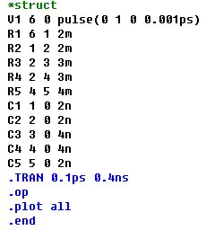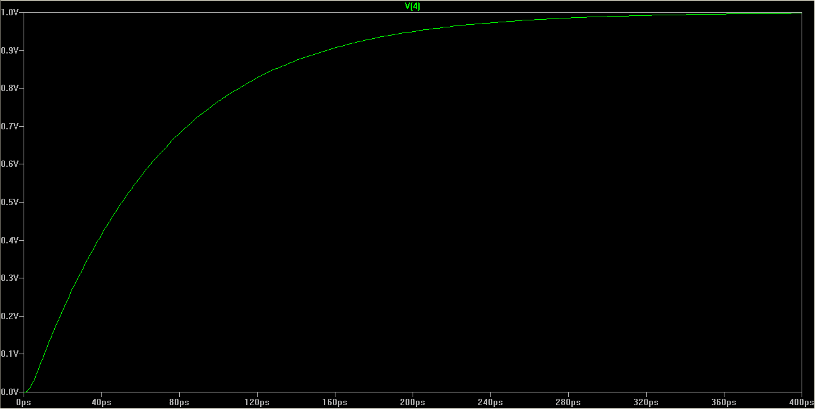

We could see the result is aroud 50ps as well which shows S2P as a good approach.

Problem#2

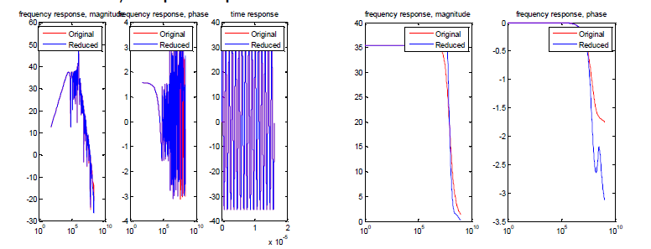

Fig1 le4 for GC9

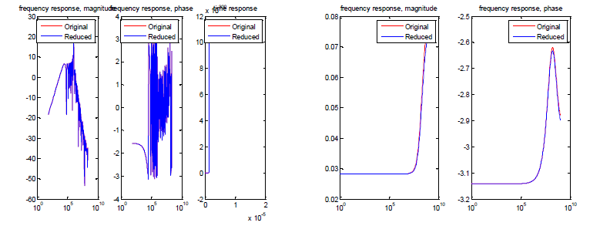Fig2 le4 for GC8

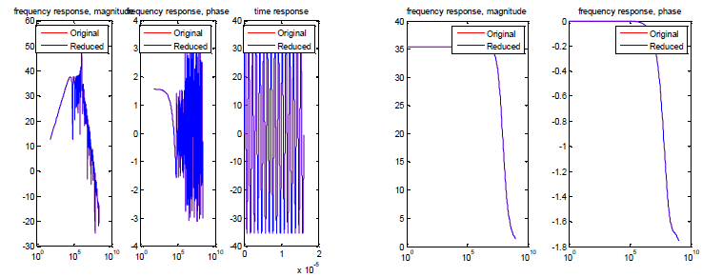Fig3 multiple expansion le3, le5, le7, le9 for GC9

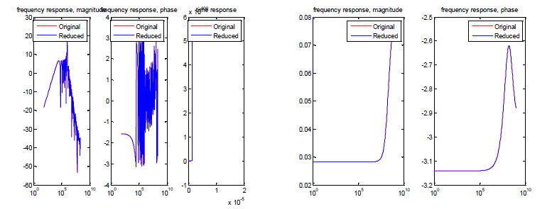 Fig4 multiple expansion le3, le5, le7, le9 for GC8

We could see that from one expansion point graphs, we can clearly see the difference between the reduced model and original model at high frequency span. However, for multiple expansion point, the results for two models remain constant and stable. This holds for both GC8 and GC9.