Project 1

Yunxuan Yu 304518158

**Problem 1.**

***1. Follow the DC analysis method to reconstruct the circuit(e.g. replace C with zero current source for 0th moment calculation, etc).***

***2. Write the corresponding netlist for SPICE analysis.***

***3. Run DC analysis in SPICE to get the voltage across the capacitance as the moment.***

***4. The above should be done repeatedly until all the desired moments are acquired.***

The modified circuit and the spice script can be found in the attached files. The simulation results are shown below:

**0th moment:**

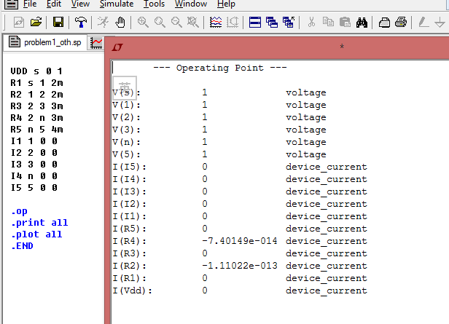

**1th moment:**

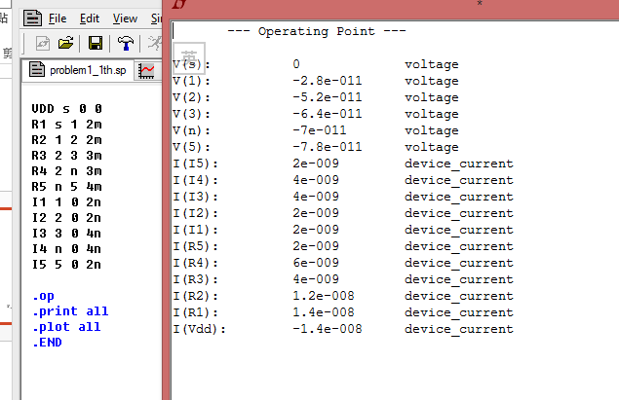

**2th moment:**

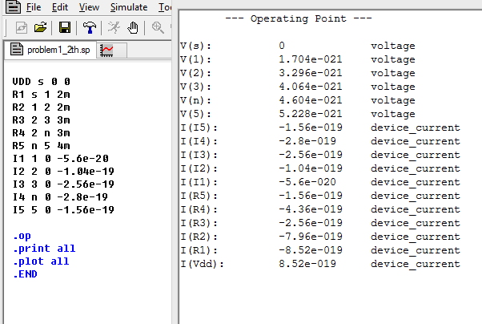

**3th Moment:**

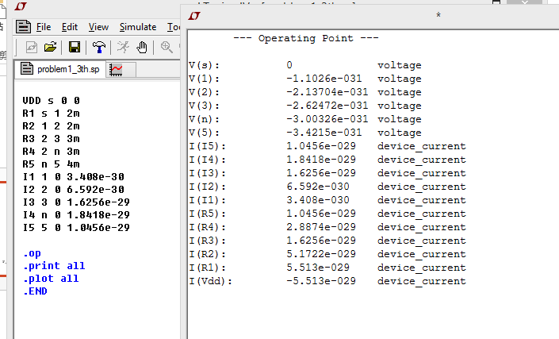

**Question 2:**

***1. Write the SPICE net-list of the circuit, run transient simulation, and probe the voltage response at node n.***

***2. Record the time when the voltage at node n reaches 0.5V. That time is the 50% delay.***

***3. Elmore Delay: Use the Elmore delay formula to calculate the Elmore delay.***

***(find the shared path between each node and node n).***

***4. S2P*: Write down the transfer function H(s) and driving point admittance Y(s) of the circuit with input s and output n.***

***5. Expand the transfer function to get the moments m0* and m1*.***

***6. Expand the driving point admittance to get m1, m2, m3, and m4.***

***7. Follow the S2P algorithm to get S2P approximation ĥ(s) in frequency domain.***

***8. Use the frequency domain expression (ĥ(s) ) to derive the time domain expression (ĥ(t) ).***

***9. Plot the obtained time domain waveform to get the 50% delay for the S2P model.***

***10. Compare the results.***

The answer to steps 1-2 are shown below:

Write down the spice code for simulating the step response delay.

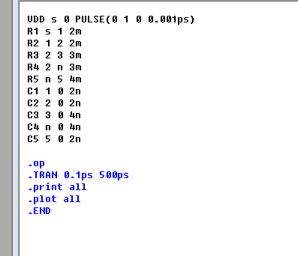

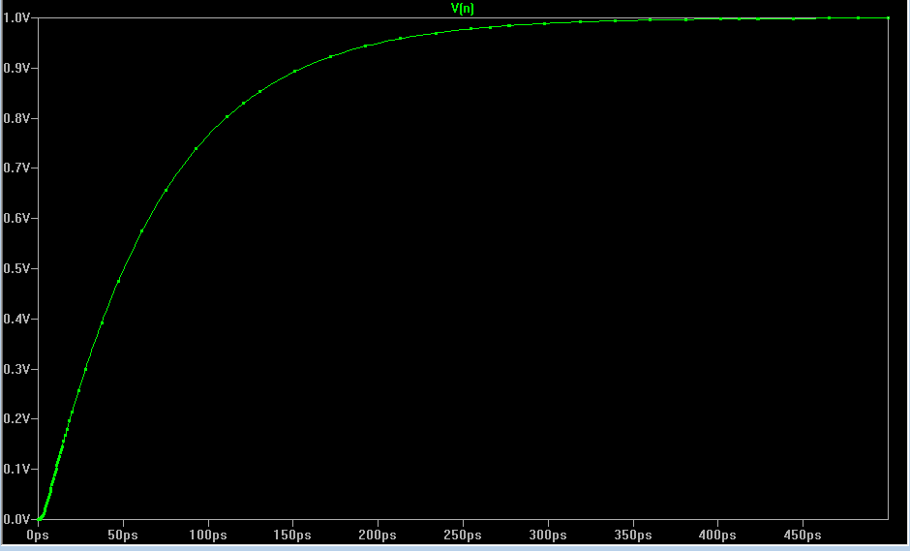

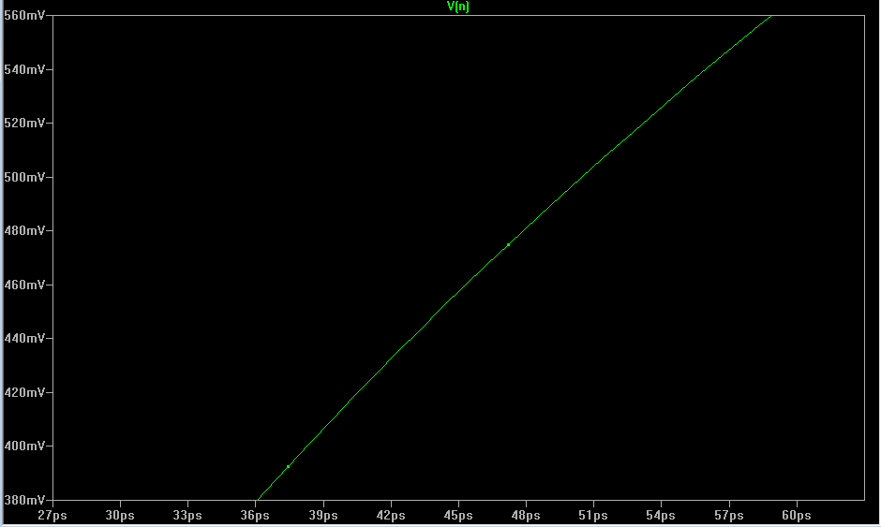

From the simulation result we can find that the 50% delay point is around 51ps.

The answer to step 3 is here:

**Calculating the Elmore delay:**

T1 = R1*(C1+C2+C3+C4+C5)+R2*(C2+C3+C4+C5)+R4*(C4+C5) = 48.3 ps

The answer to steps 4-9 are shown below:

We can find the S2P algorithm as follows:

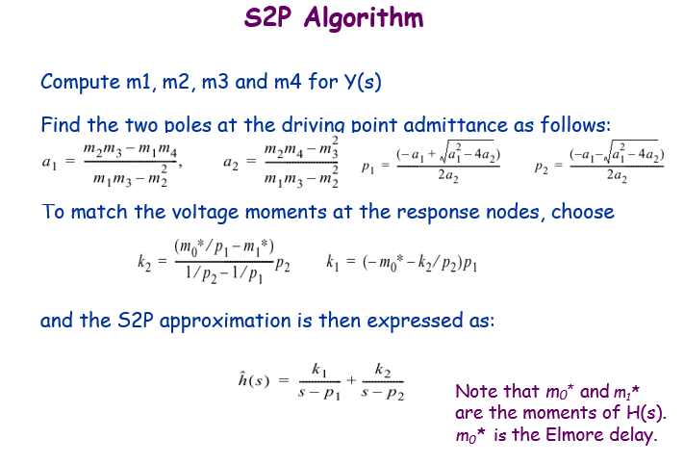

From our former calculation of the different moments in the first question. We can find that:

M0* = 1; M1* = -7e-11; they come from the voltage of node n at moment 0 and moment 1.

M1 = 1.4e-8; M2=-8.52e-19; M3 = 5.5128e-29; M4 = -3.5833e-39; they come from the input current at moment 1, 2, 3 and 4.

**We use Matlab to calculate the value:**

Matlab code:

ms0 = 1;

ms1 = -7e-11;

m1 = 1.4000e-8;

m2 = -8.5200e-19;

m3 = 5.5128e-29;

m4 = -3.5833e-39;

a1 = (m2*m3 - m1*m4) / (m1*m3 - m2*m2);

a2 = (m2*m4 - m3*m3) / (m1*m3 - m2*m2);

p1 = (-a1 + sqrt(a1*a1 - 4*a2))/(2*a2);

p2 = (-a1 - sqrt(a1*a1 - 4*a2))/(2*a2);

k2 = p2 * (ms0/p1 - ms1) / (1/p2 - 1/p1);

k1 = (-ms0 - k2/p2) * p1;

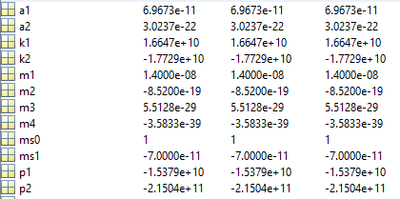

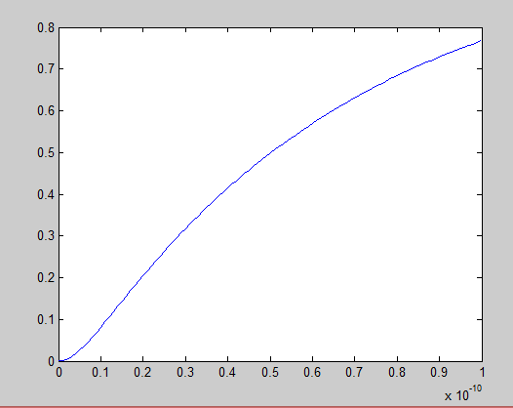

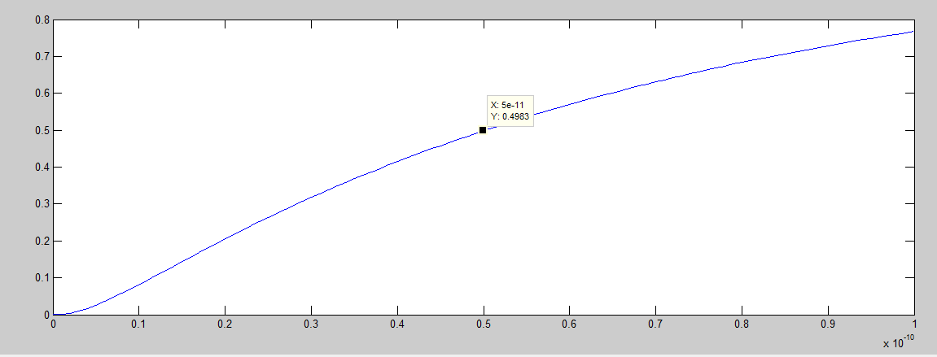

From the result graph we can see that the 50% delay point is 50 ps.

The answer to step 10 is shown below:

For the comparison of the delay results. We can found that the baseline delay value from simulation is around 51ps, while the one calculated using Elmore delay is 48.3ps. Then the delay calculated using S2P is around 50ps. Which indicates that S2P is more accurate than Elmore delay.

**Problem 3.**

The modified prima algorithm can be found in the attached file.

For result comparison:

For dataset GC9:

The result at single point expansion at frequency point 1e-4:

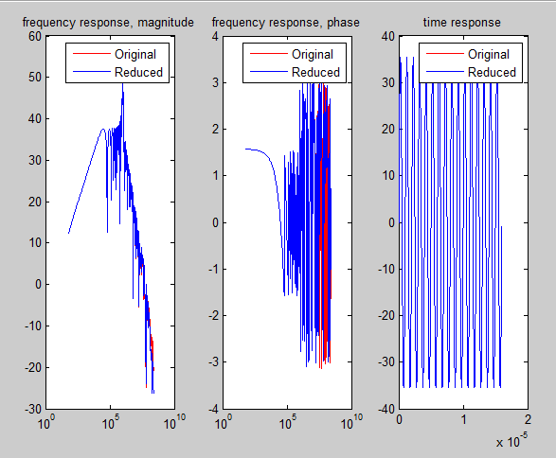

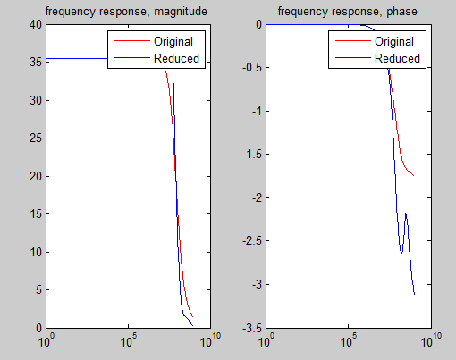

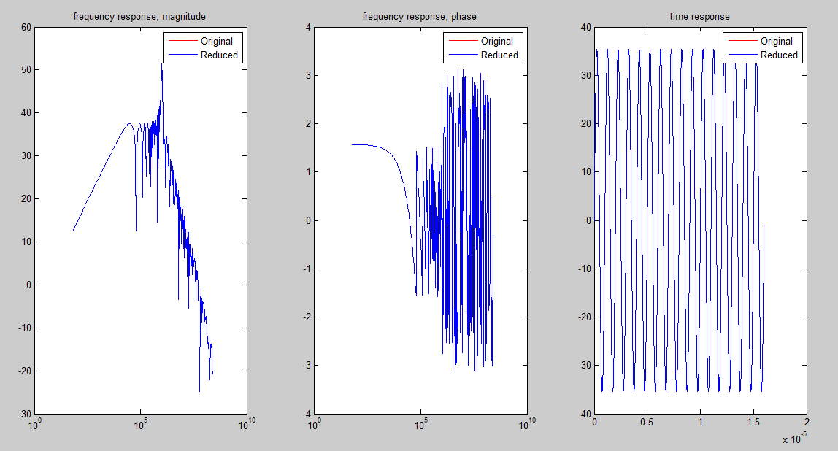

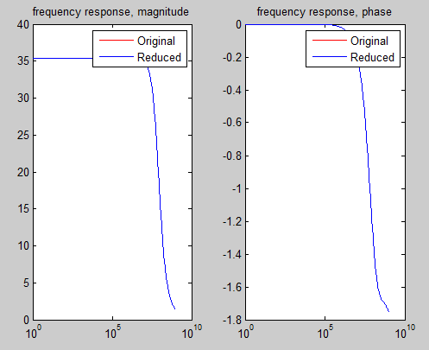

For dataset GC8:

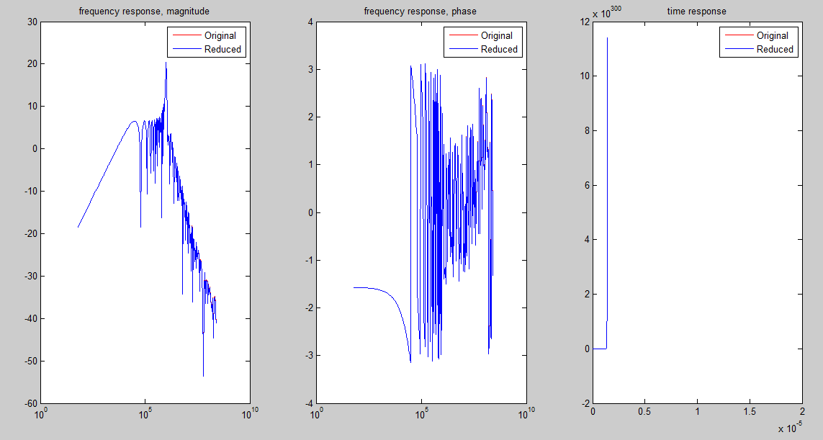

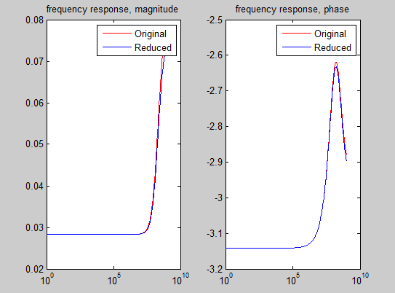

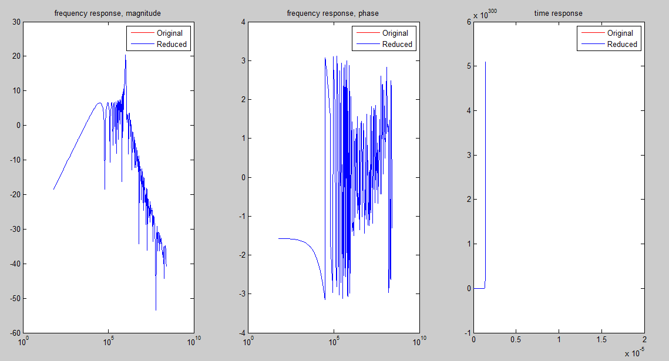

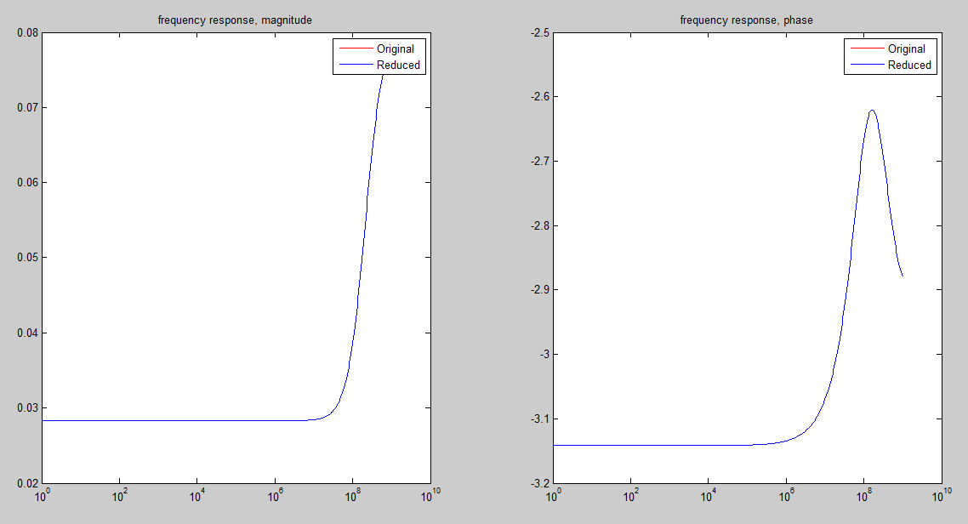

G,C,B,U,L matrices have been generated.

Prima begins:

时间已过 0.092707 秒。

Prima done!

Calculate original time domain response:

时间已过 57.234266 秒。

Original time domain response done!

Calculate reduced time domain response:

时间已过 2.298405 秒。

Reduced time domain response done!

Calculate original frequency response:

时间已过 3.878346 秒。

Original frequency response done!

Calculate reduced frequency response:

时间已过 0.020520 秒。

Reduced frequency response done!

Calculate original impulse response:

时间已过 5.339826 秒。

Original impulse response done!

Calculate reduced impulse response:

时间已过 0.027695 秒。

Reduced impulse response done!

**The comparison:**

From the results we can find out that when expand at multiple frequency points the accuracy is much better than span at one point.