Problem 1:

Answer:

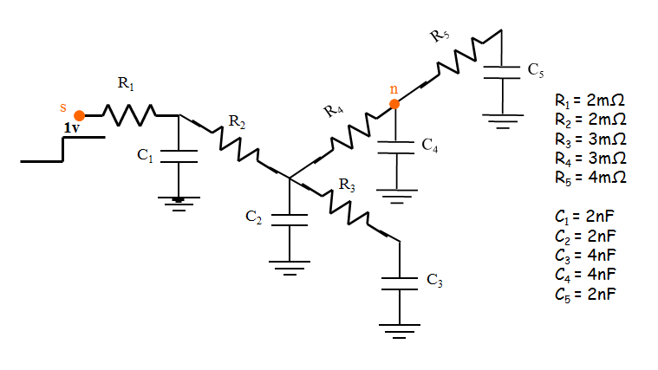

Derive the netlist of the above circuit in Spice. To measure the 0th moment of C4, we replace all the capacitors into zero current sources as the following:

\*struct

V1 6 0 DC = 1V

R1 6 1 2m

R2 1 2 2m

R3 2 3 3m

R4 2 4 3m

R5 4 5 4m

I1 1 0 0

I2 2 0 0

I3 3 0 0

I4 4 0 0

I5 5 0 0

.op

.end

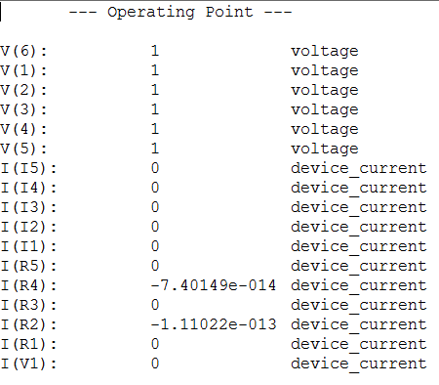

Figure 1.1 Measurement of first order

Thus, the 0th moment of C4 $M_{0}$ = V(4) = 1. Then, we replace the capacitors with current sources with each value = $I_{k}= C_{k}*M_{0}$. Thus, we can do the process iteratively, which are shown in Figure 1.2 to Figure 1.4.

\*struct

V1 6 0 DC = 0V

R1 6 1 2m

R2 1 2 2m

R3 2 3 3m

R4 2 4 3m

R5 4 5 4m

I1 1 0 2n

I2 2 0 2n

I3 3 0 4n

I4 4 0 4n

I5 5 0 2n

.op

.end

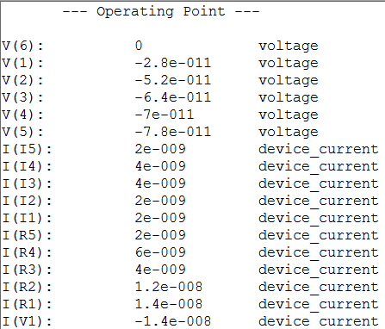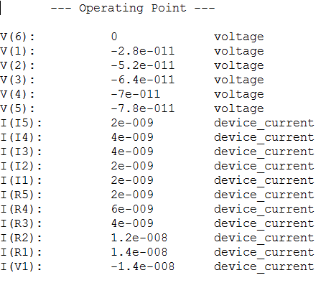

\*struct

V1 6 0 DC = 0V

R1 6 1 2m

R2 1 2 2m

R3 2 3 3m

R4 2 4 3m

R5 4 5 4m

I1 1 0 2n

I2 2 0 2n

I3 3 0 4n

I4 4 0 4n

I5 5 0 2n

.op

.end

Figure 1.2 Measurement of second order

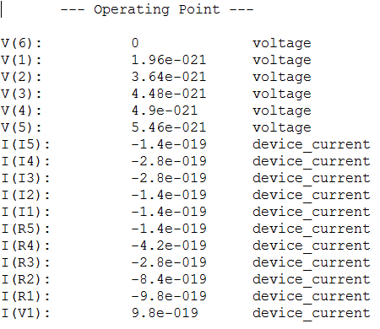

\*struct

V1 6 0 DC = 0V

R1 6 1 2m

R2 1 2 2m

R3 2 3 3m

R4 2 4 3m

R5 4 5 4m

I1 1 0 -1.4e-19

I2 2 0 -1.4e-19

I3 3 0 -2.8e-19

I4 4 0 -2.8e-19

I5 5 0 -1.4e-19

.op

.end

Figure 1.3 Measurement of third order

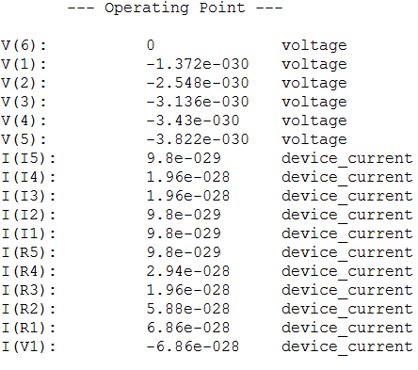

\*struct

V1 6 0 DC = 0V

R1 6 1 2m

R2 1 2 2m

R3 2 3 3m

R4 2 4 3m

R5 4 5 4m

I1 1 0 9.8e-29

I2 2 0 9.8e-29

I3 3 0 1.96e-28

I4 4 0 1.96e-28

I5 5 0 9.8e-29

.op

.end

Figure 1.4 Measurement of fourth order

Thus, $m_{0}=1; m_{1}= -7e-11; m_{2}=4.9e-21; m_{3}= -3.43e-30$.

Problem 2 :

Answer:

1. Single point expansion at s = 1e4;

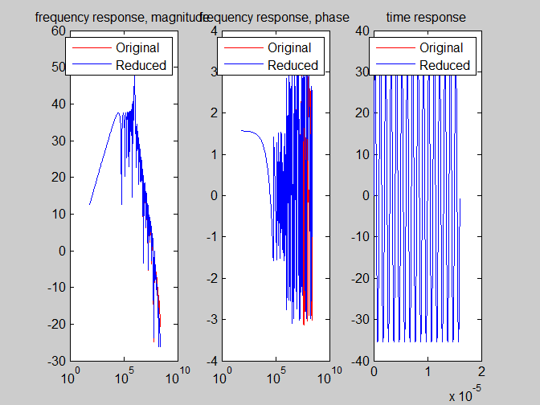

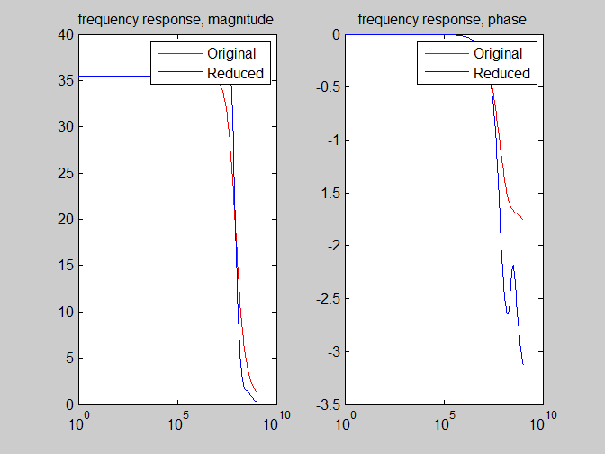

1. Four points expansion at s = 1e3, 1e5, 1e7, 1e9;

To adjust the prima function, we just need to do the prima at each frequency point, then we can get the V = [V1 V2 V3 V4] as a linear combination of all the frequency points to make it more accurate. As we can see below, the two lines are nearly the same.

