**EE201C Project1**

**Name: Peidong Chen**

**UID: 204432674**

***Problem#1***

*Steps for Problem 1*

1. *Follow the DC analysis method to reconstruct the circuit (e.g. replace C with zero current source for 0th moment calculation, etc).*

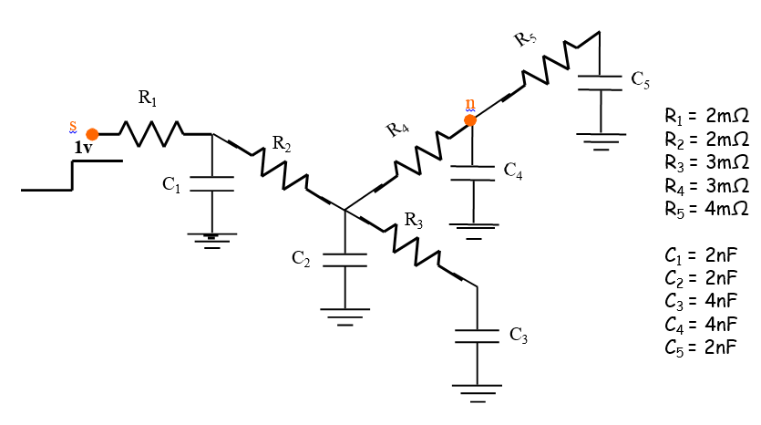

*2. Write the corresponding netlist for SPICE analysis.*

*3. Run DC analysis in SPICE to get the voltage across the capacitance as the moment.*

*4. The above should be done repeatedly until all the desired moments are acquired.*

**Solution**

We Use LTspice for the DC analysis, and the results are shown below.

When moment is 0,

the netlist is:

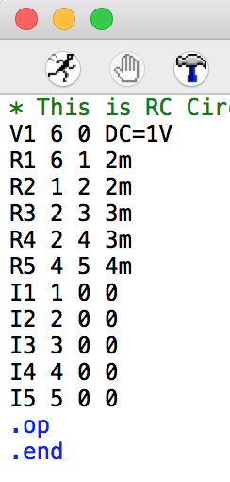 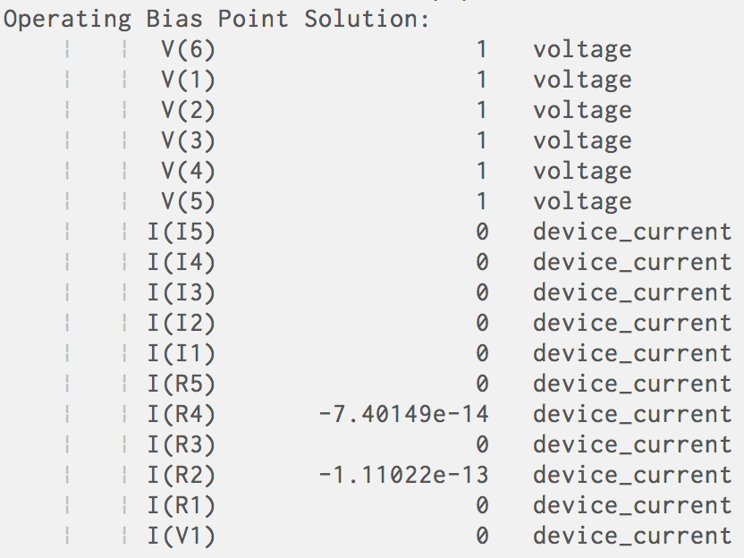

When moment is 1,

the netlist is:

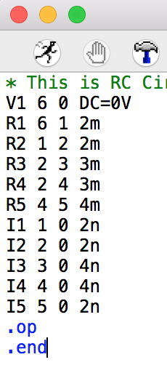 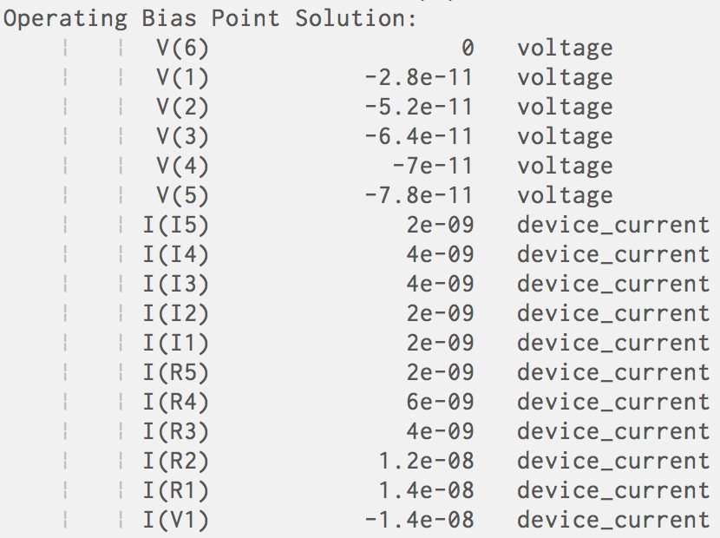

When moment is 2,

the netlist is:

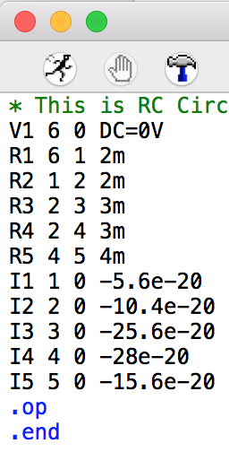 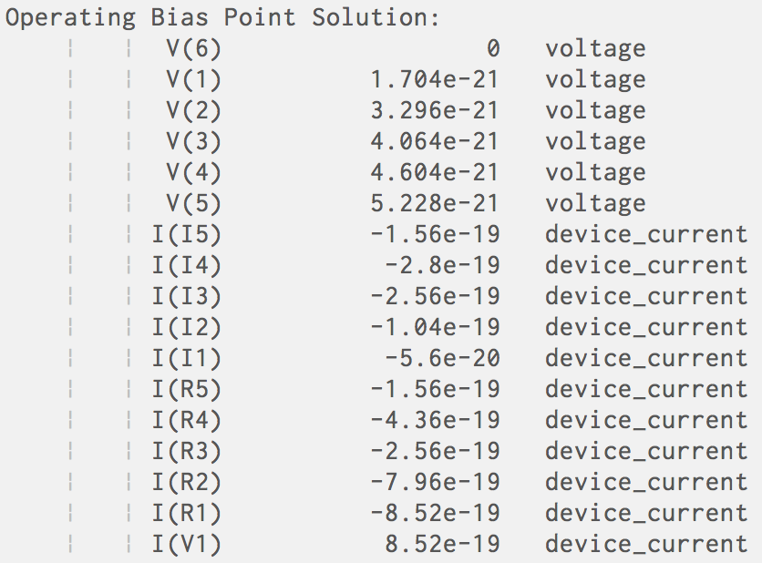

When moment is 3,

the netlist is:

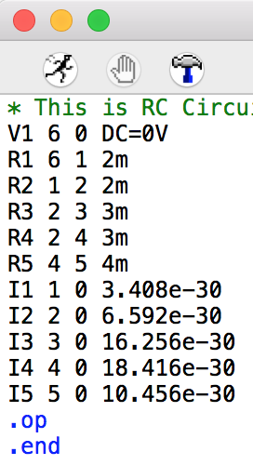 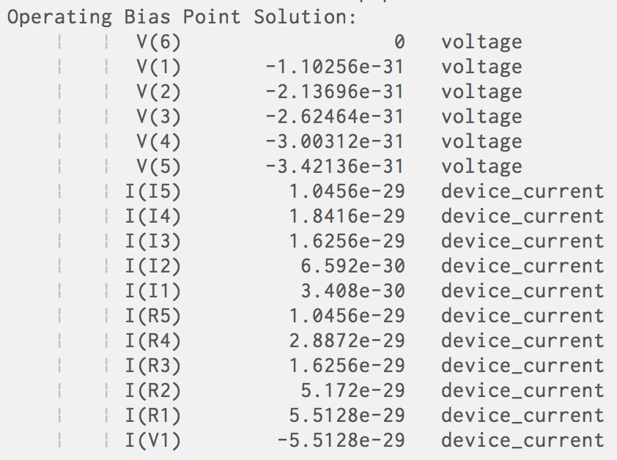

When moment is 4,

the netlist is:

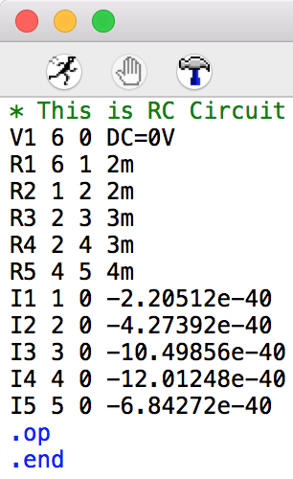 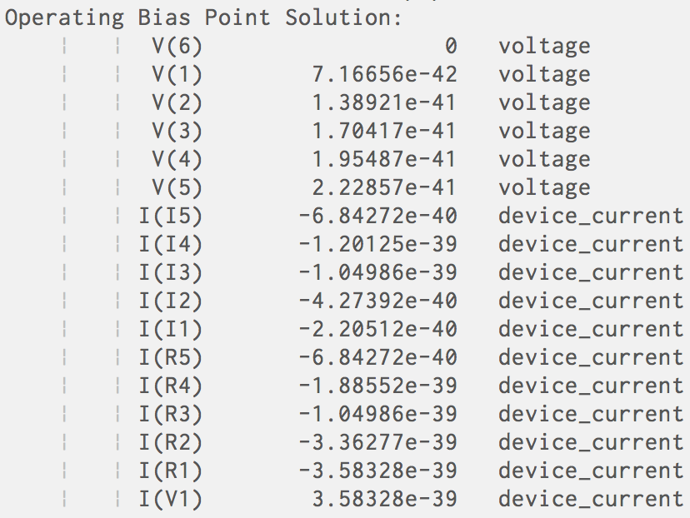

***Problem#2***

*Steps for Problem 2*

*1. Write the SPICE net-list of the circuit, run transient simulation,*

*and probe the voltage response at node n.*

*2. Record the time when the voltage at node n reaches 0.5V. That*

*time is the 50% delay.*

**Solution**

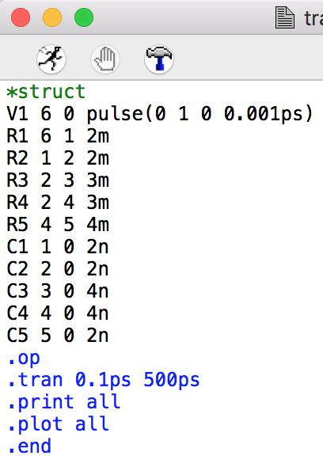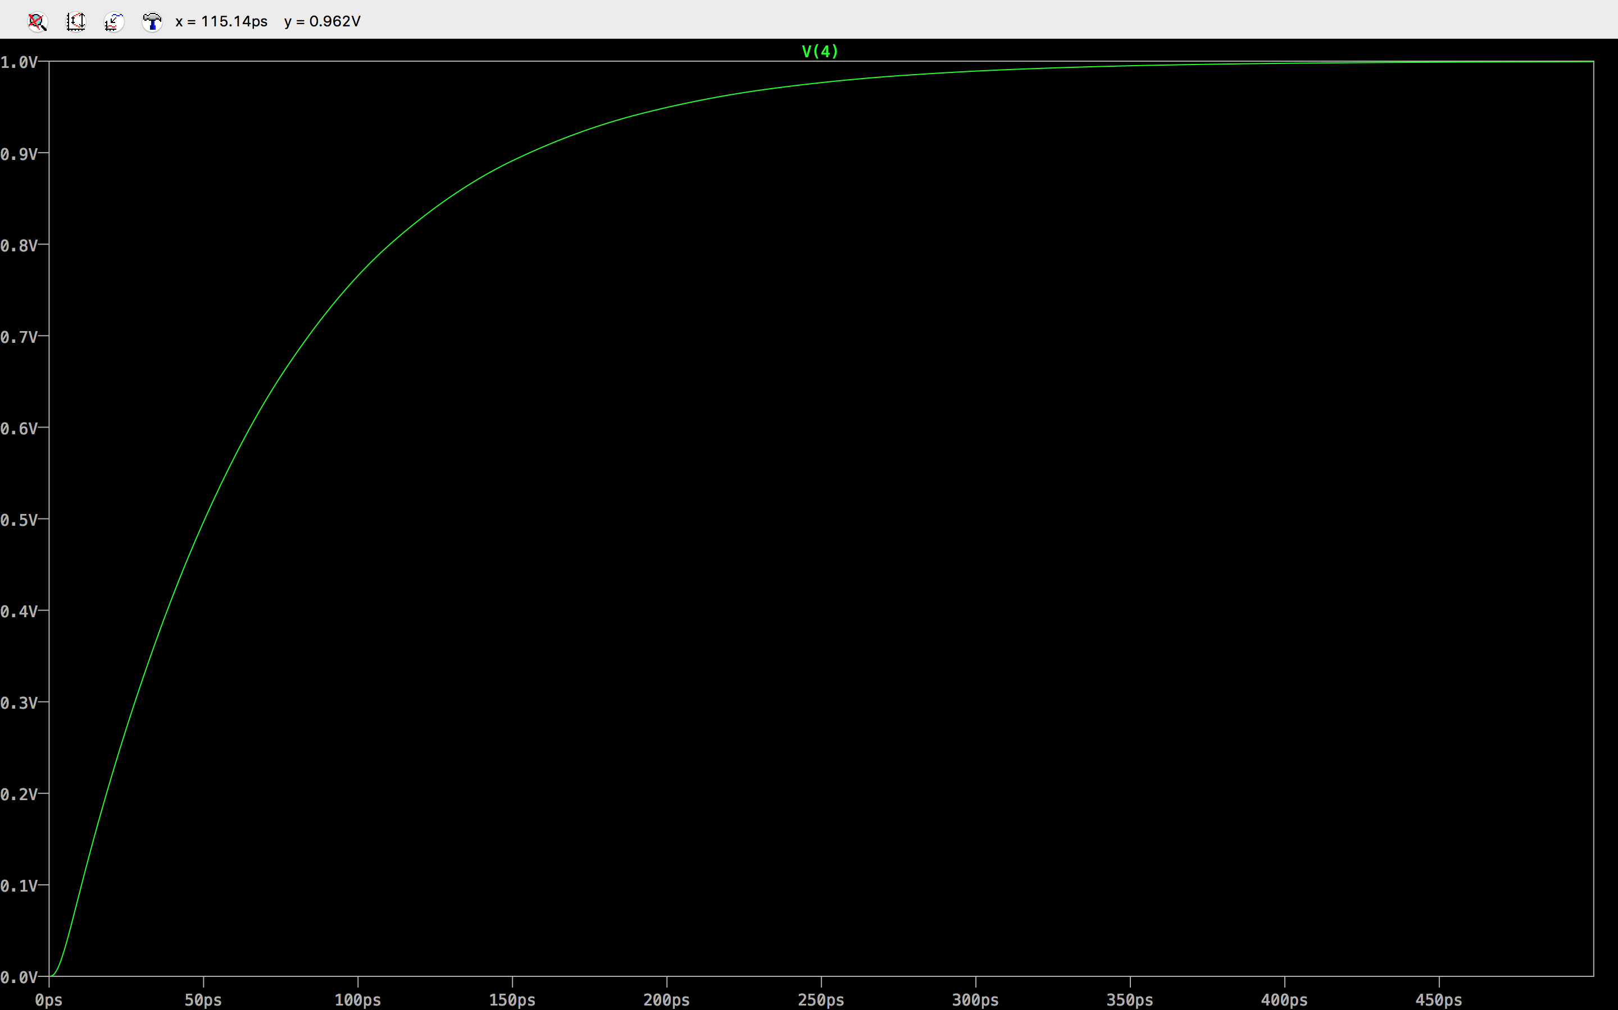

We could see the 50% delay for transient simulation in LTSPICE is also around 50ps, which shows S2P model is a good approach.

*3. Elmore Delay: Use the Elmore delay formula to calculate the Elmore*

*delay.*

**Solution**

Elmore delay

T = R1*(C1+C2+C3+C4+C5) + R2*(C2+C3+C4+C5) + R4*(C4+C5) = 48.3ps

*4. S2P*: Write down the transfer function H(s) and driving point*

*admittance Y(s) of the circuit with input s and output n.*

*5. Expand the transfer function to get the moments m0* and m1*.*

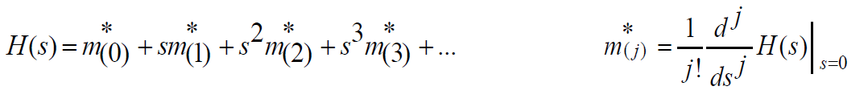

Because m0* and m1* are for H(s), they are voltage for R4. We can conclude that m0* is V(4) at moment 0, and m1* is V(4) at moment 1.

*6. Expand the driving point admittance to get m1, m2, m3, and m4.*

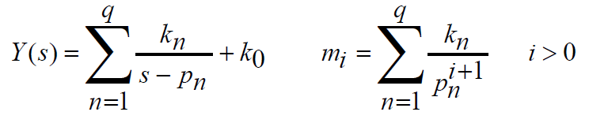

Because m1, m2, m3 and m4 are for Y(s), they are current for R1. We can conclude that m1, m2, m3 and m4 are I(R1) with moments from 1 to 4.

*7. Follow the S2P algorithm to get S2P approximation ĥ(s) in*

*frequency domain.*

*8. Use the frequency domain expression (ĥ(s)) to derive the time*

*domain expression (ĥ(t)).*

*9. Plot the obtained time domain waveform to get the 50% delay for*

*the S2P model.*

*10. Compare the results.*

**Solution**



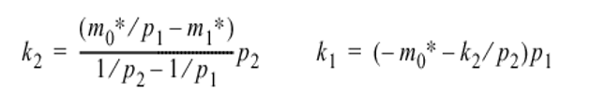

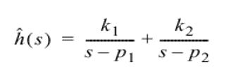

The Matlab code of S2P algorithm is shown below:

mc0 = 1;

mc1 = -7e-11;

m1 = 1.4000e-8;

m2 = -8.5200e-19;

m3 = 5.5128e-29;

m4 = -3.5833e-39;

a1 = (m2*m3 - m1*m4) / (m1*m3 - m2*m2);

a2 = (m2*m4 - m3*m3) / (m1*m3 - m2*m2);

p1 = (-a1 + sqrt(a1*a1 - 4*a2))/(2*a2);

p2 = (-a1 - sqrt(a1*a1 - 4*a2))/(2*a2);

k2 = p2 * (mc0/p1 - mc1) / (1/p2 - 1/p1);

k1 = (-mc0 - k2/p2) * p1;

syms s t;

y=ilaplace ((k1/(s-p1) + k2/(s-p2))/s, s, t);

t=0:0.01e-10:1e-10;

y = (4647675873662383*exp(-(7046493530475741*t)/32768))/56371948243805928 - (2909319386021367*exp(-(8063176603863135*t)/524288))/2687725534621045 + 151512324731213179422899432613341/151512324731213166623240004554760;

plot(t,y);

Here is the figure which is plotted by the above matlab code:

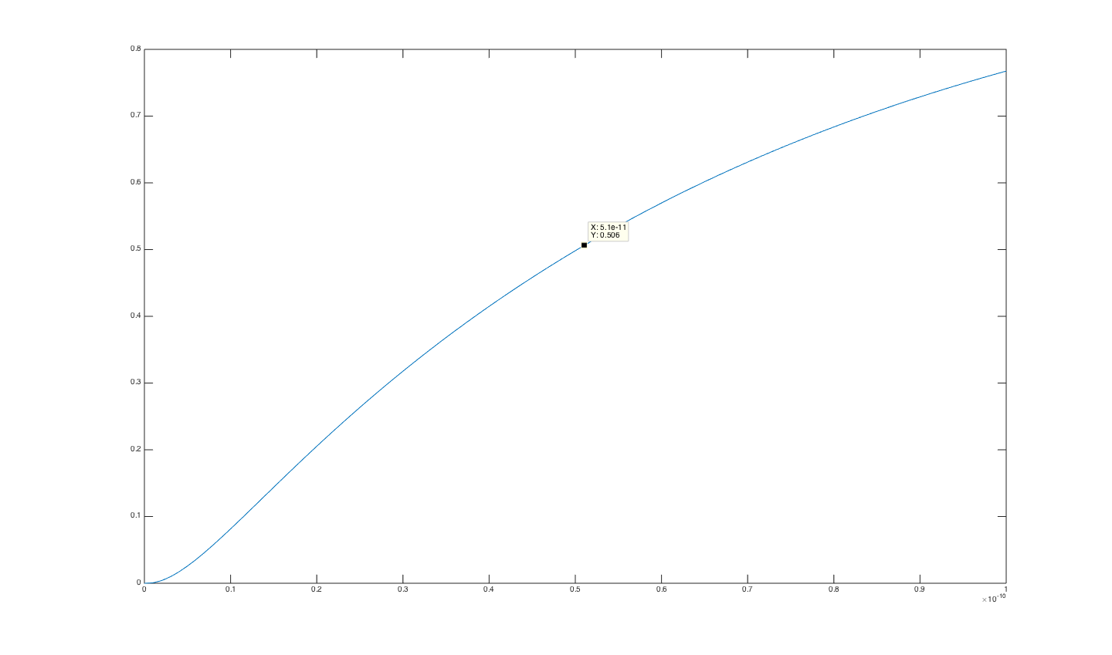

From the plot, we could see the delay at node4 is about 50ps.

k1 = 1.6647e+10

k2 = -1.7729e+10

p1 = -1.5379e+10

p2 = -2.1504e+11

When we compare the figures generated by S2P algorithm and SPICE, we can find out that S2P is a good approach.

***Problem#3***

*Steps for Problem 3*

*Modify the PRIMA code with single frequency expansion to multiple points expansion. You should use a vector fspan to pass the frequency expansion points. Compare the waveforms of the reduced model between the following two cases:*

*1. Single point expansion at s=1e4.*

*2. Four-point expansion at s=1e3, 1e5, 1e7, 1e9.*

**Solution**

The matlab code for problem3 is in the attached folder. And the results are shown below:

1.

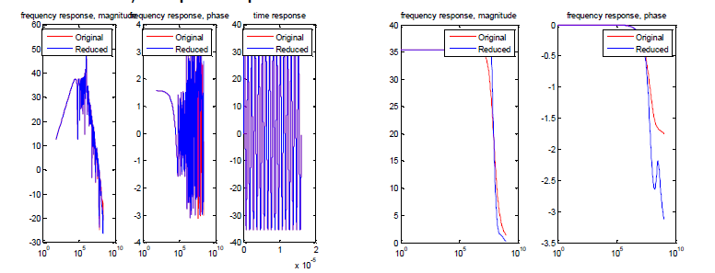

Fig1 le4 for GC9

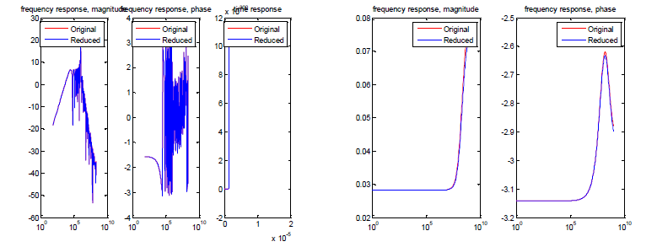

Fig2 le4 for GC8

2.

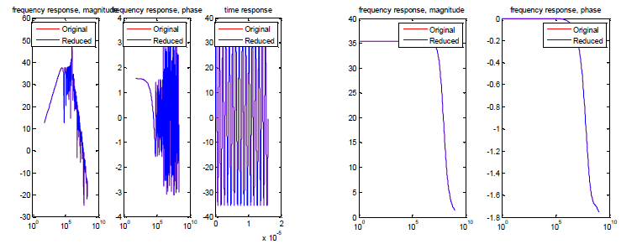

Fig3 multiple expansion le3, le5, le7, le9 for GC9

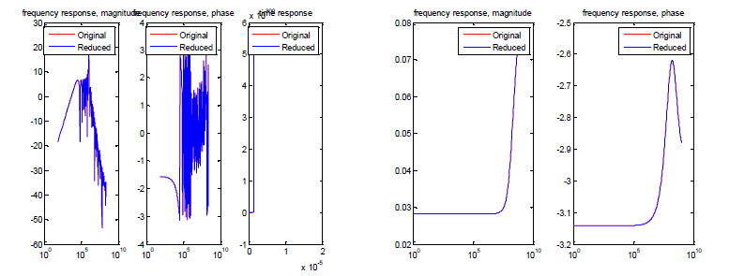

Fig4 Multiple expansion le3, le5, le7, le9 for GC8

We could see that from single expansion point graphs, we can clearly see that the difference between the reduced model and original model is at high frequency span. However, for four-point expansion, the results for two models remain constant and stable. This is suitable for both GC8 and GC9.