EE202C

Networked Embedded Systems Design

Smart Drone

10/24/2015

Week4 Engineering Progress Report

Group members: Peidong Chen, Yitian Hu, Yang Yang, Jiayu Guo

Table of Contents

Table of Contents 2

1 Progress Report Referencing Design Document 3

2 Source Code 3

3 Development Progress 3

4 Test Results 3

5 Development Concerns or Limitations Noted 4

6 References 4

# Progress Report Referencing Design Document

This is the general format for our reports.

For this section please include:

1. Progress statement ***by each* team member with *attributions* to each team member**. Each team member must contribute a paragraph with a detailed description of their specific contributions to the project mission.
2. Describe problems encountered by the group
3. Describe solutions developed by the group
4. Describe proposed changes in plans by the group
5. Describe any changes in schedule by the group and approaches for resolving schedule delays.
6. Changes that result in design modifications (for example a new interface specification) must also be reflected in design document with a revision update

Progress by each team member:

Peidong Chen: Rewrite all the code from Python to C code. I have done several C code so that the Edison board can communicate with the server. I have implemented multithread, http request, json encoding and decoding, hash, pwm in C code. Also we can use iPhone and iPad to control the Edison board.

Yitian Hu: Mainly complete the solder work of the power distribution board and ESC connector; use the raw data read from the MPU9250 sensor to get stable and reliable yaw, pitch and roll based on the Madgwick AHRS algorithm; Study the PID control algorithm.

Jiayu Guo: Improve the ultrasonic sensor module with 6 ultrasonic and combine the I2c control to multithread program.

Yang Yang: IOS control application debug; Implemented multithread, http request, json encoding and decoding in C; Study and implement PID control algorithm in C, which can be used to provide a stable control from the value of yaw, pitch and roll.

Problems:

1. Because the Amazon shipment is delayed and the 3D printer cannot work for one week, we cannot do further mechanical work of our drone.
2. We need real flight experiment to adjust PID parameters, which might take much time.

# Source Code

This section includes a source code development history. This may be a list and description of modules that have been developed along with a brief description (one sentence).

This may also include source code excerpts or entire programs that have been developed that you feel are important to highlight.

Our source code is on [www.github.com/peidong/drone](http://www.github.com/peidong/drone).

<https://github.com/peidong/drone/tree/master/Edison/main>

# Platform Development

This section includes a platform development history. This may be a list and description of systems including sensor systems, sensor components, embedded platform components and any other assets that have been developed along with a brief description (one sentence).

This may also include architectural diagrams and images of systems have been developed that you feel are important to highlight.

The drone that we assembled shows in the figure below.

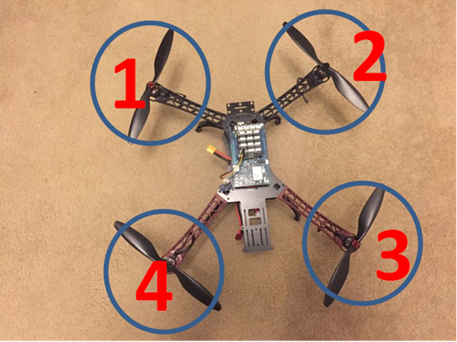

# Development Progress

This section includes a development history of progress in the area of algorithm development, system implementation, or other areas as applicable. This may be one paragraph to one page in length.

1. We can establish the communication between Edison and cloud server, which can be demonstrated with an IOS app on IPAD
2. We can read the real-time pitch, roll and yaw through sensor fusion using the MPU9250 sensor. The algorithm needs a small amount of time to do initialization for all three angles. So if the drone is not exactly heading the reference direction that we defined in our code, it will take some time to initialize. We can see the yaw rising from 0 or falling from 360 in those figures below.

In the Fig.1. below, the blue line is the yaw. When we rotate the drone manually, we can see that the yaw changes smoothly and the effect to pitch and roll is very small.

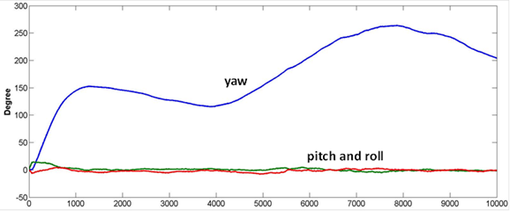

Fig.1 Change the heading of drone

And in the figure below, it shows that we only change the pitch of drone manually. The pitch is shown in the red line. We can find that the pitch value varies about ±30°. But the yaw and roll change little because my hand is unsteady. Also the change of pitch is very smooth thanks to the madgwick filter.

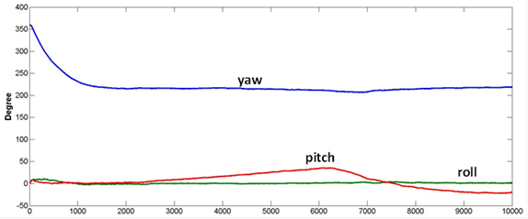

Fig.2 Change the pitch of drone

1. We can get the ultrasonic distance detection result:

Ultrasonic distance detection would be realized by using 6 ultrasonic sensors. Each sensor would be focused on one direction. Thus the up, down, forward, backward, left and right directions can always be obtained simply by combining a series of data together. These data can be quickly sent to the Edison board through i2c communication. The data from 6 sensors is grouped into one string and the string sent by i2c is then decoded to original data separately.

1. Also we prepare to utilize the ultrasonic sensors. Based on those sensors, the algorithm to avoid obstacles can be tested. This simple interactive algorithm which can intelligently observe the surrounding environment and move automatically.
2. We have studied the PID control algorithm, which can be mainly described in one simple equation:

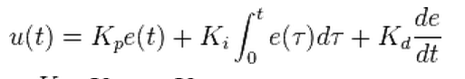

The control process is briefly shown below. We use the equation above to compute the PID value of each angle(yaw, pitch and roll) continuously. These PID values will be used to adjust the PWM of each four motors. And the result of the adjust will be return to the PID by e(t) to minimize the error.

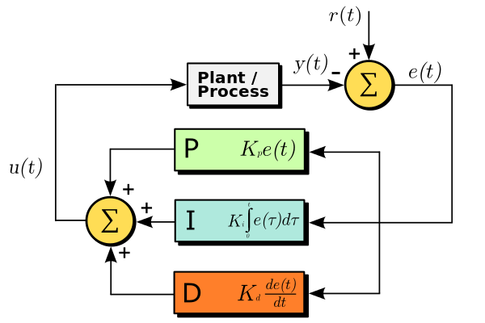

# Development Concerns or Limitations Noted

This section includes any discoveries that lead to confusion, recognition of development unknowns or risks, or any other concern. We will address each of these with planning and assistance.

We need the flying adjustment may take some time. And we don't have much experience about the adjustment. It also takes time for us to setup all the software and hardware modules in a robust system. How to mechanically assemble our board to the flight is another issue.

# References

This section lists any new references that you have found important or required in this last week.

1. The madgwick algorithm:

[http://www.x-io.co.uk/res/doc/madgwick_internal_report.pdf#page30](http://www.x-io.co.uk/res/doc/madgwick_internal_report.pdf)