EE202C

Networked Embedded Systems Design

IOT Smart Drone

11/30/2015

Week9 Engineering Progress Report

Group members: Peidong Chen, Yitian Hu, Yang Yang, Jiayu Guo

Table of Contents

Table of Contents 2

1 Progress Report Referencing Design Document 3

2 Source Code 3

3 Development Progress 3

4 Test Results 3

5 Development Concerns or Limitations Noted 4

6 References 4

# Progress Report Referencing Design Document

This is the general format for our reports.

For this section please include:

1. Progress statement ***by each* team member with *attributions* to each team member**. Each team member must contribute a paragraph with a detailed description of their specific contributions to the project mission.
2. Describe problems encountered by the group
3. Describe solutions developed by the group
4. Describe proposed changes in plans by the group
5. Describe any changes in schedule by the group and approaches for resolving schedule delays.
6. Changes that result in design modifications (for example a new interface specification) must also be reflected in design document with a revision update

Progress by each team member:

Peidong Chen: Write the BeagleBone black code in order to make it work with Edison. We make the BeagleBone to act as a flight controller since Edison's i2c and uart are not stable for being flight controller. Modify Edison code to let Edison act as a fully IoT funtion boart while BeagleBone is a flight control function board.

Yitian Hu: Beaglebone Black UART communication with Edison, read from MPU9250 by I2C of BBB, test PID.

Jiayu Guo: UART communication with GPS, read&analyze GPS format data; design series PID control, test PID for drone stability.

Yang Yang: Implement tracker, which will be used to increase the following accuracy. Implement deep learning algorithm rcnn, which will be used as accurate detection. Help PID test and Edison communicate with BeagleBone black.

# Source Code

This section includes a source code development history. This may be a list and description of modules that have been developed along with a brief description (one sentence).

This may also include source code excerpts or entire programs that have been developed that you feel are important to highlight.

Our source code is on [www.github.com/peidong/drone](http://www.github.com/peidong/drone).

# Platform Development

This section includes a platform development history. This may be a list and description of systems including sensor systems, sensor components, embedded platform components and any other assets that have been developed along with a brief description (one sentence).

This may also include architectural diagrams and images of systems have been developed that you feel are important to highlight.

1. We found i2c will freeze before, so we try to use UART to send data between Edison and UNO. Unfortunately, this method does not work well. Because the reading interval on Edison varies a lot. It is weird that mraa_uart_read() will take a few milliseconds sometimes. And sometimes Edison just reboots when reading UART data maybe it is due to the high bardrate (115200) that we are applying. We really feel that Edison is not suitable for fight controller, although it has very powerful functions. So Edison will work only for IOT functions.
2. We change to use Beaglebone black as the flight controller and use Edison to sent our command and communicate with server.
3. 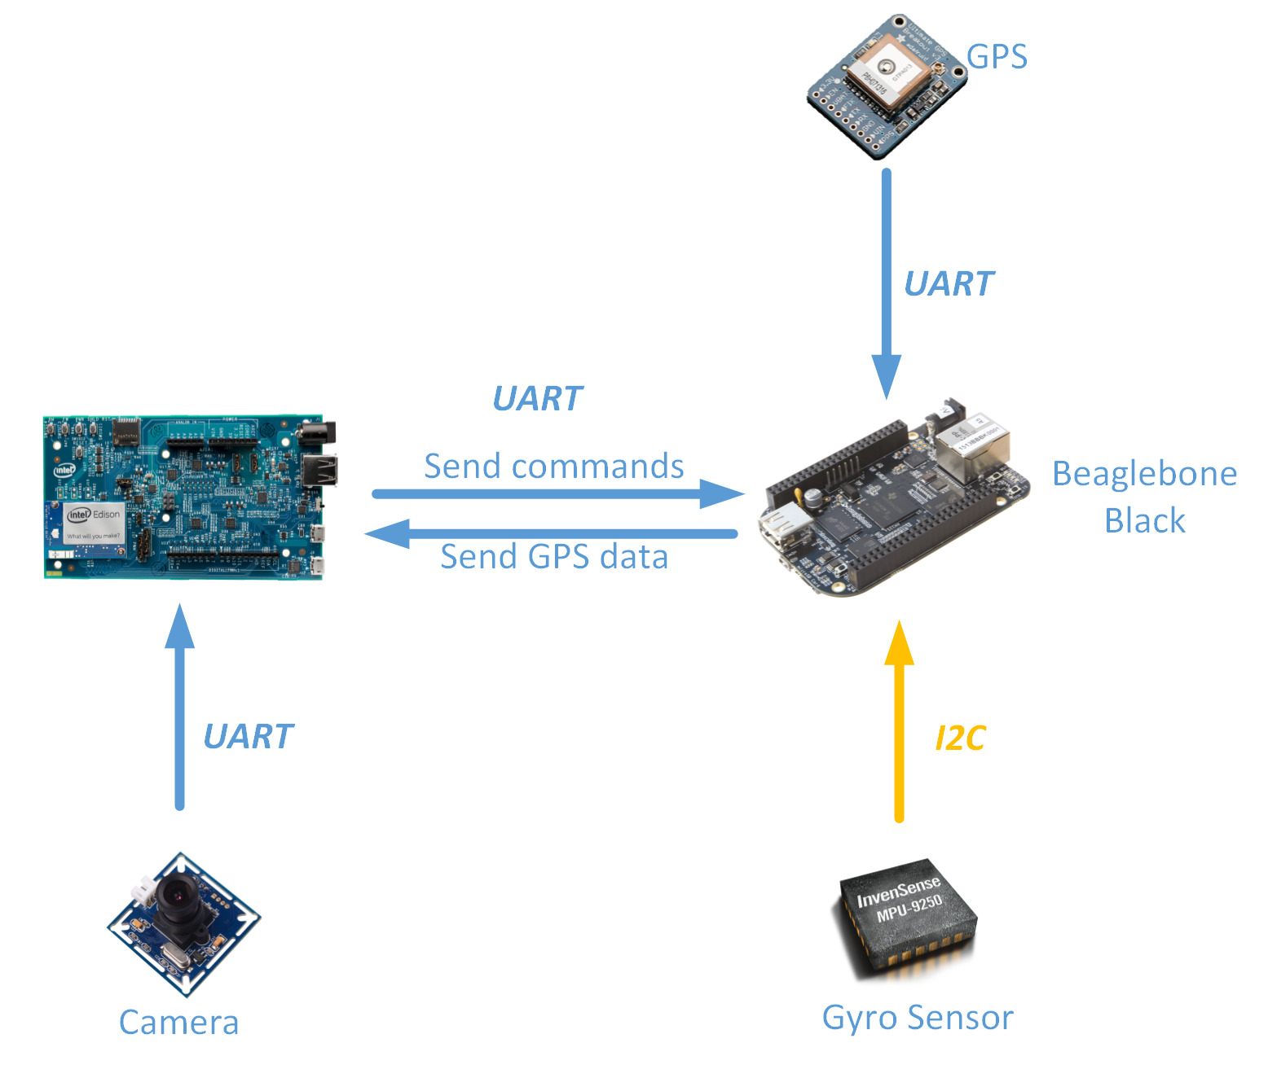
4. We choose ultimate GPS as our GPS navigation module. We could obtain standard NMEA sentence through rx/tx by UART communication. The $GPRMC (Global Positioning Recommended Minimum Coordinates or something like that) and the $GPGGA sentences contains the required basic information for us to start parse the latitude and longitude as well as speed and altitude. By including and parsing this information from GPS. The navigation instruction can be transmitted to our microprocessor.
5. Since our test, a beginner's PID cannot keep a complex system like drone to be stable. We look for a series PID loop to improve our first PID loop. Compared to the old version of PID which contains a linear increase in change. On contrary, a series PID does not directly control the angle difference, it changes the angle speed rate, which smooth the oscillation of our propeller. Now according to our test, our drone

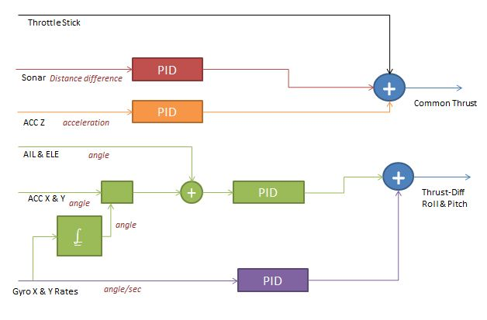

# Development Progress

This section includes a development history of progress in the area of algorithm development, system implementation, or other areas as applicable. This may be one paragraph to one page in length.

1. As the SURF detection algorithm will have some inaccuracy result. We add a tracker using Meanshift algorithm. This will help tracking the object providing accracate movement information. We then, according to the movement of the object, send command to Edison to finish the following function.
2. We will also use some deep learning algorithm like rcnn to do accurate detection. This algorithm needs GPU to do computation. So will use this on Server. In detection model, edison will keep take pictures and sent it to server. Then our server will do rcnn to detect whether there are objects we want in the picture. If we detect the picture, we can then send the tracking information to let our drone turn into track model. This function will be used like detect some specific object like people when doing patrol tasks. We have implement the deep learning environment and rcnn will then do some test.

# Development Concerns or Limitations Noted

This section includes any discoveries that lead to confusion, recognition of development unknowns or risks, or any other concern. We will address each of these with planning and assistance.

# References

This section lists any new references that you have found important or required in this last week.

1. http://arxiv.org/abs/1504.08083