# EE239AS Special Topics in Signals and Systems

Project 1 Report:

**Regression Analysis**

**Group Members:** Jiayu Guo(504413188),

Yitian Hu(904516321), Peidong Chen(204432674), Yang Yang(804522285)

Winter 2016

01/30/2016

## Question 1

For each workflow, we can use one file to represent the upload condition. Thus we choose one file in each workflow and plotted the actual copy sizes of all the files on a time period of 20 days. The plot is shown below.

Figure 2 #nfl tweets per hour over time

In workflow 0 we choose file 0; In workflow 1 we choose file 6; In workflow 2 we choose file 12; In workflow 3 we choose file 21; In workflow 4 we choose file 24. In each workflow, we can see a rough repeat pattern in the pictures. The repeat cycle is about 1 week for workflow 0-2. For workflow 3, although the repeat is not as obvious as the others, we can still figure out a repeat trend. The peak of the copy size repeatedly in a cycle of 1 week. For workflow 4, the cycle is also about 1 week.

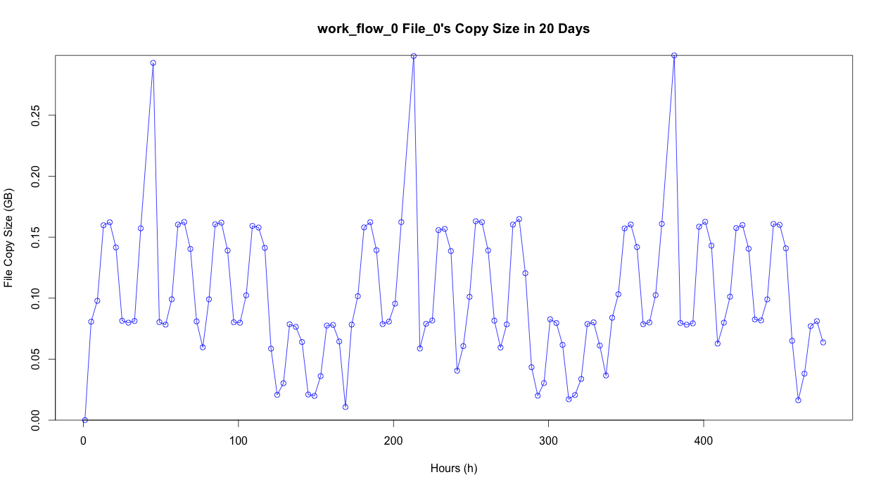

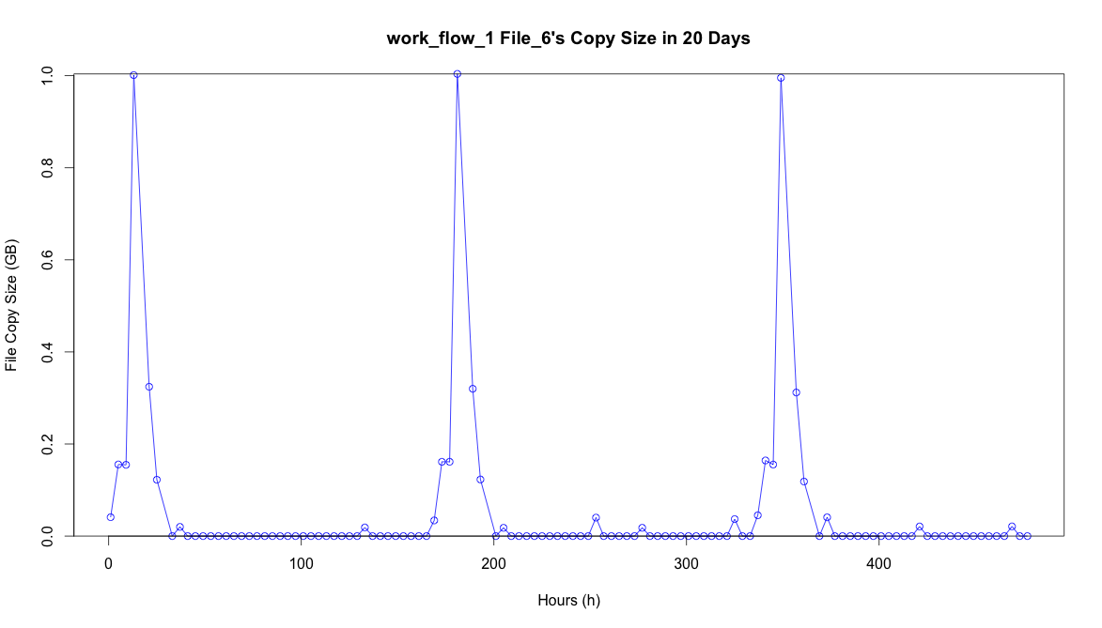

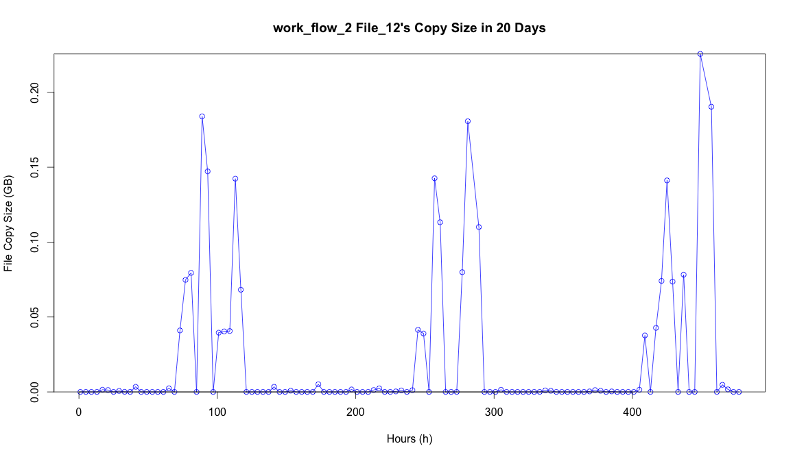

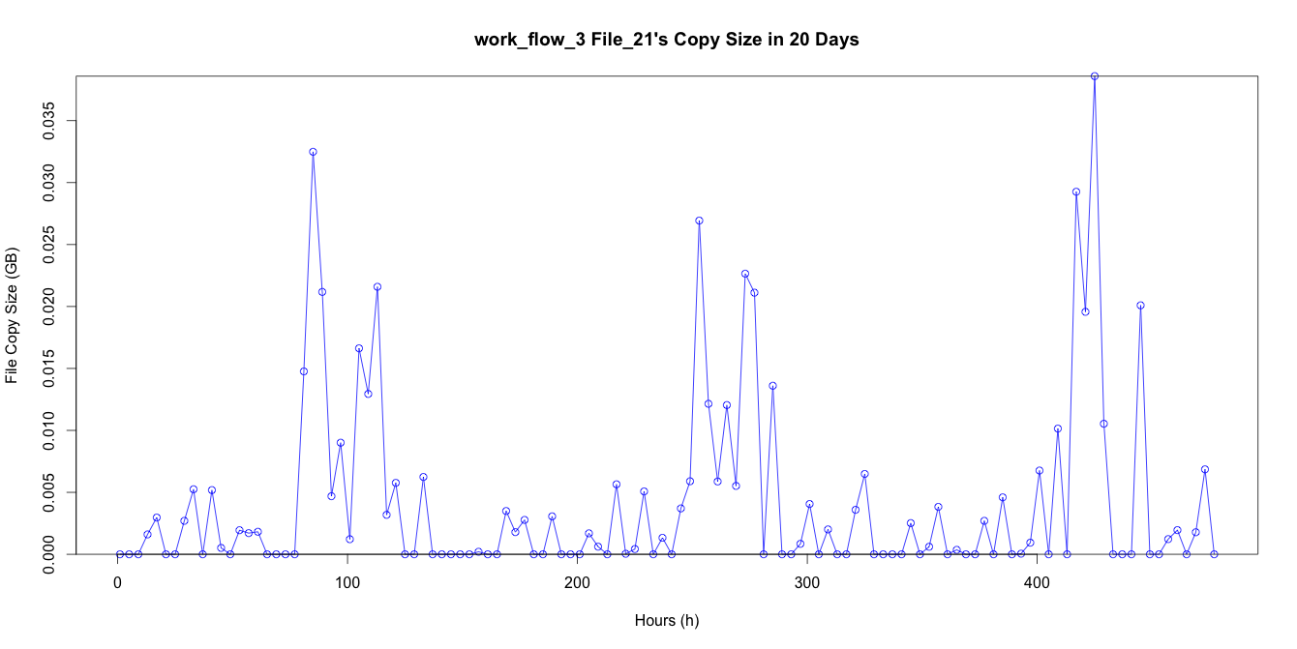

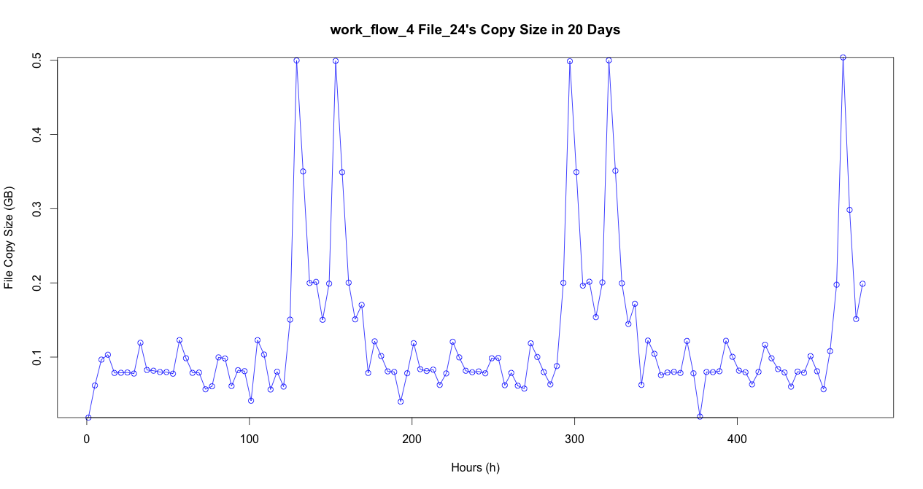

## Question 2

a) Fit linear regression model:

We do 10-fold Cross-validation using linear model.

The significance of different variables with the statistics obtained from the model are shown below:

|  |  |
| --- | --- |
| Variables | Significance |
| Intercept | -0.0304717608415 |
| Week | 0.0001212423713 |
| DayOfWeek | 0.0013189671131 |
| StartTime | 0.0009633665451 |
| WorkFlowName | 0.0021885715069 |
| FileName | 0.0001190829549 |
| TimeBackup | 0.0712918216619 |

We can see that TimeBackup is the most significant variable.

The average RMSE is 0.0792344.

The following figure shows "Fitted values and actual values scattered plot over time". The red points show the actual values, and the blue points show the fitted values.

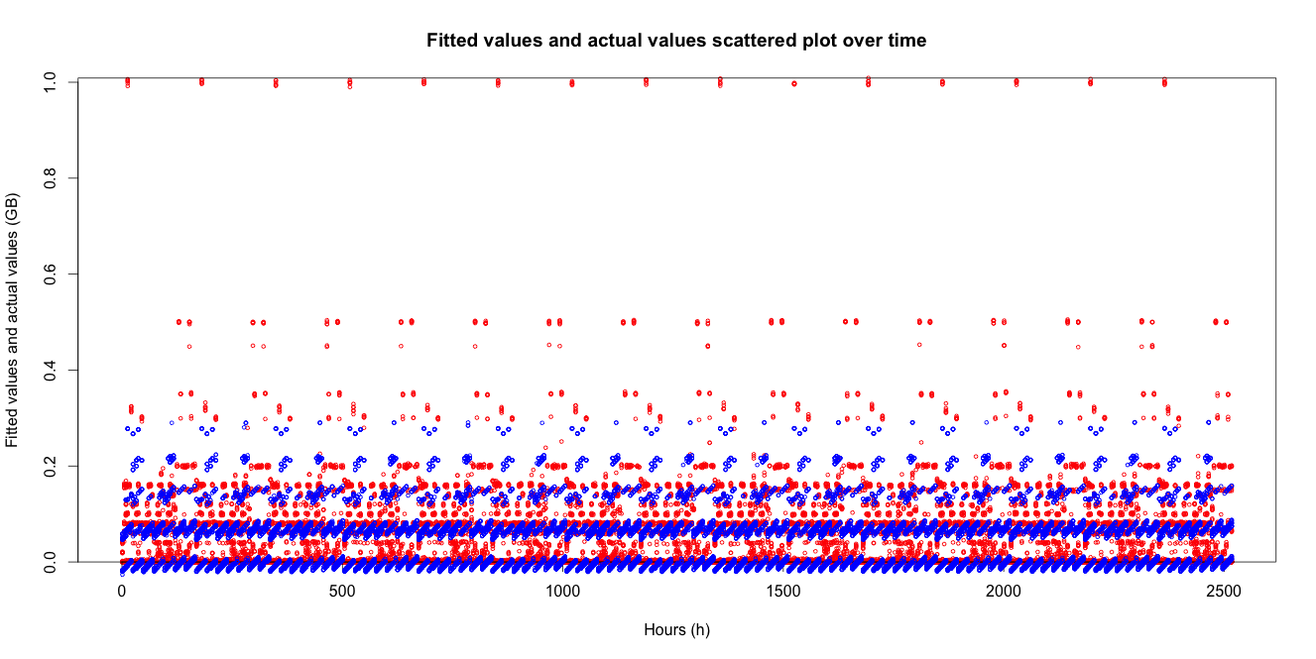

The "residuals versus fitted values plot" is shown below.

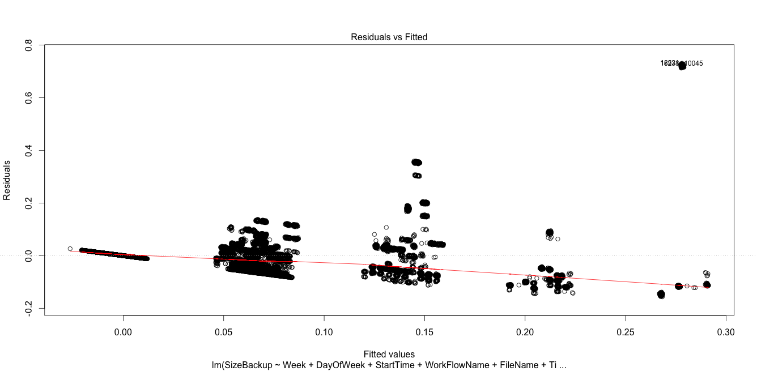

From the 'Fitted values and actual values scattered plot over time', we can see there are many value our model can not fit. From the 'residuals versus fitted values plot', we can see the residual do not "bounce randomly" around the 0 line. There are also some outliers in the basic residual pattern. This all indicates the relationship of our data is not linear. Linear model is not a ideal model for our data.

b) Use a random forest regression model:

We plot 3D figures to see the relationship between "Number of trees", "Depth of each tree" and "RMSE values".





After analyzing the figures, we tune the "Number of trees" to be 25 and "Depth of each tree" to be 15. And the best RMSE we get is 0.008703.

The patterns we observed are that when the depth is larger than 10, it contributes little to the RMSE value. And also the number of trees doesn't affect the value of RMSE.

Here is the detail of our fitted model. From the variable importance we can see that, the variable week will not affect the result. This indicates that sizeBackup has a repeat cycle of 1 week. Which is the same as our pattern found in part 1.

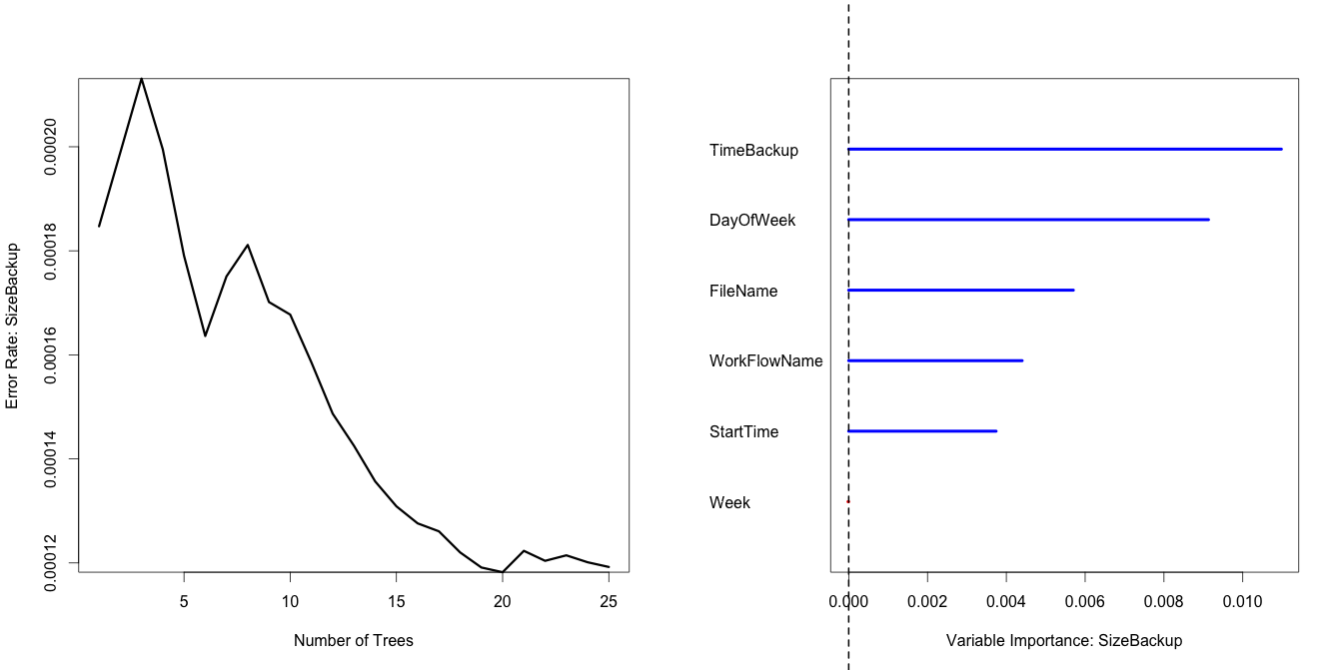

c) Use neural regression model:

TO BE DONE.

## Question 3

The following figure shows the relationship between degree and RMSE value.

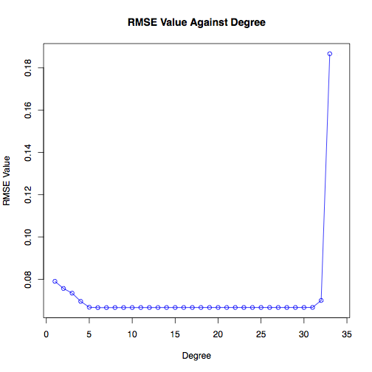

And the following figure shows the RMSE in log scale.

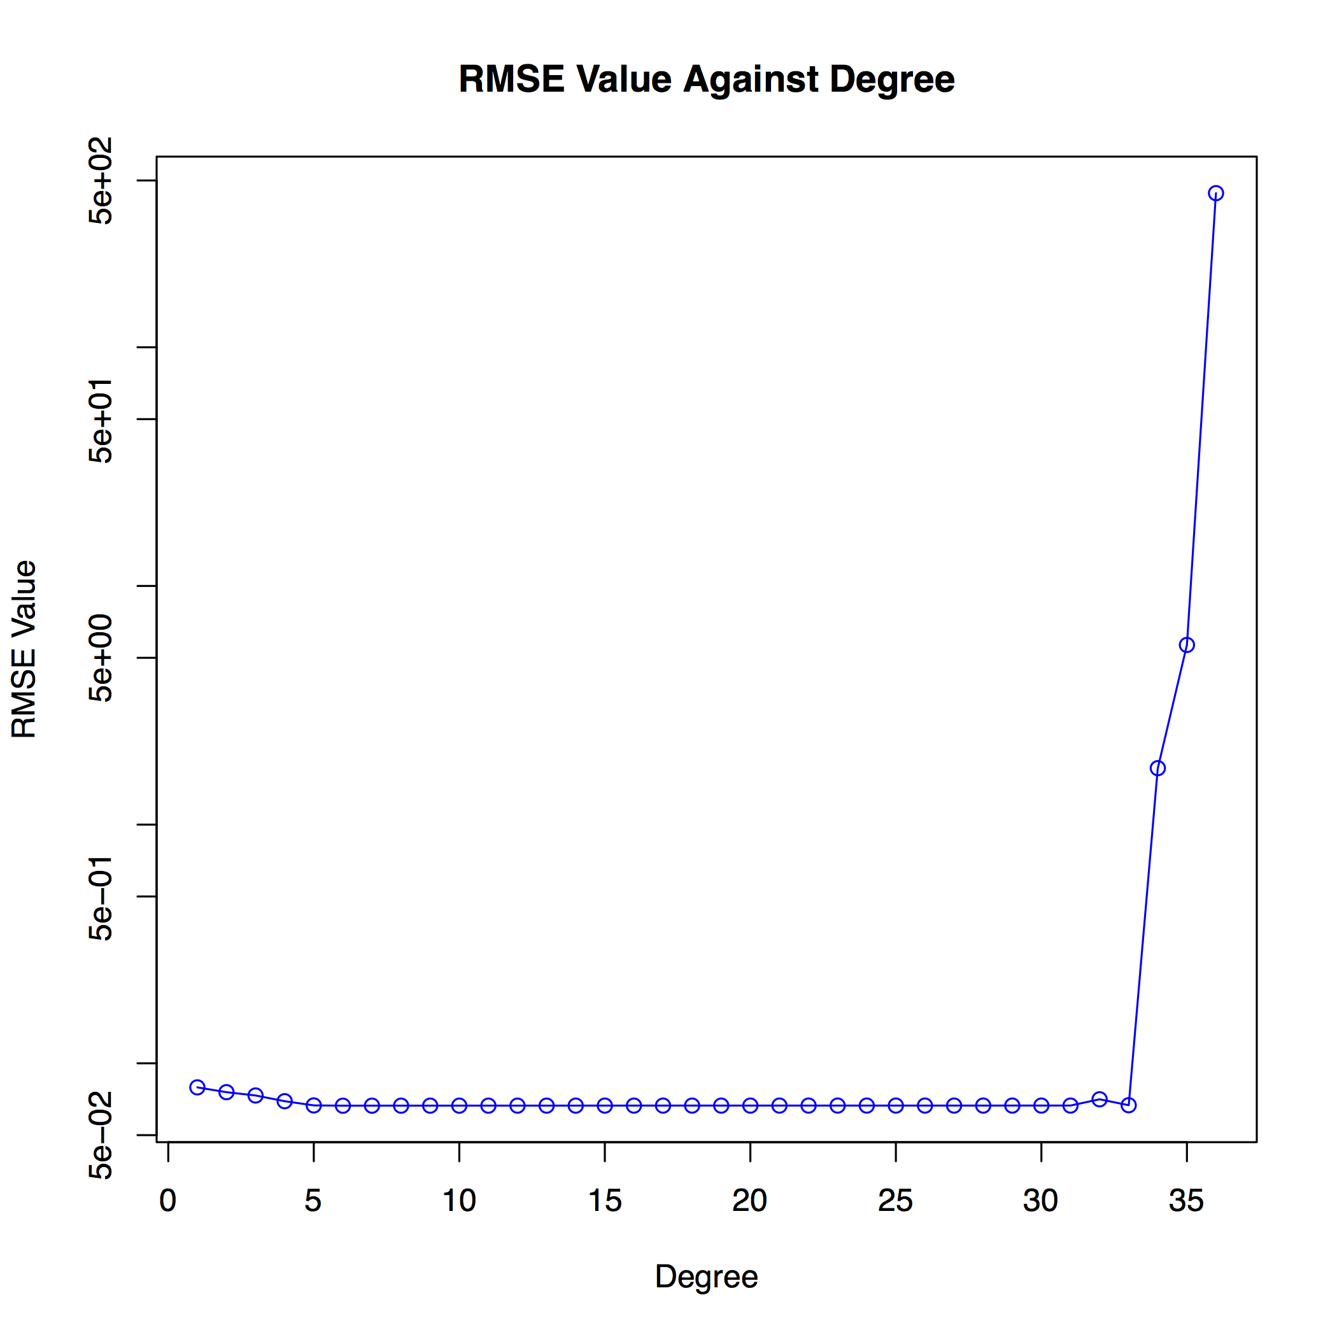

We can see that the best degree is 6.

We find the threshold degree is 33, and when the degree is greater than 33, the RMSE value is getting worse.

In general, the more complex our model is, the more success will our model 'learning' the training data. However, With the improve of our model complexity, when it is excessively complex, overfitting will happen in our model. This will cause our model to "memorize" training data rather than "learning" to generalize from trend. So the model will do well in training data, but when use this model to do prediction, the result will be bad. By using cross validation, we will divide our data into training set and validation set. This two set are separate, thus when overfitting happen, the model will not 'memorize' the validation data and will have much errors when doing validation. For this reasons, cross validation will help us evaluate the model objectively. It can help us choose the most suitable complex of our model.

## Question 4

We do 10-fold Cross-validation using linear model.

The significance of different variables with the statistics obtained from the model are shown below:

|  |  |
| --- | --- |
| Variables | Significance |
| Intercept | 36.58863419733 |
| CRIM | -0.10151449937 |
| ZN | 0.05373695243 |
| INDUS | 0.01887539615 |
| CHAS | 2.82064623774 |
| NOX | -17.16498921368 |
| RM | 3.62595999313 |
| AGE | 0.01262356371 |
| DIS | -1.48548234670 |
| RAD | 0.29722579772 |
| TAX | -0.01136922489 |
| PTRATIO | -0.96120709560 |
| B | 0.01025428746 |
| LSTAT | -0.58130370238 |

We can see that NOX is the most significant variable.

The average RMSE is 4.8137655.

The following figure shows "Fitted values and actual values scattered plot over time". The red points show the actual values, and the blue points show the fitted values.

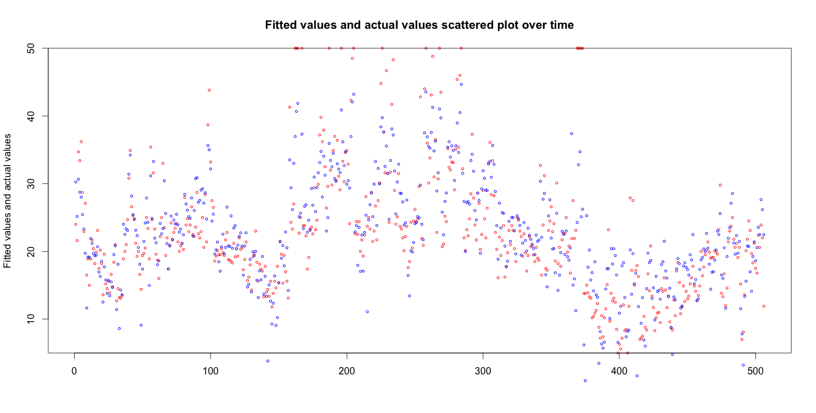

The "residuals versus fitted values plot" is shown below.

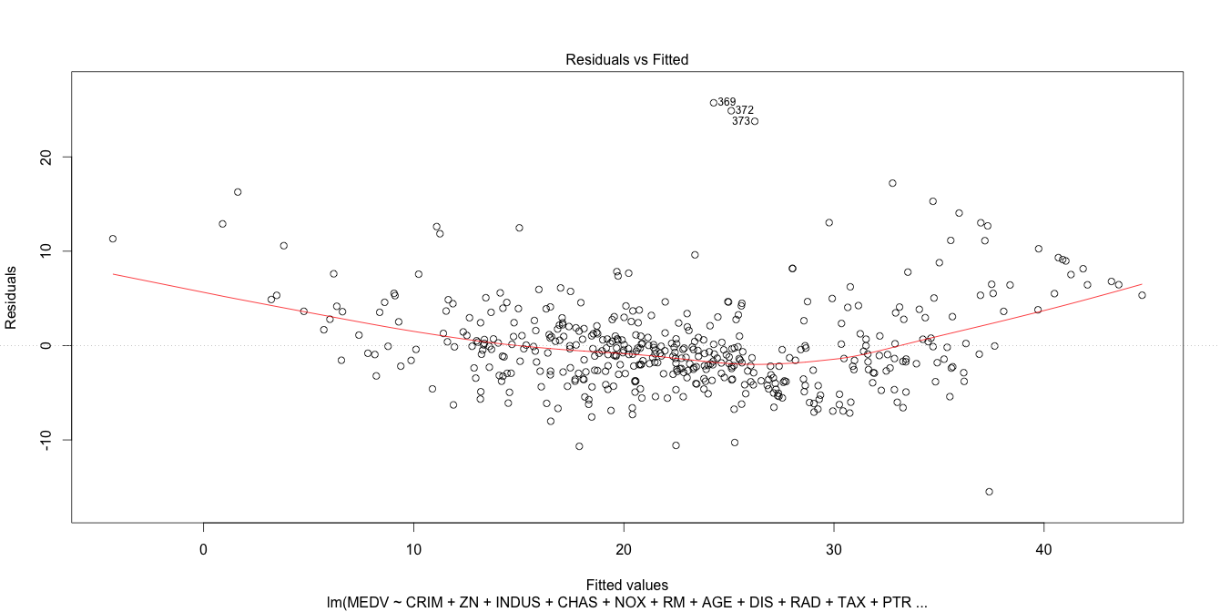

From the 'Fitted values and actual values scattered plot over time', we can see our model has a better result in question 2a, though there are also some value our model can not fit. From the 'residuals versus fitted values plot', we can see the residual do not "bounce randomly" around the 0 line, which indicates linear is also a ideal model for this data.

The following figure shows the relationship between degree and RMSE value in log scale.

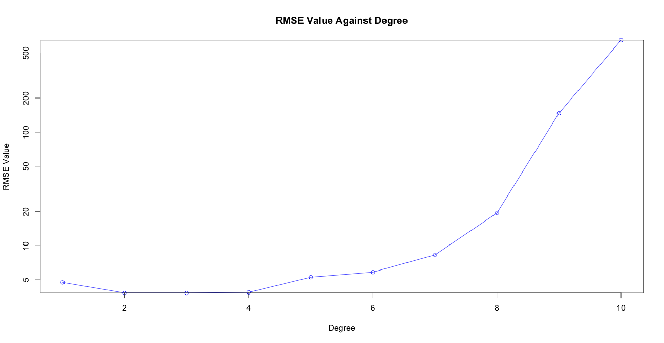

And the optimal degree is 3.

## Question 5

a) When using ridge regression

The relationship between α and RMSE is shown in the following table.

|  |  |
| --- | --- |
| α | RMSE Value |
| 0.1 | 4.791298 |
| 0.01 | 9.586534 |
| 0.001 | 14.382500 |

The best RMSE is 4.791298.

b) When using Lasso regularization

The relationship between α and RMSE is shown in the following table.

|  |  |
| --- | --- |
| α | RMSE Value |
| 0.1 | 4.887751 |
| 0.01 | 9.728448 |
| 0.001 | 14.571951 |

The best RMSE is 4.887751.