CentOS6.6高可用集群LVS+Keepalived

类别：转载 服务器

本文参考
本文的安装部分参考：《CentOS6.5高可用集群LVS+Keepalived(DR模式)》 http://www.it165.net/admin/html/201312/2220.html
LVS 安装参考：《LVS 三种工作模式基本配置（不含HA）》 http://jedy82.blog.51cto.com/425872/1628085

说明
目的：使用LVS对两台web服务器进行负载设置，并提供LVS本身的高可用性
本文只做LVS本身的keepalived配置，所有LVS的部分将直接使用脚本。
本文以LVS/DR模式为例，LVS的其它工作模式配置方法类似

有关LVS安装、测试详细过程请参看《LVS 三种工作模式基本配置（不含HA）》 http://jedy82.blog.51cto.com/425872/1628085

LVS-master 10.10.6.201
LVS-backup 10.10.6.202
VIP 10.10.6.200
Web1 10.10.6.211
Web2 10.10.6.212

操作系统：CentOS release 6.6 (Final)

1、检查linux内核是否集成lvs模块：modprobe -l | grep ipvs
2、开启路由转发功能：echo "1">/proc/sys/net/ipv4/ip_forward
3、安装ipvsadm

安装ipvsadm配置

安装前的准备
检查linux内核是否集成lvs模块
[root@LVS-master ~]# modprobe -l | grep ipvs
开启内核路由转发功能
[root@LVS-master ~]# echo "1">/proc/sys/net/ipv4/ip_forward
关闭selinux和iptables
[root@Web1 ~]# getenforce
Disabled
[root@Web1 ~]# chkconfig iptables off
[root@Web1 ~]# service iptables stop
[root@Web1 ~]#

安装ipvsadm
[root@LVS-master ~]# yum install ipvsadm
[root@LVS-master ~]# chkconfig ipvsadm on
[root@LVS-master ~]# service ipvsadm start
[root@LVS-master ~]# ipvsadm
IP Virtual Server version 1.2.1 (size=4096)
Prot LocalAddress:Port Scheduler Flags
-> RemoteAddress:Port Forward Weight ActiveConn InActConn
[root@LVS-master ~]#

Keepalived配置

安装keepalived（以LVS-master为例，LVS-backup相同）
安装依赖包和必须工具
[root@LVS-master ~]# yum -y install kernel-devel gcc openssl popt popt-devel libnl libnl-devel popt-static openssl openssl-devel wget

[root@LVS-master ~]# wget http://www.keepalived.org/software/keepalived-1.2.16.tar.gz
[root@LVS-master ~]# tar -zxvf keepalived-1.2.16.tar.gz -C /usr/local/src/
[root@LVS-master ~]# cd /usr/local/src/keepalived-1.2.16/
[root@LVS-master keepalived-1.2.16]# ./configure --prefix=/usr/local/keepalived-1.2.16 && make && make install
[root@LVS-master keepalived-1.2.16]# cd
[root@LVS-master ~]# ln -s /usr/local/keepalived-1.2.16 /usr/local/keepalived
[root@LVS-master ~]# cp /usr/local/keepalived/etc/rc.d/init.d/keepalived /etc/rc.d/init.d/
[root@LVS-master ~]# cp /usr/local/keepalived/etc/sysconfig/keepalived /etc/sysconfig/
[root@LVS-master ~]# ln -s /usr/local/keepalived/etc/keepalived /etc/
[root@LVS-master ~]# ln -s /usr/local/keepalived/sbin/keepalived /usr/sbin/

将keepalived配置成系统服务
[root@LVS-master ~]# chkconfig --add keepalived
[root@LVS-master ~]# chkconfig keepalived on
[root@LVS-master ~]# chkconfig --list keepalived
keepalived 0:off 1:off 2:on 3:on 4:on 5:on 6:off
[root@LVS-master ~]# service keepalived start
Starting keepalived: [ OK ]
[root@LVS-master ~]#

keepalived配置（以LVS/DR模式为例）

LVS-master的keepalived 配置（LVS-backup只修改router_id、state和priority）
[root@LVS-master ~]# cp /etc/keepalived/keepalived.conf /etc/keepalived/keepalived.conf.bak
[root@LVS-master ~]# vim /etc/keepalived/keepalived.conf
[root@LVS-master ~]# more /etc/keepalived/keepalived.conf
! Configuration File for keepalived

global_defs {
notification_email {
jedy@qq.com #接受通知邮件的email地址
}
notification_email_from jedy@189.cn #发送通知邮件的email地址
smtp_server smtp.189.cn
smtp_connect_timeout 30
router_id LVS_MASTER #BACKUP上修改为LVS_BACKUP
}

vrrp_instance VI_1 {
state MASTER #BACKUP上修改为BACKUP
interface eth0 #通信端口
virtual_router_id 51 #虚拟路由标识，主从相同
priority 100 #BACKUP上修改为90
advert_int 1 #主从心跳检测时间
authentication {
auth_type PASS #主从认证方式必须一致
auth_pass 1111 #主从认证密码必须一致
}
virtual_ipaddress { #Web虚拟IP（VTP）
10.10.6.200
}
}

virtual_server 10.10.6.200 80 { #定义虚拟IP和端口
delay_loop 6 #检查真实服务器时间，单位秒
lb_algo rr #设置LVS负载调度算法，rr为轮训
lb_kind DR #设置LVS负载均衡DR模式（这里可以根据需要改成tun或nat，如果修改，后端的web服务器也要做相应更改）
persistence_timeout 60 #会话持久时间，同一IP的连接60秒内被分配到同一台真实服务器（测试时可以将这个注释）
protocol TCP #使用TCP协议检查realserver状态

real_server 10.10.6.211 80 { #第一个web服务器
weight 1 #节点权重值
TCP_CHECK { #健康检查方式
connect_timeout 3 #连接超时
nb_get_retry 3 #重试次数
delay_before_retry 3 #重试间隔，单位秒
}
}

real_server 10.10.6.212 80 { #第二个web服务器
weight 1
TCP_CHECK {
connect_timeout 3
nb_get_retry 3
delay_before_retry 3
}
}
}
[root@LVS-master ~]#
[root@LVS-master ~]# service keepalived restart

后台Web服务器设置（以web1为例，web2相同）

关闭iptables和selinux
[root@Web1 ~]# getenforce
Disabled
[root@Web1 ~]# chkconfig iptables off
[root@Web1 ~]# service iptables stop
[root@Web1 ~]#

安装apache和php
[root@Web1 ~]# yum install httpd php php-fpm
[root@Web1 ~]# vi /etc/httpd/conf/httpd.conf
ServerName :80
[root@Web1 ~]# service httpd restart
[root@Web1 ~]# service php-fpm restart
[root@Web1 ~]#
[root@Web1 ~]#
[root@Web1 ~]# more /var/www/html/phpinfo.php
<?php
phpinfo()
?>
[root@Web1 ~]#
[root@Web1 ~]# more /var/www/html/index.html \\web2 这里全部要做相应的修改
<html>
<head>
<title>web1</title>
</head>
<body>
hostname: Web1<br>ip : 10.10.6.211
</body>
</html>
[root@Web1 ~]#
[root@Web1 ~]#
[root@Web1 ~]#

测试web站点：
http://10.10.6.211/phpinfo.php
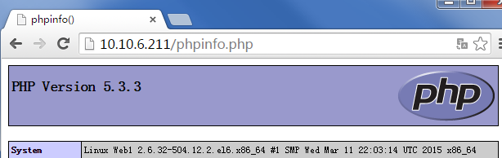
http://10.10.6.212/phpinfo.php
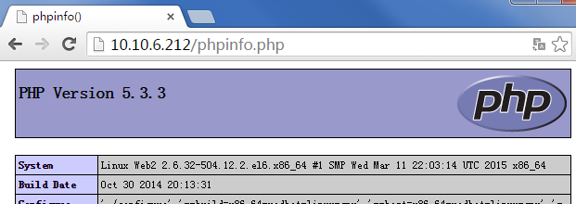

http://10.10.6.211
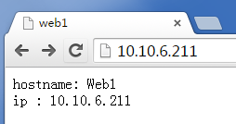
http://10.10.6.212
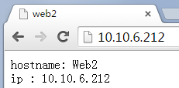

Real Server启动脚本（以web1为例，web2相同）
[root@Web1 ~]# vi dr-rs.sh
[root@Web1 ~]# more dr-rs.sh
#!/bin/bash
#
# Script to start LVS DR real server.
# description: LVS DR real server
#
. /etc/rc.d/init.d/functions
VIP=10.10.6.200
host=`/bin/hostname`
case "$1" in
start)
# Start LVS-DR real server on this machine.
/sbin/ifconfig lo down
/sbin/ifconfig lo up
echo 1 > /proc/sys/net/ipv4/conf/lo/arp_ignore
echo 2 > /proc/sys/net/ipv4/conf/lo/arp_announce
echo 1 > /proc/sys/net/ipv4/conf/all/arp_ignore
echo 2 > /proc/sys/net/ipv4/conf/all/arp_announce
/sbin/ifconfig lo:0 $VIP broadcast $VIP netmask 255.255.255.255 up
/sbin/route add -host $VIP dev lo:0
echo "LVS RealServer Start OK"
;;
stop)
# Stop LVS-DR real server loopback device(s).
/sbin/ifconfig lo:0 down
echo 0 > /proc/sys/net/ipv4/conf/lo/arp_ignore
echo 0 > /proc/sys/net/ipv4/conf/lo/arp_announce
echo 0 > /proc/sys/net/ipv4/conf/all/arp_ignore
echo 0 > /proc/sys/net/ipv4/conf/all/arp_announce
echo "LVS RealServer Stoped OK"
;;
status)
# Status of LVS-DR real server.
islothere=`/sbin/ifconfig lo:0 | grep $VIP`
isrothere=`netstat -rn | grep "lo:0" | grep $VIP`
if [ ! "$islothere" -o ! "isrothere" ];then
# Either the route or the lo:0 device
# not found.
echo "LVS-DR real server Stopped."
else
echo "LVS-DR real server Running."
fi
;;
*)
# Invalid entry.
echo "$0: Usage: $0 {start|status|stop}"
exit 1
;;
esac
[root@Web1 ~]# chmod +x dr-rs.sh
[root@Web1 ~]# ./dr-rs.sh start
LVS RealServer Start OK
[root@Web1 ~]#
[root@Web1 ~]# echo "/root/dr-rs.sh start" >>/etc/rc.local
[root@Web1 ~]#

测试Keepalived

测试LVS功能
http://10.10.6.200
第一次访问
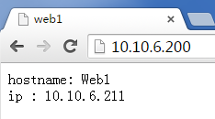
第二次访问
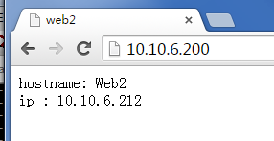
第三次访问
第四次访问
[root@LVS-master log]# ip addr
1: lo: <LOOPBACK,UP,LOWER_UP> mtu 65536 qdisc noqueue state UNKNOWN
link/loopback 00:00:00:00:00:00 brd 00:00:00:00:00:00
inet 127.0.0.1/8 scope host lo
inet6 ::1/128 scope host
valid_lft forever preferred_lft forever
2: eth0: <BROADCAST,MULTICAST,UP,LOWER_UP> mtu 1500 qdisc pfifo_fast state UP qlen 1000
link/ether 00:50:56:ae:2d:e1 brd ff:ff:ff:ff:ff:ff
inet 10.10.6.201/24 brd 10.10.6.255 scope global eth0
inet 10.10.6.200/32 scope global eth0
inet6 fe80::250:56ff:feae:2de1/64 scope link
valid_lft forever preferred_lft forever
3: eth1: <BROADCAST,MULTICAST> mtu 1500 qdisc noop state DOWN qlen 1000
link/ether 00:50:56:ae:32:1e brd ff:ff:ff:ff:ff:ff
[root@LVS-master log]#
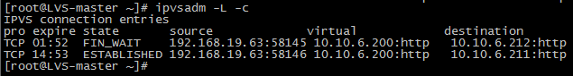

测试Keepalived功能
http://10.10.6.200 #访问一直刷新会轮训显示10.10.6.211/212模拟宕掉主LVS，服务器照常工作，再宕掉Web1，这时只会显示Web2，这样就实现ip负载均衡，高可用集群。当主LVS恢复后，会切换成主动服务器，如果Keepalived监控模块检测web故障恢复后，恢复的主机又将此节点加入集群系统中。

关闭LVS-master
[root@LVS-master ~]# service keepalived stop
从LVS-backup的log中看到，服务状态变为master
[root@LVS-backup log]# tail -f messages
Apr 9 11:29:43 LVS-backup Keepalived_vrrp[2322]: VRRP_Instance(VI_1) Transition to MASTER STATE
Apr 9 11:29:44 LVS-backup Keepalived_vrrp[2322]: VRRP_Instance(VI_1) Entering MASTER STATE
Apr 9 11:29:44 LVS-backup Keepalived_vrrp[2322]: VRRP_Instance(VI_1) setting protocol VIPs.

通过ip addr，查看 VIP在LVS-backup eth0端口上
[root@LVS-backup log]# ip add
1: lo: <LOOPBACK,UP,LOWER_UP> mtu 65536 qdisc noqueue state UNKNOWN
link/loopback 00:00:00:00:00:00 brd 00:00:00:00:00:00
inet 127.0.0.1/8 scope host lo
inet6 ::1/128 scope host
valid_lft forever preferred_lft forever
2: eth0: <BROADCAST,MULTICAST,UP,LOWER_UP> mtu 1500 qdisc pfifo_fast state UP qlen 1000
link/ether 00:50:56:ae:06:2a brd ff:ff:ff:ff:ff:ff
inet 10.10.6.202/24 brd 127.255.255.255 scope global eth0
inet 10.10.6.200/32 scope global eth0
inet6 fe80::250:56ff:feae:62a/64 scope link
valid_lft forever preferred_lft forever

开启LVS-master
[root@LVS-master ~]# service keepalived start
从LVS-master的log中看到，服务状态变为master，接管VIP
[root@LVS-master log]# tail -f messages
Apr 9 11:31:57 LVS-master Keepalived_vrrp[2764]: VRRP_Instance(VI_1) Entering MASTER STATE
Apr 9 11:31:57 LVS-master Keepalived_vrrp[2764]: VRRP_Instance(VI_1) setting protocol VIPs.
Apr 9 11:31:57 LVS-master Keepalived_healthcheckers[2763]: Netlink reflector reports IP 10.10.6.200 added

