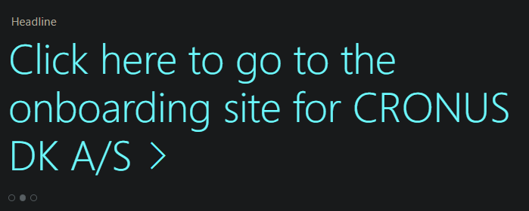

# Standard Headline Messages

There are two different message type used in the Headline Messages:

Default Messages will usually show texts like:

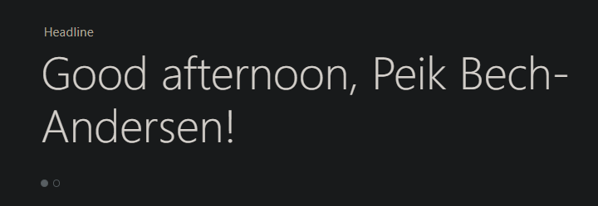

and

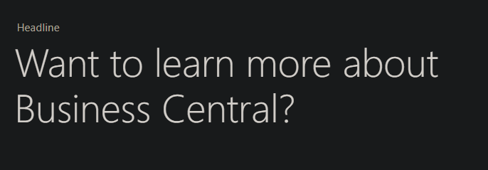

This is unless the app “Essential Business Headlines” is installed, then the messages will differ depending on the role center.

The default message will be removed and only the Greetings Headline will be shown together with some of these:

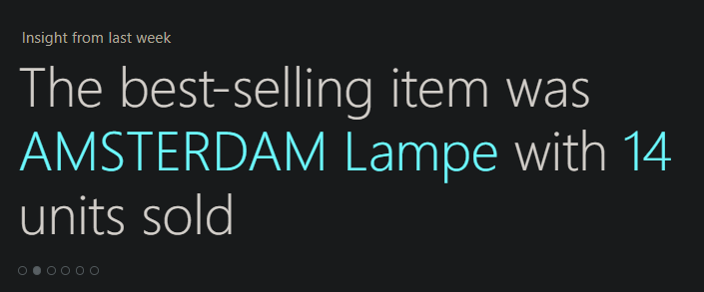

Or

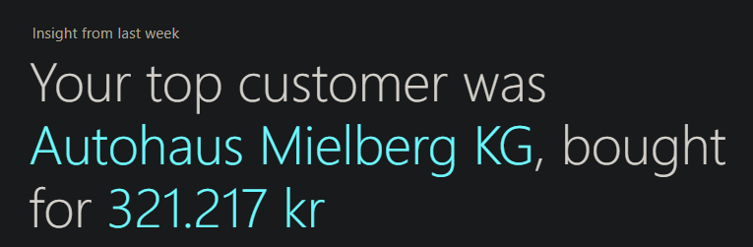

This means that the “Essential Business Headlines” app will take over at least one of the messages shown.

The “Essential Business Headlines” app consist of these insights:

* Largest sales order,
* Largest Sale
* Busiest Resource
* Most Popular Item
* Sales Increase
* Top Customer,
* Open VAT Return,
* Overdue VAT Return,
* Recently Overdue Invoices

The app will alternate between the different insights and the number of insights vary from Role Center to Role Center.

Personally, I am not a fan of exposing business-confidential information in large writing on a Role Center that might be open to whoever that passes by the screen. However, it is possible to uninstall the “Essential Business Headlines” app to avoid that problem, and that will also enable the use of the default message Headline (Want to learn more about Business Central).

# The Headline Message App

The Headline Message App serves two different purposes:

* It will control the default message Headline and ensure that the text on the headline can be customized
* and it can relay messages to groups of users.

The overview of the app is like this:

The Default Message can point to a onboarding site or ticket system.

(1) Headline Segments will create message groups

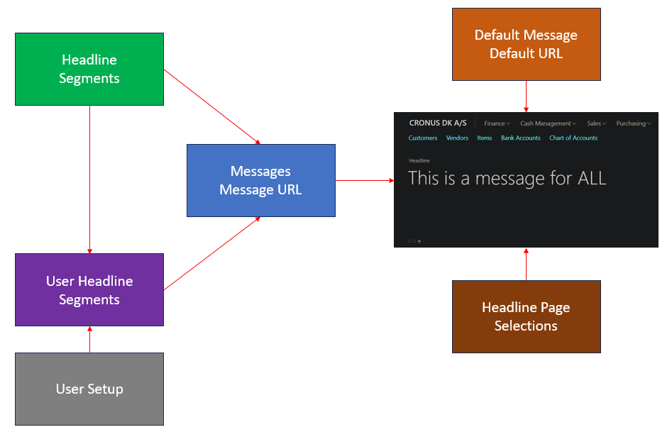

The messages to be shown for each segment

Headline Page Selection decide if messages should be shown on the Role Center or not

Headline Page Selection decide if messages should be shown on the Role Center or not

(2) Users can be divided into groups in by selecting which segments they belong to

The System is set up from the Headlines Setup page:

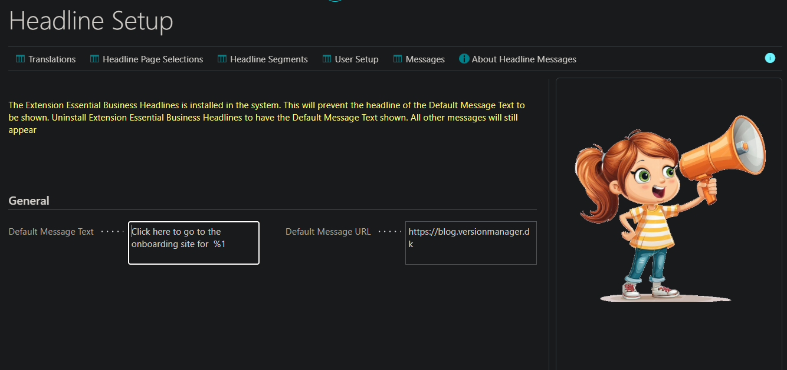

This is including the warning about the installed “Essential Business Headlines” app, with out the app the page look like this:

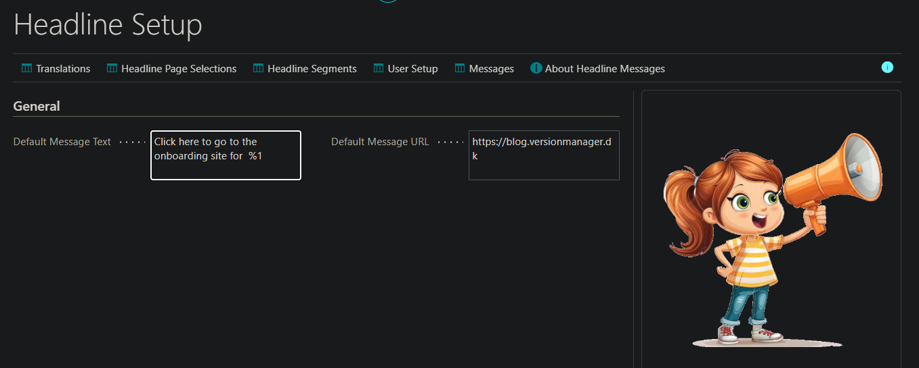

In here, the default message can de added together with a default message url.

The result will be this:

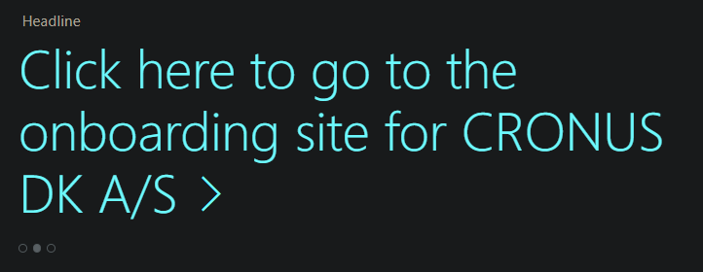

The Arrow represents the link that will open the url.

Translations can also be made to the default message:

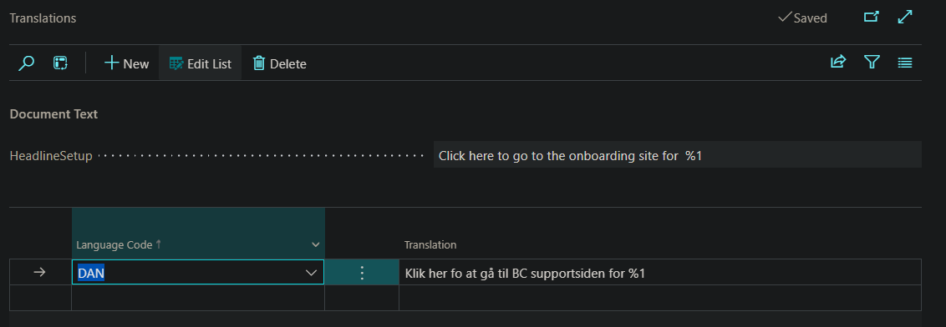

Then it is necessary to create the segments which represents the different part of the organization that should receive the messages:

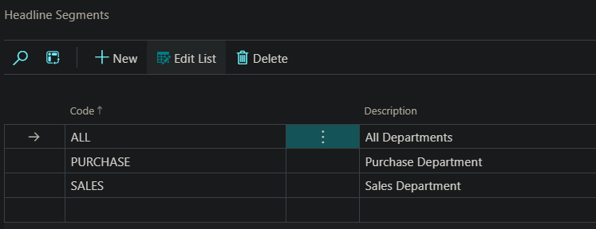

Then it is necessary to assign the segments to the users. That is done in the User Setup:

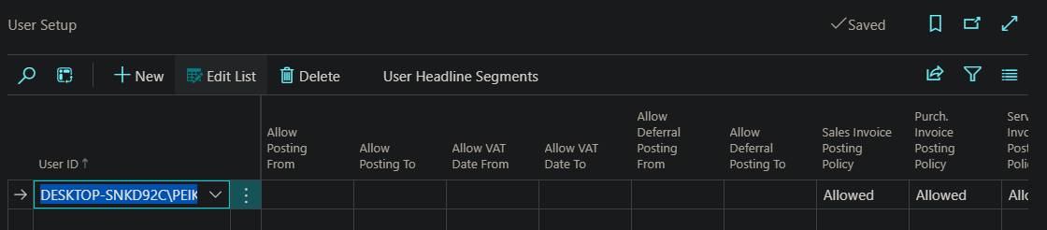

User Headline Segments:

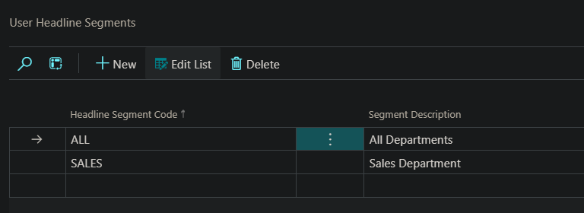

This user is only assigned to two segments but can be assigned up to five segments.

Now, it is necessary to decide which Role Centers the messages should appear on. That is done in the Headline Page Selections:

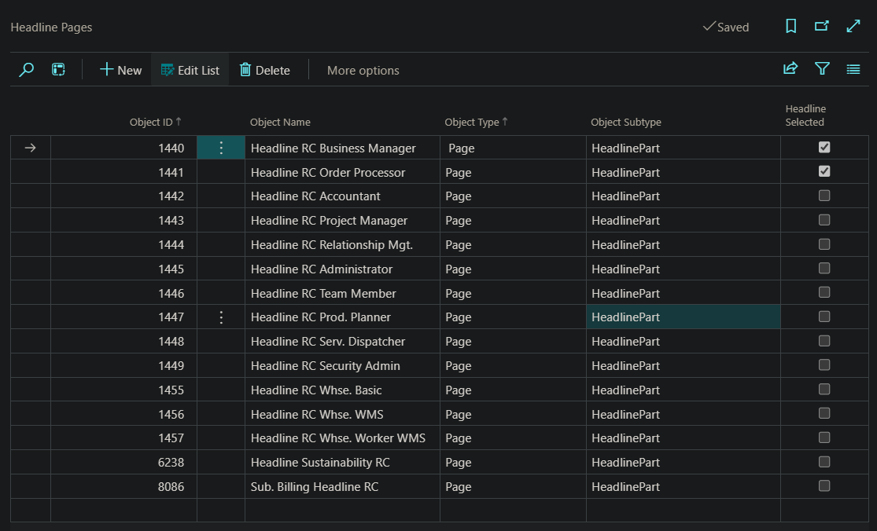

Here, only the Business Manager and the Sales Order Processor is selected, but it is possible to select all.

Lastly it is necessary to add the messages with or without the url:

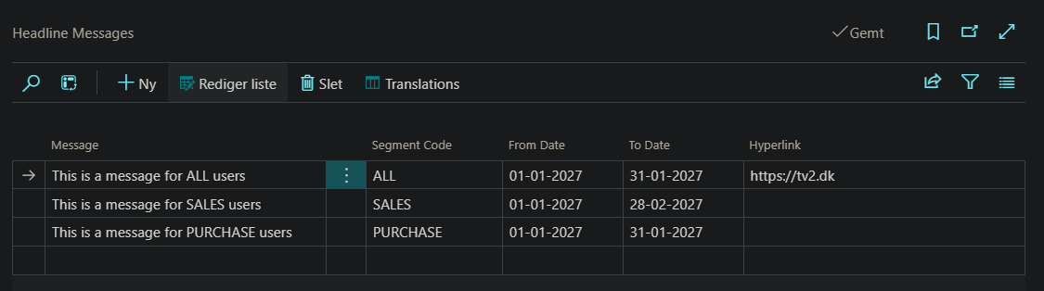

Since we have set up a date span from 01-02-2027 to 28-02-2027 for the sales message, it will only appear in that period. In this case, the Workdate is set to 27-01-2027. And the messages shown for his users are:

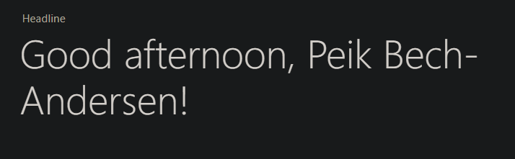

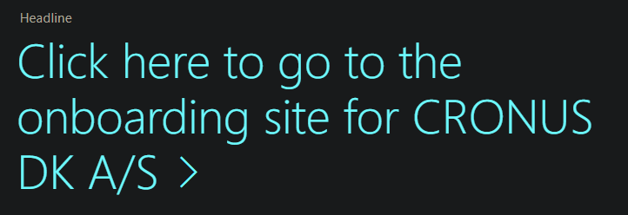

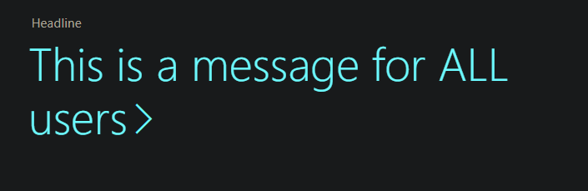

When the date is changed to 02-02-2027 and additional message is shown:

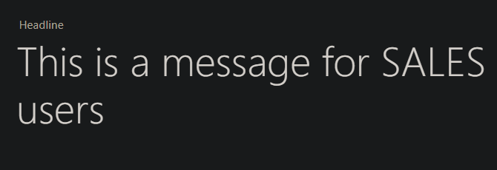

Using translations, it is possible to translate the message to other languages:

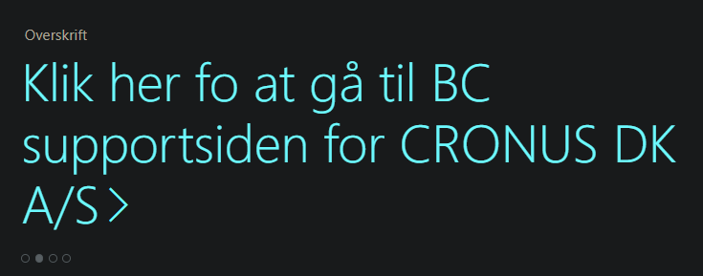

This is the Danish translation of the Default Message

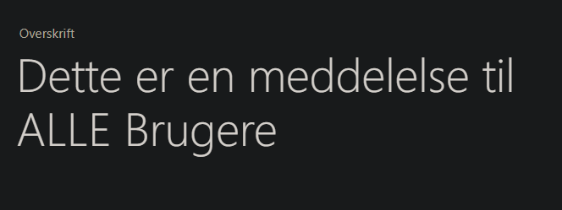

And the Danish message to users in the ALL segment.

# Open Source

This is an Open-Source project. It is provided with no warranty and you are using it entirely at your own responsibility.

You are free to use the app and code as you wish with no limitations.

The app and the code can be downloaded at:

<https://github.com/peikba/HeadlineMessages>