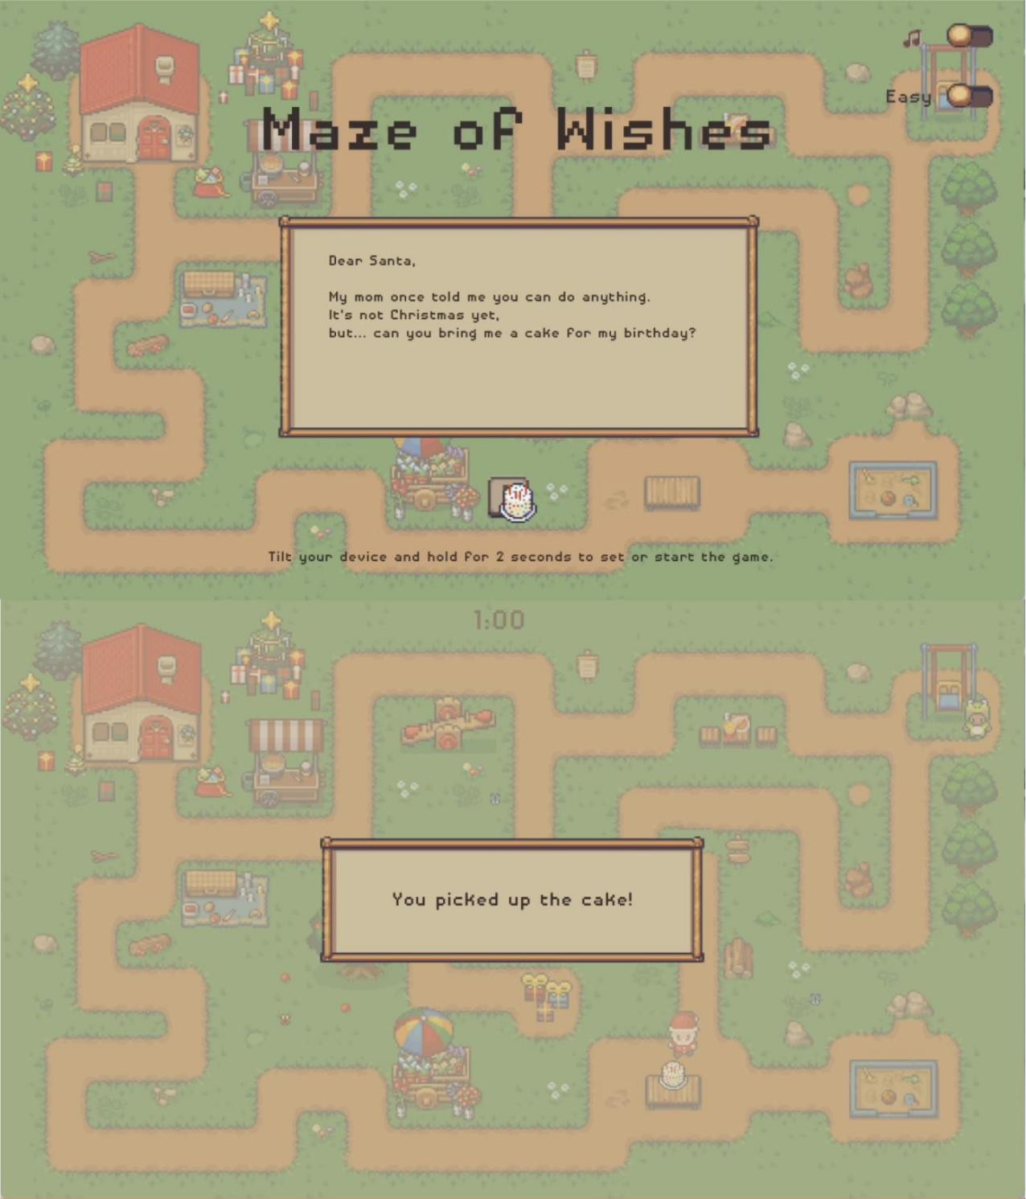

PIS - Maze of Wishes
Group member: Zeyu Liang, Peiwen Zhang

Game Overview
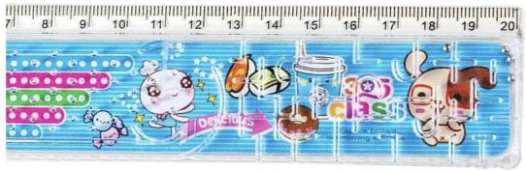
On a day off from his usual duties, Santa receives a special letter from a child whose birthday doesn’t fall on Christmas. The
child wishes to receive a birthday cake from Santa - just once. On a sunny afternoon, Santa embarks on a gentle journey to fetch the cake and deliver it with love.

The game is inspired by the nostalgic ruler mazes of childhood—those palm-sized toys where you tilt the board to guide a ball through winding paths. To recreate this tactile experience, we use ZigSim to capture the phone’s motion, allowing players to guide the character by tilting their device.

Gameplay
Players control Santa Claus by tilting their phone. The total game duration is 90 seconds. The goal is to first find the cake, then deliver it to the child to complete the mission.

Page Flow
Tutorial Page: Guides the player to complete simple tasks by tilting the phone, helping them learn the interaction style.
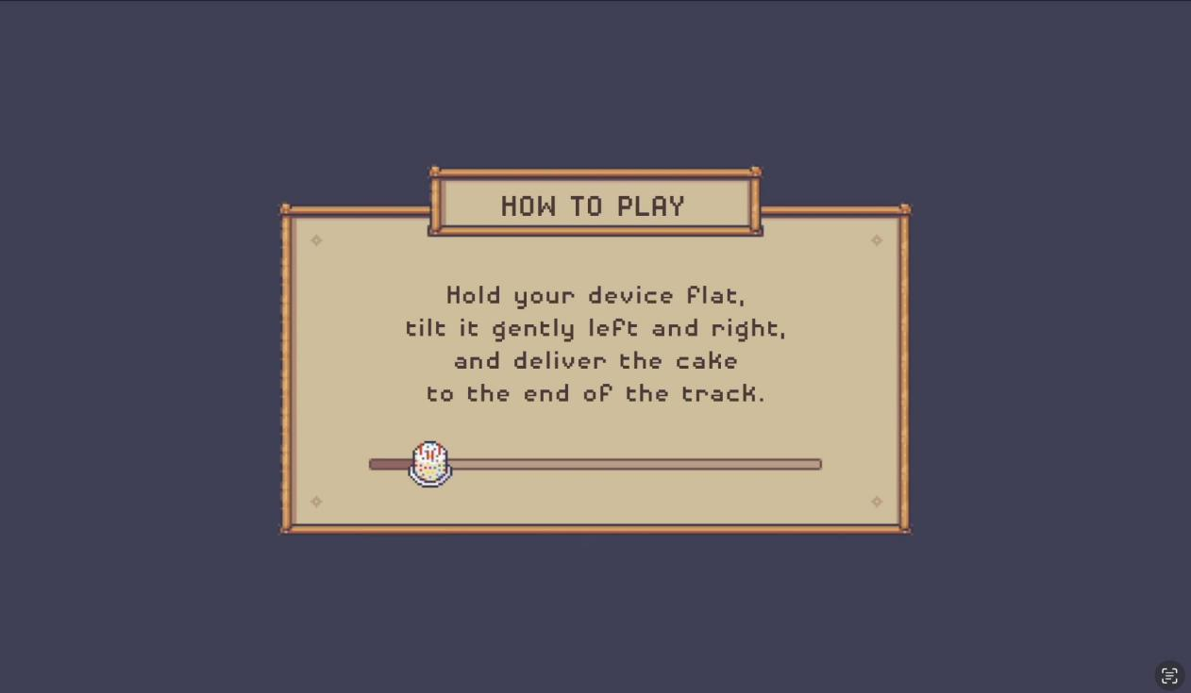

Start Page
Includes sound toggle, game mode selection, and a start button.
The player uses the cake icon as a virtual control to “hover” over UI elements. Moving the cake to the switch toggles sound or mode; hovering over “Start” triggers the game to begin.
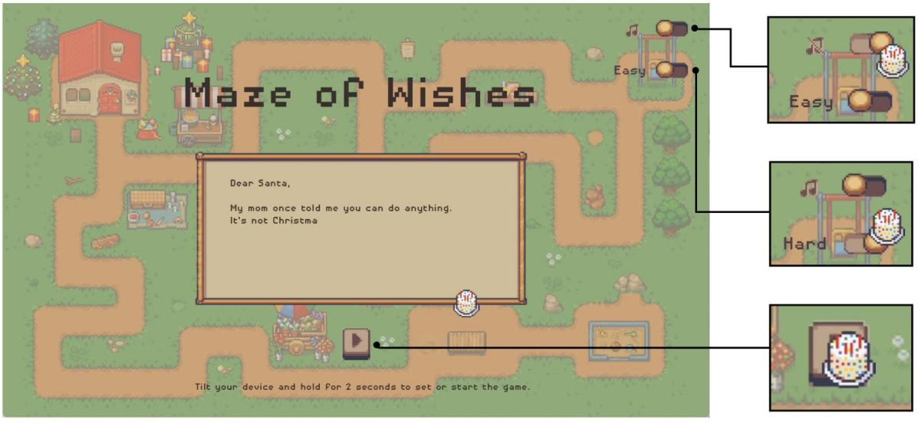

Game Page
· Easy Mode (implemented): Players must find the cake and reach the child within 90 seconds, avoiding getting lost.
· Hard Mode (in development): A ghost will chase Santa after picking up the cake. If
caught, Santa is stunned for 3s and slowed for 5s.
· Bonus: Approaching a star grants 10s speed boost and shows “speed up” prompt.
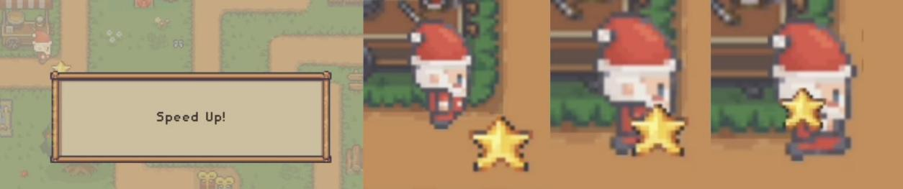

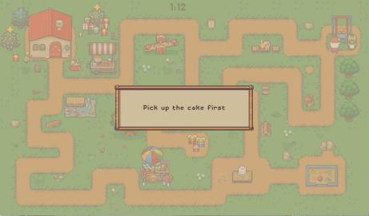
· Warnings: Reaching the goal without the cake triggers “pick up cake first”.
· Win Condition: Cake is delivered on time.
· Fail Condition: Timer runs out before delivery.

Result Page
Both success and failure pages offer two buttons: “Restart” and “Exit”.
· Restart: Returns to the Start Page
· Exit: Quits the application
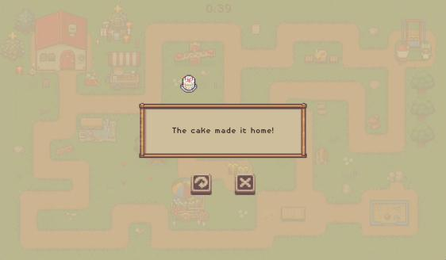
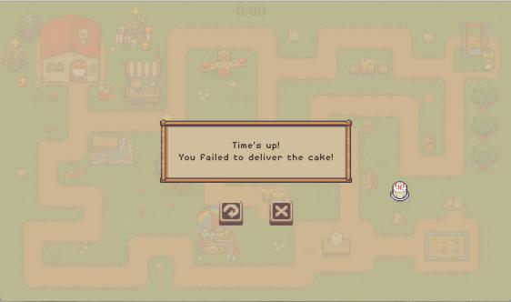

Technical Implementation

Phone Tilt Control via ZigSim and OSC
The game uses ZigSim, a mobile app that streams gravity sensor data via the OSC (Open Sound Control) protocol to the Java desktop program.
· ZigSim provides real-time gravity (accelerometer) data.
· The Java program contains an OSCReceiver that listens on a specific port and parses incoming values.
· The character’s movement direction and speed are mapped directly from the
gravity input, simulating the physical experience of tilting a maze toy.
This setup requires no external hardware - just a shared local network between phone and computer.

Map Design and Collision Detection Using Tiled and Color Mask Recognition The game map is created using the Tiled editor, with an additional color-layer image (mask) to define walkable and blocked areas.
During runtime, the program reads this mask image to determine which regions are accessible and which represent walls.
· Specific pixel colors are used to label special elements: for example, white for
paths, red for the starting point, and green for the goal. All other colors are treated as walls.

· Before each movement, the program samples the pixel color at the character’s
current position to determine whether it is walkable.
· This approach is simple and intuitive, allowing for quick adjustments to map structure and collision logic.
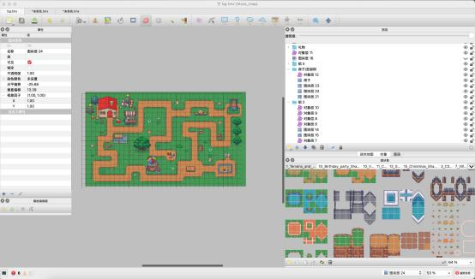
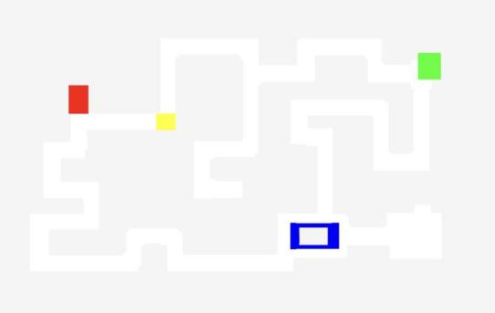

Detail & UX Design
· Breathing Animation: Key UI elements (such as the cake icon and instructional
text) feature periodic scaling effects to simulate a “breathing” rhythm, drawing the player’s attention gently.
· Item Scaling Toward Player: When a bonus item is collected, it visually scales and
moves toward the player character, enhancing the sense of interaction and reward.
· Smooth Scene Transitions: Scene changes include fade-in and fade-to-black animations to ensure fluid and visually pleasing transitions between game states.
· Interactive Tutorial Design: Instead of static instructions, the tutorial guides players
through hands-on interaction - moving a cake along a track using tilt control to intuitively learn the game mechanics.

精选了两段最具代表性的核心算法代码，分别体现像素级碰撞检测判定与重力感应坐标映射逻辑
选项一：基于足底区域的动态碰撞检测
该段代码展示了如何通过角色脚底中心点坐标定位，对其四周 $5 \times 5$ 的像素网格做碰撞预判，逻辑严密且极具说服力：

/** 检查目标位置是否触碰墙壁（检测人物脚底周围 5x5 区域） */
public boolean isBlocked(double x, double y) {
int centerX = (int) (x + 16);
int centerY = (int) (y + 60);

for (int dx = -2; dx <= 2; dx++) {
for (int dy = -2; dy <= 2; dy++) {
int px = centerX + dx;
int py = centerY + dy;
if (px < 0 || py < 0 || px >= logicMap[0].length || py >= logicMap.length) {
return true; // 超出地图边界视为墙壁
}
if (logicMap[py][px] == MaskParser.TILE_WALL) {
return true; // 区域内检测到墙壁阻挡
}
}
}
return false; // 无碰撞，允许通行
}

选项二：体感矢量与预判坐标位移计算
该段代码展示了将重力感应器传来的加速度矢量转换为实际帧位移，并在更新渲染前进行坐标预判（Rollback/Predicate）的逻辑：
/** 结合倾斜控制与碰撞预判计算角色位移 */
public void driveByAxes(double ax, double ay, double dt, double speedPxPerSec,
BiPredicate<Double, Double> canMoveTo) {
boolean movingNow = Math.hypot(ax, ay) > 0.4;

if (movingNow) {
// 计算当前帧基于时间差 dt 的预测位移向量
double dx = ax * speedPxPerSec * dt;
double dy = ay * speedPxPerSec * dt;
double newX = getLayoutX() + dx;
double newY = getLayoutY() + dy;

// 碰撞预判：仅在目标坐标安全时更新角色 Layout 坐标
if (canMoveTo == null || canMoveTo.test(newX, newY)) {
setLayoutX(newX);
setLayoutY(newY);
}
advanceWalkAnimation(dt);
}
}

