The Auto-segmentation for Human Left Ventricles

Author: Pei-Yan Li (Alvin)
Contact Email: d05548014@ntu.edu.tw

Introduction

This technical document summarizes the programs (as shown in table 1) that have been done for automatically doing the segmentation of the left ventricles (LV’s). The main idea is to utilize the designed U-net model to ultrasound images of LV’s. Besides, image processes and how to generate ground truth labels are also illustrated to readers. Please read and follow the instructions to get familiar with it before move a step forward.

Other information might also be useful that can be found in this directory: /home/alvinli/Desktop/EF/Weekly_Reports.

Table 1: Developed Programs @ /home/alvinli/Desktop/EF/bin.
Program | Purpose
image_preprocess.py | Enhance images for labeling
boundary_fill.py | Get ground truth masks
data_rename.py | Rename files consistently
data2_pool.py | Pull data into a pool
data2_batched.py | Partition data to train_batch and test_batch
Unet_input.py | Create a training queue
Unet.py | The Unet model
Unet_train.py | Training the model
Unet_eval.py | Evaluating the model
volumn_calculator.py | Calculate the volume of LV

Materials

The ultrasound images of LV include two types: 2-chamber images and 4-chamber images, which were named by A2C and A4C, respectively.

This directory stores the original images without any modification: /home/alvinli/Desktop/EF/Raw_data.

From here, images would be selected for training purposes. Only the types of A2C and A4C were used and processed. An image with two screens (double A2C or A4C) should not be selected.

The selected images of A2C and A4C were respectively copied to: /home/alvinli/Desktop/EF/dataset/A2C_patients and
/home/alvinli/Desktop/EF/dataset/A4C_patients.

A table called “Folder_information.ods” describing the information of data is inside both directories of A2C and A4C.

Please update this table manually if any folder is added or renamed.

Labeling process

For each patient folder in either /home/alvinli/Desktop/EF/dataset/A2C_patients or /home/alvinli/Desktop/EF/dataset/A4C_patients, please execute the program image_preprocess.py to enhance the images in entire folder.

Ex:
alvinli@ComputerVisionLab:~$ cd ~/Desktop/EF/dataset/A2C_patients/180234_20190510_1
alvinli@ComputerVisionLab:~/Desktop/EF/dataset/A2C_patients/180234_20190510_1$ python Desktop/EF/bin/ image_preprocess.py

Then, you get “*_enhanced.png” for each “*.png” accordingly.

The “enhanced images” are used to label the border of LV.

After the enhance process being done, open “labelme” app to label and save label information in the same folder.

This is how to open “labelme” graphic user interface:
You can see this window on your screen:
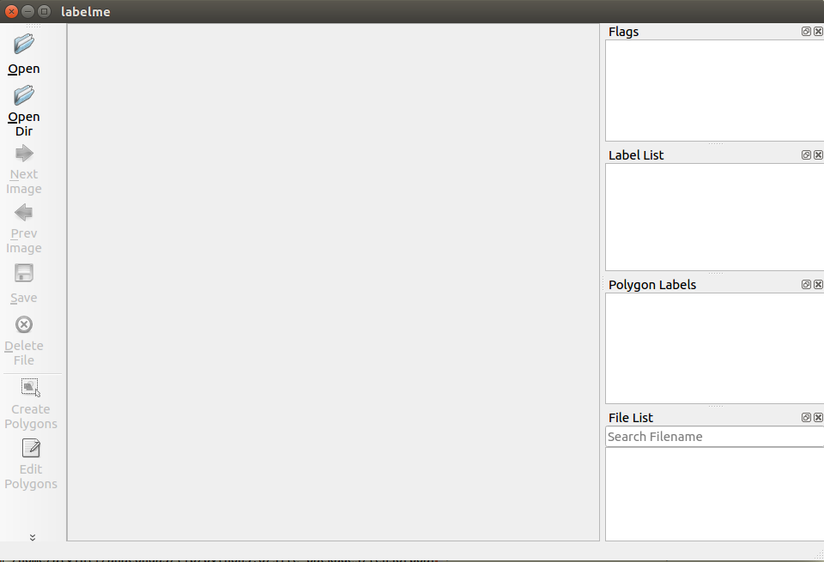

Click “Open” to select an image with the name “*_enhanced.png”:
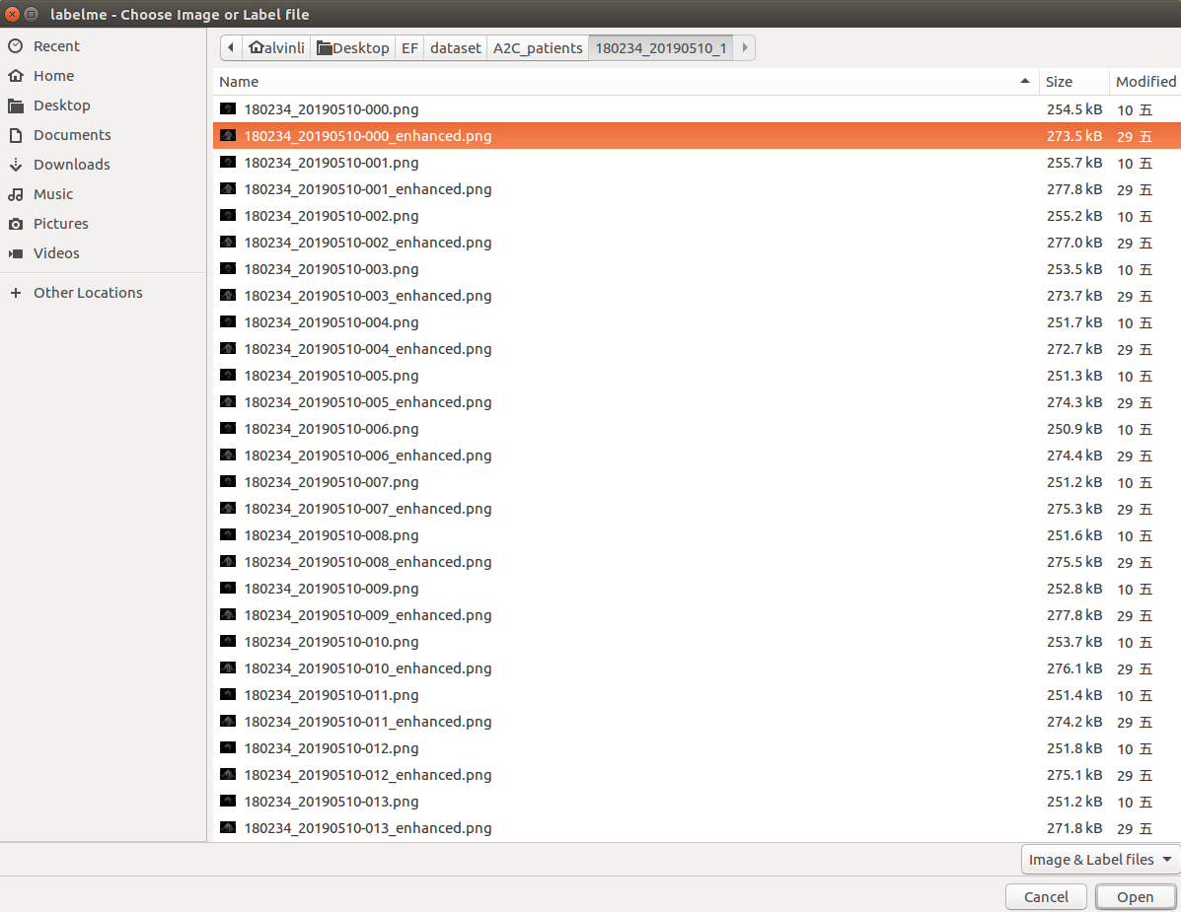

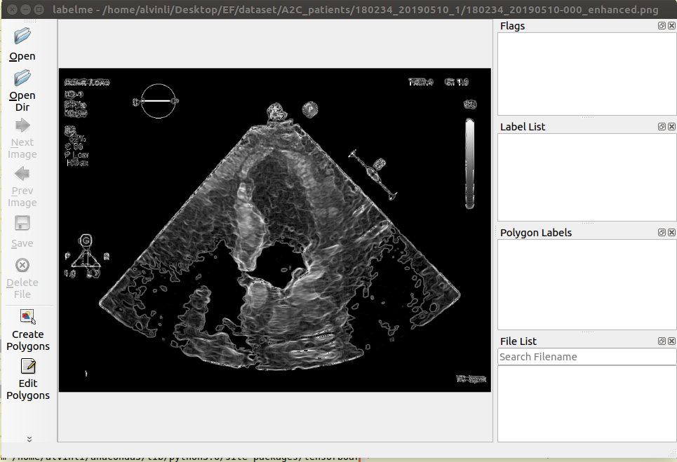
Click “Create Polygons” to use the label tool and store it with label index as ‘LV’:
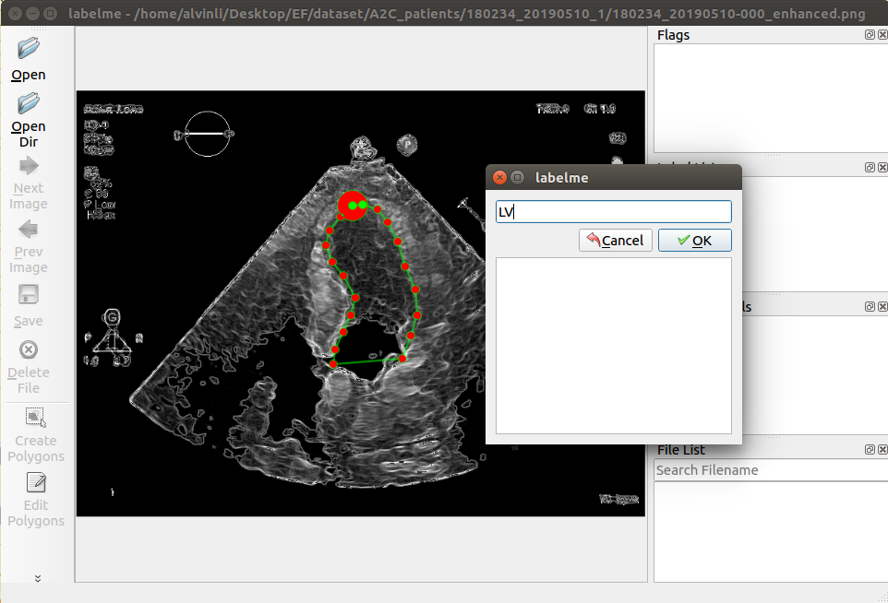

Click “Save” to save it in the folder with the name of “.json” without “_enhanced” (delete it from the recommended name):
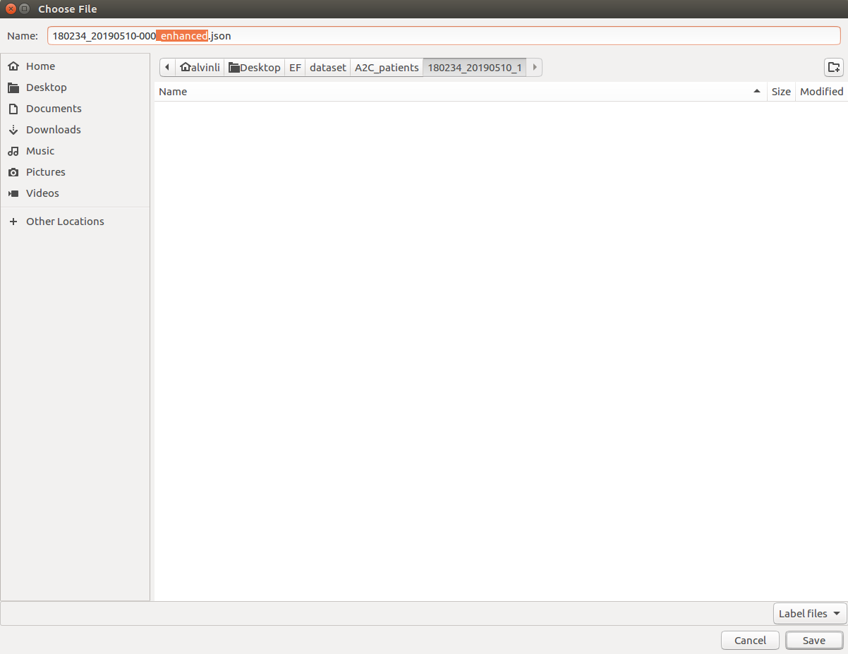

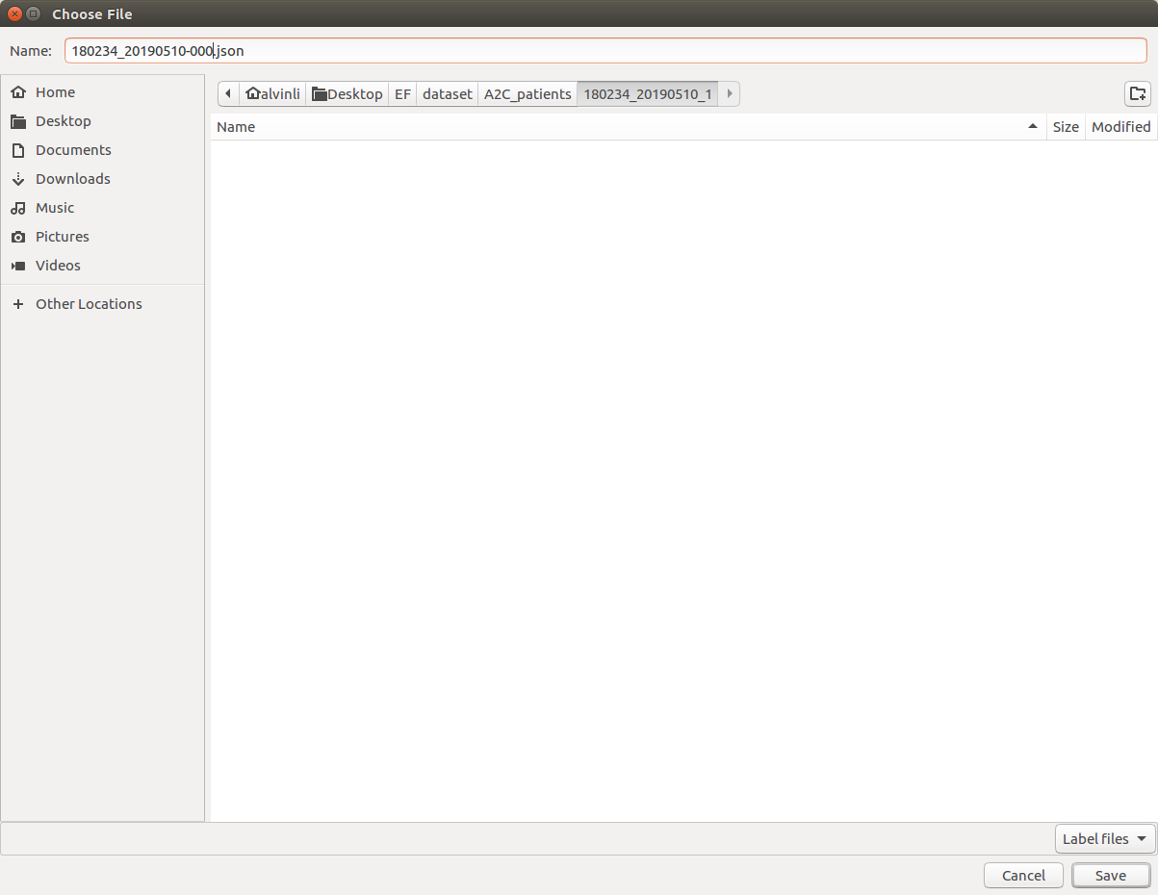

Do it for every “*_enhanced.png” to get the “*.json” accordingly.

Generate ground truth masks

After you have labeled all the enhanced images in the same folder, please execute the program boundary_fill.py at the same folder to get the ground truth mask with the name of “*_ROI_mask.png”.

Ex:
Then, please rename the folder manually to this form “A2C_patient_xxxxx” or “A4C_patient_xxxxx” like:

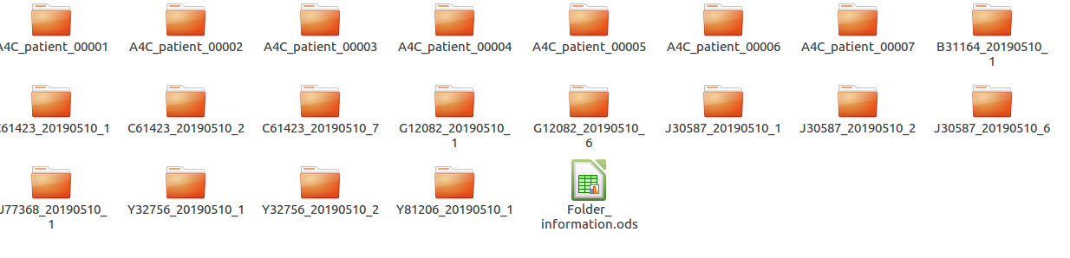
This will make the folder names in a consistent way for further processes. However, please only rename the folder after you have labeled all the inside enhanced-images. This can make a difference to distinguish the folders with or without labeling. And please update “Folder_information.ods” to make a record for this change.

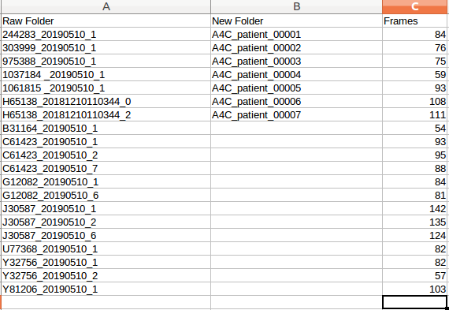

Then, please execute the program data_rename.py to rename all the files in the folder:

This will make the files’ name in a consistent way:

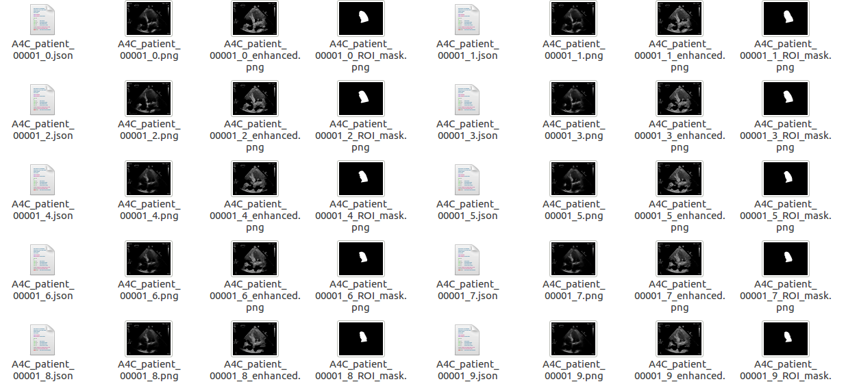

Partition data to train_batch (80%) and test_batch (20%)

Step 1:

Create a folder called ‘EF-training-Pool’ at the path like this:
‘/home/alvinli/Desktop/EF/dataset/EF-training-Pool’

Step 2:

run the program data2_pool.py :
Step 3:

run the program data2_batches.py :

Then you should get this:

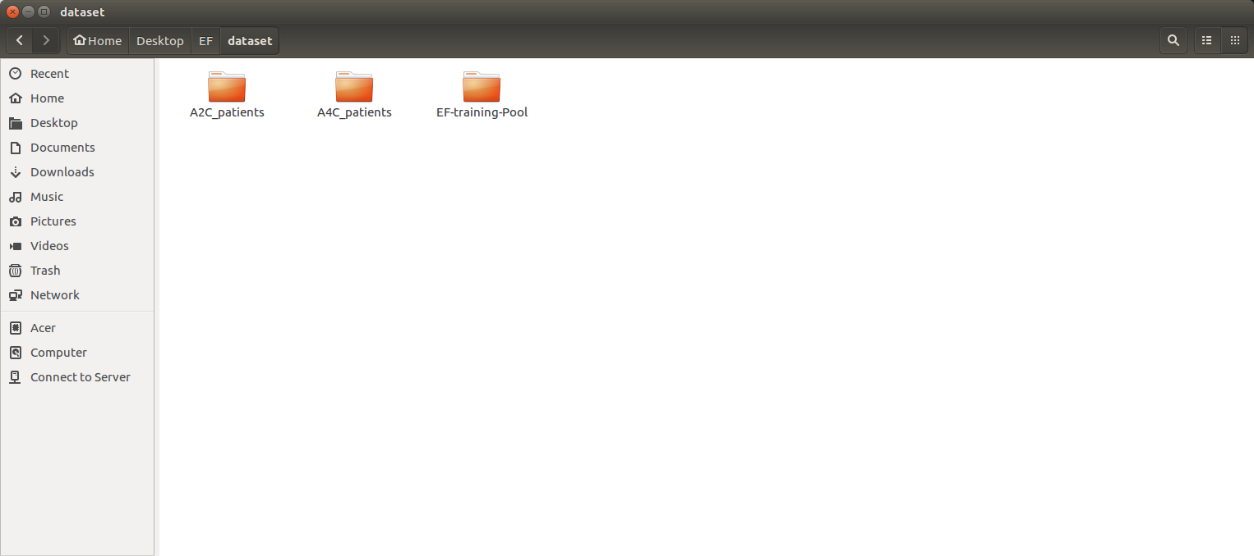

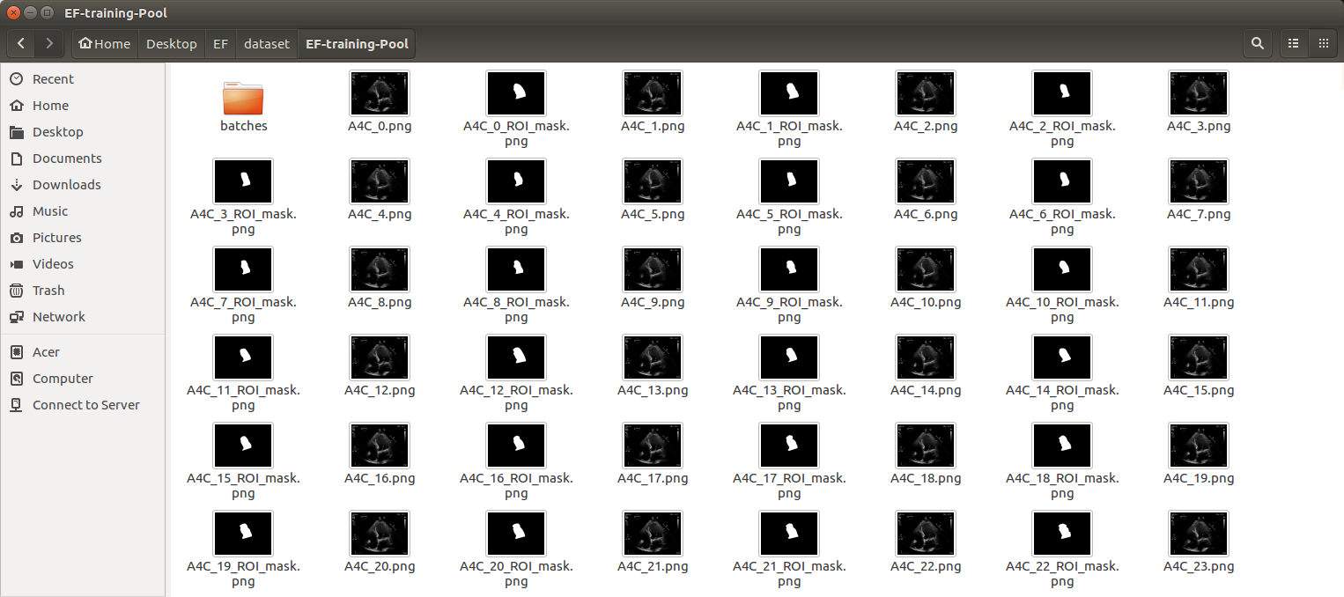

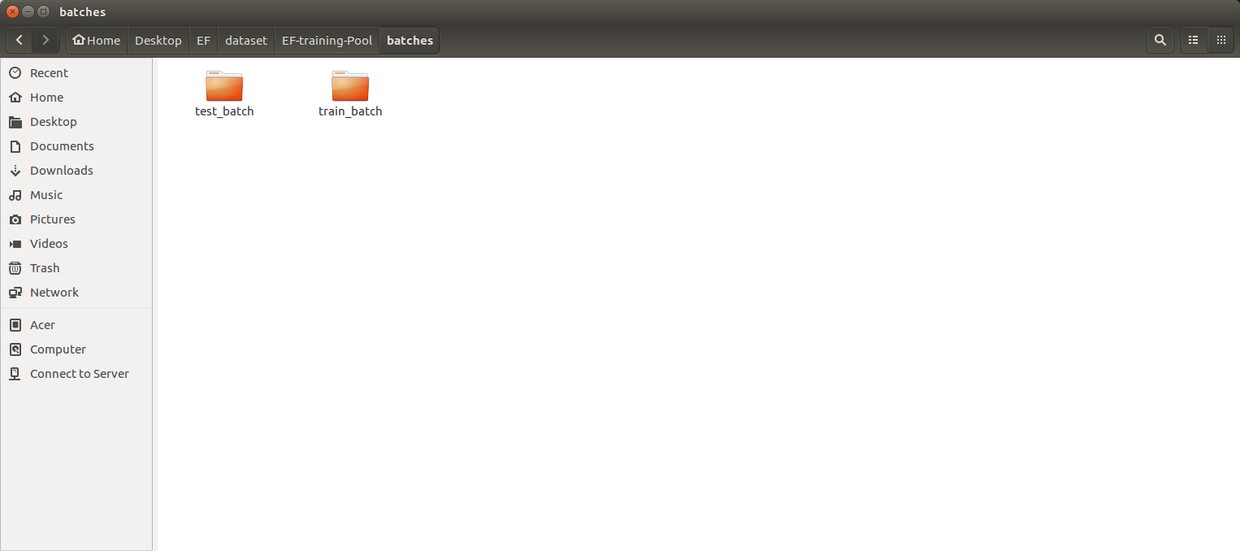

Train model

~$ python Unet_train.py

Evaluate model

~$ python Unet_eval.py

About the model structure, please refer to the working notes:
/home/alvinli/Desktop/EF/Weekly_Reports

volumn_calculator.py
→ calculate the volume of LV by the modified Simpson’s Method.
The input file is a *.json file storing the discrete labels.
The “nothing” function can output the ejection fraction with a heart pumping circle chart.
