Introduction to OpenStack Networking

Created by: Alvin Pei-Yan, Li

Abstract:

OpenStack promises to provide a scalable and automated approach to manage next-generation networks. Neutron is the project name for the OpenStack Networking service, can be distributed over multi-hosts or either a single node to provide a scalable application. OpenStack Networking can be used by administrators or users to maximize the utilization of existing data center resources. Complementing other OpenStack services such as Nova (compute), Keystone (identity), Cinder (block), Swift (object) and Horizon (Dashboard), OpenStack Networking can provide a complete cloud solution.

A simplified example of Neutron combining with other agents and a database for keeping the network configuration can be seen here. In a typical environment, network agents will be scattered across controller and compute nodes and performs duties on their respective node:
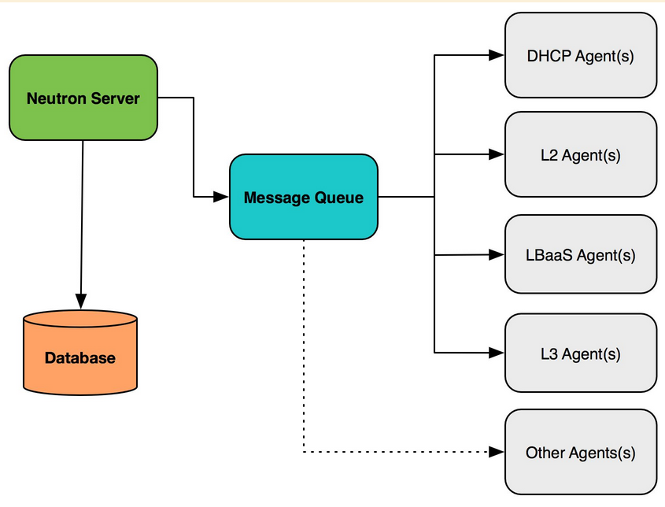
OpenStack Networking includes switching, routing, load balancing, firewalling, virtual private networks and network function virtualization. It provides a framework of the cloud can be enhanced by third party vendors.

Switching
A virtual switch connects virtual machines to virtual networks at the data-link layer (L2). Besides, virtual switches can be used to facilitate communication between instances and devices outside the control of OpenStack including hardware switches, network firewalls, storage devices, bare-metal services, and so on.

Neutron supports Linux bridges and Open vSwitch. Open vSwitch, also known as OVS, is an open source virtual switch that provides standard management interfaces and protocols.

Routing
Configuring a router within Neutron enables instances to communicate with outside networks or other networks in the cloud. OpenStack Networking supports routing and NAT capabilities by the use of IP forwarding, iptables, and network namespaces.

Load balancing
Load Balancing as a Service (LbaaS v2) supports users to be capable to distribute client requests across multiple instances or servers. OpenStack Networking is equipped with a plugin for LbaaS v2 that utilizes HAProxy in the open source reference implementation, besides, plugins are available to be provided by third party network vendors to manage virtual and physical load-balancing appliances.

Firewalling
OpenStack Networking provides two API-driven methods of securing network traffic to instances: security groups and Firewall as a Service (FWaaS). Security groups are based on Amazon’s EC2 security groups. Like security groups, security policies built using FwaaS are implemented at the port level, but can also be applied to ports of routers as well as instances.

Virtual private networks
Neutron provides a set of APIs to allow users to create IPSec-based VPN tunnels from Neutron routers to remote gateways when using the open source reference implementation.

OpenStack Networking supports project-owned resources, including each project having multiple private networks and routers. Projects can be left to choose their own IP addressing scheme, even if those addresses overlap with other project networks, or administrators can place limits on the size of subnets and addresses for allocation.

There are two types of networks that can be expressed in OpenStack: project/tenant network and provider network.

Project network
A virtual network created by a project or administrator on behalf of a project. The physical details of the network are not exposed to the project.

Provider network
A virtual network created to map to a physical network. Provider networks are typically created to enable access to physical network resources outside of the cloud, such as network gateways and other services, and usually map to VLANs. Projects can be given access to provider networks.

