1. Because of the logger.properties configs.

2. The line coms from the logger.properties file in the src/main/resources. It defines different level logging, as for the FINER is lower than the INFO — ( SEVERE (highest), WARNING, INFO, CONFIG, FINE, FINER, FINEST(Lowest).

3. Assertions.assertThrwos allow us to test multiple exceptions within the same test. Asserts that execution of the supplied executable throws and exception of the expectedType and returns the exceptions.

4.

1. The serialVersionUID is a unique identifier of Serializable classes. This is used during the deserialization of an object, to ensure that a loaded class is compatible with the serialized object. If not, and InvalidClassException is thrown.

2. To pass information to the base constructor of Exception.

3. no need for more functionality.

5. The static block is execute once when the class is first accessed

6. README.md is a format of markdown file, bitbucket supports markdown syntax

7. The reason why the test falling is it expects a TImerException for the nullpointer Eceptions, and the result was a null value.

8. The timer is running until is interrupted, and it throws timer exception indicates the conditions. As for the sleep is invalid, it will have different conditions that it will throws different timer exception to indicate it.

9.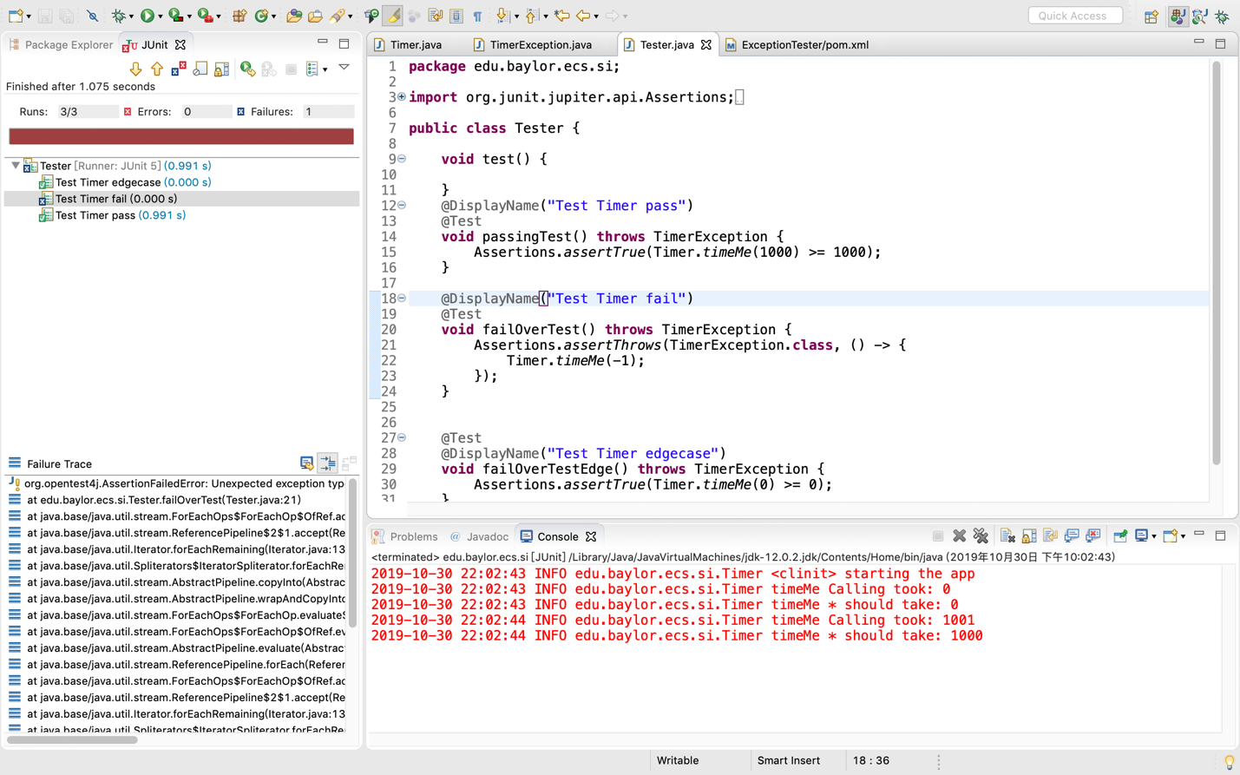

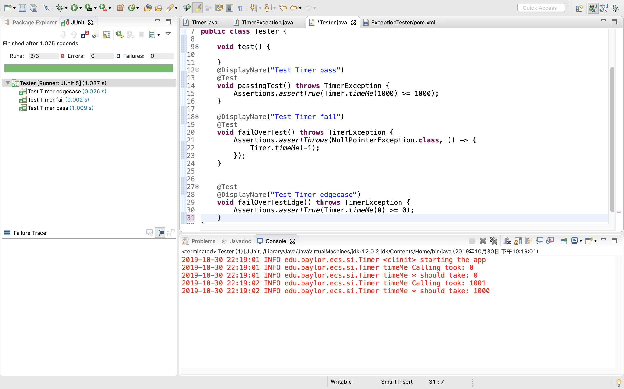

10.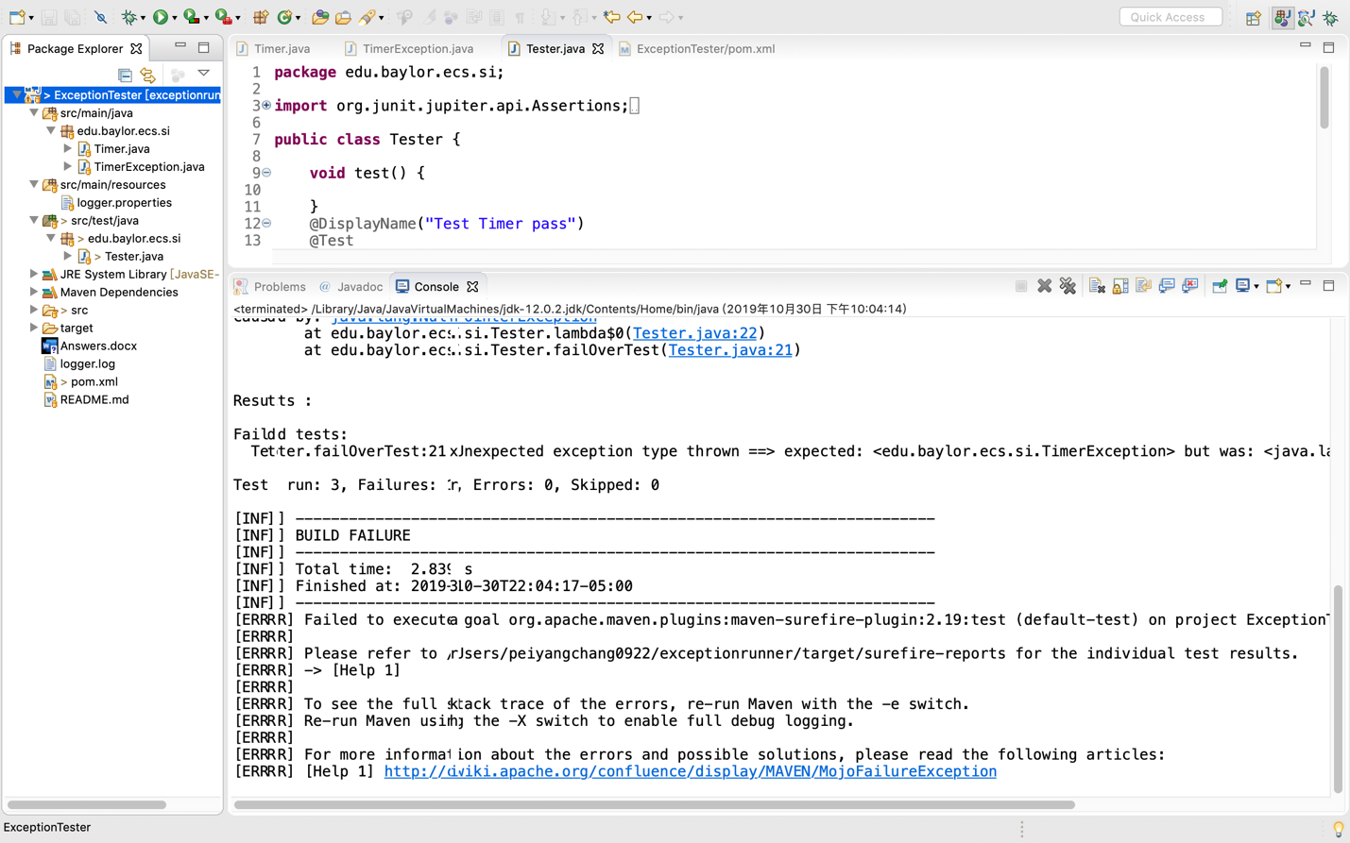

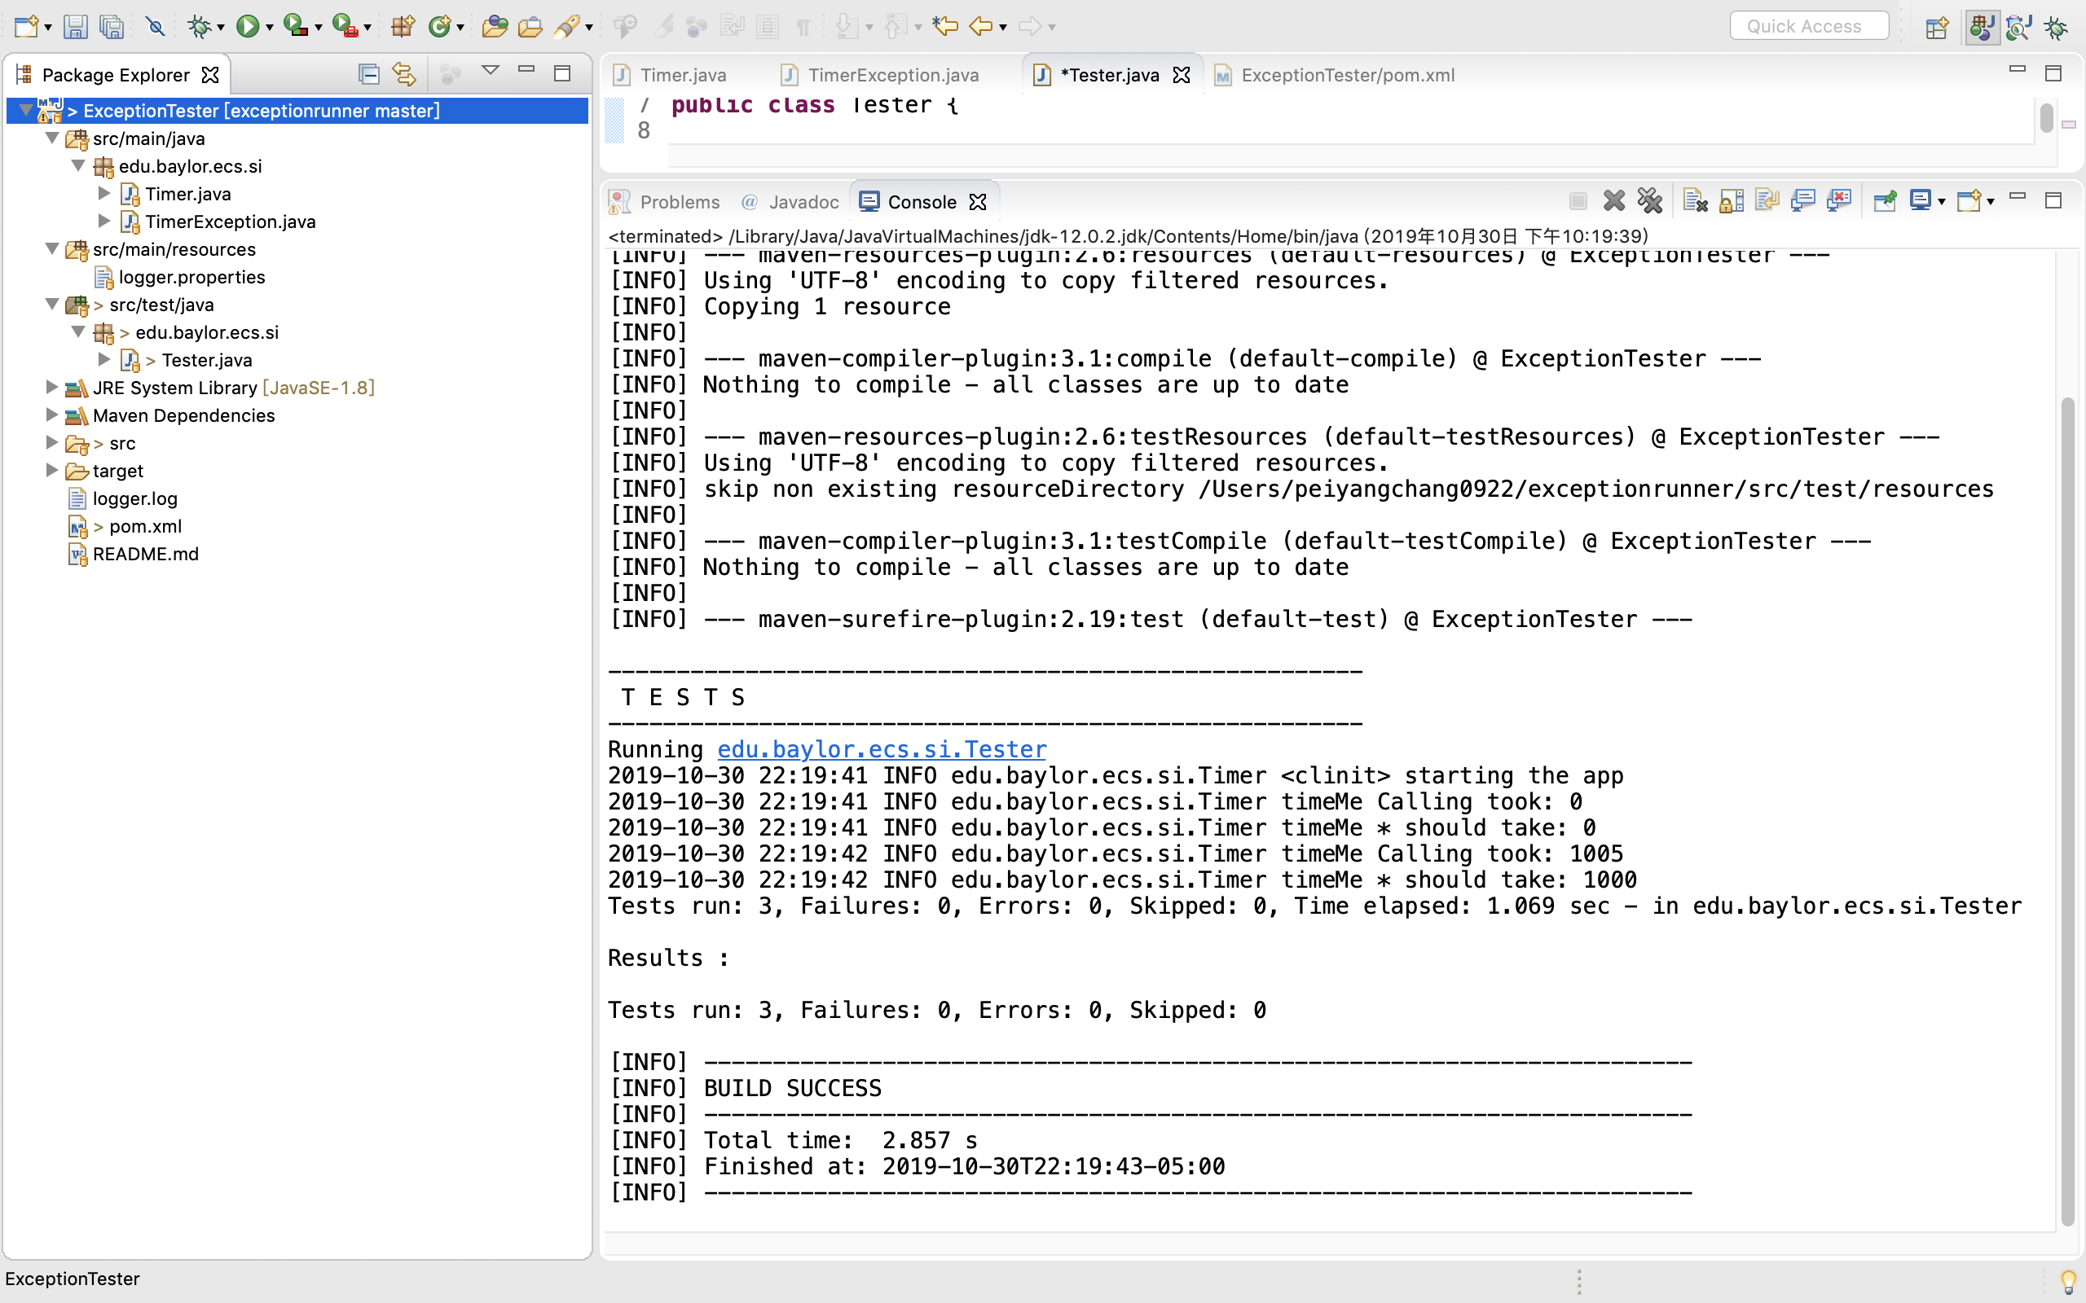

11. NullpinterException is a situation in code where you try to access an object which has not been initialized yet (the object is not pointing anywhere and refers to nothing or null.) which is unchecked exception and extends to RuntimeException. As for TimerException is alos belong to RuntimeException, and extends to DecisionEception.