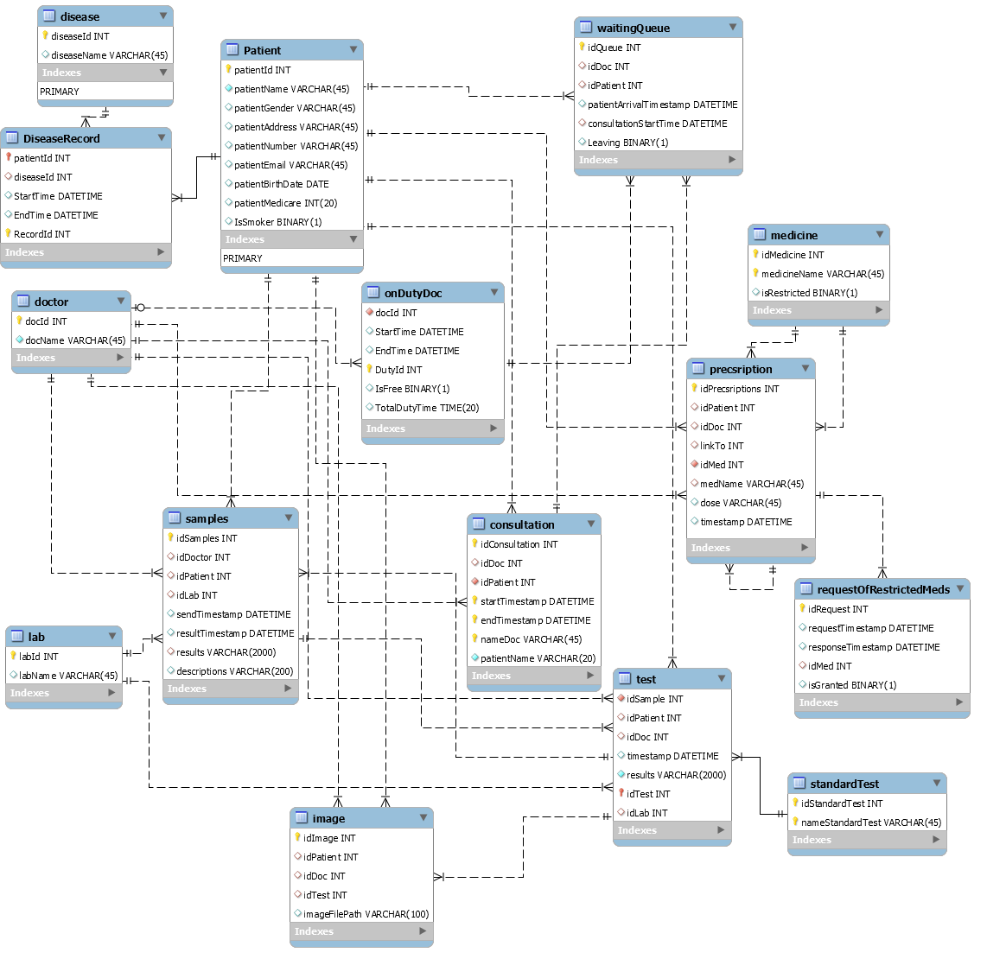
Data Dictionary
Entity 'Patient'
This is a table that stores patients and their information in the question.It’s expected that 20 million different patients will come to the clinic during its life.
Attribute | Description
PatientId | This is the primary key of entity ‘patient’. It is a unique integer for one specific patient and it is issued by the system once the patient has completed registration.Then next time the patient comes, he can use it for signing in.
PatientName | The name of the patient, and it’s usually a string, e.g. ‘Benjamin Li’, varchar. Repetition is allowed.
PatientGender | The gender of the patient, binary. ‘1’ represents male and ‘0’ represents female.
PatientAddress | This field holds the address of patients, a string e.g. ‘746 Swanston St.’, varchar. Since some patients could be roommates, it’s not unique.
PatientNumber | The phone number of the patient. No longer than an eleven-digit number, but the data type is varchar.
PatientEmail | Holds the email address of the patient e.g. ‘jili@gmail.com’, varchar.
PatientBirthDate | The birthdate of the patient e.g. ‘1995-12-03’, date. After the registration, the birthdate will be used as password of the account. So, birthdate should be converted into an 8-digit number e.g. 19951203.
PatientMedicare | The unique 20-digit number of every patient, integer.
IsSmoker | A binary number ‘0’ and ‘1’ means ‘Not a smoker’ and ‘Is a smoker’, respectively. This will help to build a record of the patient.

Entity 'DiseaseRecord'
A record for the patients and their disease. Including the time when it was recorded(added) and recovered(removed) of the disease.
Attribute | Description
RecordId | This is the primary key of entity ‘Disease’. It is a unique integer for the record of disease of a patient.
PatientId | This is the first foreign key of entity ‘DiseaseRecord’. It is a unique integer for one specific patient and it links to the attribute ‘PatientId’ in entity ‘Patient’.
DiseaseId | This is the second foreign key of entity ‘DiseaseRecord’. It is a unique integer for a type of disease and it links to the attribute ‘DiseaseId’ in entity ‘Disease’ which holds more than 300 different names of diseases.
StartTime | The time when the disease was recorded e.g. ‘2017-04-22 08:00:00’, datetime.
EndTime | The time when the disease was cured e.g. ‘2017-05-21 09:00:00’, datetime.

Entity 'Disease'
A table that holds more than 300 different normative names of diseases.
Attribute | Description
DiseaseId | This is the primary key of entity ‘Disease’, integer.
DiseaseName | Data type is varchar, the name of the disease e.g. ‘Migraine’.

Entity 'WaitingQueue'
After the register/signing in, patients will come to the queue and wait for the consultation. The entity includes the arrival time, consultation starting time and if the patient leaves before the consultation so as to calculate the typical arrival time and waiting time, and any leaving without consultation.
Attributes | Description
IdQueue | This is the primary key of entity ‘WaitingQueue’, integer.
IdDoc | It’s the first foreign key related to the attribute ‘DocId’ in entity ‘OnDutyDoctor’, integer. When a doctor is free, the next patient will be called to his room for consultation.
IdPatient | The second foreign key related to the attribute ‘PatientId’ in entity of ‘Patient’, integer.
PatientArrivalTimestamp | The time when patients get into the queue e.g.‘2018-07-10 10:00:00’, datetime. It’s recorded for counting the typical arrival time and waiting time.
ConsultationStartTime | The time when patients are called for the consultation e.g.‘2018-07-10 11:00:00’, datetime. It’s also recorded for counting the typical arrival time and it’s the third foreign key linked to the attribute‘StartTimeStamp’ in entity of ‘consultation’. And they share the same value.
Leaving | A binary number ‘0’ and ‘1’ means ‘Not leaving’ and ‘Has left’, respectively. This will help to build a record of whether the patient leaves and if they have left then the system will ignore them to call the next patient.

Entity 'Doctor'
The collection of all doctors, whether they are on duty or not.Temporarily, there are 20 doctors in this clini, and it’s expected to be around 100 doctors in the clinic over the whole life.
Attribute | Description
DocId | This is the primary key of entity ‘Doctor’, a unique integer.
DocName | This is the name of the doctor and it is a repeatable varchar.

Entity 'OnDutyDoctor'
Doctors who are on the duty and if he or she is ready for seeing a patient. Everyday there will be 10 doctors on duty to make consultations for patients.
Attribute | Description
DocId | This is the first foreign key of the entity ‘OnDutyDoctor’ and it links to, the attribute ‘DocId’ of the entity ‘Doctor’, the attribute ‘IdDoc’ of the entity ‘Consultation’, the attribute ‘IdDoc’ of the entity ‘Queue’, respectively.
StartTime | This is the time when the doctor starts working e.g. ‘2017-04-22 08:00:00’, datetime.
EndTime | This is the time when the doctor stop working e.g. ‘2017-05-21 09:00:00’, datetime.
DutyId | This is the primary key of entity ‘OnDutyDoctor’, a unique integer.
IsFree | This is a binary number indicates whether the doctor is free or not. It’s controlled by the doctor, to help the system in entity ‘Queue’ let the next patient stop waiting and start consultation.
TotalDutyTime | This is the primary key of entity ‘patient’. It is a unique integer for one specific patient and it is issued by the system once the patient has completed registration.(虽然我还是不明白这个属性干嘛用的。。)

Entity 'Consultation'
When the doctor is free, then a consultation between a certain doctor and a certain patient begins. The doctor will record the start time and end time of the consultation and write a note(not more than 200 words). The doctor will also write a prescription for the patient and decide whether they need to be tested. When a consultation is over, the doctor will signal to the system to call the next patient.It’s expected that there will be approximately 200 million consultations during the clinic’s life.
Attributes | Description
IdConsultation | This is the first primary key of entity ‘Consultation’, a unique integer.
IdDoc | This is the first foreign key of the entity ‘Consultation’ and it links to the attribute ‘DocId’ of the entity ‘Doctor’, integer.
IdPatient | This is the second foreign key of the entity‘Consultation’ and it links to, the attribute ‘PatientId’ of the entity ‘Patient’, integer.
StartTimestamp | The time when doctors and patients start the consultation e.g.‘2018-07-10 11:00:00’, datetime. It’s the third foreign key linked to the attribute ‘ConsultationStartTime’ in entity of ‘WaitingQueue’. And they share the same value. It’s the second primary key in the entity.
EndTimestamp | This is the time when the consultation ends e.g. ‘2017-05-21 09:00:00’, datetime. When the doctor record the end time, he will inform the system to call the next patient.
NameDoc | The name of the doctor in this consultation e.g.‘Benjamin Super Li’, varchar. It should fit the doctor ID.
PatientName | The name of the patient in this consultation e.g. ‘Patrick Chicken Wang’, varchar. It should fit the patient ID.
Note | A set of notes that the doctor records for this certain consultation e.g. ‘The patient gets psychosis that he always thinks that he is an apple.’, varchar.

Entity 'Prescription'
During the consultation, the doctor will write a prescription for the patient to get the medicine.

Attribute | Description
IdPrescription | This is the first primary key of prescription, which is a unique integer that varies from different columns
IdPatient | This is a foreign key which links to attribute ‘patientId’ of entity ‘Patient’
IdDoc | This is also a foreign key which links to attribute ‘docId’ of entity ‘doctor’
LinkTo | This is a special foreign key linking to the attribute ‘IdPrescription’ which shows this row of prescription is extended from an old one.
IdMed | This is a foreign key that links to attribute ‘idMedicine’ of entity ‘medicine’
MedName | This is a foreign key that links to attribute ‘medicineName’ of entity ‘medicine’
Dose | This is an attribute that stores how much and how often that the patient should take the medicine
timestamp | This is a DATETIME type attribute that records when the prescription is issued

Entity 'Medicine'
This contains information for all the medicines that the doctors in this clinic can prescribe to the patients.

Attributes | Description
idMedicine | This is the first primary key of this entity which is a unique integer for each medicine
medicineName | This is also a primary and records the name of medicine
isRestricted | This is a binary type attribute which identifies whether the medicine is restricted. ‘1’ for restricted and ‘0’ for not.

Entity 'RequestOfRestrictedMeds'
This holds information about the request for restricted medicines and response.
Attributes | Description
idRequest | This is the primary key that holds a unique integer for each request sent
requestTimestamp | This is a DATETIME type attribute that records when the request is sent to the authorities
responseTimestamp | This is a DATETIME type attribute that records when the response is received
idMed | This records which medicine is requested, and is a foreign key which links to attribute ‘idMed’ of entity prescription, hence only the restricted medicine in the prescription need request.
isGranted | This is a binary type attribute, which records whether the request is granted or not. ‘1’ for granted and ‘0’ for not.

Entity 'Test'
This contains information about the tests need to perform on the patients required by doctors.
Attributes | Description
idSample | This is a foreign key which links to attribute ‘idSamples’ of entity ‘samples’
idPatient | This is a foreign key that links to attribute ‘patientId’ of entity ‘patient’
idDoc | This is also a foreign key which links to attribute ‘docId’ of entity ‘doctor’
timestamp | This is a DATETIME type attribute that records when the test is performed
results | This contains the test result
idTest | This is the primary key of this entity, which contains a unique integer for each test
idLab | This is a foreign key which links to attribute ‘labId’ of entity ‘lab’

Entity 'StandardTest'
This is a table that holds information about standard tests that the clinic can perform.
Attributes | Description
idStandardTest | This is a primary key which holds a unique integer for each standard test
nameStandardTest | This holds the name of the test

Entity 'Samples'
This contains information about the samples that are taken from patients for tests
Attributes | Description
idSamples | This attribute holds a unique for each sample that need to be sent for tests, and is a primary key
idDoctor | This is a foreign key which links to attribute ‘docId’ of entity ‘doctor’
idPatient | This is a foreign key that links to attribute ‘patientId’ of entity ‘patient’
idLab | This is a foreign key that links to attribute ‘labId’ of entity ‘lab’
sendTimestamp | This is a DATETIME type attribute recording when the sample is sent to the lab performing the requested test
resultTimestamp | This records when the result comes out
results | This holds the results, of which length needs to < 2000
descriptions | This contains the description of the sample

Entity 'Lab'
This is the table that holds relevant information for labs
Attributes | Description
labId | This is a unique integer that identifies each lab, which is a primary key
labName | This stores names of labs, also a primary key

Entity 'Image'
This contains medical images of the patients, if required by the doctor
Attributes | Description
idImage | This is a unique integer that identifies different image, which is a primary key
idPatient | This is a foreign key that links to attribute ‘patientId’ of entity ‘patient’
idDoc | This is a foreign key which links to attribute ‘docId’ of entity ‘doctor’
idTest | This is a foreign key which links to attribute ‘idTest’ of entity ‘Test’
imageFilePath | This attribute stores the file path to the image

