HCDE 310

Fall 2014

Lisa Hu (1126112)

**HW0**

Part One:

1. Two shots running my first_program.py

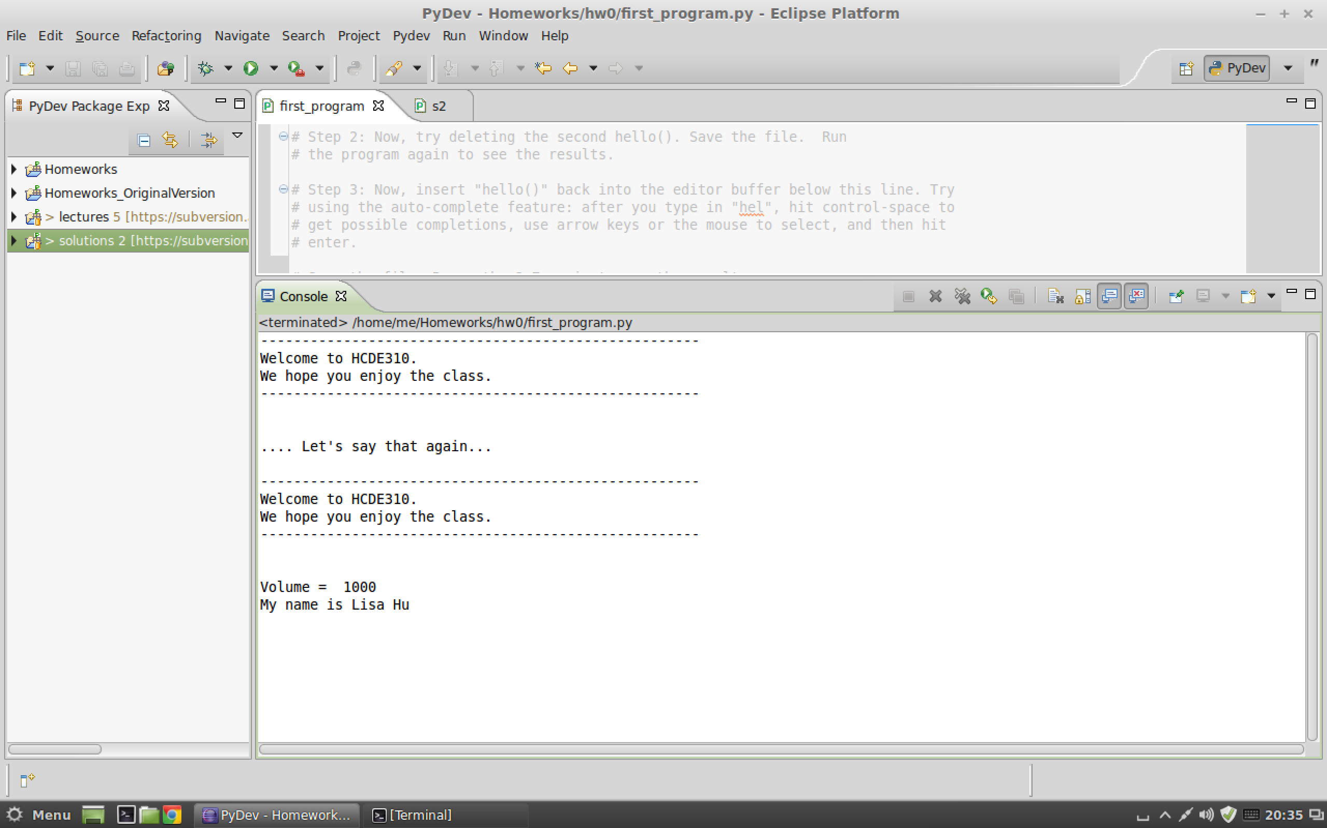

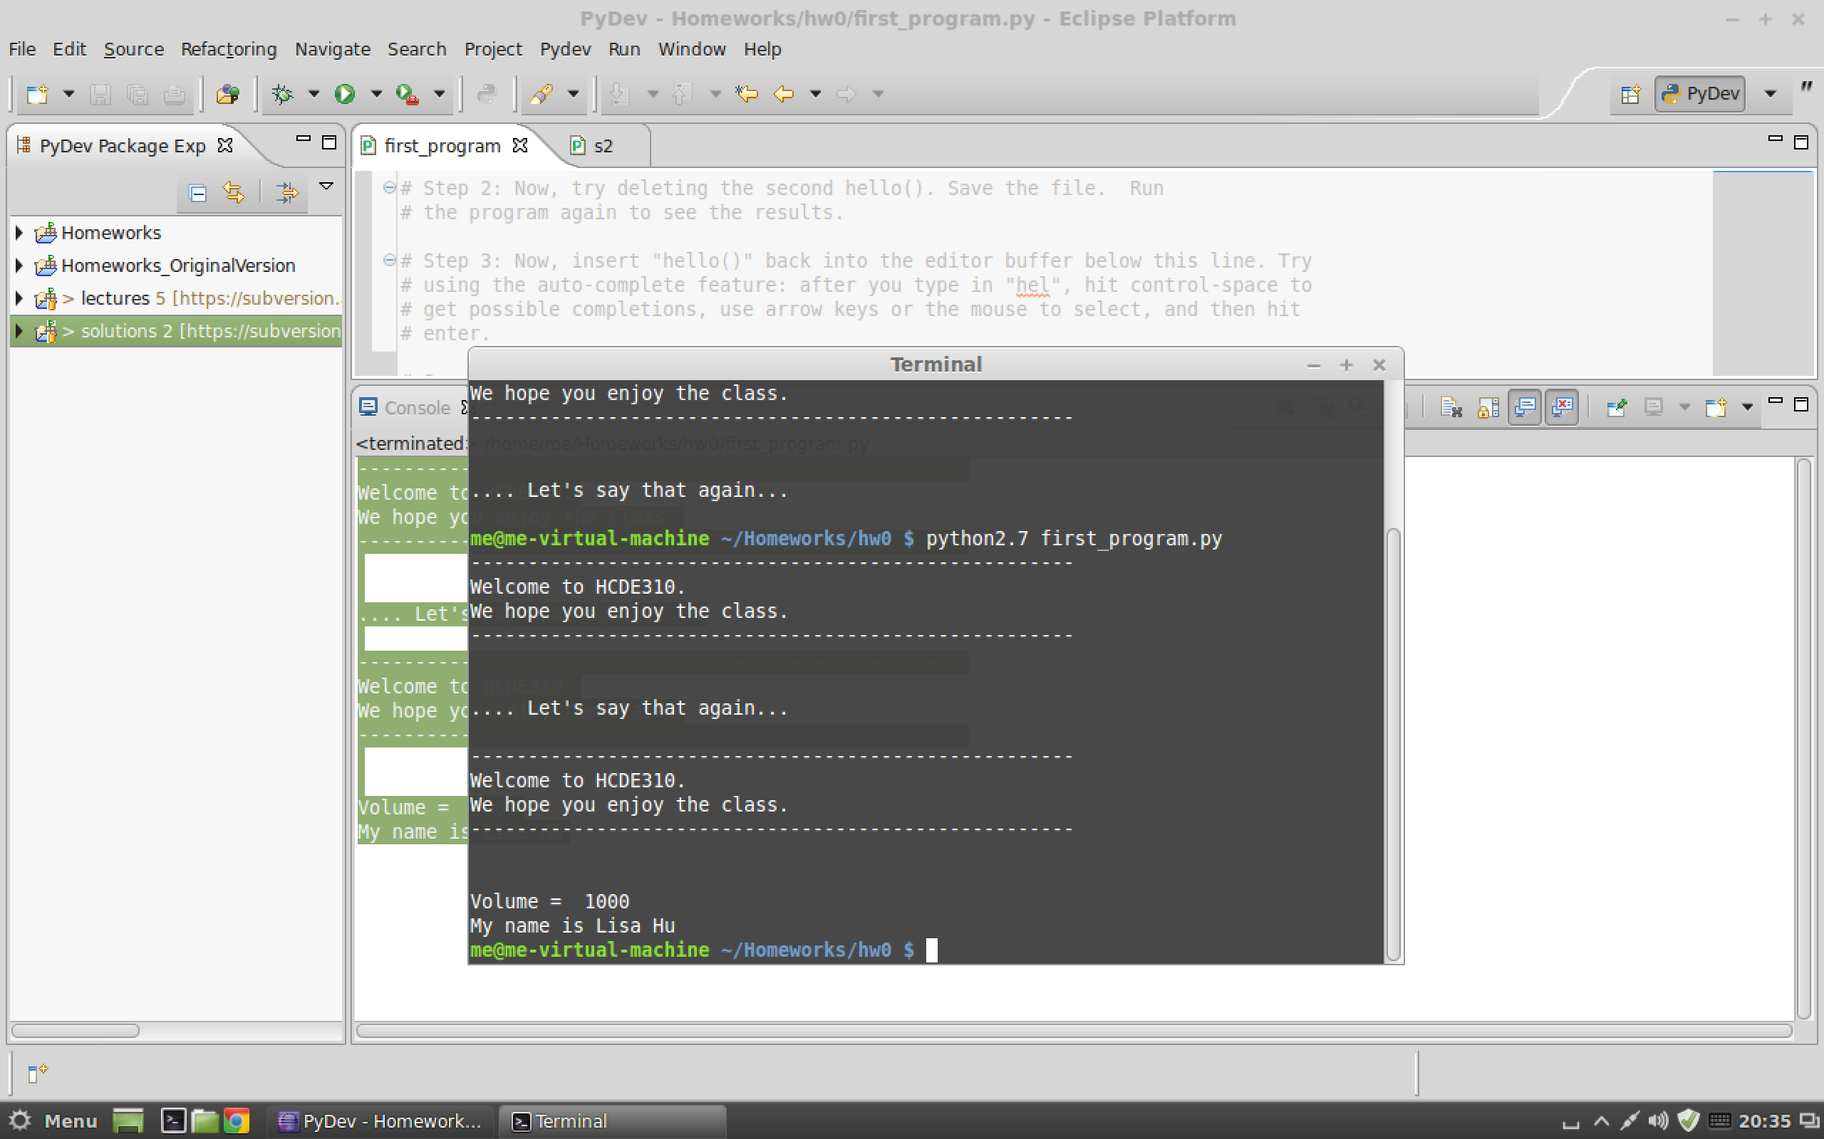

b) Lecture two updated.

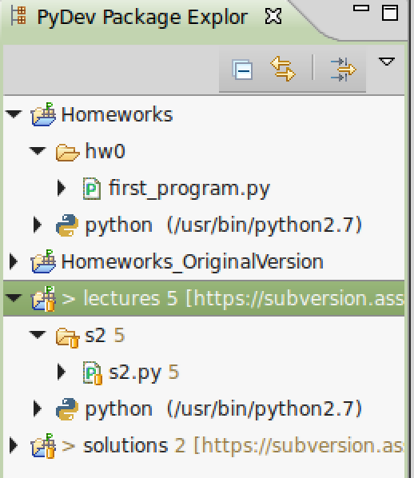

c) Two texts I wrote for Part 8 and Part 9

Part 8: When you open a document, start from the top left, end when there is nothing left. Word is everything from the first character (could be letter or number) to the space count, and that counts as one. Total word counts would be adding up all the words.

Part9: I think the previous task is not easy. I need to explain common sense, for example what a word is, where do you start to count, what does total count mean. But it is a good way to prepare us writing code, because computer does not know anything apart from what we put into! We needs to define and control every step, be clear and concise.