Architecture and Sizing of System for Remote Control of Renewable Energy Sources Powered Station for Electric Vehicles Charging

Jovan Vujasinović
School of Electrical Engineering
University of Belgrade
Belgrade, Serbia
jovan.vujasinovic@vfholding.rs

Goran Savić
School of Electrical Engineering
University of Belgrade
Belgrade, Serbia
gsavic@etf.rs

Željko V. Despotović
Institute Mihailo Pupin
University of Belgrade
Belgrade, Serbia zeljko.despotovic@pupin.rs

Abstract— In this paper, architecture of system for remote control of renewable energy sources powered station for electric vehicles charging is presented. Sizes and combinations of various components (renewable sources, batteries, chargers etc.) for different purposes (households, existing petrol stations replacements and large parking slots in shopping malls, public garages etc.) are also considered. This system allows integration of many different functionalities which contribute to more efficient utilization of several different subsystems: subsystem for remote control of electric vehicle chargers, subsystem for remote control of smart storage batteries, subsystem for remote control of smart electricity meters and subsystem for remote control of cash registers. This way, stations for electric vehicles charging, powered by renewable energy sources, become more accessible to users of electric vehicles. This contributes to increasing the usage of electric vehicles powered by energy from renewable sources, which decreases the level of air pollution, as well as, the negative effects related to that.
Keywords— electric vehicle chargers, renewable energy sources, remote control system

Introduction
Obtaining energy from renewable sources (hydroelectric power plants, wind power plants, photovoltaic power plants, solar-thermal power plants) is becoming increasingly important due to the growing problems associated with air pollution. One of the biggest causes of air pollution is the significantly increased emission of carbon dioxide into the atmosphere, which is the result of intensive use and combustion of fossil fuels. The only solution that can reduce the emission of harmful gases into the atmosphere is the use of renewable energy sources. In this regard, the governments of many countries have committed themselves to reducing carbon dioxide emissions into the atmosphere in the coming years and decades, by reducing the use of fossil fuels. In parallel with this process, in order to meet the still growing energy needs, the share of energy obtained from renewable sources will increase. The prices of components that are an integral part of power plants for some of the renewable energy sources are falling due to increasing investments in the development of technologies for their production. Thus, the price of kilowatt-hours of electricity produced from renewable energy sources is becoming increasingly competitive with the price of kilowatt-hours of electricity obtained from power plants that use fossil fuels.
Air pollution, especially harmful PM particles, which are, among other things, the product of combustion of gasoline and diesel cars, is an increasing challenge and problem due to the enormous increase in the number of cars produced and used in the world. It is estimated that in some of the most populous countries in the world, whose economies are also among the fastest growing, the number of sold cars will increase almost tenfold by 2030 compared to 2016. For example, in 2016, about 21 million vehicles were sold in India, while the number of vehicles sold in 2030 is expected to reach around 200 million [1]. Increased air pollution, especially in countries with high economic growth rates (e.g. in China and India), leads to increased health problems of the population, as well as to an increase in the number of deaths caused by pollution.
The solution to the described problems is primarily reflected in the increase in the use of renewable energy sources, and the increased volume of use of electric vehicles, for which electricity would be produced from renewable sources. In other words, the use of electric vehicles that would be supplied with electricity from renewable sources of powered chargers, would enable a significant reduction in air pollution. Therefore, there is a need to manage renewable sources powered by charging stations for electric vehicles.
This paper will describe the architecture of the remote control system for a charging station for electric vehicles, which is powered by renewable energy sources. Section II will present the architecture of the system, section III will describe the subsystems, section IV will present the types of chargers, renewable sources and batteries, section V will define the categories of stations, section VI will shown the sizing of the residential station, and section VII will present a conclusion with a brief overview of the main results presented in the paper. Regarding the existing solutions of such a system, it is worth noting that mostly similar energy management systems can be found in industrial and commercial consumers [2], i.e. smart buildings [3]. Such systems typically include chargers for electric vehicles, smart meters, and renewable energy sources followed by smart batteries and the development of power-saving algorithms [3]. Some initial research results, presented in this paper, have been described in [4].

System Architecture
Fig. 1 shows a block diagram of the architecture of a system for remote control of a station for electric vehicles charging, which is powered from renewable energy sources.
The terminal for remote control of the electric vehicle charging station, which is powered from renewable energy sources, as a key part of the system, has the possibility of communication with electric vehicle chargers, smart battery for energy storage, smart meter and fiscal cash registers. All these parts of the system are physically located in the charging station for electric vehicles. In this way, such a terminal combines in one device all the functions of otherwise special terminals (devices), i.e. terminals for remote control of electric vehicle chargers, terminals for remote control of smart batteries, terminals for remote control of smart meters and terminals for remote control of fiscal cash registers. On the other hand, the mentioned terminal, through the appropriate connection to the Internet, has the ability to transfer stored data obtained from these peripheral parts of the system (electric vehicle chargers, smart batteries for energy storage, smart meters and cash registers), as well as their monitoring and settings, which creates preconditions for further processing of this information.
This data is also accessed by platforms such as the platform for users of electric vehicle chargers (through which users of electric vehicle chargers, i.e. owners of electric vehicles, receive all relevant information about electric vehicle chargers) and the platform for electricity trade (which enables electricity trade, available in the system). In addition, the mentioned data are available to the information system of the electricity distribution system operator, the information system of the Tax Administration, as well as to the owner of the charging station for electric vehicles.
This enables electricity suppliers, utilities, control bodies, service providers and industrial and commercial consumers (= energy producers + consumers), i.e. campus and facility managers to procure huge amounts of data and process them using state-of-the-art analytics and artificial intelligence technology. Derived information and intelligence can be used to enable innovative smart energy services, achieve various savings and more efficiently start the energy system, as well as more efficient use of the distribution network, including early detection of irregularities and preventive repairs to minimize or prevent outages [2].
Communication between the terminal on the one hand and the mentioned platforms and information systems on the other hand takes place via the built-in ETHERNET port (if the facility already has an internet connection) or via the built-in GSM/GPRS/3G/4G/5G communication modem. The protocol at the basic level is TCP/IP, while at the higher level there are mostly specific non-standardized protocols, implemented for each platform, i.e. information system separately.
Communication between the terminal on the one hand and each of the peripheral parts of the system on the other hand takes place via a suitable communication port, which can be RS232, RS485 and the like. Eventually, some of the wireless technologies can be used for this purpose: Zigbee, Lora, etc. For each device, the protocol is different, mostly non-standardized specific protocol, defined by the specific manufacturer of each special device. Smart meters generally use a standardized DLMS/COSEM protocol.

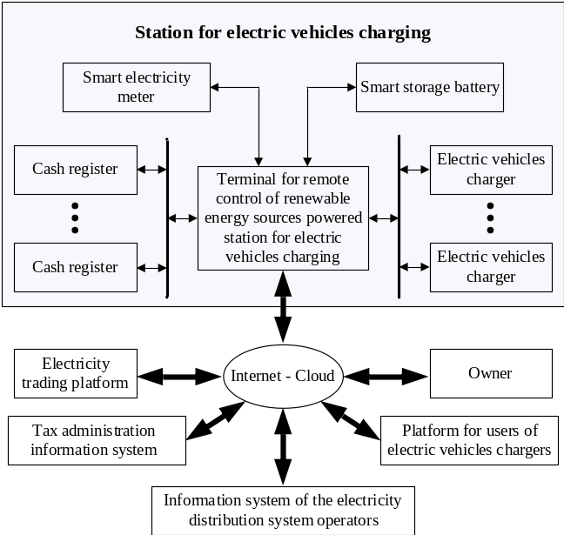
Fig. 1. Block diagram of the architecture of a system for remote control of a station for electric vehicles charging, which is powered by renewable energy sources.

Description of Subsystems
The remote control system of the electric vehicle charging station, which is powered by renewable energy sources, consists of four subsystems, namely: the subsystem for remote control of electric vehicle chargers, the subsystem for remote control of smart batteries, the subsystem for remote control of smart meters and optional subsystem for remote control of fiscal cash registers.

The subsystem for remote control of electric vehicles chargers
This subsystem [5] consists of three basic components: electric vehicle chargers, a terminal for remote control of electric vehicle chargers and a platform for electric vehicle charger users. Electric vehicles chargers receive electricity from a smart battery in which energy obtained from renewable sources is stored, and if necessary additionally from the electricity distribution network. The terminal for remote control of electric vehicle chargers receives data on currently available power, charging programs and prices from electric vehicle chargers, which it forwards to the platform for electric vehicle charger users via the internet, making them available to end consumers (ie electric vehicle charger users). With the help of appropriate software algorithms and with the appropriate communication of electric vehicle charging stations and platforms for electric vehicle charger users, this subsystem provides correction of electricity prices that can be purchased at different locations where electric vehicle charging stations are located. For example, in this way, it is possible to reduce the price of electricity at those stations where more power is available at a given moment (in order to motivate customers to supply their vehicles with electricity at those stations), while at the same time the price of electricity may increase at those stations where less power is available at a given time (thus discouraging customers from supplying their vehicles with electricity at those stations). In this way, the consumption of available energy is practically managed in an optimal way. In a separate subsystem for remote control of electric vehicle chargers, such decisions are made and implemented by the owner of the charger, while in the system for renewable sources powered station for electric vehicles chargers, making and implementing such decisions, using state-of-the-art analytics and artificial intelligence technologies can be transferred to a unified terminal that has access to all devices (smart meter, smart battery, cash registers, electric vehicle chargers) and/or appropriate information systems and software platforms.

The subsystem for remote control of smart batteries
This subsystem [6] consists of three basic components: smart batteries for energy storage, terminals for remote control of smart batteries and a platform for electricity trading. Smart batteries for electricity storage receive energy from renewable sources (from hydroelectric power plants, wind power plants, photovoltaic power plants, solar thermal power plants, etc.). The terminal for remote control of smart batteries has information on the available electricity reserves in the smart batteries at all times, and forwards this information to the electricity trading platform. In this way, owners of charging stations for electric vehicles, which at a given time have a shortage of available energy, can buy it from electricity producers (obtained from renewable sources) who at that time have a surplus of available energy. Likewise, owners of charging stations for electric vehicles, who currently have a surplus of available energy, can sell it to consumers of electricity who have a shortage of available energy at that time. Also, since the purchased energy can be stored in smart batteries for energy storage, owners of charging stations for electric vehicles can at any time buy surplus energy from electricity producers (obtained from renewable sources) who have this surplus (at reasonable prices, which are a consequence of increased supply of produced electricity from renewable sources at that time), to be sold at higher prices at intervals when there is a shortage of energy in the system (which are a consequence of reduced supply of electricity at times when there is a shortage of produced energy in the system). The terminal for remote control of smart batteries is in charge of managing the process of charging smart batteries after the purchase of electricity obtained from renewable sources.

The subsystem for remote control of smart meters
This subsystem [7] consists of three basic components: smart meters, remote control terminal for smart meters and information system of the electricity distribution system operator. Smart meters have the ability to measure active and reactive energy, register the average maximum power with a programmable period of determination of that power, the ability to measure the quality of electricity and display the appropriate data on the display. Smart meters support a flexible tariff policy, ensure the integrity of metering and have the ability to read and adjust even in the de-energized state. The meters record the profiles of the corresponding measured quantities and the event logs. They also have the possibility of power limitation, as well as remote switching on and off of consumers. The terminal for remote control of smart meters realizes communication with smart meters with the aim of collecting data from meters, configuring meters, setting meter parameters and managing consumption. On the other hand, the terminal also communicates with the information system of the electricity distribution system operator, which performs the functions of administration of components of the subsystem for remote control of smart meters, data collection and archiving functions, smart meter settings and report creation functions (with status analysis, electricity quality, on communication performance, etc.).

The subsystem for remote control of fiscal cash registers
This subsystem [8] consists of three basic components: fiscal cash registers, terminals for remote management of fiscal cash registers and information system of the Tax Administration. Fiscal cash registers have the ability to receive commands from the cashier via the keyboard with visual monitoring of data on recorded transactions, as well as the ability to remember data in operational and fiscal memory and print data on the fiscal account. Fiscal cash registers group, summarize and present data on the realized recorded turnover and the realized advertised turnover by tax rates, by articles and by cashiers. They also have the ability to download all relevant data in electronic form via the appropriate input-output port. Fiscal cash registers also meet the appropriate security criteria (protection of changes in program and fiscal memory, deletion of counters, etc.). The terminal for remote control of fiscal cash registers enables remote reading and management of fiscal cash registers by the taxpayer, for users who want to efficiently and economically read the desired information from any number of their remote cash registers, as well as update their operating parameters, article databases and prices, without disrupting the sales process. The terminal enables the programming of the fiscal cash register with data on article structures and data on article prices. The terminal downloads data from the fiscal cash register, as follows: data on current turnover, data on daily turnover by articles, data on daily turnover by cashiers, data on daily report and data on the content of fiscal memory. Based on the data thus obtained, the terminal forms appropriate reports which it transmits to the information system of the Tax Administration. The information system of the Tax Administration takes over the following types of data from the terminal for remote control of fiscal cash registers: reports on transactions at tax rates for a given period, data on reset and specifications of tax rates. Advanced functionalities involve the generation of various useful reports, using the fact that all relevant data on taxpayers exist in one place in a relational database. The Tax Administration monitors all transactions through its information system, ensuring timely tax collection.

Types of chargers, renewable sources and batteries
Electric vehicle chargers supply electricity to vehicles in the form of alternating current (AC) or direct current (DC) supply voltage. In the vehicle itself, this energy is converted in a controlled manner into the most suitable form for charging the battery. In general, we can divide the chargers into 3 different power levels [9], but again, there are many different ways of performing in each level.
- Level 1 denotes single-phase (AC/DC) chargers, which are mainly used in households, i.e. for residential users. In Europe, these chargers are usually around 3kW, and deliver maximum currents of 13A to 16A at a maximum voltage of 240V AC. In North America, their power is about 1.9kW, and they typically supply currents up to 16A at a voltage of 120V AC.
- Level 2 represents single-phase or three-phase chargers (AC/DC), which are mainly used by industrial users and in public places, and less often in households. These chargers typically have a power of about 20kW, and deliver maximum currents of up to 80A at a voltage of 208-240V AC.
- Level 3 refers to direct current chargers, which are mainly used for fast charging in public places, especially in public places accessible when traveling. The powers of these chargers go up to 240kW, and deliver maximum currents up to 400A at a maximum voltage of 600V DC. Voltages and currents vary with different values from charger to charger.
Renewable energy sources convert energy created from natural resources, which are naturally renewable, into electricity suitable for further use. They are obtained from solar energy, wind energy, hydropower and biomass and biofuel energy. Given the different availability of these sources at different times of the day and year, the best system is one that combines different types of renewable sources, which uses the so-called. hybrid configuration of renewable sources [10]. For the needs of electric vehicles charging stations, the following sources can be combined or used:
- Photovoltaic panels - are the primary source of power for charging stations for electric vehicles, because the possibility of their application is greatest. They convert solar energy into electricity, which is further used to power the chargers and/or batteries of the station. If enough energy is collected during the day from the Sun, the power supply of the whole station can be covered only by that source. The panels are constantly evolving and getting better and better characteristics every day. Today, usually a standard panel measuring 1m x 1.7m, or 1.7m², has a nominal power of about 370W, and gives a DC voltage of about 40V at the point of maximum power.
- Wind turbines - are a secondary power source for charging stations for electric vehicles. Electricity is produced on the basis of wind energy and can be used in areas where there is enough wind for their application to be economically viable. Therefore, the possibility of their application in different geographical areas is significantly lower compared to photovoltaic panels. On the other hand, the advantage over photovoltaic panels is that it can generate energy even at night. Also, on a daily basis there is compatibility with solar energy which is reflected in the fact that when the solar irradiations are low there is usually wind and vice versa. Their strength mostly depends on their dimensions. They are made in different ranges, and wind turbines from a couple of kW to a couple of MW can be found on the market. Bigger and bigger generators are developing every day, so today there are also 5MW generators.
- Biomass-based generators - are a backup power source for charging stations for electric vehicles. They convert biomass energy into electricity. It can be applied in any geographical area, if there are spatial capacities. These sources are only used to replace other sources during the night or during periods of adverse weather conditions when there is not enough energy obtained from the sun or wind. Biodiesel generators can also be used for this application
Batteries are used to store electricity. Basic battery units are made with a nominal voltage of 12V. On the market you can find basic battery units with a capacity of up to 300Ah and maximum discharge currents up to 150A. Higher voltages are achieved by connecting several basic battery units in parallel, which of course increases the capacity of such obtained battery. If there is a need only to increase the capacity, this is achieved by regularly connecting the basic battery units. In addition to batteries, fuel cells can also be used for the purpose of storing electricity. There are hydrogen and ammonia fuel cells. In the case of a hydrogen cell, in the process of charging, the obtained electricity is used to separate hydrogen from the water. The hydrogen thus obtained is placed in a special tank. In the process of discharge, electricity is obtained from the chemical reaction of combining hydrogen and oxygen. Great hope for the future is placed in this technology. For now, the biggest problem in the application is the storage of hydrogen, considering that it is very explosive in a mixture with air. The principle of operation of ammonia fuel cells is similar, except that ammonia is used instead of hydrogen. In this case, there are certain storage problems, since ammonia and its compounds are toxic.

Cattegories of stations
Based on the needs and size of electric vehicles charging stations, we can classify them into three categories - residential, commercial and industrial.
Residential stations are intended for home use only for household needs. Within this station it is expected that there are 1-2 chargers for electric vehicles. Options that meet the needs of one household are: one level 1 charger, one level 2 charger, two level 1 chargers and the maximum option with one level 1 charger and one level 2 charger, which is shown in Fig. 2. The needs of such stations can be covered by using photovoltaic panels only.
Commercial stations are small and medium stations for charging electric vehicles that have a high frequency of vehicle charging. These are usually stations intended for the sale of electricity to owners of electric vehicles, such as medium-sized stations that will eventually replace existing gas stations with 10-20 chargers, smaller stations in households with 1-2 chargers for this purpose, as well as stations in smaller parking lots with up to 20 chargers. Also, this group includes stations at smaller road carriers, etc. At these stations, it makes sense to use level 2 and 3 chargers. In some places, it may make sense to use a smaller number of level 1 chargers (smaller parking lots in front of hotels, motels and carriers). The needs of such stations cannot be covered by using only photovoltaic panels. Where the geographical area allows, it makes sense to use a wind generator. It is possible to use biomass-based generators, if the spatial capacities allow it, which may first be the case in rural areas. In urban areas, in many places the only way to make up for missing electricity is to take energy from the electricity distribution network.
Industrial stations are large charging stations for electric vehicles intended to serve a fleet of electric vehicles of a few hundred pieces. This group of stations includes stations at electric vehicle manufacturers, at big road carriers, in mass parking lots such as garages, shopping malls, etc. It makes sense to use all three groups of chargers and you need to determine the right measure of their mutual proportions. Similar to commercial stations, the needs of such stations cannot be covered by using only photovoltaic panels, and often the only way to compensate for the missing electricity is to take it from the electricity distribution network.
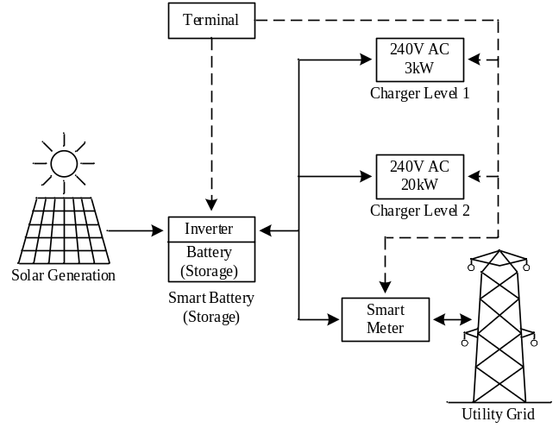
Fig. 2. Residential station for electric vehicles charging.

Sizing of the residential stations
In the paper that gives an overview of the situation in the field of home energy management systems [11], it can be seen that there are groups of papers dealing with computing trends and components [12], communication technologies [13] and residential demand response programs and load scheduling techniques [14]. In contrast, this chapter presents the sizing of the home energy management system, that is the sizing of the residential charging station for electric vehicles, which is powered by renewable electricity sources.
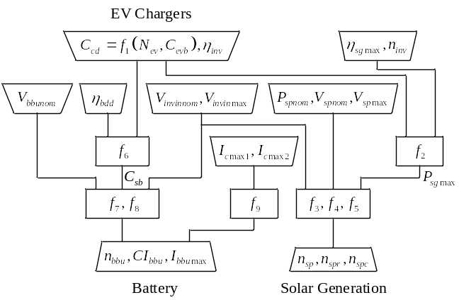
Fig. 3. Sizing of stations for electric vehicles charging – flowchart.
The general flowchart of sizing of stations for electric vehicles charging is shown in Fig. 3. As the residential station is intended only for the needs of that household, we will start from the assumption that during one day there should be energy for charging two passenger cars (N_{ev}=2). The usual capacity of a passenger car battery (C_{evb}) is 24 kWh, and level 1 charger (I_{cmax1}=16 A) takes 7.8 hours to charge up to 80% of its capacity, while a level 2 charger (I_{cmax2}=80 A) takes 1.2 hours. This means that for the maximum option of a residential station (Figure 2), that is a station with one level 1 charger and one level 2 charger, both of which are able to charge a passenger car once a day, 48kWh of electricity is required per day (C_{cd}). If we want such a station to have enough electricity from its own production, that is to be independent of the electricity network (hereinafter: autonomous residential station), it is necessary for its solar power plant to be able to produce energy worth 48kWh per day.
The power provided by a solar power plant varies during the day depending on the strength of the Sun, and rarely exceeds 80% of the maximum power for which the panels are dimensioned. Empirical results show that the energy obtained from a solar power plant on a daily basis in the summer period can be determined as the energy that this solar power plant would give in five hours of operation at maximum power (η_{sgmax}). Therefore, we can conclude that an autonomous residential station should have a solar power plant with a maximum power of 9.6kW in the event that we do not have any losses. However, as losses occur during energy conversion and storage, we need to take this into account and predict total losses (losses in energy conversion plus losses in cables and connections) of about 14%. If the energy from the panel went directly to the chargers, the losses would typically be around 7% to 8% (η_{inv}=0,92-0,93) because there would only be conversion of the DC voltage of the panel to AC voltage of the charger. However, as the station usually operates in a two-energy conversion mode (n_{inv}=2), then losses of 14% to 15% should be predicted. One energy conversion is the conversion and storage of energy from the panel into batteries during the day, and the other conversion is the conversion of DC battery voltage into AC charger voltage during the night. This means that a solar power plant with a maximum power of 11.1kW (P_{sgmax}) should be realistically designed. Such a solar power plant requires 30 (n_{sp}) solar panels with a nominal power of 370W (P_{spnom}). To accommodate these panels requires an area of 51m², which practically on a typical house with a base of 10m x 10m, can fit on one half of the roof, and of course best on south, southeast side for greater efficiency.
The smart battery consists of an inverter and a battery. Smart battery management involves optimizing the operation of the inverter and the associated batteries. Regarding the choice of inverter required for the operation of a solar power plant, empirical results show that it is best to choose an inverter whose maximum power is equal to 80% of the maximum power for which the panels are dimensioned. This system works reliably, since the panels in operation do not exceed this power level. The advantage of this choice of inverter is that its initial voltage is lower, so the inverter will be able to work even at a lower intensity of sunlight, and thus the efficiency of the solar power plant will be higher. The nominal or mean value of the inverter input voltage (V_{invinnom}) is usually about 300V DC (typically the starting voltage (V_{invinmin}) is 100V DC and the maximum it can withstand (V_{invinmax}) is 500V DC) to generate single phase AC voltage or typically about 600V (starting 200V DC and maximum 1000V DC) DC to generate three-phase AC voltage. As the nominal voltage of the solar panel (V_{spnom}) is usually 24 V, and the maximum (V_{spmax}) is 36 V, in this case 15 (n_{spr}) panels should be connected in series, and then the other panels should be added in parallel, thus forming a total of two columns (n_{spc}). The inverter operates at lower voltages, but has the best performance when operating at nominal voltage. This DC voltage and the energy obtained from the panel, the inverter converts either into alternating voltage of 240V AC for direct power supply of the charger, or into direct voltage of 300V DC for charging the batteries. These are the two possible basic modes of operation of the inverter. In addition to them, there is a third basic operating mode, in which the inverter converts the DC voltage and energy obtained from the batteries into a nominal voltage of 240V AC for direct power to the charger. The inverter can also operate in combined operating modes, which are a combination of basic operating modes. For example, one combined mode of operation is when the inverter uses the energy obtained from the panel to power both the charger and the battery. The inverter also has the ability to automatically adjust the operating mode depending on the environmental conditions, but also to receive an external command in which operating mode to operate. In this case, the inverter receives these commands from the terminal. The batteries are connected to give a voltage of 300V DC, because the inverter has the best performance and the lowest losses when operating at nominal voltage. The inverter should be able to provide a maximum current of up to 96A, due to the situation in which both chargers are switched on.
The capacity of the batteries should be determined so that they can store the complete daily electricity production of the solar power plant of the autonomous residential station. This is because energy is only collected during the day while there is sunlight, and household cars are usually charged at night while car owners are asleep and do not need to use them. So, ideally, we need to design a battery that can store 48kWh. However, we need to increase this value due to losses of 7% to 8%, which occur when converting energy from the battery to the charger. Also, as the battery should never be discharged below 20% of its capacity, that is above the discharge depth of 80% (η_{bdd}=0,8), it is necessary to provide a battery that can nominally store about 65kWh (C_{sb}). In order to achieve a voltage of 300V, it is necessary to connect 25 basic battery units (n_{bbu}) of 12V (V_{bbunom}) in a row. In that case, each of these battery units should have a current capacity of 260Ah (CI_{bbu}). The maximum discharge current of the batteries should be not less than 96A (I_{bbumax}). The typical dimensions of a lithium-ion battery unit 12V, 260Ah are 0.520m x 0.268m x 0.220m, which means that the household needs to determine a space of about 0.77m³ for the installation of overall batteries.
The solar power plant with inverter and battery designed in this way also covers the needs of an autonomous residential station with two level 1 chargers, with the only difference that the inverter and battery do not have to support a maximum current of 96A, but are enough to give a maximum current of 32A. For the needs of an autonomous residential station with one level 1 charger, a solar power plant with twice the lower capacity and a maximum current of 16A is sufficient. For the needs of an autonomous residential station with one level 2 charger, a solar power plant with twice the lower capacity but with a maximum current of 80A.
In this analysis, the most standard work of a residential station on a daily basis is considered. Of course, there may be deviations from this type of station operation, such as the following situations: in one day there were more or less than two charges of electric vehicles, in one day there was less or more solar energy, etc. These are all situations when there is a shortage or surplus of produced electricity in an autonomous residential station. For these reasons, it is good for the station to be connected to the electricity distribution network, so that all shortages of electricity can be taken from it, just as all surpluses can be handed over to it.

Conclusion
In this paper, the architecture of the system for remote control of electric vehicles charging station, which is powered by renewable energy sources, is presented. An overview of chargers, renewable sources and batteries is given. Electric vehicle charging stations are classified into three categories: residential, commercial and industrial. The sizing of the residential station for charging electric vehicles has been done, and it has been shown that with today's state of technology, it can be realized and very easily fit into the framework of an average household. It is expected that the implementation of electric vehicles charging stations will require the construction of one type of terminal for remote control of such stations, which will combine the functionalities of the current four separate types of terminals for remote control of: electric vehicle chargers, or fiscal cash registers, or smart electricity meters or management of smart batteries. It makes sense in further work to consider extending the functionality of such a terminal to the management of home devices. Also, in further work, special attention should be paid to the sizing of commercial and industrial stations.

References
- “India | International Council on Clean Transportation.” [Online]. [Accessed 2017 Oct 31]. Available from: http://www.theicct.org/india
- http://icentic.com/smart-energy/
- M.A.Hannan, M. Faisal, Pin Jern Ker, Looe Hui Mun, K. Parvin, T.M.I. Mahlia, F. Blaabjerg, “A Review of Internet of Energy Based Building Energy Management Systems: Issues and Recommendations”; IEEE Access, 1-1. Doi:10.1109/acess.2018.2852811
- J. Vujasinovic, G. Savic, i Z. Djurisic, “Arhitecture of system for remote controle of the renewable energy sources powered station for electric vehicles charging”, 64th Conference on Electronics, Telecommunications, Computing, Automation and Nuclear Engineering (ETRAN), Belgrade, Serbia, September 2020.
- Saadullah Khan, Aqueel Ahmad, Furkan Ahmad, Mahdi Shafaati Shemami, Mohammad Saad Alam, Siddiq Khateeb; “A Comprehensive Review on Solar Powered Electric Vehicle Charging System”; Smart Science; 2308-0477, 2017.
- https://sonnengroup.com/sonnenbatterie/
- Slavoljub Marjanovic, Jovan Vujasinovic, Goran Savic, Sasa Manojlovic, Branislav Ninkovic, Petar Medjedovic; “System for electric power remote reading and load management“; VI Advising the Bosnia and Herzegovina Committee CIGRE, Neum; Bosnia and Herzegovina, November 2003.
- Jovan Vujasinovic; “Terminal for remote reading and management of fiscal cash registers”; master’s thesis, Faculty of electrical engineering, University of Belgrade, Serbia, 2013.
- https://www.mpoweruk.com/infrastructure.htm
- Abdulla Al Wahedi, Yusuf Bicer, „Development o fan off-grid electrical vehicle charging station hybridized with renewables including battery cooling system and multiple energy storage units“; Elsevier; 2352-4847, 2020.
- Usman Zafar, Sertac Bayhan, Antonio Sanfilippo, „Home energy management system concepts, configurations, and technologies for the smart grid“, IEEE Access, 10.1109/ACCESS.2020.3005244
- Jovan Vujasinovic, Goran Savic, Milan Prokin; „Terminal for Remote Control of Renewable Energy Sources Powered Station for Electric Vehicles Charging“, 10th Mediterranean Conference on Emedded Computing, June 2021, Budva, Montenegro
- P. Arunkumar and K. Vijith, "IOT Enabled Smart Charging Stations for Electric Vehicle", International Journal of Pure and Applied Mathematics, vol. 119, no. 7, pp. 247-252, 2018.
- Jovan Vujasinovic, Goran Savic; „Demand Side Management and Integration of a Renewable Sources Powered Station for Electric Vehicle Charging into a Smart Grid“, 15. International Conference on Applied and Theoretical Electricity ICATE, May 2021, Craiova, Romania

