Demand Side Management and Integration of a Renewable Sources Powered Station for Electric Vehicle Charging into a Smart Grid

Jovan Vujasinović
University of Belgrade – School of Electrical Engineering
Belgrade, Serbia
jovan.vujasinovic@vfholding.rs
Goran Savić
University of Belgrade – School of Electrical Engineering
Belgrade, Serbia
gsavic@etf.rs

Abstract—This paper describes the demand side management of a renewable sources powered station for electric vehicles charging. The integration of the station into the smart grid is also considered. The architecture of the remote control system of the mentioned station is described. A general analysis of how electricity demand can be managed is given. It is also shown how demand management is applied at the charging station for electric vehicles. A controller based on fuzzy logic was then proposed. In this sensitive process of microgrid integration into a smart grid, what is important from the point of view of a smart grid and what is important from the point of view of the owner of a microgrid is analyzed.
Keywords— Demand side management, renewable energy sources, electric vehicles, smart grid

Introduction
The electricity demand varies significantly not only on a seasonal level, but also on a daily basis. In order to match the volume of electricity production with electricity demand, it is necessary to increase or decrease electricity production according to the increase or decrease in demand [1], which implies the inclusion of additional electricity sources in the system (for example renewable energy sources or energy which is stored in batteries). The inclusion of additional sources of electricity in the system, just to cover periods of increased electricity demand can cause instability of the electricity system, certainly leads to increased costs, and there are still significant prospects to not fully meet electricity demand [2]. Also, if the increase in electricity production is achieved by including additional sources of electricity such as thermal power plants, it leads to increased emissions of carbon dioxide into the atmosphere, which results in the intensification of unwanted climate change. For these reasons, there is a need for demand side management.
Demand side management includes a variety of activities related to electricity consumption. These activities [3] include controlling and modifying the way energy is used (for example increasing energy efficiency, saving electricity, storing excess of electrical energy), as well as controlling and modifying behaviors that affect electricity demand (e.g. adoption of appropriate laws and regulations, education, promotion and encouragement of the reduction of electricity demand in the periods when it is the highest, promotion and encouragement of the increase of the demand for electricity in the periods when it is the lowest).
Energy crises have had the greatest impact on the occurrence of demand side management. The first major energy crisis occurred in 1973 as a result of the Arab-Israeli War. At that time, the price of crude oil quadrupled, which led to a recession in Western economies. That situation developed awareness of the need for energy management for the first time and the first considerations for demand side management began. As a result, the first legal acts related to this topic were adopted in the United States. The second energy crisis occurred in 1979, when the Iranian revolution, and a year later the outbreak of the Iraq-Iran war, led to a significant drop in crude oil production, which resulted in an almost threefold increase in the price of crude oil. The Gulf War in 1990 also had a significant impact on the crude oil market. In order to deal with the consequences of energy crises, the United States adopted the Energy Policy Act in 1992, which emphasized the importance of increasing energy efficiency, saving and storing energy, using renewable energy sources, as well as the importance of energy management. Finally, following the 2001 electricity crisis in California, demand side management has become an imperative, and has been attracting increasing attention ever since. The importance of these techniques is further highlighted with the mass use of renewable energy sources and the increasing use of electric vehicles. Therefore, there is a need for demand side management at electric vehicle charging stations, especially if they are powered by renewable energy sources.

System for Remote Control of Renewable Sources Powered Station for Electric Vehicle Charging
Block diagram of the architecture of the system for remote control of renewable energy sources powered station for electric vehicles charging [4] is shown in Fig. 1. The system consists of a terminal for remote control of station for electric vehicles charging, which is connected by communication channels (indicated by dashed lines in the figure) to electric vehicle charger, smart battery for energy storage, smart electricity meter, fiscal cash register (located into charging station facility) and renewable energy sources. On the other hand, the terminal is connected to the cloud via the internet, which enables setting, monitoring, storage and processing of data obtained from electric vehicle chargers, smart storage batteries, smart electricity meters, fiscal cash registers and renewable electricity sources.

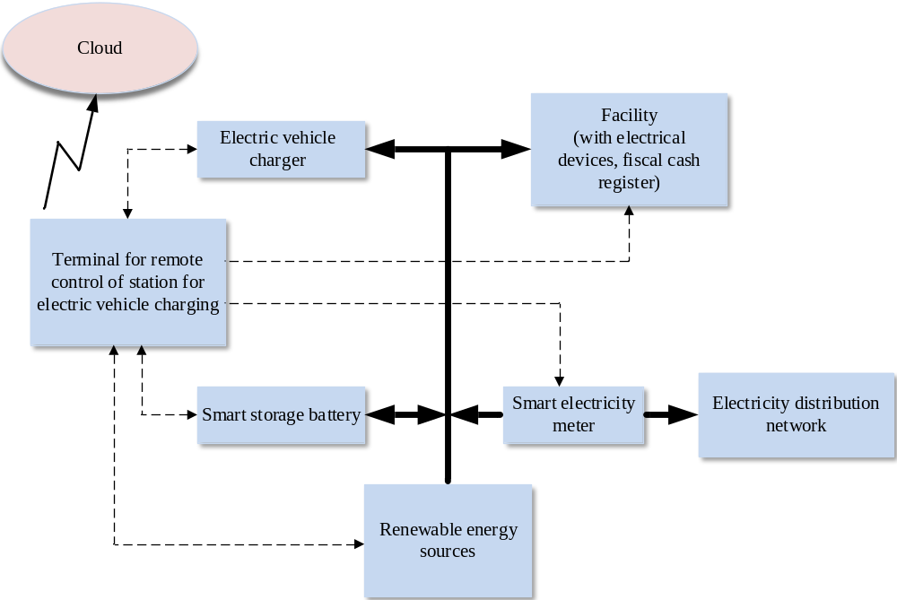
- Block diagram of the architecture of the system for remote control of renewable energy sources powered station for electric vehicle charging.

In this system, renewable energy sources via power lines (marked by solid lines in the figure) provide electricity for electric vehicle chargers, for a smart battery for energy storage, as well as for devices (including a fiscal cash register) in a facility which is part of electric vehicle charging station. Excess electricity produced by renewable energy sources is forwarded to the electricity distribution network. On the other hand, in time intervals when there is a shortage of electricity produced by renewable energy sources in the system, the required energy is provided from the electricity distribution network. The energy which this system receives or transmits to the electricity distribution network is measured by the smart electricity meter.
The system allows the provision of innovative smart energy services, savings, more efficient use of the electricity distribution network, promotion of efficient market operations, fast exchange of information on electricity production and demand, more rational and transparent transactions, improvement of electricity pricing mechanism. This system contributes to more efficient electrical energy demand management by increasing the reliability and stability of the power system and alleviating congestion in electricity demand.

General Analysis and Demand Response
Customers can generally be divided into three categories: residential, commercial and industrial customers [1]. Residential customers have the most complex demand model because they are the most numerous and mutually diverse with different habits and different home appliances. Industrial customers are large consumers of electricity, especially if they are at high voltage, and have significant peak loads. Changing the demand model for these customers is a great challenge given the confidentiality of information about the devices and machines used, and the often time-sensitive production processes. Commercial customers have a fairly typical and identical demand model, because their main loads are heating, ventilation and air conditioning systems and lighting systems. Changing the way these systems are used is relatively easy because they can be controlled according to pre-set parameters and because the influence of external factors (temperature, humidity, etc.) on their operation is predictable. Among these three categories of customers, demand management programs are easiest to implement with commercial and industrial customers. Their demand is much higher, the devices and control systems they use are much more advanced and are often equipped with backup generators, renewable energy sources and batteries.
Demand response means actions taken on the part of customers that, based on the pricing policy, affect the level and time of demand for electricity in a way that achieves the optimal way of electricity consumption for the customer, i.e. the best price-quality ratio (comfort). It is possible to define five types of actions: cutting the peaks, filling the valleys, shifting the load, strategic reduction and strategic increase.
Based on the operational characteristics, the loads at customers can be divided into two groups: according to the delays in the use of electricity and according to the adjustability of the total electricity consumption. In the first group, deferred and non-deferred loads can be defined, while in the second group, adjustable and non-adjustable loads can be defined. Deferred loads can be stopped, restarted or transferred to other time slots (boilers, dishwashers, laundry, etc.), and as such are suitable for demand response programs, i.e. for the application of load shifting action. With the appropriate pricing policy and monetary incentives, these loads can be transferred from peak to non-peak hours and thus, reduce the peak load in the electricity network. Non-deferrred loads do not withstand time shifts or interruptions, that is they must complete their schedule at a specific time (lighting, heating and air conditioning systems, etc.), and as such are not suitable for demand response programs. For adjustable loads, consumption can be reduced to a lower level or increased to a higher level (heating, air conditioning systems, etc.), and as such are suitable for demand response programs, that is for carrying out actions cutting the peaks and filling the valleys. With appropriate pricing policy and monetary incentives, these adjustable loads can be used to reduce or increase the peak load, provided that care is taken not to disturb customer comfort. In contrast, with non-adjustable loads, electricity consumption is fixed (computers, televisions, etc.), and as such are not suitable for demand response programs. In addition to the above, it is possible to implement a program of demand response, that is strategic reduction actions, by choosing energy-efficient devices (changing incandescent bulbs, switching to better energy-class devices, etc.). Furthermore, the implementation of the strategic increase action can be achieved by introducing additional devices, such as electric vehicles, batteries, etc.
In terms of the approach to demand that electricity suppliers take towards their customers, there are a number of motivational methods that encourage customers to implement demand response programs. This is defined by the appropriate service packages offered to customers, which can be classified into two groups: time packages, that is time-based demand responses, and incentive packages, that is incentive-based demand responses. Most often, time packages are suitable for residential customers, while incentive packages are more applicable for commercial and industrial customers. In the case of incentive packages, the pricing policy is determined in such a way as to encourage the appropriate behavior of the customer, on the basis of which he achieves appropriate monetary savings. Changes in customer behavior are voluntary, although disincentives for certain situations can be envisaged. There are five types of incentive packages: direct package, service package, bidding package, system capacity package and ancillary services package. With the direct package, the supplier completely remotely controls some devices at the customer's disposal (e.g., water heater, air conditioner, etc.), and by switching them on / off they can regulate the power system, while the customer in turn achieves appropriate monetary savings. The service package is similar to the direct package, with the difference that the supplier cannot freely and independently reduce / increase consumption at the customer, but in case of his need sends requests to the customer, and the customer responds to them in accordance with his capabilities. For customers whose processes are not strictly controlled and time-dependent (e.g., cement plants), the direct package is more applicable. The service package is applicable to customers where the process must be carried out very precisely (e.g., chemical industry). In the bidding package, instead of waiting for a request from the supplier, the customer enters the electricity market himself and, in accordance with his capabilities, bids for appropriate reductions in electricity consumption. Customers, who have contracted a system capacity package, are obliged to reduce their consumption when the system does not have enough capacity, according to the announcement one day in advance by the supplier. The package of ancillary services is similar to the bidding package, with the difference that the price is not auctioned, but is determined according to the current price on the stock exchange. For some suppliers, a bidding package, a system capacity package, and an ancillary services package may be combined. Therefore, we can define an active incentive package that represents the application of either only one of these packages, or a combination of two of the three packages or a combination of all three listed packages. In the case of time packages, the pricing policy is determined in such a way that it mostly depends on the time in which consumption is realized. There are four types of time packages: flat rate package, tariff package, maxi graph package and active package. If a flat rate package is applied, the price is the same all the time, so the savings can only be achieved by reducing the total electricity consumption. In the tariff package, time tariffs are introduced, that is different prices for different time periods of the day or week, and savings can be achieved by moving consumption to time periods when the price of electricity is lower. The maxi graph package is derived from the tariff package, by additionally charging the appropriate amount depending on the maximum power achieved in the billing period. With the active package, the price changes from hour to hour, mainly in accordance with the changes in the electricity exchange, and the application of this method requires intensive communication between the customer and the supplier.

Demand Side Management at the Station
For ease of understanding, this chapter performs an analysis for a mode in which the station only takes energy from the smart grid. Then, in the fifth chapter, the integration of the station into the smart grid is considered, taking into account the mode of operation in which the station delivers energy to the smart grid. A charging station for electric vehicles powered by renewable energy sources can be classified as commercial customers. In cases when the frequency of charging electric vehicles at the station is not high and when renewable sources provide a lot, that is enough electricity, the station acts as a small commercial customer. On the other hand, in cases when the frequency of charging electric vehicles at the station is high, that is when renewable sources provide little or insufficient electricity, the station can act as a large commercial customer.
In terms of load, the station has both deferred and non-deferred loads, and adjustable and non-adjustable loads. In the building of the station, the non-deferred loads are the lighting system, heating, ventilation and air conditioning system, fiscal cash register, computers, terminal, etc., while the deferred loads are the boiler, washing machines, etc. Also, in the building of the station, adjustable loads are the heating, ventilation and air conditioning system, etc., while non-adjustable loads are the lighting system, fiscal cash register, computer, terminal, etc. Seen outside the building of the station, the smart battery is a deferred load, as well as an adjustable load, whereby the charging and discharging modes must be taken into account, so as not to significantly reduce the battery life. Also, chargers for electric vehicles can be adjustable and deferred loads, taking care not to jeopardize the service and courtesy towards the users of the station, that is the owners of electric vehicles. With the consent of the owners of electric vehicles, it is possible to change the charging programs to slower and faster, thus reducing or increasing the consumption of electricity. Also, with the help of the platform for users of electric vehicle chargers, it is possible to attract or reject owners of electric vehicles in the desired time intervals, and thus increase or decrease electricity consumption, all in accordance with the current situation in the electricity system, that is, in the electricity market.
At the station, it is possible to realize all five types of actions in the demand response program. Strategic reduction is achieved by choosing energy-efficient devices and systems, which are installed in the station during the construction itself, and possibly renewed later if necessary. In terms of strategic increase, in addition to the station being equipped with a battery that can be used for these purposes, the station can significantly realize this type of action with the help of a large number of electric vehicles available to it, of course with smart policy towards their owners. Battery and electric vehicles, that is the policy pursued towards their owners, are also key to the realization of the remaining types of actions in the demand response program: cutting the peaks, filling the valleys and shifting the load. In addition, other adjustable and deferred loads listed in the previous paragraph may be used to perform these actions.
In terms of choosing the optimal service package for the owner of a renewable energy sources powered station for electric vehicles charging, given the wide range of adjustable and deferred loads, as well as the possibility of inserting energy into the electricity system, from an economic point of view most benefits can be achieved with active package. This package provides the most space for exploiting the stated potentials of the station in terms of the implementation of the demand response program, while requiring active engagement, i.e. management on the station side. This can be done by the owner or the appropriate manager of the station, or the system, that is the terminal by applying artificial intelligence techniques.

Integration of the Station into the Smart Grid
A renewable energy sources powered station for electric vehicles charging is a microgrid, which must be integrated, that is connected in an appropriate way to the electricity distribution network, that is the smart grid. When integrating any microgrid into a smart grid, it is necessary to do so taking into account two very important factors. First, it is necessary to do it in the best possible way from the point of view of maintaining the stability of the electric power system. Secondly, from the point of view of the owner of the microgrid, it is important that the integration is done in the best possible way in terms of the economic interest of the owner, that is the maximum realization of economic benefits for the owner. Therefore, it is necessary to take these two factors into account when integrating the renewable energy sources powered station for electric vehicles charging into the smart grid. It is to be expected that decisions that meet these conditions largely coincide. Namely, the interest of the owner is that the energy produced in the microgrid is delivered to the smart grid when the price of electricity is high, as well as to be taken from the smart grid at times when the price of electricity is low. On the other hand, as the law of supply and demand prevails in the smart grid, and from the point of view of maintaining electricity stability, in situations when the price of electricity is high, it means that there is a lack of energy in the system and it is desirable that at that time as many microgrids as possible starts to deliver energy to the smart grid. Also, if the price of electricity is low, at that moment there is a surplus of energy in the system and it is desirable that as many microgrids as possible starts to take energy from the smart grid. Achieving these goals requires proper management within the station itself. As the battery and chargers for electric vehicles are the most important loads in the station, it is necessary to have a decision at all times what to do with such loads. Also, as the price of electricity is variable, it is necessary to have a decision at all times about what to do with the produced electricity. The decision depends on the current price of electricity, the current state of charge of the battery, the number of vehicles present at the station at that time and of course the forecasts of appropriate meteorological conditions at the station which are important for the production of renewable energy sources. Thus, in solar sources, the input parameter is insolation, while in wind generators the wind speed is monitored. For such a complex control with many inputs, many outputs, where inputs and outputs are not precisely defined, measurable and predictable and where there is no precisely defined function of output-input dependence, it is convenient to use fuzzy logic controller [5]. Of course, there are other ways to implement control, however control based on fuzzy logic can deal with uncertainties in the system through the application of appropriate IF-THEN rules, eliminating the need to define a precise mathematical model. This is especially important for such complex systems, where it is practically impossible to determine a precise mathematical model. Variable loads, variable consumption and variable price of electricity are the main reasons for the application of fuzzy logic controllers in such a system. It should be emphasized that such a controller is fast, that is that it can work in real time. Also, it is solidly resistant to data inaccuracies. The IF-THEN rules based on which the controller makes decisions can be easily changed, which is also another advantage in the application.

Fuzzy Controller
This chapter presents a fuzzy controller for controlling a station that produces electricity from solar panels and wind turbines, and has a battery and the ability to delay charging electric vehicles, as well as the ability to take electricity from electric vehicles (so-called V2G - vehicle to grid concept). It is a controller that should optimize the consumption, production and storage of electricity. It can be used for real-time control based on real data at a given time to determine the operation of the station in the next hour. It can also be used to make operational plans for the next day based on the prediction of future data on the price of electricity on the market, its production and the load of the station in terms of the number of vehicles. The inputs on the basis of which this controller makes decisions, that is determines the state of the output, are: the price of electricity, insulation, wind speed, the state of charge of the battery and the number of vehicles in the station. The outputs from the controller are control of the energy produced and control of the vehicle energy. All inputs and outputs are assigned the appropriate fuzzy membership function. This process is called fuzzification. Fuzzification changes the input signals so that it further represents them with only a few values, which enables simple and correct application of the IF-THEN rule. Each membership function is assigned to a specific set of values.
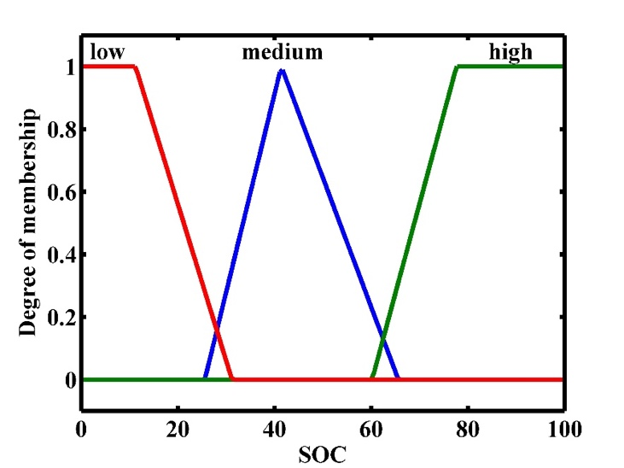
- Membership function for state of charge (SOC) of battery.
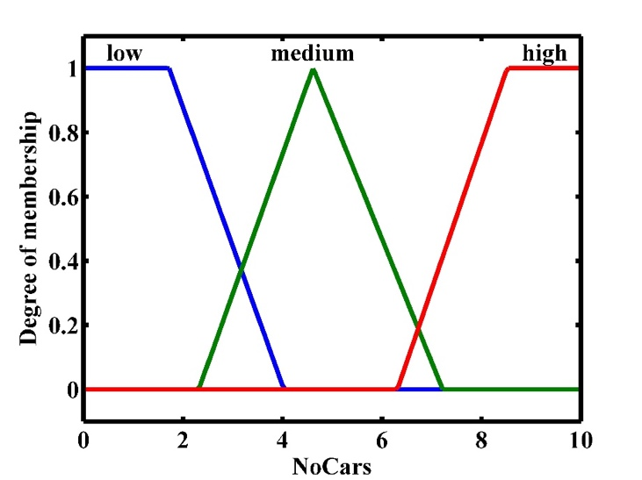
- Membership function for electric vehicle (EV) numbers.
The price of electricity is represented by four membership functions, while all other inputs are represented with three membership functions. The membership functions are related to attributes that determine: low, medium and high values of the observed input. The fourth membership function is "the highest". Fig. 2 and Fig. 3 show examples of fuzzification of the battery charge status and the number of vehicles. The battery charge status below 20% is assigned the membership function "low". The membership function “high” is assigned to the battery charge state over 80%, while the membership function “medium” represents all battery charge states between 20% and 80%. All other input signals are fuzzified in a similar way.
Two system outputs define how to control energy production and car energy. The first output ProducedEnergy refers to the energy produced with membership functions which are indicating the attributes in different ranges of numbers:
- store energy (values from the range [0, 1]),
- charge electric vehicle (EV) ([1, 2]) and
- sell energy to the distribution network ([2, 3]).
The second output CarEnergy refers to decisions for owner of EV cars:
- charge EV (values from the range [0, 1]),
- shift charging ([1, 2]) and
- sell energy from battery of EV ([2, 3]).
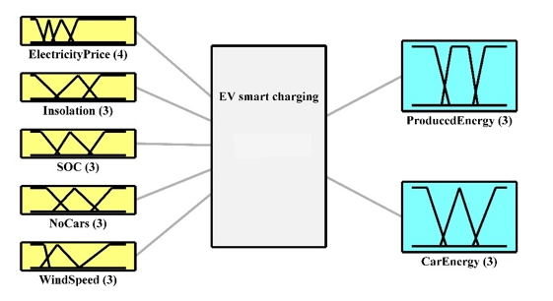
- Fuzzy controller.
Fuzzification of outputs is done in accordance with the mentioned ranges. The whole fuzzy expert system with inputs and outputs is presented in Fig. 4.
In addition to defining the fuzzification process, it is necessary to define expert rules on the basis of which the outputs are assigned the appropriate values according to the appropriate combination of values of the input signals. The general form of a simple rule is: if <condition> then <consequence>.
Complex rules also can be defined, and they consist of many simple rules, in which case the logical determinants "and", "or" and "not" are used. These rules are defined on the basis of expert knowledge and of course depend on the set goals. In this case, a renewable electricity sources powered station for electric vehicles charging, the key goals set by the station owner are maximum profit and satisfaction of the station user. For maximum profit, it is necessary to ensure the sale of produced electricity at the highest possible price, either by delivery to the smart grid, or by charging electric vehicles with the highest possible intermediary profit in energy trade between the smart grid and electric vehicle owners. At least one rule must be defined, and further rules can be added, changed, etc. An example of a rule is:
„If (Electricity price is high) and (Insolation is high) and (Wind speed is high) and (state of charge SOC is high) and (NoCars is low) then (ProducedEnergy is sell energy to the distribution network), (CarEnergy = shift charging) “.
By applying the system, over time, a validated set of rules can be obtained that give the best result. Then it may be possible to define the appropriate mathematical model, that is a precise definition of the function of the dependence of the output on the input. Such a process is called aggregation.
The last step in the management process based on fuzzy logic is defuzzification. This procedure transforms the values obtained by applying fuzzy logic into signals that further represent the outputs and trigger the appropriate actions. For example, if it is concluded that the produced electricity should be stored, the output of ProducedEnergy after defuzzification must have a value between 0 and 1. If it is concluded that the produced electricity should be sold to the distribution network, the output of ProducedEnergy after defuzzification must have a value between 2 and 3. If the energy produced is to be used to charge electric cars, the output of ProducedEnergy after defuzzification must have a value between 2 and 3. This signal further controls a switch that performs the desired action. Fig. 5 shows the described algorithm for implementing fuzzy logic. There are other ways to implement management of the station [6].
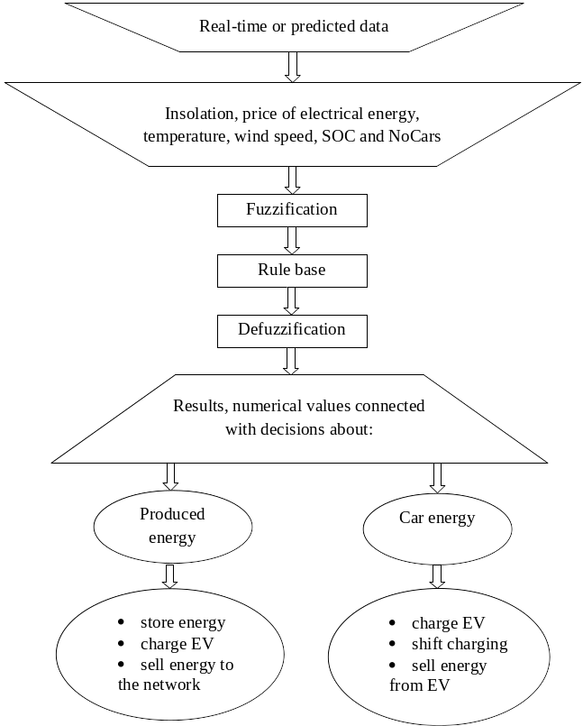
- Algorithm of fuzzy logic implementation.
What can certainly improve the results of the controller is the application of artificial intelligence methods, especially in the prediction of the values of input parameters [7].

Conclusion
The analysis of demand, first in general, and then specifically applied to the station for charging electric vehicles, has determined that the station can be classified in the commercial sector, and that it can be both a small and a large commercial customer. It has been also determined that the station has both deferred and adjustable loads, that the most important of such loads are the battery and chargers for electric vehicles, and that the station can apply appropriate demand response programs in order to optimize electricity consumption, that is savings on the side of customer (the owner of the station), and on the side of the electricity supplier (station supplier). To achieve the best results in this regard, it was first shown that for a mode in which the station only takes energy from the smart grid, it is crucial to define and implement an appropriate policy towards owners of electric vehicles in a way that does not jeopardize their comfort, but total number, maximum power and time of the vehicle charging adjust to the current situation in the power system. In connection with all this, it was concluded that at this station, at the moment, the active service package provides the most space for the implementation of demand response programs, that is enables the realization of the most economic benefits for the station owner. A controller based on fuzzy logic was then proposed. The management is realized in a way that does not jeopardize the electric power stability in the smart grid and achieves maximum benefits for the station owner. This controller has taken into account another possible mode of operation of the station, that is the mode in which the station delivers energy to the smart grid, and it also ensures that the station uses a smart battery, electric vehicles and/or renewable energy source to inject energy into the power system and to further contribute to maintaining its stability. Regarding the continuation of research, it makes sense in further work to approach first the simulation of such a system and then the practical implementation using the proposed fuzzy logic controller.

References
- D. Li, W.-Y. Chiu and H. Sun, “Demand side management in microgrid control systems”, Microgrid: Advanced Control Methods and Renewable Energy System Integration, pp. 203-230, Oct. 2016.
- V. Giordano, F. Ganga, G. Fulli, M.S. Jiménez, I. Onyeji, A. Colta, I. Papaioannou, A. Mengolini, C. Alecu, T. Ojala, et al., “Smart Grid Projects in Europe: Lessons, Learned and Current Developments,” Citeseer, 2011.
- M. Alizadeh, X. Li, Z. Wang, A. Scaglione, R. Melton, “Demand-side management in the smart grid: information processing for the power switch,” IEEE Signal Process. Mag. vol. 29, no. 5, pp. 55-67, 2012.
- Jovan Vujasinovic, Goran Savic, Aleksandar Rakic; „Demand Side Management in Renewable Energy Sources Powered Station for Electric Vehicles Charging“, 28. telecommunication forum TELFOR, November 2020, Belgrade, Serbia
- M. Žarković, G. Dobrić, "Fuzzy expert system for management of smart hybrid energy microgrid", J. Renewable Sustainable Energy 11, 034101 (2019), p. 03, May 2019, https://doi.org/10.1063/1.5097564
- Liang Luoa, Sarkew S. Abdulkareem, Alireza Rezvanid, Mohammad Reza Miveh, Sarminah Samad, Nahla Aljojo, Mehdi Pazhoohesh, “Optimal scheduling of a renewable based microgrid considering photovoltaic system and battery energy storage under uncertainty“, 2352-152X/ © 2020 Elsevier, https://doi.org/10.1016/j.est.2020.101306
- Luis Galván, Juan M. Navarro, Eduardo Galván, Juan M. Carrasco, Andrés Alcántara, “Optimal Scheduling of Energy Storage Using A New Priority-Based Smart Grid Control Method”, Energies 2019, 12, 579, doi:10.3390/en12040579

