Tries:

<https://www.youtube.com/watch?v=Xt2ouYSxWkw> implementation

[**https://www.youtube.com/watch?v=-urNrIAQnNo&t=11s**](https://www.youtube.com/watch?v=-urNrIAQnNo&t=11s) **-->Tries are used in autocomplete ,spell checking (very good video)**

ALL YOU NEED IS THE ABOVE VIDEO:

**Tries are used in autocomplete ,spell checking (very good video)**

**Instead of having right chile or right chid it has has :**

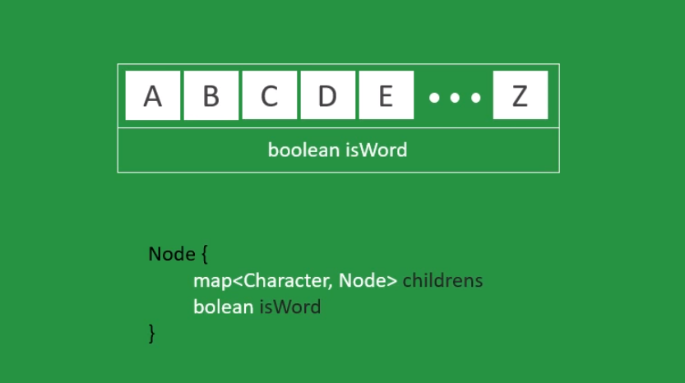

**This is how it works:**

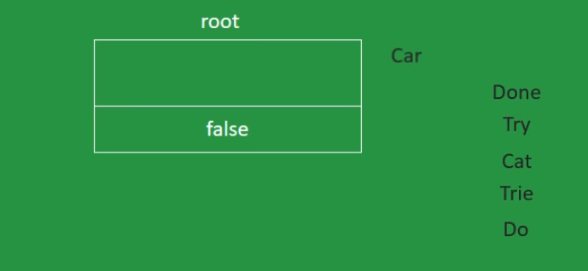

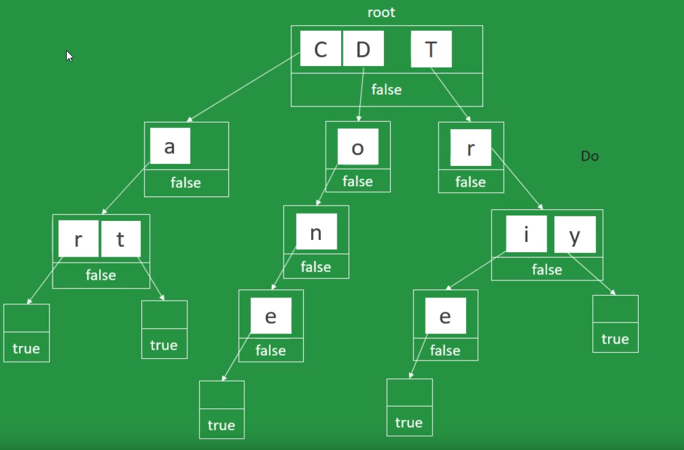

Tries is a type of tree that stores characters, a node represents a word or part of the word.

https://www.youtube.com/watch?v=vlYZb68kAY0

