15 January, 2022

**Ford C Programming Academy 2022**

**Progress Summary - Week 01**

During the first week of training, all students made significant strides in learning 'C' syntax, how to use Visual Studio effectively, and how to debug their code.

Most students scored 100% on the first exam, with an average score of 91%. There were no scores less than 70%.

All students were able to complete the group programming assignments, which included the following exercises:

**Temperature Converter**

Write a temperature converter that accepts input in either Celcius or Fahrenheit measurement system, and convert correctly to the other system, while dealing with the inherent differences in integer, single-precision FP, and double-precision FP values.

**Quadratic Formula**

Compute the real roots of the quadratic formula (if any), for various combinations of user-input coefficients. Uses math and I/O libraries, and conditional logic.

**Pointers and Pass by Reference semantics**

Change the case of characters in-place by accessing them through an address and referencing the ASCII/ISO character codes. Factor this into a function. This also deals with the differences in memory representation between char and int values.

**Animal Identifier**

Use selection statements and logical expressions to produce specific output depending on user answers to questions. Uses I/O library and conditional logic.

**Arrays and Loops**

Accept a list of floating-point numbers, place it in an array, calculate the average and display it with appropriate precision. Uses arrays, loops and I/O library.

All expressed great interest in the low-level representations of numbers, and because that is keenly relevant to MISRA (and AUTOSAR) safety recommendations, I indulged it. The week one student evaluations show that students generally approved of this approach.

We spent a lot more time in the debugger than I thought we would in the first week. We looked at a several in-memory representations that showed the effects of alignment, endianness, the size of types, and buffer overflows.

All in all, we covered an appropriate amount of material, but NOT in quite the order that I had originally anticipated. Attached (separately) is an updated copy of the original Course Outline, with the subjects we have covered highlighted in green. You'll notice that some topics from week two were actually covered in week one.

By the end of the first week, student were comfortable sharing their code with the rest of the group, and correcting/critiquing each others' solutions. Several brought examples of MATLAB output which we will examine in the next week or so.

My plan for Week 2 is to have the students continue to work together in small groups. Due to the holiday, this is a short week. We will finish up essential C syntax in the first two days, and will be working with command-line tools and git during the latter part of the week.

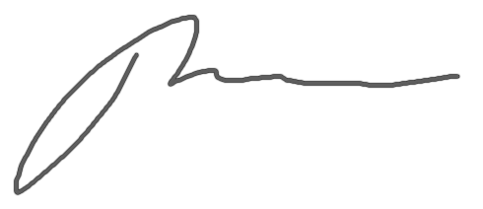

Paul Kimball

Instructor