FCPA 2022  
  
Embedded Systems

Student Workbook 15

January 28, 2022

Author

Paul Kimball  
Interface Associates

1. Embedded Systems

Keywords, anyone?

## C Language keywords

|  |  |  |  |
| --- | --- | --- | --- |
| auto | extern | short | while |
| break | float | signed | **_Alignas** |
| case | for | sizeof | **_Alignof** |
| char | goto | static | **_Atomic** |
| const | if | struct | _Bool |
| **continue** | **inline** | switch | _Complex |
| default | int | typedef | _Generic |
| do | long | union | _Imaginary |
| double | register | unsigned | **_Noreturn** |
| else | restrict | void | **_Static_assert** |
| enum | return | volatile | _Thread_local |

C Standard" Libraries

|  |  |  |  |
| --- | --- | --- | --- |
| **Header** | **Purpose of library** | **Since** | **Required in Freestanding** |
| <assert.h> | assert and static_assert (C11) macros | C89 |  |
| <complex.h> | Complex and imaginary numbers |  |  |
| <ctype.h> | Character handling | C89 |  |
| <errno.h> | Errors | C89 |  |
| <fenv.h> | Floating-point environment |  |  |
| **<float.h>** | **Characteristics of floating types** | **C89** | **yes** |
| <inttypes.h> | Format conversion of integer types |  |  |
| **<iso646.h>** | **Alternative spellings of logical and bitwise ops** |  | **yes** |
| **<limits.h>** | **Sizes and bounds of integer types** | **C89** | **yes** |
| <locale.h> | Localization | C89 |  |
| <math.h> | Mathematics | C89 |  |
| <setjmp.h> | Nonlocal jumps | C89 |  |
| <signal.h> | Signal handling | C89 |  |
| **<stdalign.h>** | **Alignment** |  | **yes** |
| **<stdarg.h>** | **Variable-length argument lists** | **C89** | **yes** |
| <stdatomic.h> | Atomics |  |  |
| **<stdbool.h>** | **Boolean type and values** |  | **yes** |
| **<stddef.h>** | **Common definitions** | **C89** | **yes** |
| **<stdint.h>** | **Integer types** |  | **yes** |
| <stdio.h> | File and console input/output | C89 |  |
| <stdlib.h> | General utilities | C89 |  |
| **<stdnoreturn.h>** | **noreturn** |  | **yes** |
| <string.h> | NULL-terminated strings | C89 |  |
| <tgmath.h> | Type-generic mathematics |  |  |
| <threads.h> | Threads |  |  |
| <time.h> | Date and Time | C89 |  |
| <uchar.h> | Unicode utilities |  |  |
| <wchar.h> | Multibyte/Wide character utilities |  |  |
| <wctype.h> | Wide character classification and mapping |  |  |

* May be included in any order
* May be included more than once
* Described in Chapter 7 and Annex B of Specification

Execution Environments

**C can be applied to either one**

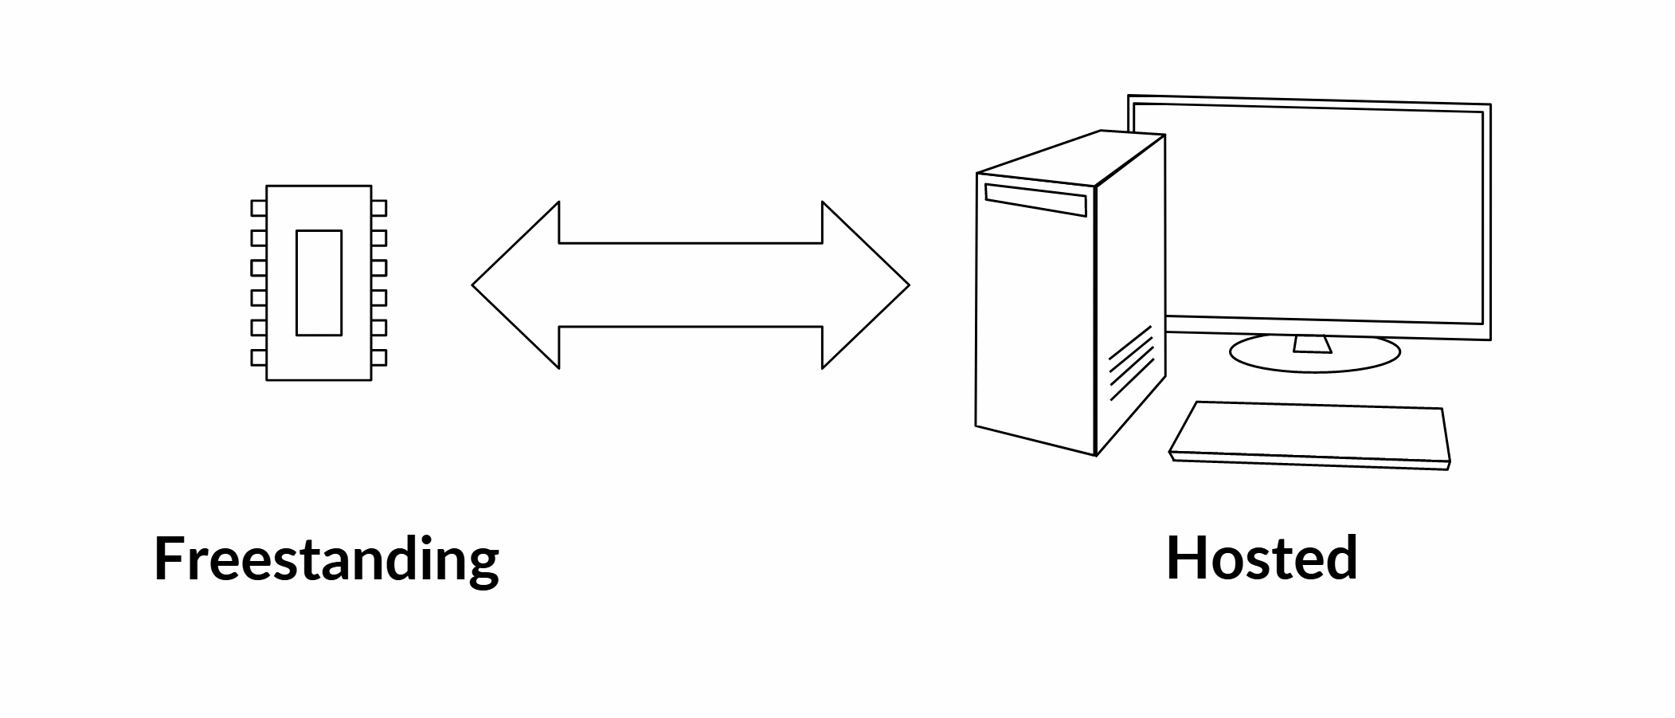

|  |  |
| --- | --- |
| Hardware resources  managed by program | Virtualized resources  managed by Operating System |
| Price / Performance | Portability |
| Precise control | Convenient programming |
| Single program | Multiple processes and threads |
| Limited, fixed amount of ROM, RAM | Expandable memory |
| Real address space | Virtual address space |
| Limited libraries | Full set of standard libraries |
| Privileged processor instructions | Privileged programs |
| Limited file system, or none | OS file system(s) |
| Hardware interrupts | Software interrupts |
| H/W specific data types | Application-specific data types |

* Note that "embedded" systems can be hosted *or* freestanding, depending on their complexity and needs

Automotive Semiconductors

* Very high price/performance ratios
* Highly reliable
* Extended temperature and vibration ranges
* Guaranteed support lifetimes (~25 years)
* May be built to spec by choosing desired features from a list
* Certified by AUTOSAR and other organizations

Data Sheets

* A Data Sheet describes the built-in features of a particular device (or family of devices)
* Let's Look at some Data Sheets!
  + A typical 8-bit processor used in automotive systems
  + A high-end 32-bit processor used in automotive systems