Student 1

China Mobile

**Company Profile**

China Mobile is the leading provider of mobile telecommunication services in China with a 70% share of the domestic market and a subscriber base of over 600 million people. With a market cap of about $200 billion, it is the largest mobile telecom company in the world. The Chinese government owns 74% of the company through its ownership of China Mobile (HK) Group Limited; the remaining 26% is publicly traded on the NYSE and Hong Kong Stock Exchange. The company has licenses from the Chinese government to operate nationwide 2G GSM and 3G TD-SCDMA services. The adoption of the new TD-SCDMA standard, which is only used in China, was announced by the government in 2006 to avoid patent fees for the use of 3G formats developed by Western countries; the license was assigned to China Mobile in 2009. The licenses for W-CDMA and CMDA2000 EVDO networks (Western 3G standards) were assigned to China Unicom and China Telecom, two smaller competitors that are also state-owned.

**Competitive Strengths**

**Largest mobile network and exclusive government license** - As a state-owned company with an exclusive network that covers 98% of the population (TD-SCDMA, the new standard assigned by the Chinese government), China Mobile is the dominant market leader. The company has the largest mobile customer base in the world and is still adding about 5 million new subscribers each month. The relatively untapped rural market is also dominated by China Mobile and holds potential for significant future growth. Now that 75% of the country’s 1.2 billion phone users are on mobile devices, we can expect a boost in wireless data usage to follow, and China Mobile is positioned to capture much of that growth.

**High-end user retention through superior voice coverage and quality** - The company has invested in maintaining a high quality network with a very low rate of dropped calls, which has allowed them to capture an estimated 90% of China’s high-end mobile users. This user base is critical since future revenue growth will largely be driven by mobile data usage on high-end smartphones. Though competitors have been able to compete on data speed, China Mobile is still the undisputed leader in voice service and coverage.

**Record of strong financial performance**- China Mobile has demonstrated strong financial performance in recent years, earning an ROE of about 20%, compared to about 7% and 3% for China Telecom and China Unicom, respectively. The company has also been able to reduce average operating expenses and SG&A expenses per user per month as it realizes benefits of scale. This should continue to benefit the company as it adds new users and expands its network coverage.

**Weaknesses**

**Inferior 3G Network Compared to Competitors** - TD-SCDMA is a new standard that is only used in China and is considered inferior to the 3G standards developed in the US and Europe. This has yet to become a significant issue because 70% of the data traffic carried in 2010 was still on the 2G network. However, the base of 3G users in China is growing rapidly, and user complaints about China Mobile’s slow download speeds (about 3-10x slower than China Unicom’s W-CDMA network) have intensified, threatening the company’s future share of the 3G market. Though China Mobile has a 70% share of the overall mobile market, it has only 44% of the 3G market.

**Incompatibility with Popular Hardware Manufacturers** - Another obstacle to high-end user retention is the lack of compatibility between popular high-end smartphones and China Mobile’s TD-SCDMA network. China Unicom, the only carrier in China that offers the iPhone with a contract (through its more common W-CDMA network), has been fiercely competing to lure high-end users away from China Mobile. In response, China Mobile has announced plans to purchase a set of new TD-SCDMA-compatible smartphones from international vendors (possibly HTC or Samsung) in the second half of 2011, but the new phones may not be enough to compete with the popularity of the iPhone and other well-known handsets.

**Margins Pressured by Infrastructure Spending** - EBITDA margins, though strong at about 46%, have been on the decline from historical levels of 50% or more. This trend is due to increasing infrastructure costs (leased lines, maintenance, personnel), and given the need for more improvements to the company’s young and problematic 3G network, we don’t expect margins to improve going forward. The increasing competition from China Unicom, in particular, will also likely pressure margins. We have already seen average revenue per user (ARPU) decline from last year.

**Revenue and Earnings Growth over 3 Years**

Analyst estimates are pricing in revenue growth of about 7-8% over the next 3 years and earnings growth of 3-5%. Due to the problems with China Mobile’s immature TD-SCDMA network, its dependence on 2G for revenues, and the lack of near-term growth drivers in the face of growing competition, we expect revenue and earnings growth to be on the lower side of those ranges. The company is a telecom giant that requires large capital investments in infrastructure in order to drive growth, but it will take at least 3 years for the more promising investments (4G networks) to pay off.

**Valuation – Hold**

China Mobile is not a growth company despite the rapidly growing market that it serves. It is a mature, defensive mega-cap name that has traded in a predictably steady range over the past 3 years. Like any large company, it is closely followed by a large number of analysts, and there have been no significant price catalysts in recent years.

We believe the stock is priced slightly below fair value. It trades at about 9x forward earnings, which is low compared to China Telecom (17x) and China Unicom (50x) but reflects expectations of mature growth rates and slightly declining EBITDA margins going forward.

We recommend a HOLD on the stock. In addition to the hefty dividend yield of 4-5%, we see limited downside risk from the current price and potential upside if competition from China Unicom is weaker than expected or 3G adoption is slower than expected.

**Figure 1**. CHL has significantly underperformed the Chinese index. The stock has only rebounded 27% from its October 2008 low during the crisis and remains 54% below its 2007 highs. The MSCI China Index, in contrast, is up 123% from its October 2008 low (and remains 24% below its 2007 high).

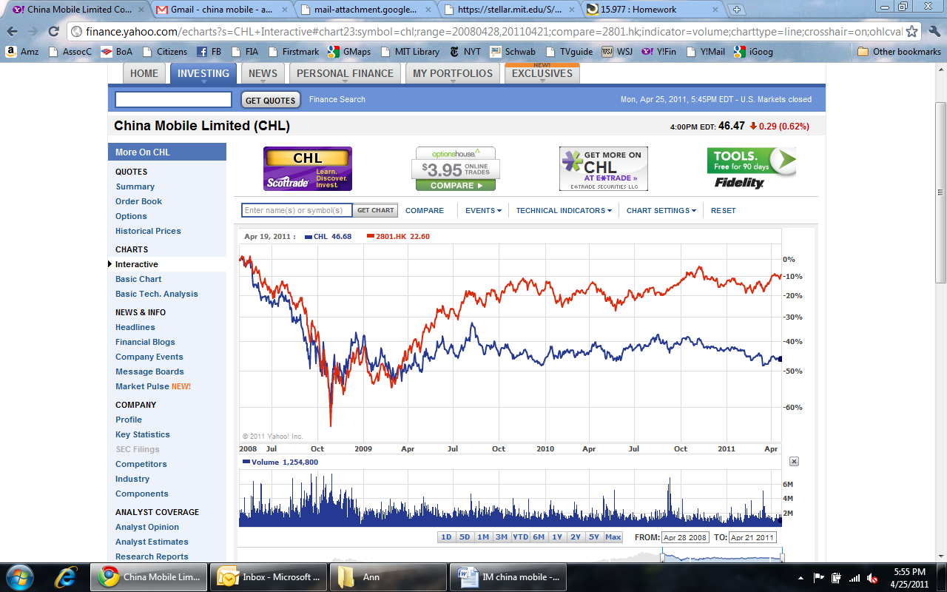

MSCI China Index

China Mobile

**Figure 2.** CHL has traded in a relatively narrow range over the past 3 years and is currently only 27% off of its financial crisis lows.

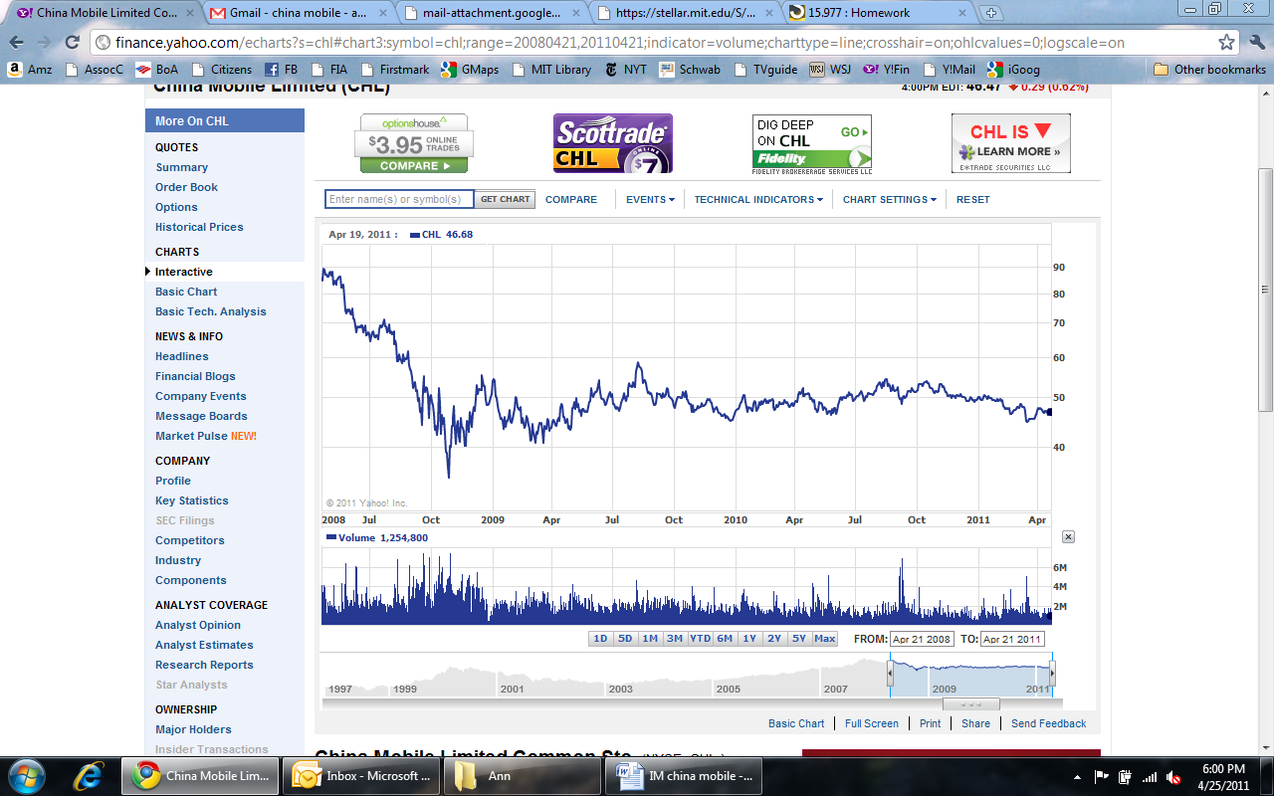

**Figure 3.** Competitor multiples and dividend yield

