**COMP 3150 Final Project**

**Hospital Management Database**

**Ryohei Takamorri, Nonika Reingold, Shieanne Bennett**

**Abstract**

The purpose of this project is to demonstrate an understanding of how to design and implement a functional and efficient database system. Using the requirements found in the project description document on the courses BrightSpace page, we designed and implemented a database to manage three hospitals staff and patients.

**Introduction**

This report gives the user an understanding of the design and functions available in the database. The hospital database management system is responsible for managing the data of three hospitals. It contains information on all admitted patients, doctors and nurses that work at each location, and the pharmacies that each hospital orders medication from. This database has five user views to give each user the necessary information relevant to the user and can be found in the “Users Views” section of this document. There are also sections containing the design diagrams and accompanying documents containing database schemas, source code, a video presentation, and database content.

**Database Design**

This database has been designed following the ER diagram seen in Fig.1 where we have six entities and six relationships.

*Fig. 1: ER Diagram for hospital database management system*

The following table shows a simplified schema for the database entities and relationships with all of their attributes.

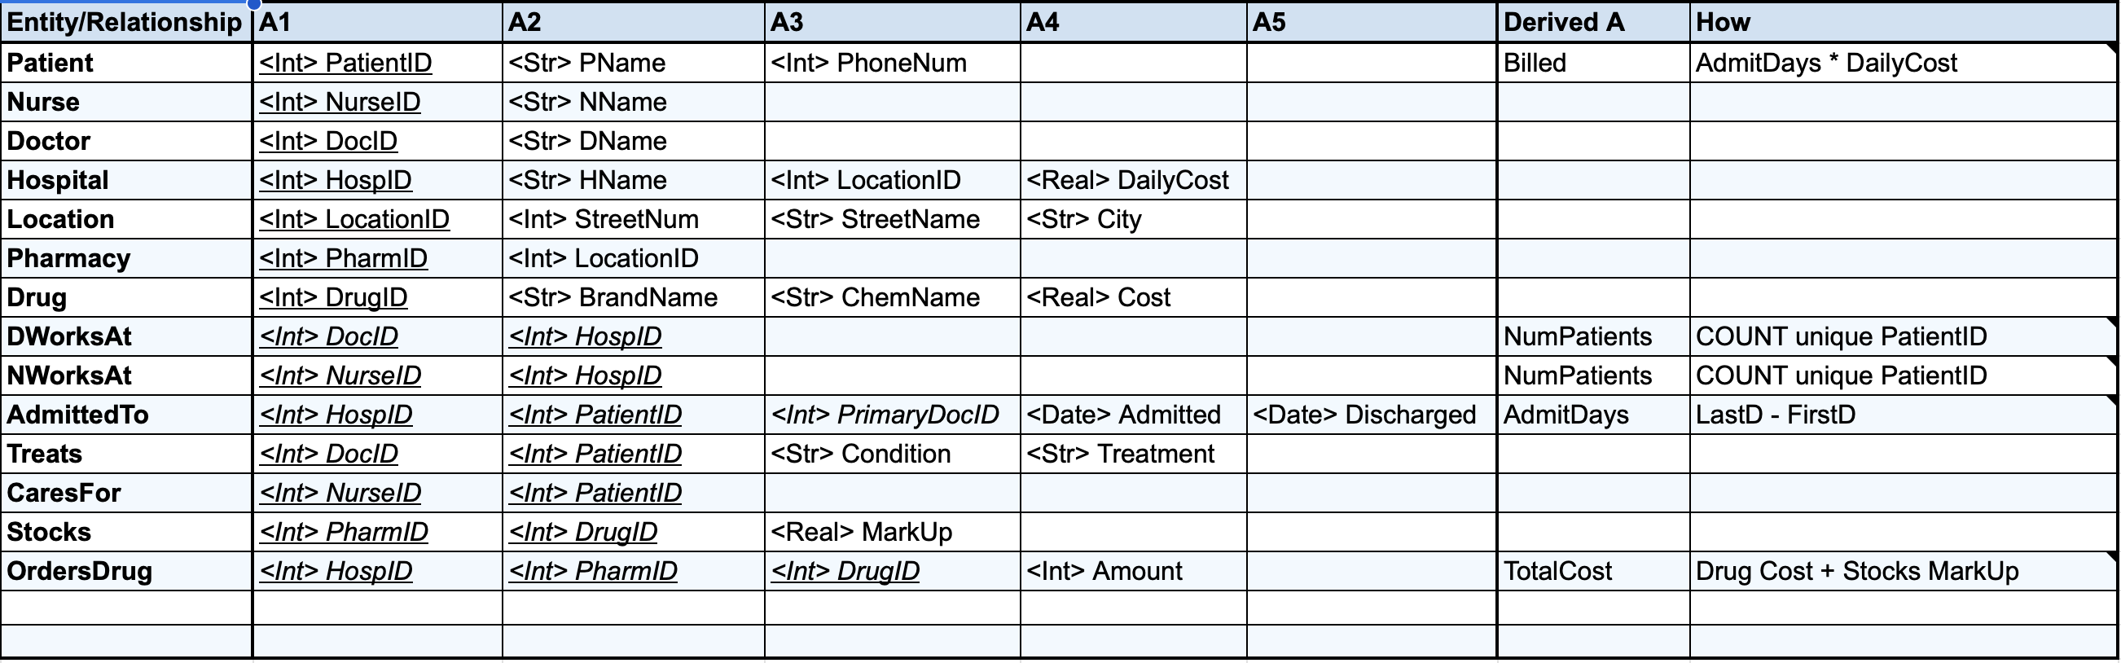

*Fig. 2: Database schema for the hospital database*

The tables in this schema have been converted to 3rd Normal Form and the official database schema made in SQL can be found in the submitted file titled “EMRSCHEMA.sql”.

**User Views**

The following explains the user views and their purpose. As previously mentioned, there are five user views in total. The hospital admin view, doctor view, nurse view, pharmacy view, and the patient chart view.

Hospital Admin View

The hospital admin view has access to the most information in the system, they can view which doctors and nurses work at the selected location, which patients are admitted, and which pharmacy bills are outstanding at which pharmacy location.

Doctor View

The doctor view is responsible for showing the doctor signed in which patients are under their care as primary doctor or attending. They can view all relevant information about the patient and have permissions to update this information. They also have access to order medication for the patient through one of the three pharmacies based on what they have in stock.

Nurse View

The nurse view displays which patients are under the nurse’s care, this gives them access to the patients information but not permission to change the information or prescribe and order medication.

Patient Chart View

The patient chart view is accessible by all users except for pharmacy. This allows doctors, nurses and hospital admins to view patients in the hospital and individual patient data when necessary. However depending on the user, they may have only read permission or read and write permissions. Hospital admins and Doctors have read and write permissions while nurses only have read permissions.

Pharmacy View

The pharmacy view allows doctors and hospital admins to view information from each of the pharmacies depending on the users permissions. Doctors can access pharmacies and their stock, while hospital admins are only interested in pharmacies and the outstanding bills.

**Presentation**

In the presentation titled “COMP3150 Hospital Database.mov” found in the submitted documents, there is a video format explanation of the database project from the design stage to the completion and how to interact with and navigate our database.