作业10

1. 编程实现求目标的骨架：

* **实验结果：**

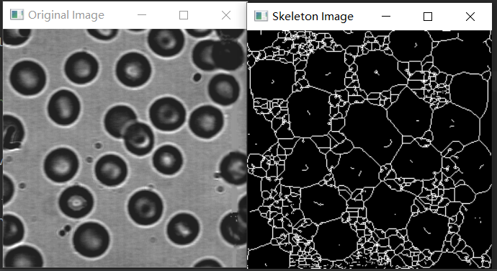

* **源代码：（MATLAB）**

% 读取图像

image = imread('input_image.jpg');

% 将图像转为灰度图像

gray_image = rgb2gray(image);

% 二值化图像

threshold = graythresh(gray_image);

binary_image = imbinarize(gray_image, threshold);

% 骨架化

skeleton = bwmorph(binary_image, 'skel', Inf);

% 显示原始图像和骨架图像

figure;

subplot(1, 2, 1);

imshow(image);

title('Original Image');

subplot(1, 2, 2);

imshow(skeleton);

title('Skeleton Image');

1. 编程实现hough 变换：

* **实验结果：**

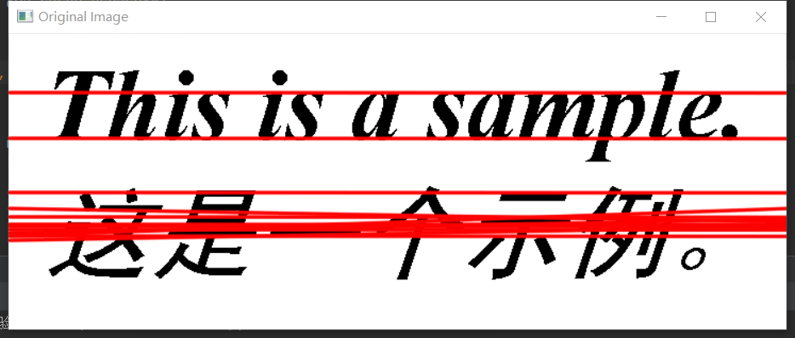

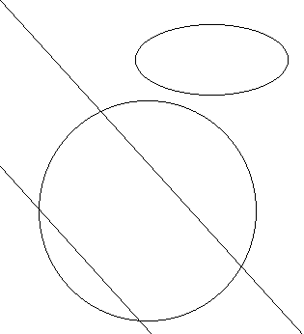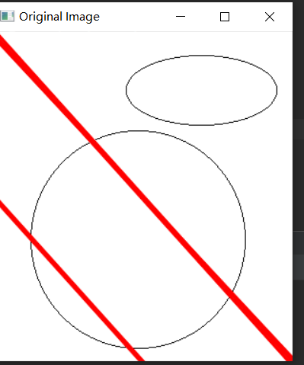

* **源代码：**

import cv2

import numpy as np

# 读取图像并转为灰度图像

image = cv2.imread('input_image.jpg')

gray_image = cv2.cvtColor(image, cv2.COLOR_BGR2GRAY)

# 边缘检测

edges = cv2.Canny(gray_image, 50, 150)

# Hough变换

lines = cv2.HoughLines(edges, 1, np.pi/180, threshold=100)

# 绘制检测到的直线

if lines is not None:

for line in lines:

rho, theta = line[0]

a = np.cos(theta)

b = np.sin(theta)

x0 = a * rho

y0 = b * rho

x1 = int(x0 + 1000 * (-b))

y1 = int(y0 + 1000 * (a))

x2 = int(x0 - 1000 * (-b))

y2 = int(y0 - 1000 * (a))

cv2.line(image, (x1, y1), (x2, y2), (0, 0, 255), 2, cv2.LINE_AA)

# 显示原始图像和检测到的直线

cv2.imshow('Original Image', image)

cv2.waitKey(0)

cv2.destroyAllWindows()