****************Draft****************
Using GTKWave to display the CVS from the rp2040-logic-analyzer
05/10/22

****************Draft****************

Need to reformat the data from pwm.txt
wc pwm.txt
27801 27808 472625 pwm.txt
g
Clock speed is 125000000
Capture speed is 1000000.000000.2
Arming trigger
0,0,0,0,0,0,0,1,
0,0,0,0,0,0,0,1,
0,0,0,0,0,0,0,1,
0,1,0,0,0,0,0,1,
0,0,0,0,0,0,0,1,
0,0,0,0,0,0,0,1,
0,0,0,0,0,0,0,1,
0,1,0,0,0,0,0,1,
0,0,0,0,0,0,0,1,
0,0,0,0,0,0,0,1,
0,0,0,0,0,0,0,1,
0,1,0,0,0,0,0,1,
.
.
.

0,0,0,0,0,0,0,1,
0,0,0,0,0,0,0,1,
0,1,0,0,0,0,0,1,
0,1,0,0,0,0,0,1,
0,0,0,0,0,0,0,1,
0,0,0,0,0,0,0,1,
0,1,0,0,0,0,0,1,
0,1,0,0,0,0,0,1,
0,0,0,0,0,0,0,1,
0,0,0,0,0,0,0,1,

downloaded an vcd example from https://en.m.wikipedia.org/wiki/Value_change_dump
to test.vcd

gtkwave test.vcd

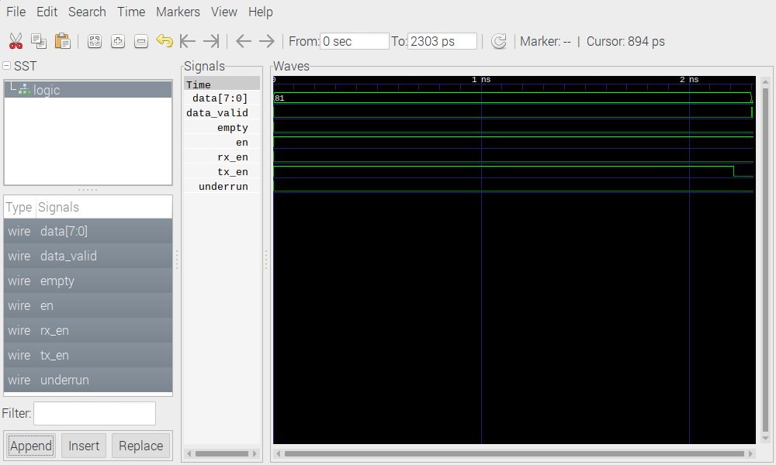
Made some changes to file an saved as test1.vcd

13,16c13,21
< $var wire 1 $ data_valid $end
< $var wire 1 % en $end
< $var wire 1 & rx_en $end
< $var wire 1 ' tx_en $end
---
> $var wire 1 $ pin17 $end
> $var wire 1 % pin18 $end
> $var wire 1 & pin19 $end
> $var wire 1 ' pin20 $end
> $var wire 1 ' pin21 $end
> $var wire 1 % pin22 $end
> $var wire 1 & pin23 $end
> $var wire 1 ' pin24 $end
> $var wire 1 ' pin25 $end
46c51,55
<
---
> #4000
> 1'
> #4010
> 0$
> #5000

gtkwave test1.vcd

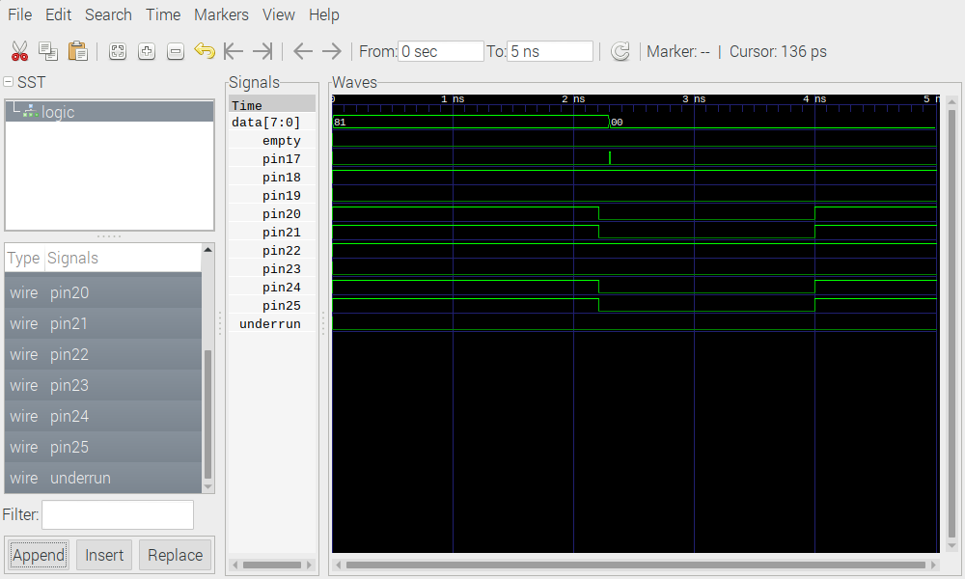
Change the timescale

< $timescale 1ps $end
---
> $timescale 1us $end

gtkwave test2.vcd

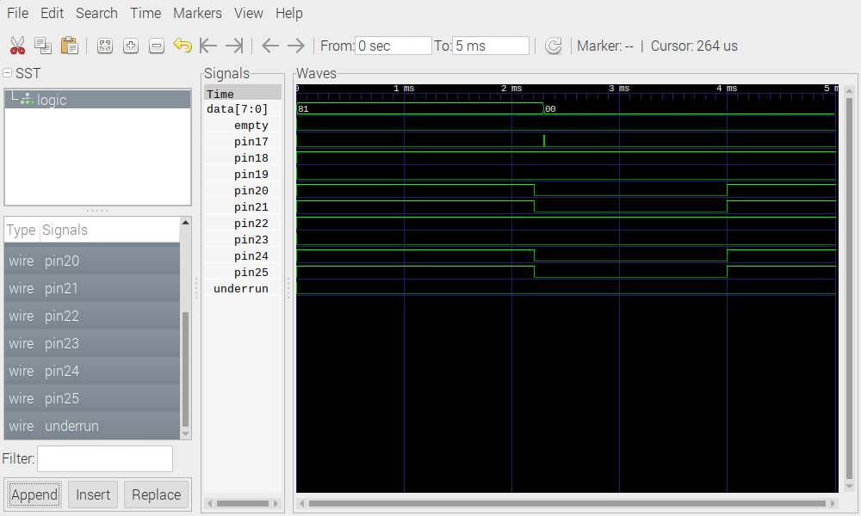
Changes for test3.vcd
The first is the name of module

11c11
< $scope module logic $end
---
> $scope module pico $end
36c36
< b10000001 #
---
> b00000001 #
53c53
< #4010
---
> #6010
55c55,62
< #5000
---
> #6015
> 0'
> #6020
> 1$
> #6025
> 0'
> #6030
> 1$
56a64,75
> #7000
> 1'
> #7010
> 0$
> #8000
> 0'
> #8010
> 1$
> #8020
> 0'
> #8030
> 1$

Now the time is further out to 8ms

