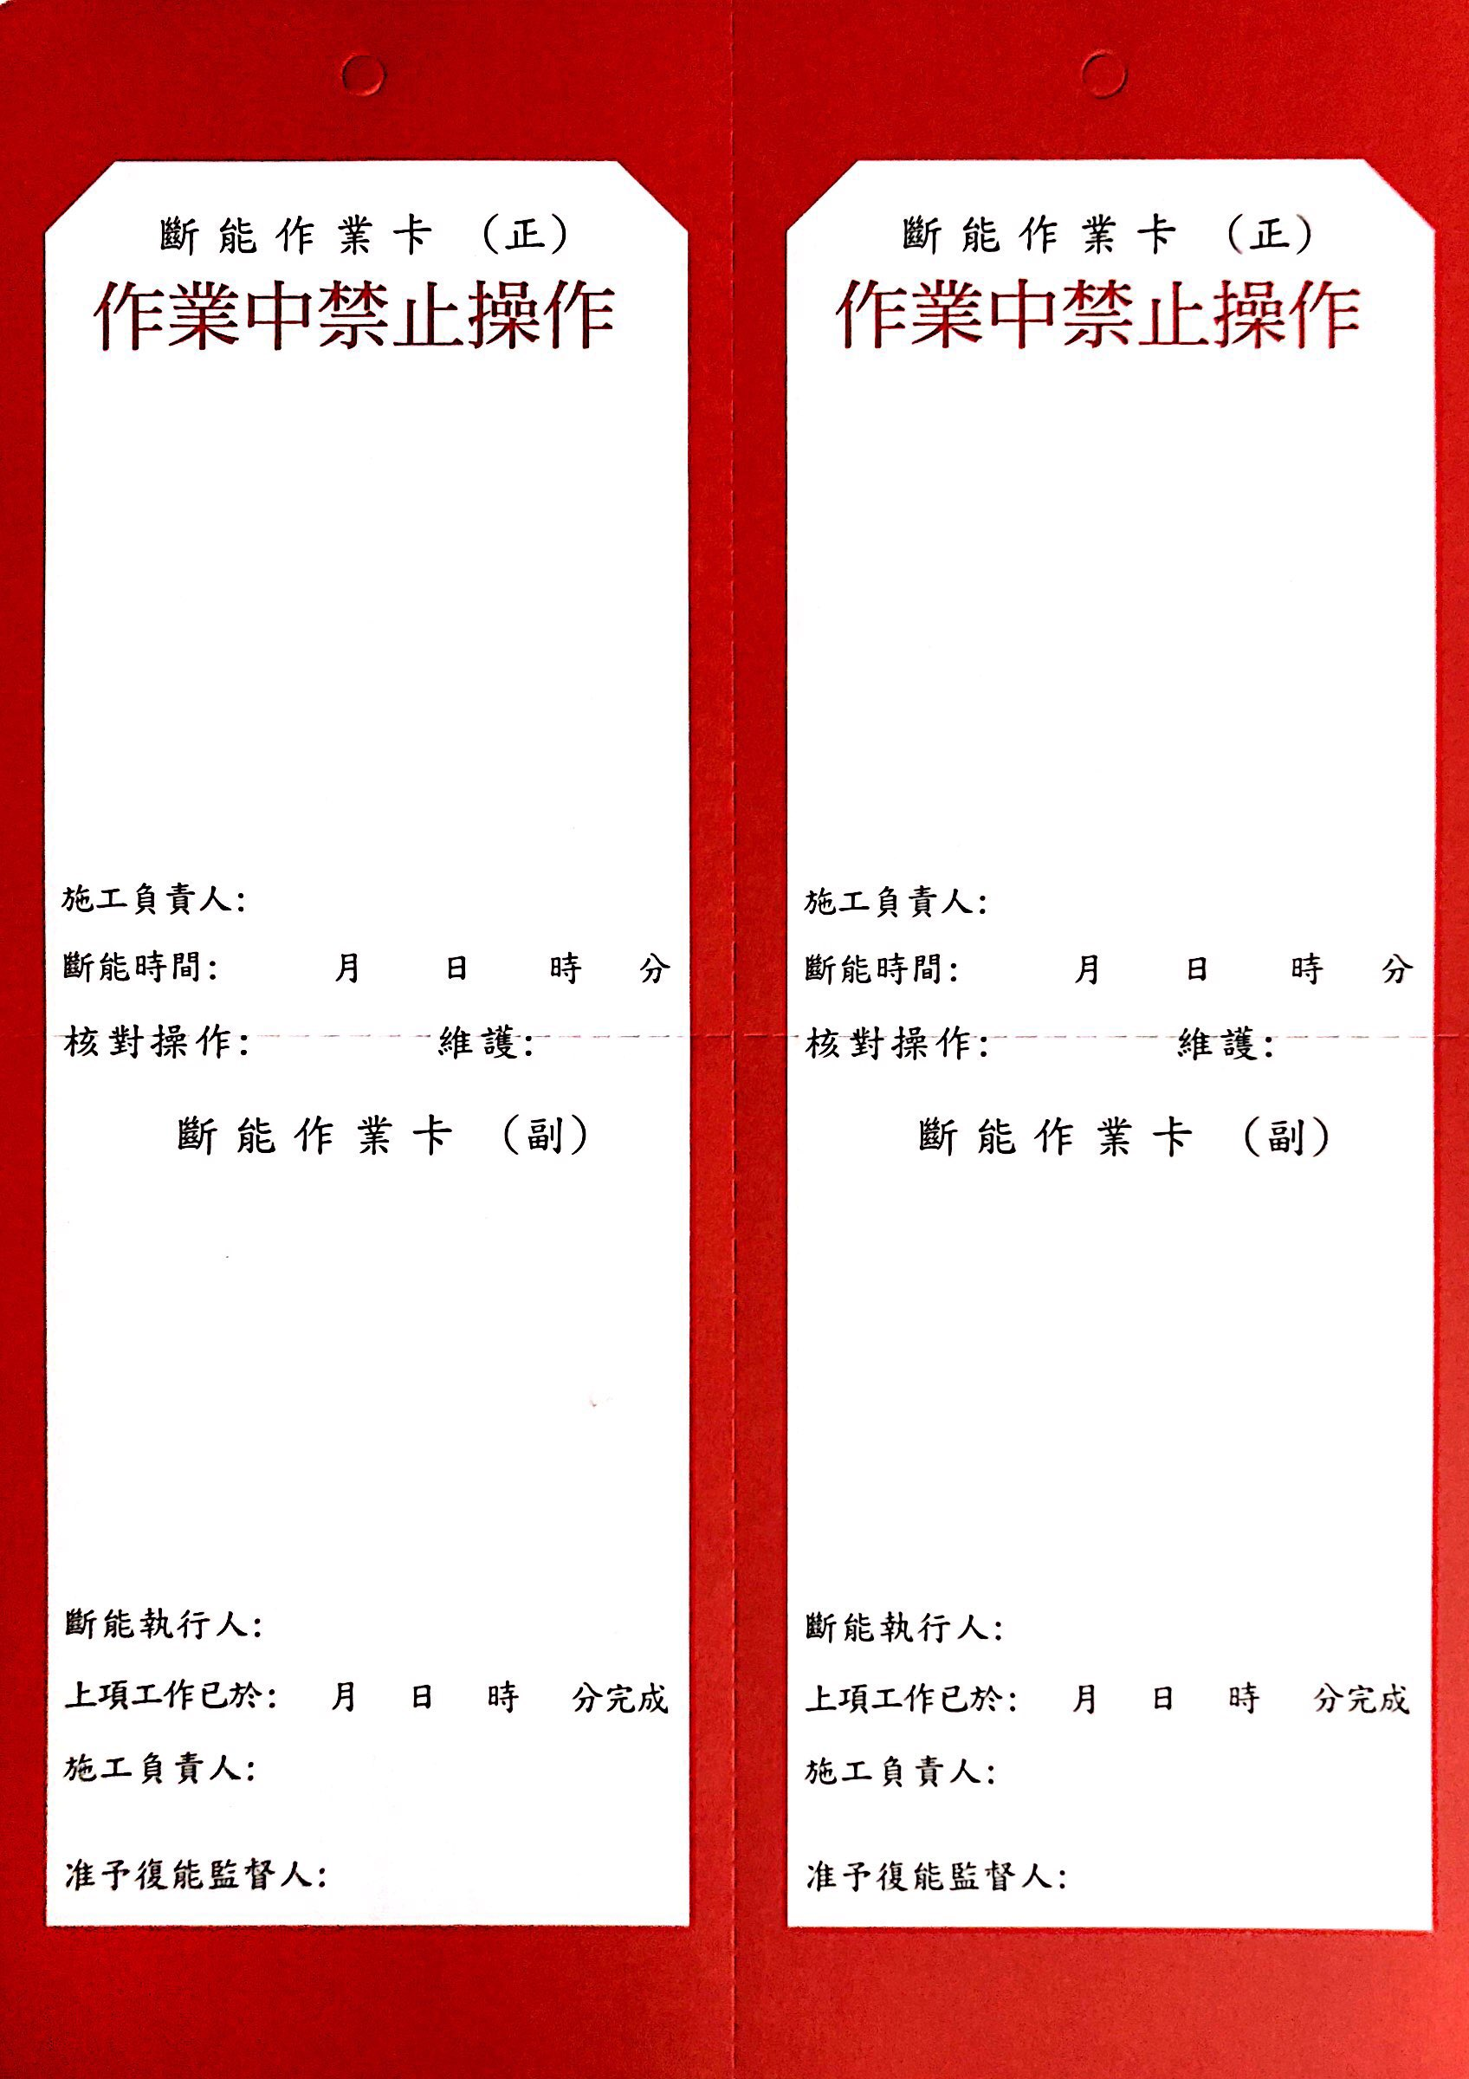

**MCC**   **Local**

**S1 Feeder S1 Feeder**

**MCC Local**

**S1 Feeder S1 Feeder**