ApartmentAdmin

1. 1
2. Introduction 2
3. Team Schema 2
4. Team Contract 3
5. Threats to teamwork 3
1. Business Model Canvas 5
2. SWOT Analysis 6
3. Porter’s Five Forces 6
4. Vision 6
5. List of risks 8
6. Østebanehus apartment management system (Apartment manager) 10
7. Inception 16

Project establishment
- Introduction
We are team DELTA, consisting of 4 team members. Our team goal is to create apartment housing and administration system which can manage different aspects of apartment complex for Østbanehus A/S. We should make a universal windows application for Windows 10 and smartphones using C#, .NET Framework and SQL. Also, we must do documentation of our work process, software and business analysis.

- DELTA team schema
Schema is necessary to assign roles for each person in the group, where each person will focus on one task more than others.
  - Roles
Name | Role | Description
Donatas Adamonis | Designer | Designing user interface
Mikkel Frederiksen | Documentator | Organizing documentation, diagrams, etc.
Paulius Klezys | Database manager | Managing databases and writing SQL queries
Marcin Zelent | Programmer | Coding in C#

  - Contact info
Table with every team member contact information
Name | E-mail | Phone
Donatas Adamonis | dona0169@edu.easj.dk | 20314164
Mikkel Frederiksen | mikk9996@edu.easj.dk | 30294104
Paulius Klezys | paul4618@edu.easj.dk | 50375530
Marcin Zelent | marc560@edu.easj.dk

We have made team contract where we state the rules that each team member has to follow for us to succeed on this project.
- Team Contract
- Be punctual
- Be respectful
- Participate in team work
- Communicate with other members
- Respect everyone’s opinion and ideas
- Do the assigned tasks on time
- Speak English

  - Project Time Schedule
This is table of estimated time for each project phase and description what has to be done in each phase respectively. We will try to keep up with these estimated times.
Phase | Estimated time | Description
Inception | 20.03.2017 – 04.04.2017 | Project establishment, business analysis, basic requirements research.
Elaboration | 05.04.2017 – 19.04.2017 | Modeling, full requirements analysis, prototyping.
Construction | 20.04.2017 – 20.05.2017 | Designing program structure, developing and testing.
Transition | 20.05.2017 – 31.05.2017 | Putting finishing touches.

- Threats to teamwork
Things usually doesn’t go smoothly as planned if you haven’t planned everything. We are aware of the threats that could interrupt our teamwork and this is the plan how we will deal with them.
Name | Possiblity (1-10) | Impact | Contingency plan
Disagreements | 7 | Low | Discuss problem and find compromise.
Sickness | 5 | Medium | Reassign tasks.
Problems with organization | 3 | High | Organize better.
Technical problems | 9 | Medium | Fix ASAP.

- Inception
- Business Model Canvas
Business model canvas helps us to write documentation regarding BeckIT company’s business. This chart shows us the elements of the product that we are making, such elements as: key partners, key activities, key resources, value propositions, customer segments etc.
  - Key Partners
- Sven Westergaards Ejendomsadministration A/S
- Board members
- Tenants
  - Key Activities
- Renting apartments
  - Key Resources
- Building
- Maintenance staff
  - Value Propositions
- Apartments
- Maintenance of building
  - Customer Segments
- Mass market
  - Customer Relationships
- Every tenant is a shareholder in the company
  - Channels
- Website
- Telephone
- E-mail
  - Cost Structure
- Maintenance
- Improvements
  - Revenue Streams
- Rent from the tenants

- SWOT Analysis
We decided to do our SWOT analytics on Østbanehus itself because, in our point of view they are the end client, while Beck IT is a contractor working on the behalf of Østbanehus. Our analytics are based around the housing market and Østbanehus part in said market.

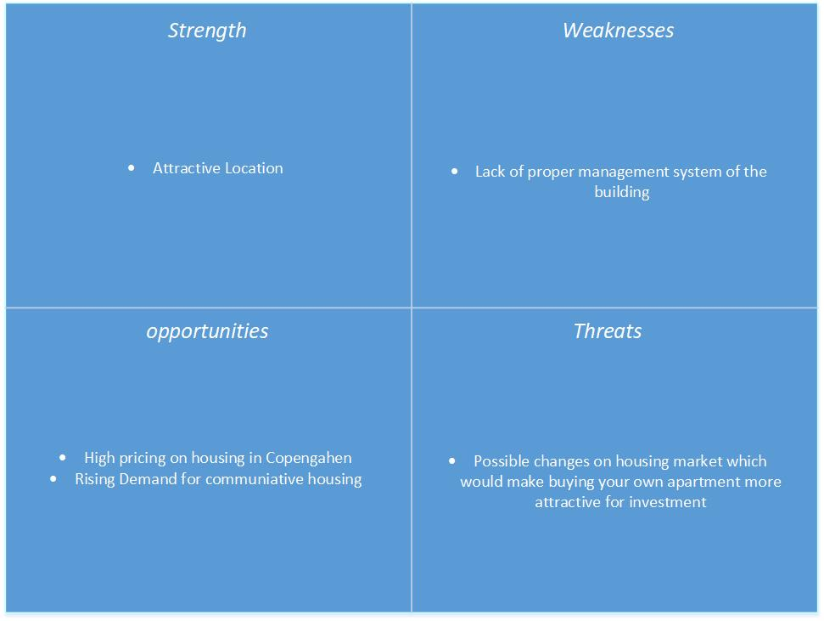
  - Strengths:
- We could only find one point of strength for Østbanehus and that is its location. Østbanehus is in Østerbro which is a very attractive part of Copenhagen especially for families and students looking for a place to live in Copenhagen.

  - Weaknesses:
- We had a hard time finding any weaknesses for Østbanehus, mostly because of the high demand for apartments in Copenhagen. The one thing we came up with was the lack of a proper management system for the complex. The goal for our app is to remove this weakness form Østbanehus and give them a completive edge over their competitors.

  - Opportunities:
- The greatest opportunities for Østbanehus stems from the volatile housing market in Copenhagen. With rising costs, and demand, for an apartment in Copenhagen communitive housing is becoming very popular alternative to buying your own apartment.

  - Threats:
- As with weaknesses we had a tough time finding any threats for Østbanehus, but we decided that the possible changes in the housing market might dissuade byers because as it might be a better investment for them to buy non-communitive housing.

- Porter’s Five Forces

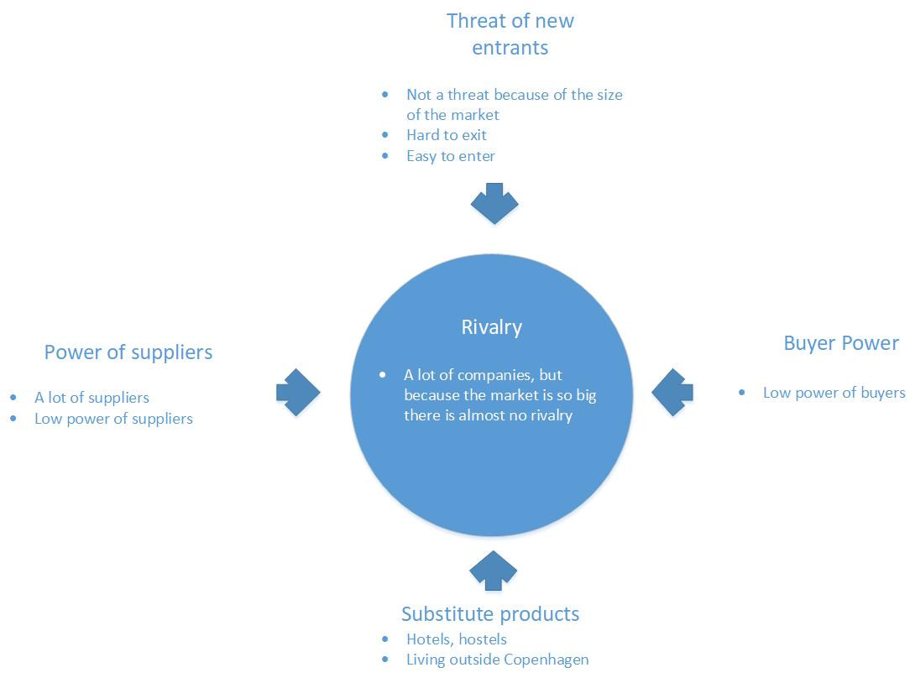
As with our SWOT analytics we did our Porters five forces analytics based around Østbanehus and the housing market, primarily in Copenhagen.

  - Rivalry
- There is almost no rivalry in the housing market in Copenhagen, even though there are a lot of competitors in the housing market, the sheer demand for a place to live outweighs the number of competitors to create a market with very low rivalry.

  - New entrants
- We had some hard discussions on the threat on new entrants. It’s hard to enter the housing market in Copenhagen because there is not a lot of free space for you to build new housing (alternatively you could buy a preexisting building). That forces the new entrants to build their housing further away from the central parts of Copenhagen where the lot prices are lower but the attractiveness of the area is lower as well. So, in a sense it’s both hard and easy to enter the market.

  - Substitute products
- This is a tricky area because everyone needs a place to live so the only substitute product we could find where hotels, hostels or finding a place to live outside of Copenhagen.

  - Suppliers
- The power of the suppliers is low since there is not a single large supplier but a lot for smaller suppliers which are competing among each other.
  - Buyers
- As with the power of suppliers the power for the buyers is low due to the large number of buyers.

In retrospect:
In retrospect, we could have done a SWOT and P5F (porters five forces) analysis on Beck IT since you could argue that they were our end client and Beck IT would sell the app to communicative housings such as Østbanehus. During the inception phase, we as a group decided to make a more universal application and not focus solely on Østbanehus in which case it would have been better to do SWOT and P5F for Beck IT as mentioned earlier.

- Vision

Now that we have done proper analysis of the business, we have thorough understanding of aspects affecting business.
This business has a very good opportunity to succeed and it could bring good annual revenue. We need to solve a problem – create a universal windows application for managing apartments and tenants living in Østebanehus. A successful solution would be an application, which could manage apartments and residents in Østebanehus.

  - Introduction
We are creating administraton system for Østebanehus which will help them manage information about apartments, tenants and damages (especially to downpipes and windows). It is going to be UWP app for Windows 10 and Windows 10 Mobile written in C#, using .NET Framework and SQL Database.
  - Positioning
    - Problem Statement
Stating the problem, what it affects and what is the solution to solving this problem.
The problem of | administrating of apartments
affects | Østebanehus
the impact of which is | spending money on third-party company
A successful solution would be | administration system

    - Product Position Statement
A short summary of our product and its purpose.
For | Østebanehus
Who | need apartment management system
The | ApartmentAdmin
That | helps to manage apartments
Unlike | Sven Westergaards Ejendomsadministration A/S
Our product | allows management and tenants to manage the building themselves

Stakeholder Summary
Stakeholder summary table states all the stakeholders describing who are they, what is their position in this project and what responsibilities they will have.
Name | Description | Responsibility
Board members | Tenants chosen to manage the building. | Managing the building.
Tenants | People living in the building. | None.
Sven Westergaards Ejendomsadministration A/S | Third-party company hired by Østebanehus. | Administration work.
BeckIT | IT company. | Creating administration system.

    - User Environment
There are requirements, needs and features of the software, which end-user is expecting to have. We have to identify and describe them so our developed software would match user’s expectation.
  - Product overview – Needs and Features
List of needs and features. This list is essential for software development part, to see what exact functions app has to perform and what to display
Need | Priority | Features | Description
Tenants management system | Very High |  | Overview of the information send to the residents in the building.
General Building Info | High |  | Administrator, Board members, General assembly and building maintenance info.
Downpipes Info | High | All downpipe pictures overview | Overview of the condition of all pipes in the building
Apartment Info | High | Downpipe picture upload | address, size, number of rooms, number of square meters, ”fordelingstal”
Resident Info | High | Residents Log. | Overview of the whole family living in an apartment
Washing machine booking system | Medium |  | Book washing machine.

  - Other Product Requirements
These are other, minor yet very important, software qualities that our software must have.
Software Qualities | Priority | Description
Data integrity | Very high | Program must run smoothly through its life-cycle, without crashing
Precision | Very high | User is expecting program to work as it is intended to work.
Maintainability | Medium | It shouldn’t be hard to implement new features to the program, as there might be a need of them in the future
Performance | Medium | Program must have a decent speed – user doesn’t have to wait very long for operation to be completed
Flexibility/Reusability | High | Ability to easily reuse and implement code to the other platforms: phones, tablets, etc.…

- List of risks

This is a list of risks, that could potentially interrupt our work and slow us down. We need to understand the risks so we could anticipate and prevent them from happening. The most important thing is to find the right solution to a possible risk.

Risks | Effect | Solution
Absence | Hard to cooperate and get feedback/thoughts on assigned tasks that we do | Meet another day to compensate time that we’ve lost
Lack on information | Inability to fully understand requirements to be implemented to the software | Talk to teachers, meet company owner and ask them questions
Time management | We can’t predict how long we will take to do certain tasks, as well as the program itself | Manage our time. Talk to each team member and adjust our individual-personal schedules
Software problems | Impossible to work on our project. Can’t do the programming part, neither write the report | Fix it as soon as possible. Look for errors before it gets worse

- Østbanehus apartment management system (Apartment manager)

Project establishment
Our group goal is to create administration system for Østbanehus which will help Østbanehus residents manage information about apartments, tenants and defects. We have separated our group work individually, each of us can focus more on certain parts, as mentioned above.

Rich pictures
Rich picture shows interaction between system users and apartments, how each of the user manages apartment in their own ways. Having, not only written artifacts and diagrams, but also a rich picture, summarizes, how end result should look like. In addition, it visualizes how the system should look like.
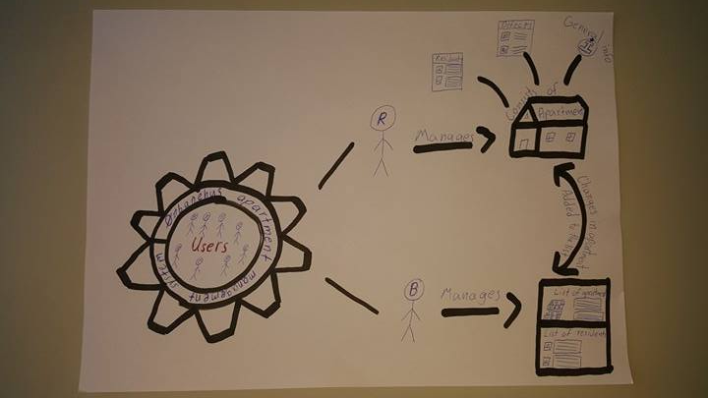

Technology resources
Before starting to work, we must evaluate our technical resources, whether it is possible to make required software at all
    - Software resources
From software point of view, we must have our programming environment - Visual studio 2015 installed on our machines. Visual studio 2015 comes along with many NuGet packages and it is a must in software for the project. Not only that, Microsoft office word is also a must-have program to write report.
    - Hardware resources
Visual studio 2015 is quite ‘heavy’ software computer resources usage-wise. Before beginning to work on project, we had to make sure that our computers are eligible to run Visual studio 2015
    - Technical problems
We have run into a few problems with software, having to reinstall not only Visual studio 2015, but also Windows operating system. However, we were aware of it and have prepared installation files for, both, Visual studio and Windows. Other than that, our hardware is good enough to run Visual studio 2015, but sometimes not so smoothly as we would expect it to run
  - Work plan and working process

    - Arranging meeting times
In our group, every single team member is working. We can’t have strict schedule with meeting times. To organize meetings, using messenger app to decide on time when everyone is available
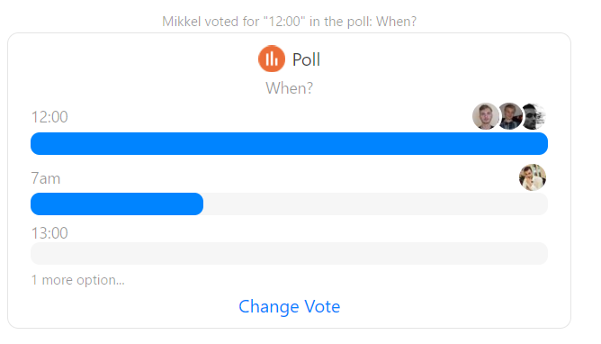

    - Communication in group
Communication is the most important thing and it is very important for everyone to be reachable. For this purpose, messenger app is being used, because everyone has it and it is possible see when a person is online
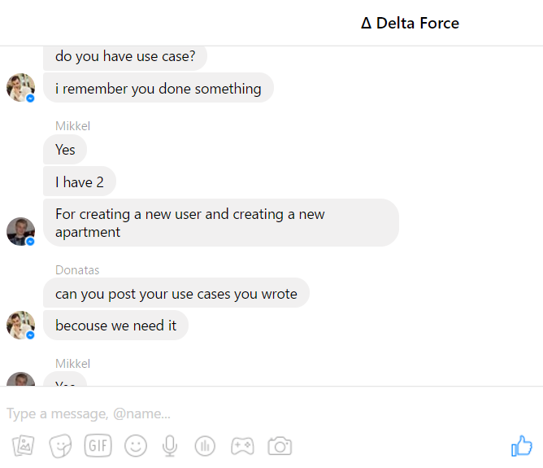

    - Diary and logs
While working on our project, we are using Github (scrum board) and Visual studio team services, where we can write what we have done, as well as we can see what others have done. In addition to this, in college, we are writing log of things that we have already done, are about to do and doing now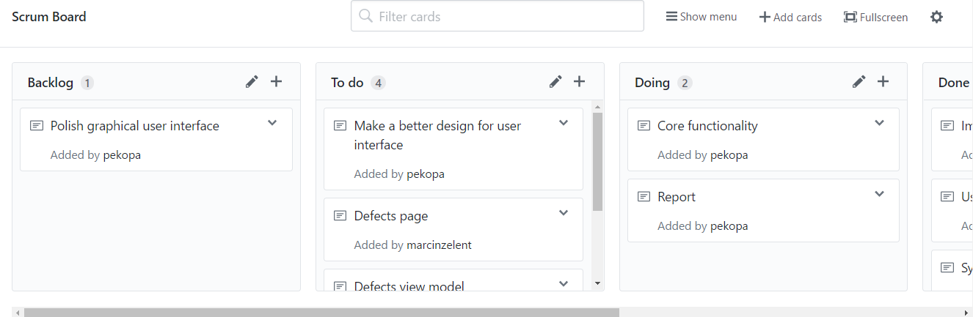

    - Working techniques
We don’t have one technique that we are using all the time. Instead, we are pair programming, working individually, working in a group altogether. Working this way is more efficient and is less boring

  - Short summary for Inception, elaboration, construction and transition

    - Inception phase
Inception phase is necessary to have a common vision and basic scope of the project. A decent preparation is very important before beginning to do the programming part. Maybe it’s not even worth to begin working on this project and it might be not feasible at all. Only the small part of the requirements should be defined in this phase
Artifact | Description
Vision | Gives a summary of the system
Risk list & risk management plan | Potential risks than can slow our working process and solutions to those risks
Software development plan | Preparing for the upcoming work. Evaluating resources needed to develop software (time, hardware, software, team members)

    - Elaboration phase
Elaboration phase is where most of the requirements should be defined, build core architecture, estimate how long it would take to make the software and what are essential resources for it.

Artifact |  | Description
Domain model |  | Visualization of the domain concepts
Design model |  | Diagrams, which describes logical design (System sequence diagram, Design class diagram, Database design diagram)
Software architecture document |  | Shows relation between separate software components
    - Construction phase
Construction phase is where most of the programming is being done according to previously defined requirements. Minor part of analysis & design and requirements are defined.

    - Transition phase
If our program will look good and will satisfy customer needs, we will transit our product for production, but that depends on the owner of BeckIT company.

  - Graphical user interface prototype
Drawing prototype of graphical user interface helps us to visualize our application and how would it look like, what features and functions would it have. Not only it helps with design, but also with possible actions that it could perform. In addition, it defines some of the requirements for the software. 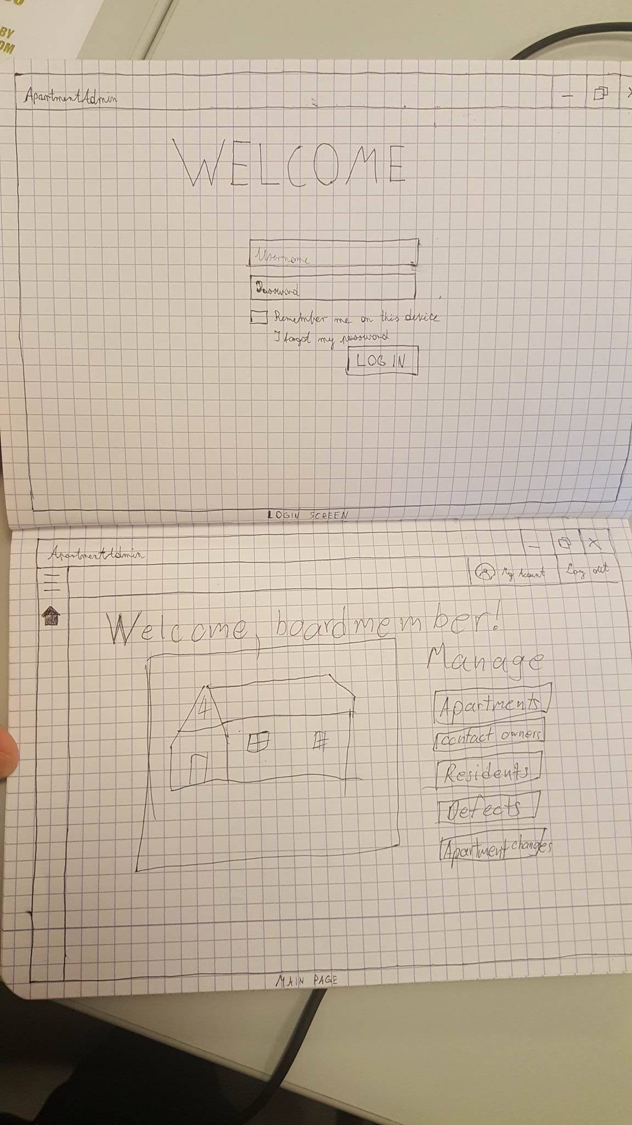

  - Use cases:
GUI prototype has also helped us to define use cases easier. We have defined use cases to discover, clarify and identify system requirements – core functions of the app (behavioral requirements). Use cases show how users interact with the system to achieve certain goals. It will also serve as for several stages of software development.
    - Validation of the use cases:
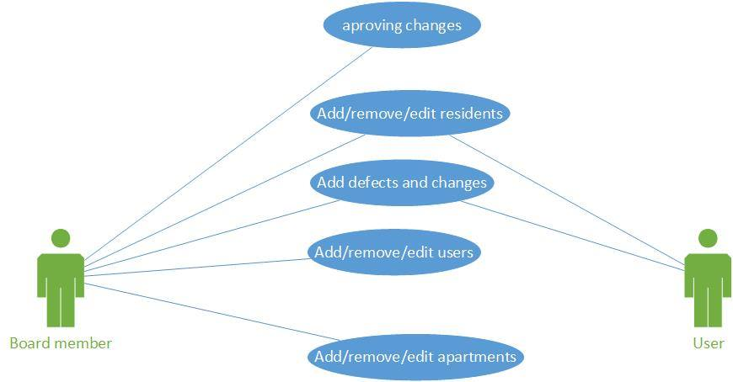

Having uses cases we can proceed defining ever-changing requirements for the software and eventually start the implementation part.

The order of the use cases, according to their significance in the system:
Add/remove/update apartment > add/remove/update resident > add/remove/update defects > change apartment
Explanation: residents cannot be assigned to the apartments which do not exist, neither can defects and changes to the apartment can be.

Name: Add resident
Primary actor: Person (user) living in Østebanehus
Secondary actor: Board member living in Østebanehus
Scope: Universal windows app - Østebanehus
Level: User goals. Actor is trying to get something done
Stakeholders and interests: People living in Østebanehus, BeckIT company
Preconditions: Apps starts, user or board member logs in and successfully navigates to the add resident page
Triggers: New resident has moved in to the apartment
Success Guarantee: New resident is successfully assigned to the apartment. Updated view with the new user is shown.
Main success Scenario: User or board member selects ‘Add resident’, new page opens and user or board member fills fields with information regarding new resident. Then he clicks ‘create’, app adds new resident to the list and displays a message box ‘New resident has been successfully added’
Extension: Ability to view residents and owners living in the current apartment. Ability to go back to the main menu page. Also, ability to view pictures, comments and description of other, already existing, defects
Special requirements: Universal windows app, serialization to JSON, web API, Database, usage of GRASP patterns
Frequency of occurrence: Based on the residents of Østebanehus

Name: Remove apartment
Primary actor: Board member in Østebanehus
Scope: Universal windows app - Østebanehus
Level: User goals. Actor is trying to get something done
Stakeholders and interests: People living in Østebanehus, BeckIT company
Preconditions: Apps starts, board member logs in and successfully navigates to the apartment list page
Triggers: Existing apartment has been remade, or something has been changed
Success Guarantee: Existing apartment is successfully removed from the list. Updated view of the list of apartments, without the old apartment, is shown.
Main success Scenario: Board member selects apartment to be removed from the list, clicks ‘remove’, app removes apartment to the list and displays a message box ‘Existing apartment has been successfully removed from the list’.
Extension: Ability to view residents and owners living in the current apartment. Ability to go back to the main menu page. Also, ability to view pictures, comments and description of other, already existing, defects
Special requirements: Universal windows app, serialization to JSON, web API, Database, usage of GRASP patterns
Frequency of occurrence: Based on the will of Østebanehus owners

Name: Update defect
Primary actor: Person (user) living in Østebanehus
Secondary actor: Board member living in Østebanehus
Scope: Universal windows app - Østebanehus
Level: User goals. Actor is trying to get something done
Stakeholders and interests: People living in Østebanehus, BeckIT company
Preconditions: Apps starts, user or board member logs in and successfully navigates to the update defect page
Triggers: Something has changed regarding the defect
Success Guarantee: Existing defect is successfully updated in the apartment. Updated view with the existing defect and its pictures is updated.
Main success Scenario: User selects defect that he wants to update. User can choose which fields he wants to change and fills in information regarding existing defect. Then he clicks ‘update’, app updates existing defect from in list and displays a message box ‘Defect has been successfully updated’
Extension: Ability to view residents and owners living in the current apartment. Ability to go back to the main menu page. Also, ability to view pictures, comments and description of other, already existing, defects
Special requirements: Universal windows app, serialization to JSON, web API, Database, usage of GRASP patterns
Frequency of occurrence: Based on occurrences of defects in the apartments of Østebanehus and personal responsible for maintenance

Elaboration
Domain Model:

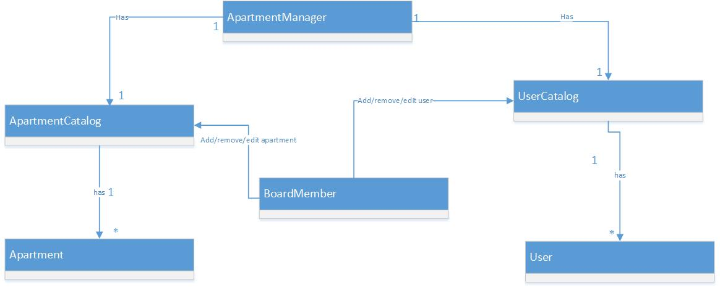

As we can see from our Domain model the ApartmentManager has a UserCatalog which is comprised of users and a ApartmentCatalog which is comprised of Apartments in the center we have the BoardMember which can add, remove and edit users and apartments in the catalogs.

Database
Our database is being stored in Microsoft Azure cloud and we are using their services. It consists of the following tables:

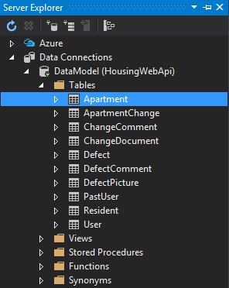
For instance, we will take Apartment table from our database:
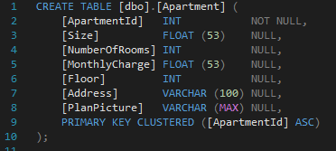
Primary key is ApartmentID, therefore it cannot be null. The rest of the remaining attributes can be null.

Database and normalization:

This diagram helps us to organize our database. We need to know what tables we will have and what attributes they will include. It also helps to reduce data redundancy and improve data integrity.
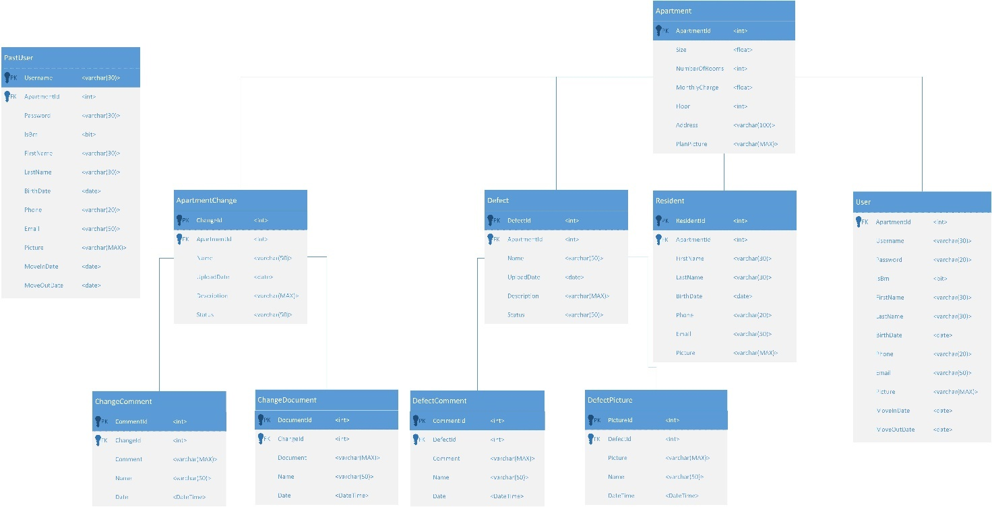

Normalization

We have done most of the functional dependency diagrams for most of our tables, we have skipped some for the tables because they resemble other tables such as ApartmentChange and Defect have a lot of similarities and their functional dependencies are very similar.

Apartment table

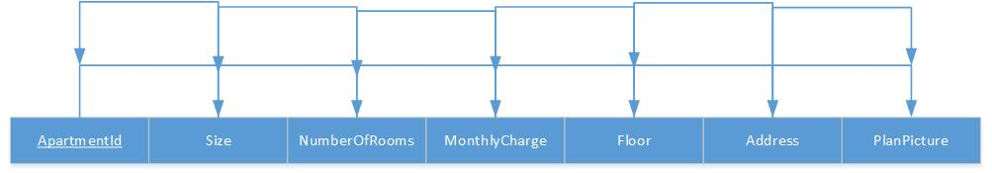

In the apartment table the primary key is the ApartmentId but the Address could be a candidate key since its unique for each apartment but its usability is not good because of the length of a normal address

User table

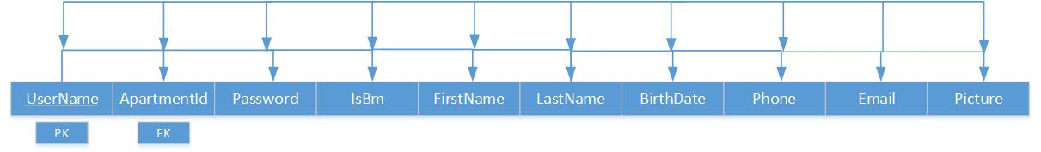

In the user table the primary key is the UserName and the foreign Key is the ApartmentId and the relationship is a 1: * since an apartment can have multiple users.
The email is a candidate key because it is most likely that it would be unique for each user.
The phone might look like a candidate key if the phone is a mobile phone, but if the phone is a landline the risk of overlap is too great.

Resident table

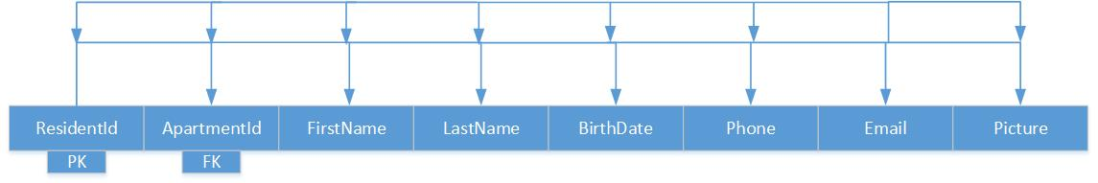

The primary key for this table is ResidentId and the foreign key is ApartmentId, the rest of the table is very similar to the previous table where the email is a candidate key and the phone might be a candidate key but it is too risky. The relationship is also the same as the user table where it is 1:* because an apartment can have multiple residents.

Defect table

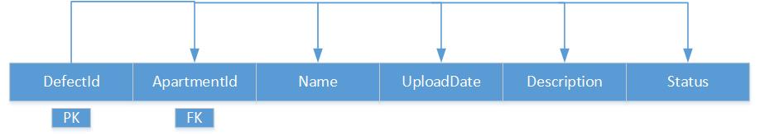

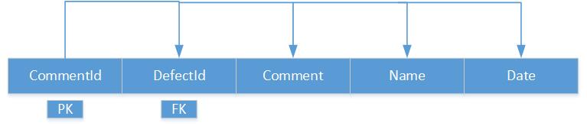

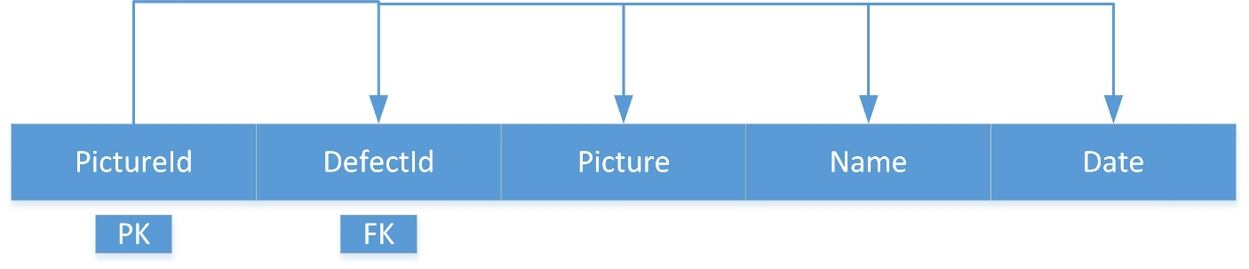

The Defect, DefectComment and DefectPicture is split in this way to ensure that the tables upholds the first normalization form, because we want a defect to contain multiple comments and pictures. The relationship between the defect table and apartment is 1:* as an apartment should be able to have a minimum of 1 defect. The same relationship applies to DefectComment and DefectPicture with Defect.

Changes table

The changes table is an exact copy of defect except instead of the DefectPicture it has ChangeDocument where you can upload relevant documentation on your planed changes.

Sequence diagram
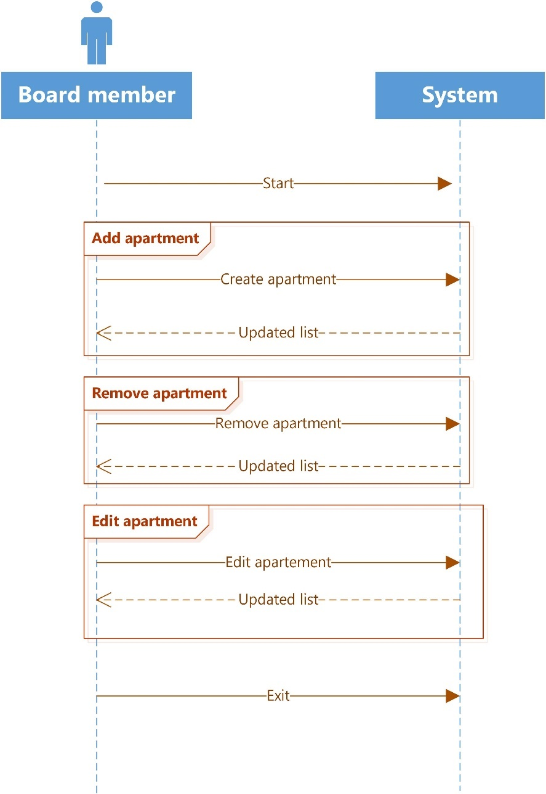
Here we see a design overview on how the board member interacts with the system to add, remove, and edit and apartment.
Design Class Diagram

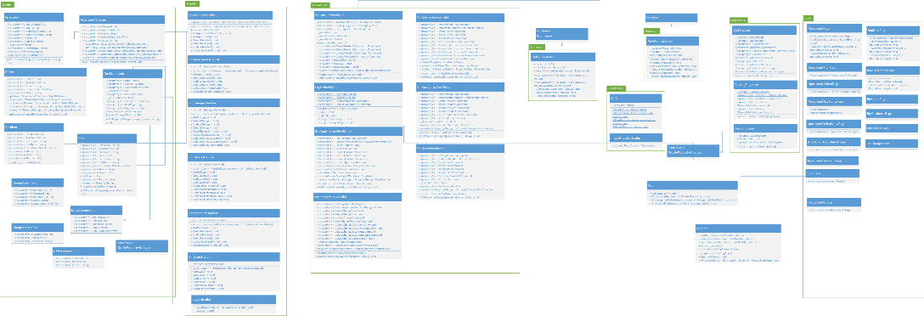

A full version can be found in the appendix
Here we have our design class diagram. Our application uses the MVVM design pattern and you will find all our views on the righthand side. We have also implemented the singleton pattern and you can find them to the left of the views. Our models can be found on the far-left side connected to their handler class. The view models are to the right of the handlers and the BoardMemberViewModel and ApartmentViewModel are connected to the INotifyPropertyChanged class under the ApiClient. In the commom area we have our RelayCommand class to handle our ICommands. We also have a NavMenuView.

Controller:
We would classify our handlers as the controllers, our ApartmentHandler is the apartment controller, the BoardMemberHandler is the BoardMember controller and the same applies to the two other handlers. We base this on the definition of a controller which is the first object behind the UI layer and handles the use cases. Our ApartmentHandler handles all the use cases that should do with apartments i.e. Create resident, delete resident and update resident. Our other handlers do similar actions with apartments and users. Therefor we conclude that our handlers fall well under the guidelines for a controller.

High cohesion and low coupling:

Our application has high cohesion, and you can see this from our DCD. All of our persistency is handled by our persistency class, our handlers are fall under the guidelines of controllers and our View Models handles all the UI. In conclusion, our classes are highly focused and therefor our application has high cohesion.
Low coupling and High cohesion are very intertwined and high cohesion is in general supported by low coupling. When you have High cohesion, you will in most cases also have low coupling, just as in our application our classes are focused and streamlined as an example the only class that know about the BoardMemberCatalog is the BoardMemberViewModel because it is the only class that needs to know about it.

- Evaluation of the process

Management:
Even though we had estimated time for each of the phase, at some parts we were lacking time and couldn’t finish them on our estimated time. However, we had done a few things faster and
It’s not hard to catch up. We also had problems (sickness, hardware and software problems) with threats to the teamwork, but we have anticipated them and we were doing just fine after that.

Unified process:
In general, the UP is a great foundation to build a project upon. Our inception phase went well we got our business analytics done early on and had a good idea off what we had to do to progress with our project. The only negative thing is that we feel that if the plan starts to slip it’s hard to get back on track and it can put a strain on the team, even though slippage is something that is acceptable in the UP.

C# and Visual studio:
Our group has no real grief with C# in the context of make this particular application since its windows based application, but C# has its limitations if you want to make applications for other platforms and you don’t want to use addons like Xamarin.
We had some issues with Visual studio but it was most likely because we had updated to Visual Studio 2017 from Visual studio 2015 but some of the issues got fixed after a reinstall of visual studio.

Databases:
Working with SQL has been fine, there hasn’t been any complaints the only problem was we had to go from a local DB to get or DB hosted on Azure, but it was a smooth transition.

Architectural patterns

- Model – View – ViewModel (MVVM)

Model
View
ViewModel

MVVM is a software architectural pattern which is used to separate the concern and thus ease the work on the project developed by many people with different tasks. It consists of free components:

- Model – contains classes which are blueprints for future objects used throughout the program, i.e. class Car with properties Model, Brand and Color. It is a representation of business logic.
- ViewModel – this is where all the magic happens, inside it there are classes with methods for manipulating the data, the objects based on the Models are also created here. ViewModel acts like a bridge between Model and View.
- View – this is what the user of the program is able to see, GUI. In UWP apps View usually stores Pages and User Controls as well as methods for navigating between them as well as changing properties of elements inside them.

There are specific relationships between these components. The Model does not know about the existence of the ViewModel but the latter is aware of the Model and uses it for data storage and manipulation. The interaction between View and ViewModel is similar – View is using ViewModel which is unaware of the View. View uses commands to call ViewModel's methods which perform operations on the data and make results displayable on the View with data bindings.

MVVM provides a lot of benefits. It divides the program into smaller parts making it easier for developers to work at the same time. Designers can focus on the user interface without interruptions because the programmers code in a different part. It is also easier to redesign user interface and modify code without breaking the whole program. Another benefit is that it is possible to make unit tests without using the View, because all methods are in the ViewModel.

We use this pattern in our project. We have split our UWP app according to MVVM rules. The Pages we created are almost only XAML and some small methods for navigating between them, which is allowed by MVVM because they only change the View. The actual operations on data are performed in the classes of ViewModel. The communication between View and ViewModel is achieved using commands, data bindings and notifications. Lastly, we have Model classes which represent business logic.

Although MVVM is a great pattern which has many pros, it also has some disadvantages. It takes more effort to implement simple things, because apart from just writing the method the programmer usually has to also create bindings, commands and use interfaces for notifying the View about changes done in the ViewModel. It can also lead to difficult situations, where it is hard to implement a feature without breaking MVVM principles. Our team stumbled upon such situation when we were making login system. We have a login page with fields for username and password, and a button to log in. The Textboxes are bound to properties in the ViewModel and button has command to call LogIn method which is in the login handler. This method checks if the username exists in the database and if the password put by the user is correct. If entered credentials are correct the user should be taken to the main page. The problem is that it is very hard to notify the View that password was incorrect and stay on the login page. We should not check conditions in the code-behind and we should not navigate between pages using ViewModel. We were trying to find a solution to this problem but we were unable to do so. That is why we settled for navigation using ViewModel.

- Evaluation of the product

We feel that we have implemented the functionality that we wanted to have in our application. Our application can manage the residents and has the capability handle various defects a tenant might have. We had sign up for the washing services as a maybe at the start off the project but as the project progressed we found out that we would not have the time to get it done. Our application has the key functionalities as set by Beck IT and we feel that the application could help Østbanehus and other communitive housing complexes insource their management.

- Perspective

As mentioned in the evaluation of the product, sign up for the washing service is something we would add to or application if we had more time. In general, it’s hard to figure out where the project would evolve if we had more time, especially because we are using the UP and in our opinion the UP is very good at enabling your application to evolve organically, and we can only guess what new ideas and functionalities would come up under the development of the signup for the washing service.

- Conclusion

Our task was to solve a problem – find a solution. The problem was: how an application can be used to help to manage apartments and its residents living in Østbanehus. We can gladly state that we have accomplished our goal – to create fully functioning, bug-free, user-friendly and other, user needs satisfying, software.
First things first, we had to look at the BeckIT company, do the analysis, whether such 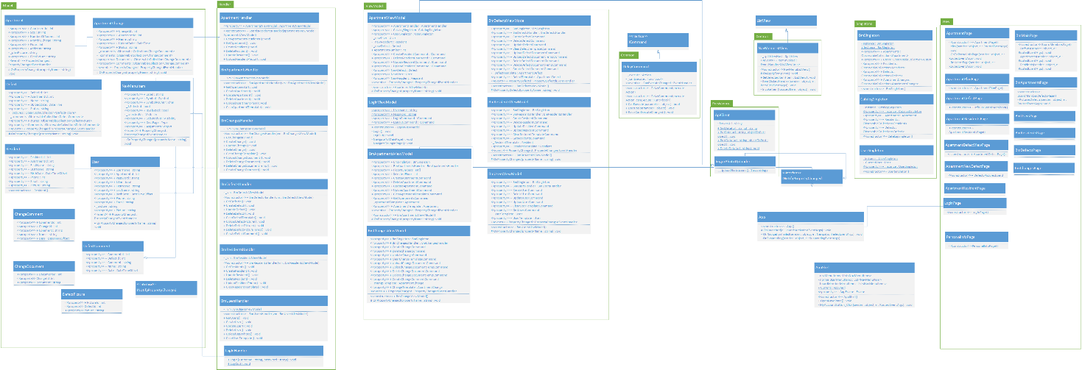project is feasible at all and what it takes to succeed, what are the risks and threats that could make it less doable. In the process, we have written documentation of every step we did and how we did it. Many artifacts, assisting us in understanding everything more in depth, were created in the process too.
Writing documentation wasn’t that hard as it seemed at first. Everyone in our team has contributed into writing the report and was sharing ideas, giving suggestions on how we should do this or that. The hardest part was to write the elaboration part, which consists of disciplines where they are at their ‘peak’ of iteration, which means we had to write a lot about almost every discipline.
For the programming part, we had quite a few problems and obstacles to overcome. Sometimes it was hard to find a bug and see why our application crashes, or certain parts of functionality is not working, or not working as intended. We had a problem with MVVM pattern, which is essential for developing good quality software. Also, it was hard to define database design, because it was constantly changing throughout programming phase, many things had to be redone or adjusted from time to time.
All in all, we have learned a lot doing this project and we can firmly declare that it was really challenging. Things like programming, documenting our work, cooperating with company owner and even our own team members (it can get rough sometimes too!). We believe that, not only the company, but the end users will be satisfied with the product that we have made.

Tl;dr

We have achieved our goal to create fully-functioning software and document it.

- Appendix

  - Remaining use cases:

Name: Remove resident
Primary actor: Person (user) living in Østebanehus
Secondary actor: Board member living in Østebanehus
Scope: Universal windows app - Østebanehus
Level: User goals. Actor is trying to get something done
Stakeholders and interests: People living in Østebanehus, BeckIT company
Preconditions: Apps starts, user or board member logs in and successfully and navigates to the residents list page
Triggers: Existing resident is moving out of the apartment
Success Guarantee: Chosen resident is successfully removed from the list. Updated view of the list of residents, without the old resident, is shown.
Main success Scenario: User or board member selects resident to be removed from the list, clicks ‘remove’, app removes resident from the list and displays a message box ‘Existing resident has been successfully removed from the list’.
Extension: Ability to view residents and owners living in the current apartment. Ability to go back to the main menu page. Also, ability to view pictures, comments and description of other, already existing, defects
Special requirements: Universal windows app, serialization to JSON, web API, Database, usage of GRASP patterns
Frequency of occurrence: Based on the residents of Østebanehus

Name: Update resident
Primary actor: Person (user) living in Østebanehus
Secondary actor: Board member living in Østebanehus
Scope: Universal windows app - Østebanehus
Level: User goals. Actor is trying to get something done
Stakeholders and interests: People living in Østebanehus, BeckIT company
Preconditions: Apps starts, user or board member logs in and successfully and navigates to the residents list page
Triggers: Information regarding existing resident has changed
Success Guarantee: Existing resident is successfully updated. Updated view with the new user is shown.
Main success Scenario: User or board member selects ‘Update resident’, new page opens and user or board member fills fields with information regarding existing resident. Then he clicks ‘update’, app updates existing resident and adds him to the list and displays a message box ‘Existing resident has been successfully updated’
Extension Ability to view residents and owners living in the current apartment. Ability to go back to the main menu page. Also, ability to view pictures, comments and description of other, already existing, defects Special requirements: Universal windows app, serialization to JSON, web API, Database, usage of GRASP patterns
Frequency of occurrence: Based on the residents of Østebanehus

Name: Add apartment
Primary actor: Board member in Østebanehus
Scope: Universal windows app - Østebanehus
Level: User goals. Actor is trying to get something done
Stakeholders and interests: People living in Østebanehus, BeckIT company
Preconditions: Apps starts, board member logs in and successfully navigates to the add apartment page
Triggers: New apartment has been made, or something has been changed
Success Guarantee: New apartment is successfully created and added to the list. Updated view of the list of apartments, with the new apartment, is shown.
Main success Scenario: Board member selects ‘Add apartment’, new page opens and user fills fields with information regarding new apartment. Board member clicks ‘create’, app adds new apartment to the list and displays a message box ‘New apartment has been successfully added’
Extension: Ability to view residents and owners living in the current apartment. Ability to go back to the main menu page. Also, ability to view pictures, comments and description of other, already existing, defects
Special requirements: Universal windows app, serialization to JSON, web API, Database, usage of GRASP patterns
Frequency of occurrence: Based on the will of Østebanehus owners

Name: Update apartment
Primary actor: Board member in Østebanehus
Scope: Universal windows app - Østebanehus
Level: User goals. Actor is trying to get something done
Stakeholders and interests: People living in Østebanehus, BeckIT company
Preconditions: Apps starts, board member logs in and successfully navigates to the apartment list page
Triggers: Apartment has been remade, or something has been changed
Success Guarantee: Selected apartment is successfully updated in the list. Updated view of the list of apartments, altogether with chosen updated apartment, is shown.
Main success Scenario: Board member selects apartment to be updated from the list, clicks ‘update’, app updates apartment in the list and displays a message box ‘Selected apartment has been successfully updated’.
Extension: Ability to view residents and owners living in the current apartment. Ability to go back to the main menu page. Also, ability to view pictures, comments and description of other, already existing, defects
Special requirements: Universal windows app, serialization to JSON, web API, Database, usage of GRASP patterns
Frequency of occurrence: Based on the will of Østebanehus owners and new residents

Name: Add defect
Primary actor: Person (user) living in Østebanehus
Secondary actor: Board member living in Østebanehus
Scope: Universal windows app - Østebanehus
Level: User goals. Actor is trying to get something done
Stakeholders and interests: People living in Østebanehus, BeckIT company
Preconditions: Apps starts, user or board member logs in and successfully navigates to the add defect page
Triggers: New defect has occurred
Success Guarantee: New defect is successfully assigned to the apartment. Updated view with the new defect and its pictures is shown.
Main success Scenario: User selects ‘Add defect’, new page opens and user fills fields with information regarding new defect. Then he clicks ‘create’, app adds new resident to the list and displays a message box ‘New defect has been successfully added’
Extension: Ability to view residents and owners living in the current apartment. Ability to go back to the main menu page. Also, ability to view pictures, comments and description of other, already existing, defects Special requirements: Universal windows app, serialization to JSON, web API, Database, usage of GRASP patterns
Frequency of occurrence: Based on occurrences of defects in the apartments of Østebanehus

Name: Remove defect
Primary actor: Person (user) living in Østebanehus
Secondary actor: Board member living in Østebanehus
Scope: Universal windows app - Østebanehus
Level: User goals. Actor is trying to get something done
Stakeholders and interests: People living in Østebanehus, BeckIT company
Preconditions: Apps starts, user or board member logs in and successfully navigates to the remove defect page
Triggers: Existing defect has been fixed in the apartment
Success Guarantee: Existing defect is successfully removed from the apartment. Updated view without the old defect and its pictures is no longer shown.
Main success Scenario: User selects defect that he wants to remove. Then he clicks ‘remove’, app removes old defect from the list and displays a message box ‘Defect has been successfully removed’
Extension: Ability to view residents and owners living in the current apartment. Ability to go back to the main menu page. Also, ability to view pictures, comments and description of other, already existing, defects
Special requirements: Universal windows app, serialization to JSON, web API, Database, usage of GRASP patterns
Frequency of occurrence: Based on occurrences of defects in the apartments of Østebanehus and personal responsible for maintenance

Name: Change apartment
Primary actor: Person (user) living in Østebanehus
Secondary actor: Board member living in Østebanehus
Scope: Universal windows app - Østebanehus
Level: User goals. Actor is trying to get something done
Stakeholders and interests: People living in Østebanehus, BeckIT company
Preconditions: Apps starts, user or board member logs in and successfully navigates to the change apartment page
Triggers: Owner of Østebanehus or resident wants to do major changes to the existing apartments
Success Guarantee: Request has been sent to the board member asking for permission to do major changes to the already existing apartment or apartments.
Main success Scenario App sends resident’s request to the board member for approval. Board member successfully receives request and a new message appears for him ‘You have a new request’. Board member can approve or disapprove resident’s request.
Extension: Ability to view residents and owners living in the current apartment. Ability to go back to the main menu page. Also, ability to view pictures, comments and description of other, already existing, defects
Special requirements: Universal windows app, serialization to JSON, web API, Database, usage of GRASP patterns
Frequency of occurrence: Based on the will and wishes of residents of Østebanehus

  - Remaining sequence diagrams

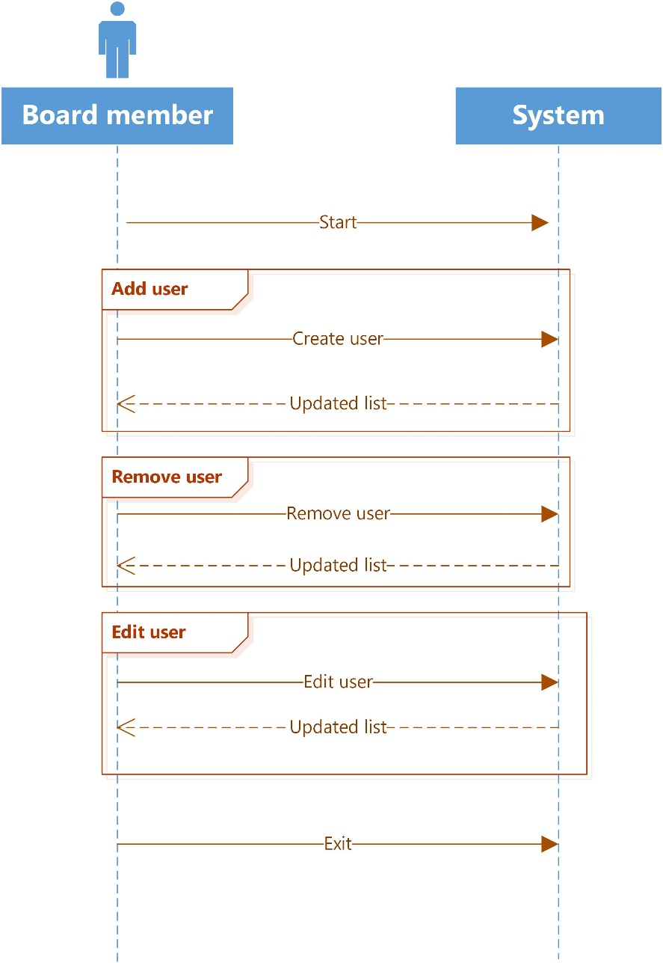

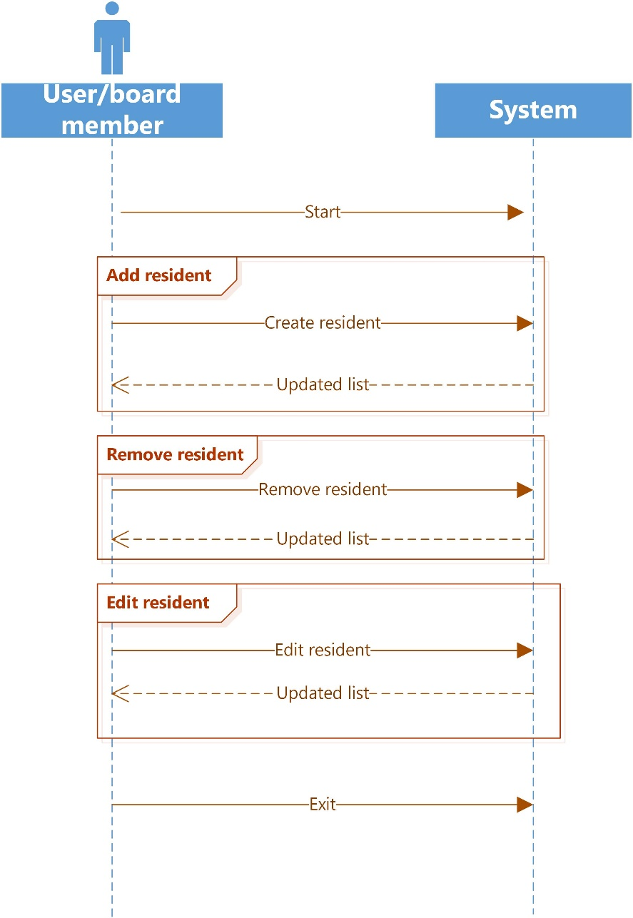

https://en.wikipedia.org/wiki/Business_Model_Canvas https://canvanizer.com/new/business-model-canvas
https://www.mindtools.com/pages/article/newTMC_08.htm https://en.wikipedia.org/wiki/Porter%27s_five_forces_analysis
http://www.test-institute.org/What_Is_Software_Risk_And_Software_Risk_Management.php
Applying UML and patterns by Craig Larman
https://en.wikipedia.org/wiki/Use_case http://searchsoftwarequality.techtarget.com/definition/use-case
http://www.ambysoft.com/unifiedprocess/aup11/html/elaboration.html

