SDC HACKATHON 2026
Technical & Tools Declaration
Hosted by Xiamen University Malaysia (XMUM) AI Club
Submission Deadline: 1st November 2026
Instructions: Declare every API, cloud service, AI tool, dataset, model, and sponsor resource your team used to build the project. Complete every section; where a category does not apply, tick “No” or write “None” – do not leave it blank. Submit as a single PDF document named “SDC2026_TeamName_TechDeclaration.pdf” together with your project submission. Undeclared third-party resources discovered at judging may affect your score or eligibility.

1. Team & Project Overview
Team Name | Hands Off Our Rights
Project / Solution Name | Future Skills: find the part of IT that suits you, and the job to aim for
Name (Leader) | Hong Zhi Yang
Email & Phone (Leader) | zhiyang19015@gmail.com | +60 11-4035 9109
University Affiliation(s) | Universiti Tunku Abdul Rahman (UTAR)
Live Prototype URL | https://future-skills.replit.app
Code Repository URL (public / access granted to judges) | https://github.com/pekoremon/future-skills

2. Architecture & Technology Stack

2.1 System Architecture Overview
Describe how the components declared in this document connect end-to-end (e.g., user interface → backend → AI model/API → database → cloud hosting). Attach a system block diagram as an appendix if available.
[Maximum 200 words]
The browser front end (plain HTML, CSS and JavaScript, no build step; English, Bahasa Melayu and Chinese) opens on the Future Skills Radar, then guides a student through an optional CV upload, a 36-item interest questionnaire and a short skills test on the 3–5 IT areas these point to. PDF CVs are read with PDF.js and Python answers run with Pyodide, both in the browser.
The back end is one Python 3.12 program using only the standard library. It scores the questionnaire and test, matches the student to 25 roles in 5 IT areas, applies three future scenarios, and builds learning paths and SDG contributions from CSV tables in data/ (O*NET, DOSM, MyCOL, arXiv, courses), where every row carries its source and date. SQL answers run in a read-only, in-memory SQLite database.
Only the CV reader and “Why this job?” call an LLM: gpt-5.4-mini through the SDC sponsor KrackedDevs gateway, an OpenAI-compatible API; if the call fails, rule-based text is shown. “Update data” refreshes trend inputs from the OpenDOSM and arXiv APIs. Hosting: Replit Deployments; code: GitHub. Block diagram: Appendix A.

2.2 Languages, Frameworks & Libraries
List the main programming languages, frameworks, and third-party libraries that your team did not create. Open-source use is permitted provided it is declared and properly licensed/attributed.
Name & Version | Purpose in Project | License
Python 3.12 standard library (http.server, sqlite3, csv, json, gzip, urllib, unittest) | Back end, data scripts, 216 automated tests; no third-party Python packages | PSF License
JavaScript (ES2020), HTML5, CSS3 | Web front end, written by the team without a framework | Open web standards
Pyodide 0.26.4 (jsDelivr CDN) | Runs students' Python code answers in the browser | MPL 2.0
PDF.js 3.11.174 (Mozilla, cdnjs CDN) | Reads the text of a PDF CV in the browser | Apache 2.0
SQLite (bundled with Python) | Read-only, in-memory database for SQL test answers | Public domain
UN SDG icons | The 17 goal tiles on matches and learning paths | UN SDG icon guidelines (information use)
Google Fonts: Press Start 2P, Orbitron, Pirata One | Display fonts for the optional game themes (play.js) | SIL Open Font License 1.1
Unsplash photos (images.unsplash.com) | Background photos on the landing pages (fx.css, fx.js) | Unsplash License

3. APIs & Cloud Services

3.1 External APIs
List every external API your solution calls (GenAI, maps, payments, messaging, data feeds, etc.). Do not include API keys or secrets in this document.
API & Provider | Purpose in Project | Access Tier (free / paid / sponsor-provided)
KrackedDevs LiteLLM gateway (litellm.rapidscreen.io, OpenAI-compatible) | Live: CV reading and the “Why this job?” text with gpt-5.4-mini | Sponsor-provided (KrackedDevs keys)
Fireworks AI chat completions API (OpenAI-compatible) | Same features with gpt-oss-120b until 31 Oct 2026; kept as a drop-in alternative | Paid (team's own account)
OpenDOSM / data.gov.my Data Catalogue API (DOSM) | Employment and wage data for the “Update data” trend refresh | Free, no key
arXiv API (Cornell University) | AI paper counts per IT area for the AI-momentum signal | Free, no key
jsDelivr and cdnjs (public CDNs) | Serve Pyodide and PDF.js to the browser | Free
Microsoft Learn Catalog API, YouTube oEmbed (development only) | Collecting course details and checking that every learning link opens (check_links.py) | Free, no key

3.2 Cloud Platforms & Deployment
List every cloud service used for hosting, storage, databases, authentication, or compute, and indicate how the prototype is deployed.
Service & Provider | Purpose in Project | Plan / Region
Replit Deployments (Replit) | Hosts the live prototype; the LLM key is kept in Replit Secrets | Cloud Run deployment target, Replit default region; SDC sponsor credits
Replit Workspace (Replit) | Shared development, preview and test environment; publishing | SDC sponsor credits
GitHub (GitHub, Inc.) | Public code repository and commit history | Free plan
KrackedDevs LiteLLM gateway | Serves the gpt-5.4-mini model the live app calls | SDC sponsor credits (US$20 keys)
Fireworks AI serverless inference | Served gpt-oss-120b until 31 Oct 2026 | Pay as you go, team's own account
Replit web analytics (Replit) | Page-view statistics Replit Deployments adds to the live site | Included with Replit Deployments
Database, file storage, login | None: data ships as CSV files in the repository; the server keeps only an anonymous SDG tally (random id, role, hours) | Not applicable
Google Forms, Google Sheets and Apps Script (Google) | KPI 1 pilot survey (create-survey-form.gs); answers kept in the team's sheet, no names asked | Free plan

4. AI Tools, Models & Datasets

4.1 AI Models Used in the Solution
List every AI model embedded in or called by your application, including pre-trained, fine-tuned, and self-trained models.
Model & Version | Source / Provider | Usage (pre-trained / fine-tuned / self-trained) | License / Terms
gpt-5.4-mini (OpenAI), live | OpenAI, via the KrackedDevs LiteLLM gateway | Pre-trained, used as is (no fine-tuning) | OpenAI usage policies; KrackedDevs sponsor terms
gpt-oss-120b (OpenAI open-weight, 120B), until 31 Oct | Fireworks AI (accounts/fireworks/models/gpt-oss-120b) | Pre-trained, used as is (no fine-tuning) | Apache 2.0 with the gpt-oss usage policy; Fireworks AI terms
No other model | Matching, test grading, trend scores, scenarios and learning paths are rule-based code written by the team | Not applicable | Not applicable

4.2 Datasets
List all datasets used for training, fine-tuning, evaluation, or in the running application. State clearly if a dataset contains personal or sensitive data.
Dataset Name | Source / URL | Type (public / private / self-collected / synthetic) | License | Personal Data? (Y/N)
O*NET 31.0 Database (skills, technologies, interests, job zones) | https://www.onetcenter.org/database.html | Public | CC BY 4.0 | N
DOSM / OpenDOSM labour, wage, Job Market Insights and Graduates Statistics 2024 | https://open.dosm.gov.my ; https://www.dosm.gov.my | Public | OpenDOSM CC BY 4.0; DOSM releases cited | N
MyCOL 2024/2025 critical occupations list (TalentCorp) | https://www.talentcorp.com.my/mycol/ | Public | Published report, cited | N
arXiv paper counts per category | https://export.arxiv.org/api/query | Public | arXiv metadata CC0 | N
UN SDG targets (233 role/skill links with reasons) | https://unstats.un.org/sdgs/indicators/indicators-list/ | Public; mapping self-made | UN, cited; mapping Apache 2.0 | N
Free course and video links (88 courses, 158 resources: Microsoft Learn, CS50, freeCodeCamp, Cisco, AWS, Google, etc.) | data/courses.csv, data/learning_resources.csv | Public (links and titles only) | Each creator's terms; linked, not copied | N
IT skills test (77 questions) and interest questionnaire (36 items) | data/it_assessment.json, data/interest_items.json | Self-made by the team | Apache 2.0 (project licence) | N
Demo student profiles | data/sample_profiles.json | Synthetic (fictional people) | Apache 2.0 (project licence) | N

4.3 AI-Assisted Development Tools
Tools used to help write code, design, content, or documentation (e.g., chat assistants, code completion tools, image generators). Declaring these tools does not reduce your score; undeclared use may.
Did your team use any generative-AI tool to help create code, design, text, or other project material?
☑ Yes ☐ No
If yes, list them below:
Tool & Version | Used For | Extent of Use (minor / moderate / major)
Claude Code (Anthropic, Claude Opus models) | Writing and testing code, data cleaning and checks, research for sources, drafting documentation | Major
ChatGPT (OpenAI) | Discussing ideas and answering questions in chat; not used to write code | Minor
Replit Agent (Replit) | Deployment settings and publishing on Replit | Minor
persona-panel plugin for Claude Code (Anthropic models) | A simulated panel of 100 AI personas to brainstorm features to add; not used as user evidence | Minor

Briefly describe how your team reviewed, tested, and took responsibility for AI-generated output:
[Maximum 100 words]
The team set the direction, the IT areas, the questionnaire items and the score weights; Claude Code wrote code to that plan. Every change was run before merging: 216 automated tests, a data validator that checks each row has a source and date, a link checker, and a walk-through in the browser on desktop and phone. Data the AI gathered was checked against the original sources. Team members reviewed the code and can explain each part; no number in the app is invented.

5. Sponsor-Provided Resources
Declare any official SDC sponsor-provided GenAI API, cloud credits, tools, mentoring, or data that your team used.
Did your project use any official SDC sponsor-provided resource?
☑ Yes ☐ No
If yes, list them below:
Sponsor | Resource (API / credits / platform / data) | How It Was Used in the Project
Replit | Cloud credits and platform (Workspace and Deployments) | Development workspace, preview and hosting of the live prototype
KrackedDevs | GenAI API (OpenAI-compatible LiteLLM keys, gpt-5.4-mini) | The live CV reader and “Why this job?” explanations

Was the sponsor resource essential to the core functionality of the prototype, or could it be replaced? Explain briefly:
[Maximum 100 words]
Neither is essential. Replit hosts the live prototype, but the app is one Python program with no packages, so it runs anywhere with Python 3.12. KrackedDevs serves the live LLM, but the code accepts any OpenAI-compatible API (we ran Fireworks AI before 31 Oct), and without any key every feature still works with rule-based text. Matching, trends and pathways never use the LLM.

6. Security, Privacy & Responsible Use

6.1 Data Handling & Privacy
What user or personal data does your application collect, store, or send to third-party services (including AI APIs)? How is it protected, and how long is it kept? State “No user data is collected” if applicable.
[Maximum 150 words]
No accounts or logins, and no analytics of our own; Replit Deployments adds its standard page-view script. Answers and learning progress stay in the student's browser (localStorage) and are sent to our server only to compute results; the server keeps only an anonymous tally (random id, role, study hours) for the SDG totals.
If a student uploads a CV, its text goes to our server and, through the KrackedDevs gateway, to the LLM to find evidence per IT area. Before it leaves our server, our code removes IC numbers, phone numbers and emails; the server never writes it to disk, logs or caches it, and the page asks students to leave out their address. “Why this job?” sends only computed match facts. The API key is in Replit Secrets, not in the code. Demo profiles are fictional. The app collects no age, gender or background.

6.2 Known Limitations & Risks
Identify the main technical limitations of your AI components (e.g., hallucination, bias, rate limits, dependency on a single provider) and any mitigation you have implemented.
[Maximum 150 words]
Hallucination: the model only words text. A reply with any number not in our computed facts is rejected and a rule-based text shown; CV quotes not found in the CV are dropped.
Single provider: if the KrackedDevs gateway fails or runs out of credit, every feature still works with fallback text, and any OpenAI-compatible API (e.g. Fireworks AI) can replace it by changing secrets.
Data: role skills come from O*NET (U.S.). Malaysian per-role demand data is thin (DOSM publishes job ads for one IT occupation; MyCOL is one edition), so trend scores are coarse and labelled as estimates; each number shows its source and date, a missing number is never estimated, and a failed source keeps its last good data.
Bias: weights are team choices shown on screen; scores never hide a role.

7. Compliance & Readiness Checklist
Tick all boxes that apply before submitting.
☑ | All APIs, cloud services, AI tools, models, and datasets used in the project are declared in this document.
☑ | All third-party code, datasets, and models are used in accordance with their licenses, and attribution is provided where required.
☑ | No API keys, passwords, or other credentials are exposed in the code repository, prototype, or this document.
☑ | Any use of generative-AI tools for development has been disclosed and reviewed by the team.
☑ | Any use of official SDC sponsor resources has been declared in Section 5.
☑ | The prototype described here is accessible to judges through the links provided in Section 1.
☑ | All fields in this template have been completed within the word limits stated.

8. Declaration
By submitting this document, the team leader confirms that the information provided is complete and accurate to the best of the team’s knowledge, and that every API, cloud service, AI tool, dataset, model, and sponsor resource used in the project has been declared.
Team leader: Hong Zhi Yang Signature: 
Date: 1 November 2026

Appendix A. System block diagram
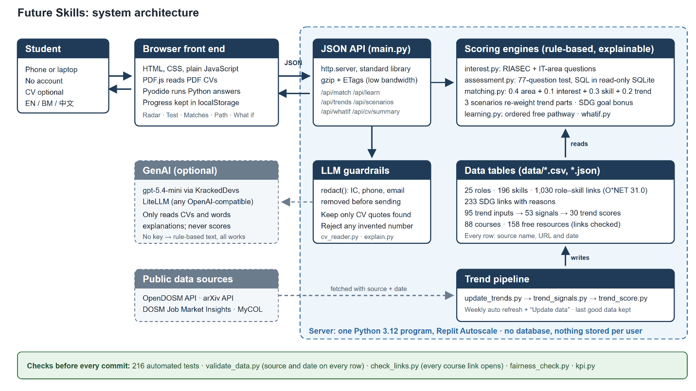
Solid boxes run on our server; dashed boxes are outside services. The LLM is optional: without a key every feature still works with rule-based text.

