Below are the results

node liri.js movie-this shazam

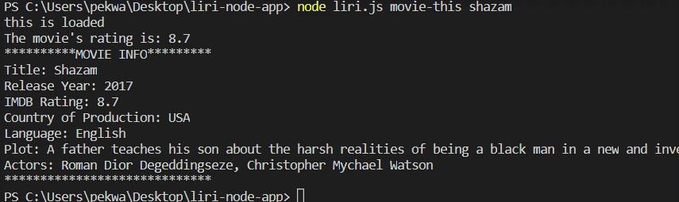

Results for undefined movie

node liri.js movie-this

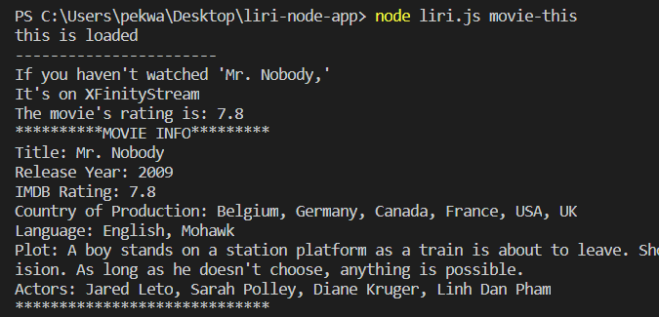

node spotify-this-song love

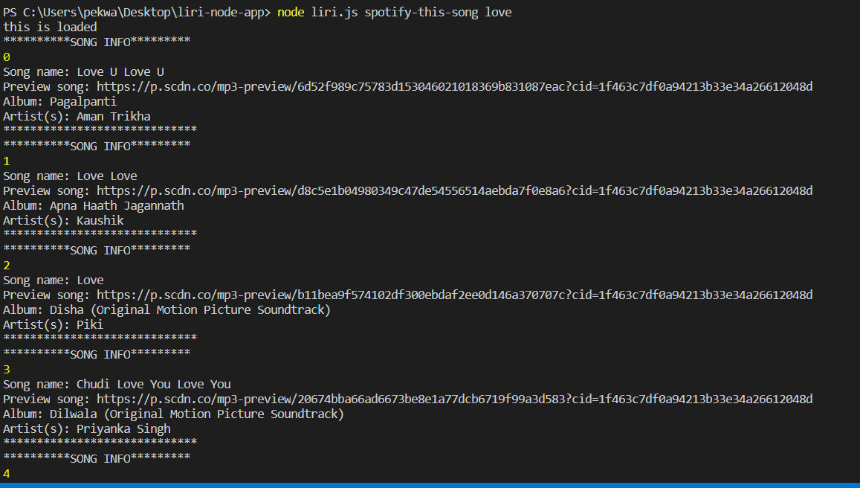

node spotify-this-song

For undefine parameter default song is hello

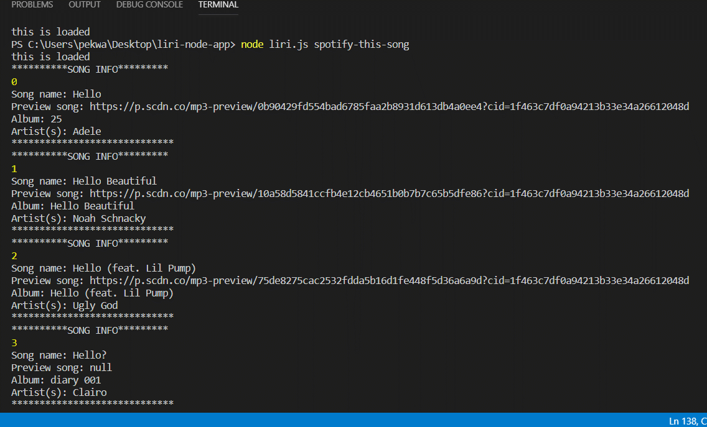

Concert-this The Raconteurs

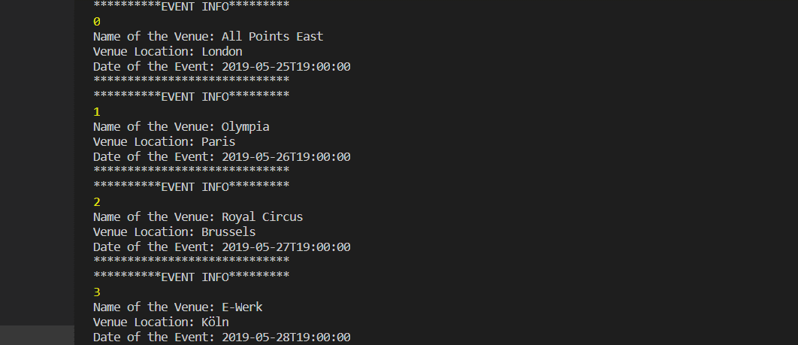

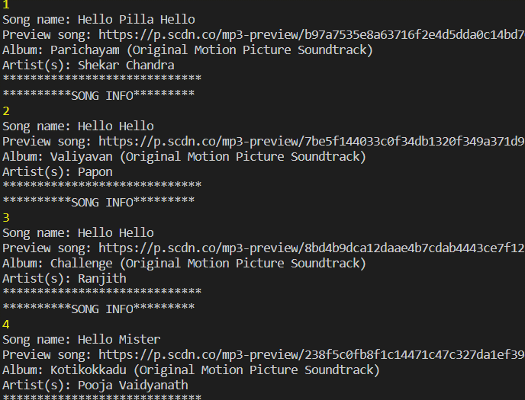

Node liri.js do-what-it-says

