BamazonCustomer.js

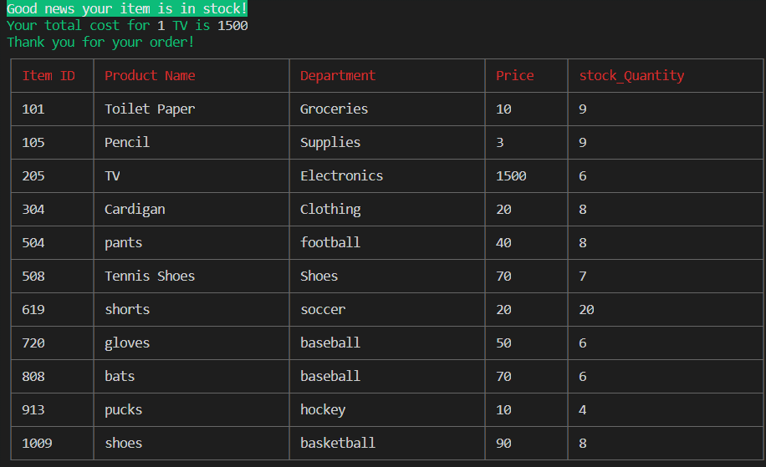

If the quantity order is <0

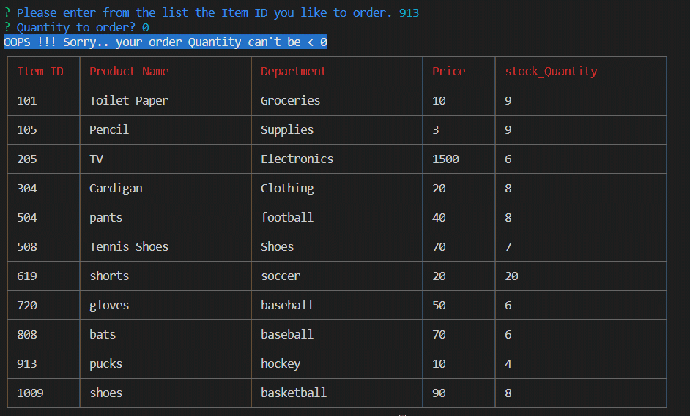

If the quantity is more than the quantity in stock

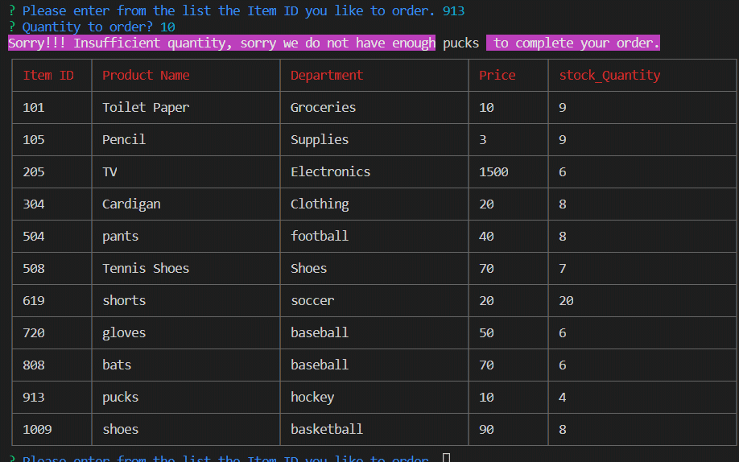

bamazonManager.js

I’ve completed 3 modules

View Products for Sale

View Low Inventory

Add to Inventory

