
VideoXpert 3.10 – Generic Access Control Server - Installation and Operation Guide

Contents
Introduction 4
Version Information 4
Integration Component Version 4
System Overview 5
Event Service 5
Administration Tool 5
Installer 5
Installation 6
Example Code 6
Generic Access Control Service 6
Code 7
Build Tools 7
GenericAccessControlEventService Project 7
VxEventServer Project 7
VX_ACS_Administration project 7
Running from the IDE 7
Operation 10
Administation Program 10
Settings Tab 10
Camera Associations Tab 11
Event Map Tab 11
Custom Situations Tab 12
Scripts Tab 13
Script Edit Button 14
Integration Service 15
Operation 15
Communications 15
VxSdk 16
Access Control IPC library 16
Third Party Communication 16
Troubleshooting 17
Console Mode 17
Console Commands 17
XML Files 18
Pelco Troubleshooting Contact Information 19

Introduction
This document is the installation and operation guide for the Generic Access Control Server along with instruction on building the code and making it into an integration for a specific Access Control System.

Version Information

Integration Component Version
# | Component Name | Version | Description
1. | VxSdk.Net | 3.0.33 | SDK used for communications with VideoXpert

System Overview
The Generic Access Control Server is a set of fully functional example code complete with an Administration Application, an Integration Service and an Installer that can be used to develop a working integration between VideoXpert and a specific Access Control System.

Event Service
Upon installation the Generic Access Control Server Service will appear in the Services dialog. The service will be set to run using the Local System account and to start up Manually as it needs configuration. When configuration is saved using the Administration Tool, the user will be prompted to allow the Administration Tool to start the service.

Administration Tool
The Generic Access Control Server Service Administration Tool will need to be used to configure the service. The Administration Tool will appear in the Program Files.

Installer
A Wix based installer is included in the project that registers both the Administation Tool and Event Service and installs all dependencies.

Installation

Example Code
Unzip the GenericAccessControlServer_3.10.0.0.zip file to your hard drive.

Generic Access Control Service
Once you have built the code, run the Setup.msi found in Installer\bin\Release.

Code
The Code is built with Visual Studios 2019. A single Visual Studio Solution is provided that contains all the necessary projects to build the Administration Program, Service and Installer.

Build Tools
- Visual Studios 2019
- Wix ToolSet v3.11.2.4516

GenericAccessControlEventService Project
The GenericAccessControlEventService project is a service with that may also be run in the console for debugging purposes. Console commands (see Troubleshooting section for a list of commands) can be found in the RunInteractive() method of Program.cs, which also contains the main startup method. The purpose of the GenericAccessControlEventService project is to be a host for the VxEventServer.dll.

VxEventServer Project
The VxEventServer library is the workhorse of the service. All communications and forwarding of events between systems is done within this library.

VX_ACS_Administration project

Running from the IDE
The service may be ran from inside the VS IDE. First the VX_ACS_Administration project should be run to configure data for the service.
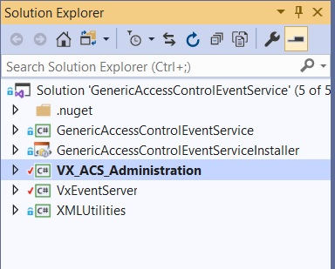
Once configuration is saved, xml files will appear in the executable directory of the Admin App. These files may be copied over to the executable directory for the service.
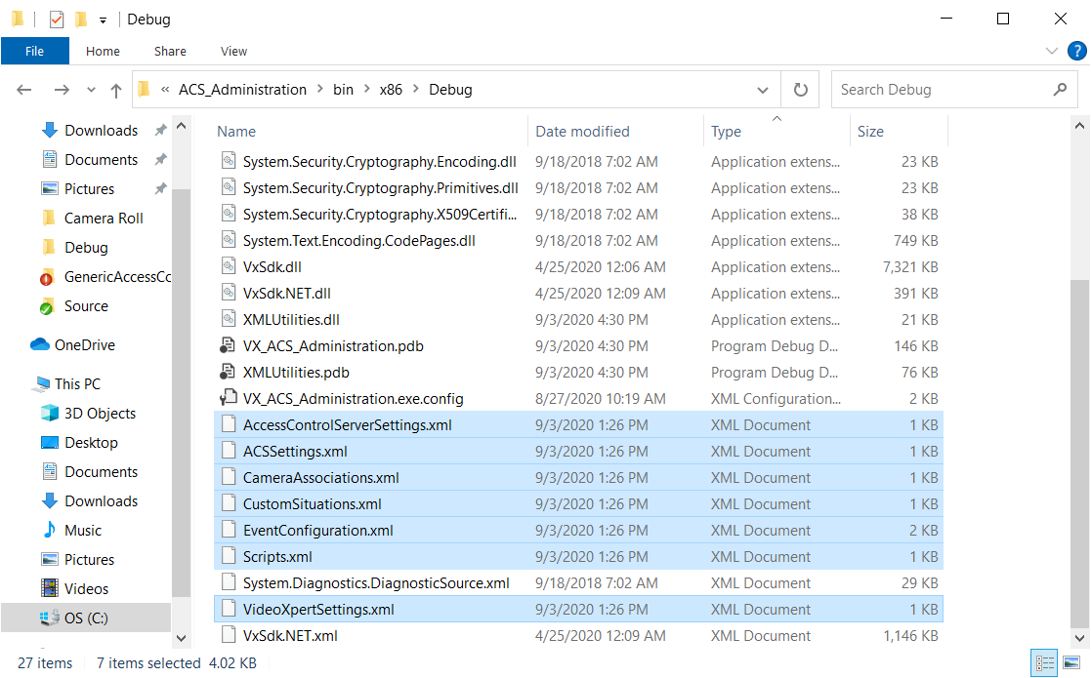

Once the configuration files are copied over, set the GenericAccessControlEventService as the Startup Project and run it. Any further configuration changes will need to be manually copied and the service restarted.

Operation

Administation Program
The Administration Program allows the user to set up configuration used by the Service and will prompt the user to start/re-start the Service upon configuration change.

Settings Tab
The Settings Tab lets you specify connection information to the Access Control System, VideoXpert and the Access Control Server within the Service itself. The sample code fakes the Access Control System (see ACSWrapper.cs) but provides a real connection to VideoXpert and a real Access Control Server that can be queried by the VideoXpert Ops Center Access Control Plugin.
Once the connection parameters have been satisfied, press the corresponding Connect button. If everything is configured correctly, the Connection LED will turn green. Once both connections are established, the remaining tabs may be configured.
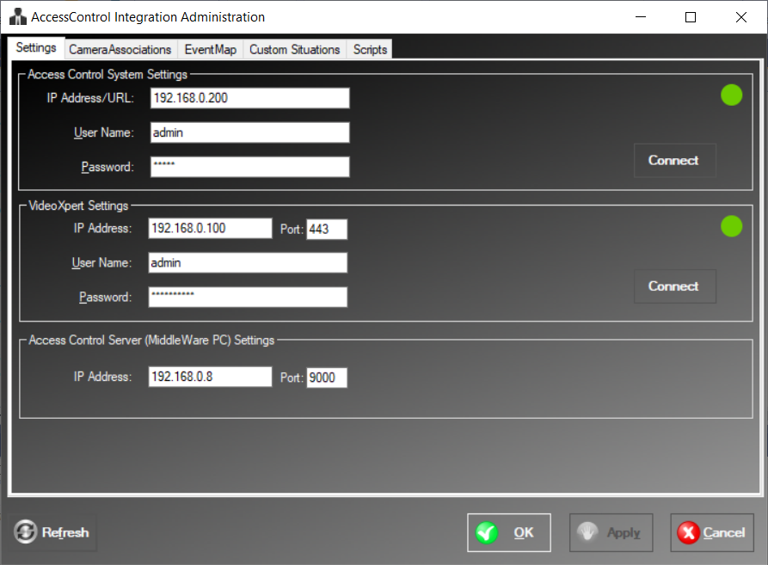

Camera Associations Tab
Camera Associations link a VideoXpert Camera to an Access Control Door and Event associated with the Door. The ACSWrapper.cs class will fake Access Control data while Camera information is retrieved from VideoXpert via the VxSdk. These associations are used to fill our properties when injecting events into VideoXpert that occur on the Access Control System.
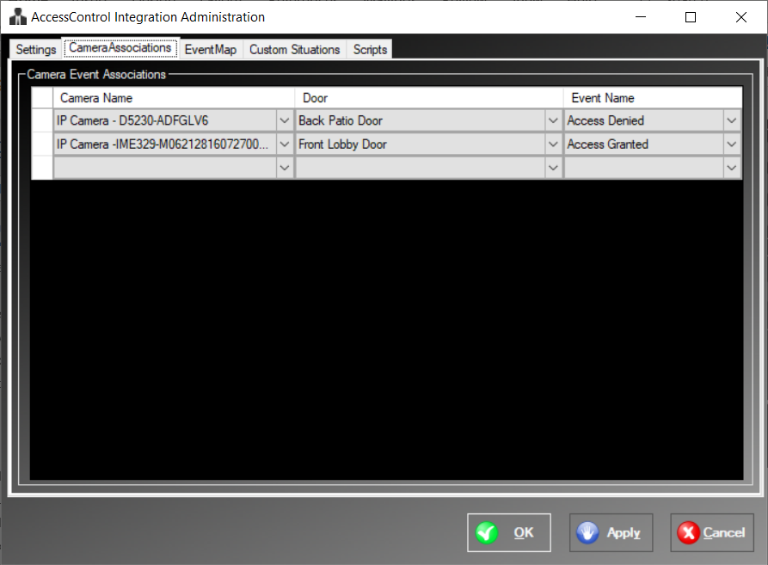

Event Map Tab
The Event Map is used to determine which events are shared between the systems and which direction the events flow. In the screen capture below, Door Open/Closed events will be sent from the Access Control System to VideoXpert and injected as system/access_door_opened/_closed situations while analytic/motion and system/device_offline situations will be injected into the ACS system. At the same time a system/access_door_closed situation in injected into VideoXpert, script 1 is executed and when that event is acknowledged, script 2 is executed.
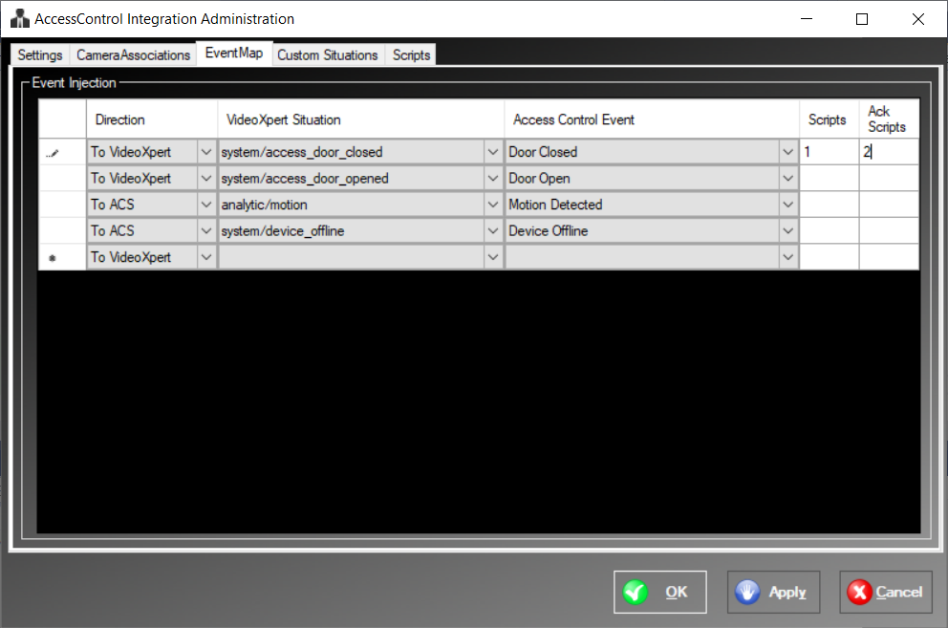

Custom Situations Tab
VideoXpert contains several built-in situations for handling Access Control Events (system/access_denied for instance), but allows for user defined situations called “external” situations which are being referred to here as Custom Situations. Situations defined under the Custom Situations will exist in VideoXpert as “external/<external system>/<external situation type>”. In this case “external/GenericACS/AccessDenied” and “external/GenericACS/AccessGranted” situation types will be added to VideoXpert and may be used by the integration to inject events with. Parameters for how VideoXpert handles the situation can be modified with each situation.
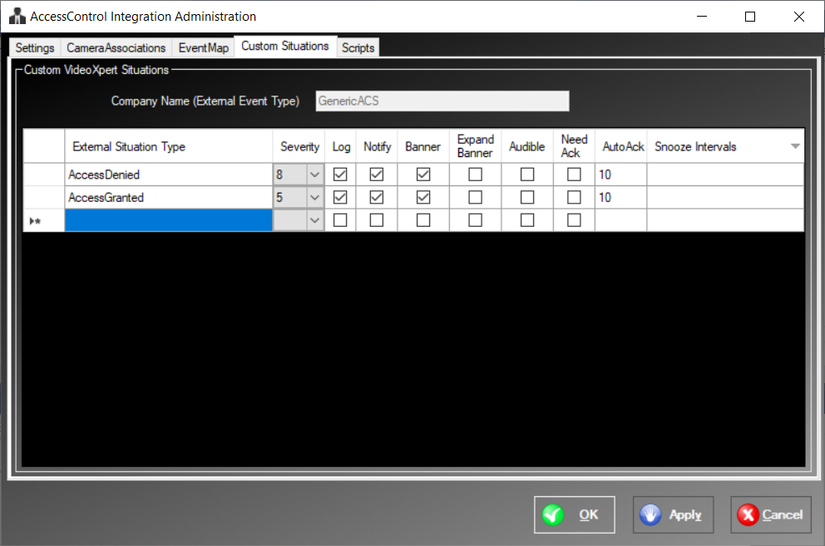

Scripts Tab
The Scripts Tab allows you to define scripts that can be run when matching events occur. The unique Script Number is used to define which script to run from the Event Map screen.
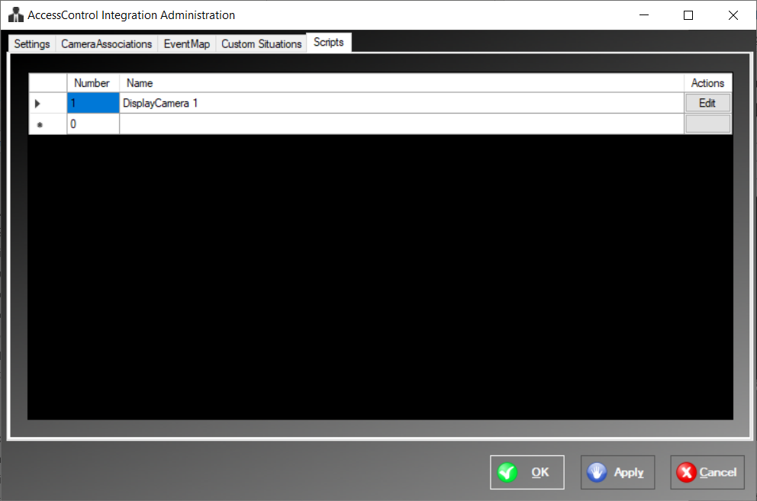

Script Edit Button
The Script Edit Button lets you define the actions within a script. Actions are run in order they are placed in the script. Each action takes different parameters which will be editable if required by the action and blacked out if unavailable for a particular action.

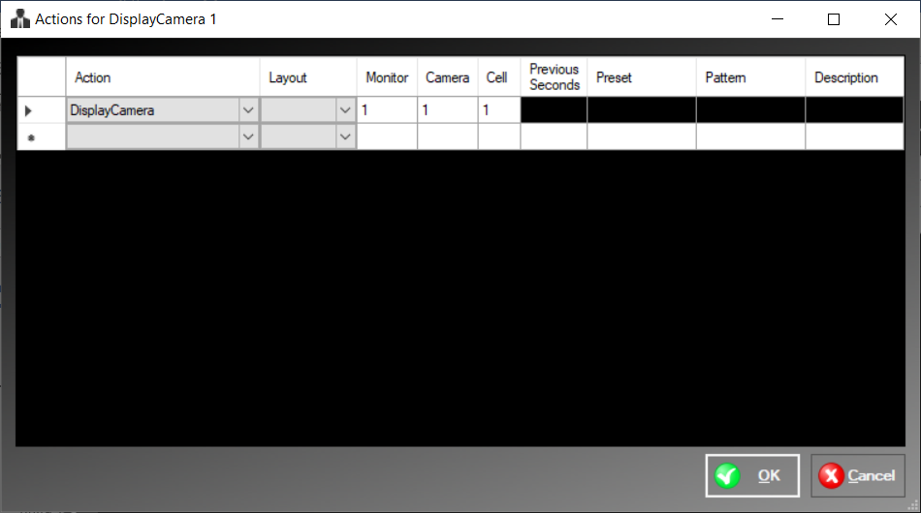

Integration Service
The Integration Service registers as a service and appears in the services.msc dialog where it may be configured manually. The Administation program, when saving a configuration, will prompt the user to start/stop the service which will also set the service to start automatically.

Operation
The Integration Service reads in the xml files created by the Administration Programs for configuration. It will log into VideoXpert, log into the Access Control System (in this case a fake ACS using ACSWrapper.cs) and start the Access Control IPC Server. Heavily used VideoXpert resources are cached and subscriptions to event situations are established. Threads maintain cached information, poll for events from the ACS (if needed) and process events that are queued from either polling events or callbacks.

Communications
There are three main communication pathways maintained by an Access Control Server Service (the MiddleWare).
- From the MiddleWare to VideoXpert. The VxSdk fulfills this communications channel.
- From the MiddleWare to VideoXpert Access Control specific clients. An Access Control IPC Server within the Access Control IPC library is used for this purpose.
- From the Middleware to an Access Control System. To be determined by developer. Code comes with a wrapper class ACSWrapper.cs that contains test data.

VxSdk
Communications between the Administration Application, Service and VideoXpert are provided by use of the VideoXpert VxSdk.Net which is pulled into projects requiring communications with Vx via a Nuget package. This provides the majority of communication with VideoXpert.

Access Control IPC library
The Access Control IPC library provides a simple client/server for use between an Access Control System and VideoXpert components. In this case, the Access Control IPC Server class within the Access Control IPC library is used to provide information to Access Control IPC Clients. The VideoXpert Ops Center Access Control Plugin uses the Access Control IPC Client.

Third Party Communication
Communication to a third-party Access Control System is left up to the developer. Areas of the code that need attention such as this, are marked with comments like // todo:

Access Control System Viewer Plugin
The ACS Plugin is an Access Control IPC client that is able to query the ACS IPC Server built into the Generic Access Control Service. Doors will be listed as Access Points and users will be listed. An image of the selected user will also be shown if available.
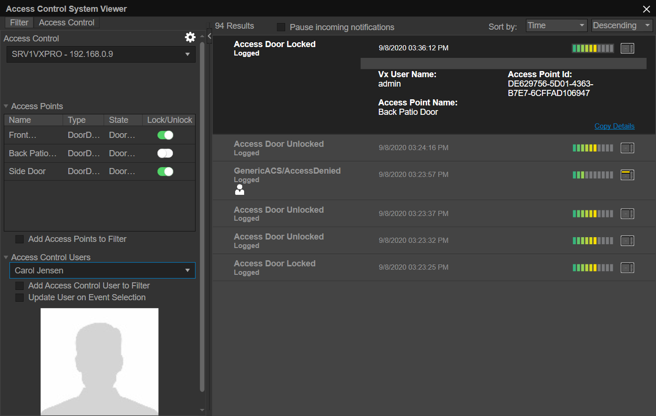

Maps
Once the Generic Access Control Device has registered with the system, the system acts as an Access Control IPC Client. Access Points will be available to place on Maps created within VxToolBox.
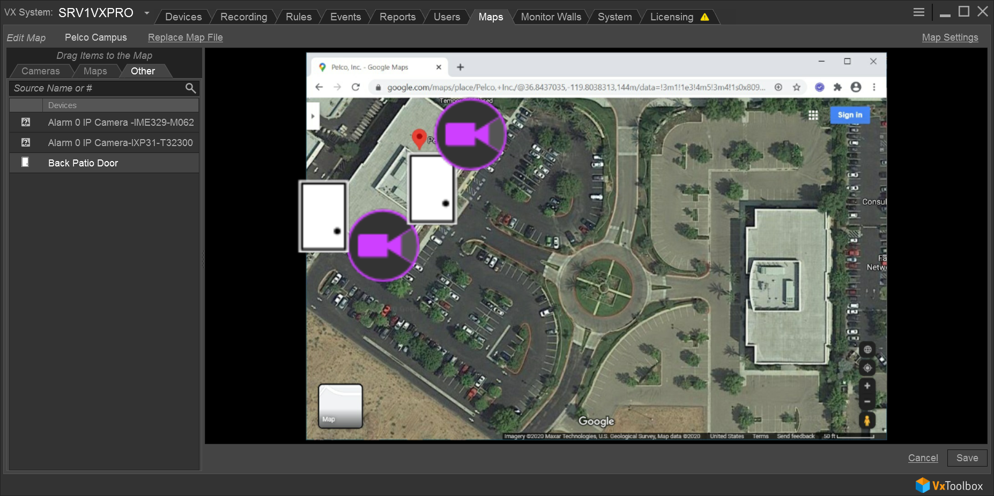
Access Points can then be locked or unlocked from within Ops Center and their status will be shown.

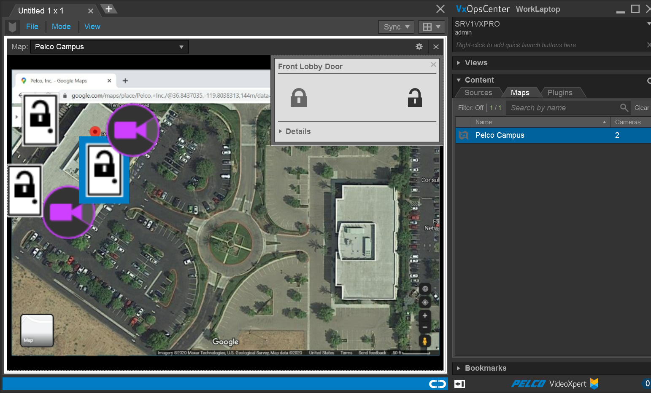

Troubleshooting
The VxSdk outputs a log to C:\ProgramData\Pelco\VxSdk\Logs that will help diagnose commdunication errors with VideoXpert.

Console Mode
The Generic Access Control Event Service may be run from command line or windows explorer in order to debug the service. The console provides debug output as well as several commands to help diagnose issues with the service. The steps to run in console mode are as follows:
- Stop the “Generic Access Control Event Service” from the services.msc dialog if it is currently running.
- Open windows explorer, go to “C:\Program Files (x86)\Pelco\GenericAccessControlEventService” and double click on “GenericAccessControlEventService.exe”.
- The application when run from the command line will start in console mode and provide a list of commands that may be entered from the console. Debug output will also be shown as events occur. Note that typing “Debug 2” in the console will provide verbose debug output.

Console Commands
The following commands are available from the console of the Service:
- "QUIT" to close
- "DEBUG" followed by an integer for the level. Higher numbers output more verbose debug.
- "STATUS" to print current status
- "DATASOURCE" optionally followed by part of a camera name to list datasources
- "MONITOR" optionally followed by part of a monitor name to list monitors
- "SITUATIONS" followed by part of a situation name to list situations containing that substring. (if blank, all situations will be listed)
- "EVENTINFO" followed by part of an application name to list events containing that substring. (if blank, all events will be listed)
- "USERS" followed by a partial username to filter on if desired
- "DOORS" followed by a partial door name to filter on if desired
- "SETDOOR" followed by a partial door name and status (i.e. setdoor front closed)
- "FAKEACSEVENT" to create a random fake event using data from the ACSWrapper class.
- "H" or “?” for help (lists console commands)

XML Files
Data is stored in XML files in the installation directory where the executables live. These files can be viewed with an editor to determine whether or not the expected data is present within. Note that usernames and passwords are encrypted.
Pelco Troubleshooting Contact Information
If the instructions provided fail to solve your problem, contact Pelco Product Support at 1-800-289-9100 (USA and Canada) or +1-559-292-1981 (international) for assistance.


Pelco, Inc.
625 W. Alluvial Ave.
Fresno, CA 93711
Tel. +1 559-292-1981
www.pelco.com

Pelco, the Pelco logo, and other trademarks associated with Pelco products referred to in this publication are trademarks of Pelco, Inc. or its affiliates. ONVIF and the ONVIF logo are trademarks of ONVIF Inc. All other product names and services are the property of their respective companies. Product specifications and availability are subject to change without notice. ©Copyright 2019, Pelco, Inc. All rights reserved.

