1. Examine the site map in Figure 2.30. What type of site organization is used for the JavaJam website? Is it the most appropriate organization for the site? Why or why not?

JavaJam uses Hierarchical & Shallow website organization. JavaJam has a clear homepage with navigation links to major site sections for example in this case menu, music and jobs.

It is the proper organization since it is a commercial site and should be kept relatively simple and easy to navigate. Shallow can be used in this case because there are only 3 content pages, so there aren’t too many navigation links.

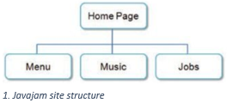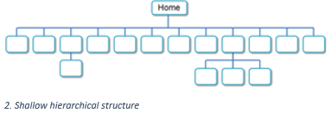

2. Review the recommended web design practices from this chapter. Use the Web Design Best Practices Checklist (Table 5.1) to evaluate the JavaJam site that you created in earlier chapters. Cite three design practices that have been well implemented. Cite three design practices that could be implemented in a better way. How else would you improve the website?

Practises implemented well.

* Consistent site header and logo, the header is entirely made in one CSS-file and therefor is the same on every page.
* No horizontal scrolling or lack of information with 1024 x 768 resolution. With this resolution there is no scrollbar horizontally, the page fits well on the screen and everything except the footer is seen before vertical scrolling.
* To assist screen readers, there is a lang-attribute given in the HTML documents.

Practises that need improvement

* JavaJam website doesn’t work on mobile devices.
* Navigation isn’t structured in unordered list.
* Footer doesn’t have timestamp for latest revision.

Something else to improve.

* Hyperlink for Jobs doesn’t work but still visible on the site.
* The winding road picture could be colour graded to fit the colour scheme better.
* Internet Explorer doesn’t support header image.