HTML:

index/menu/music

index:

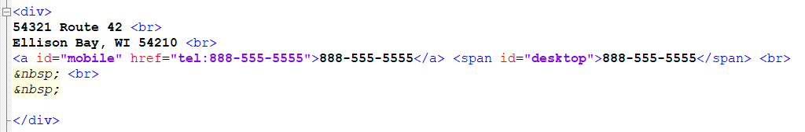

Modified CSS:

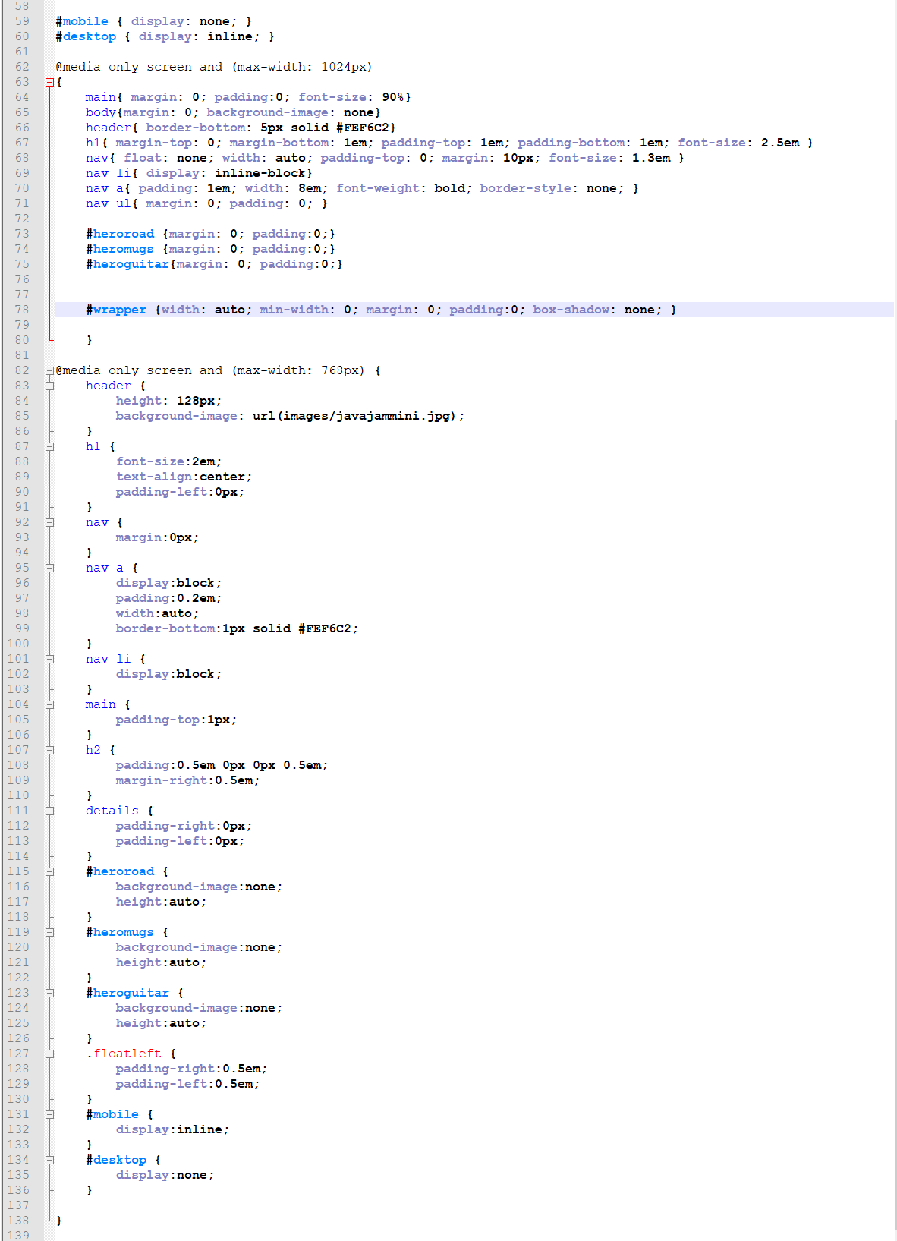

W3C validator tool:

