**Exercise: 7**

**Name: Pekka Lehtola**

**How many tasks did you do:**

**Were the tasks easy, ok, difficult:**

**Do you need help/comments in any task (if yes, to which ones):**

Screen capture of Task 1

Screen capture of the output of Task 1

Screen capture of Task 2

Screen capture of the output of Task 2

Screen capture of Task 3

Screen capture of the output of Task 3

Screen capture of Task 4

Deck class:

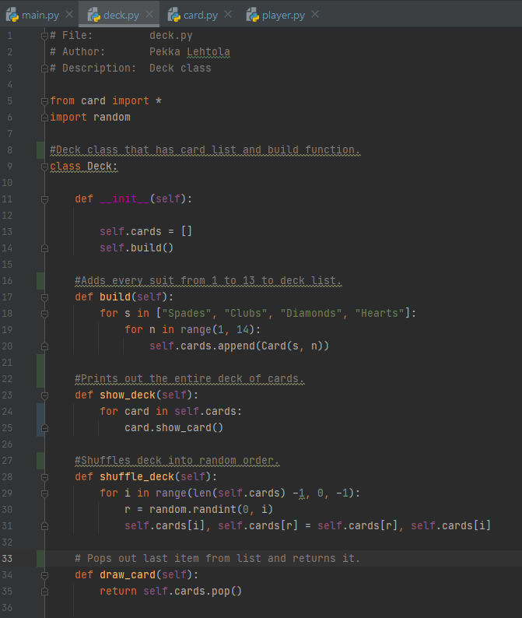

Card class:

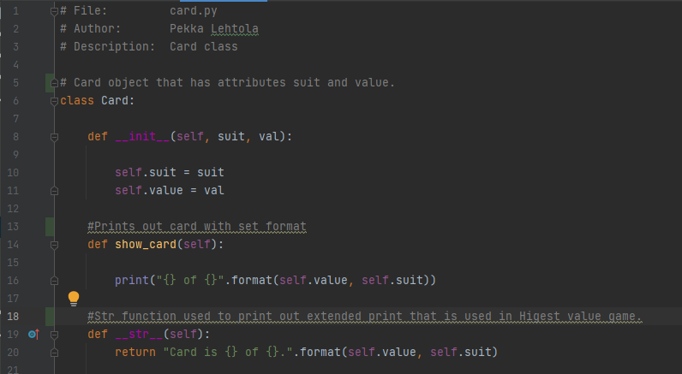

Player class:

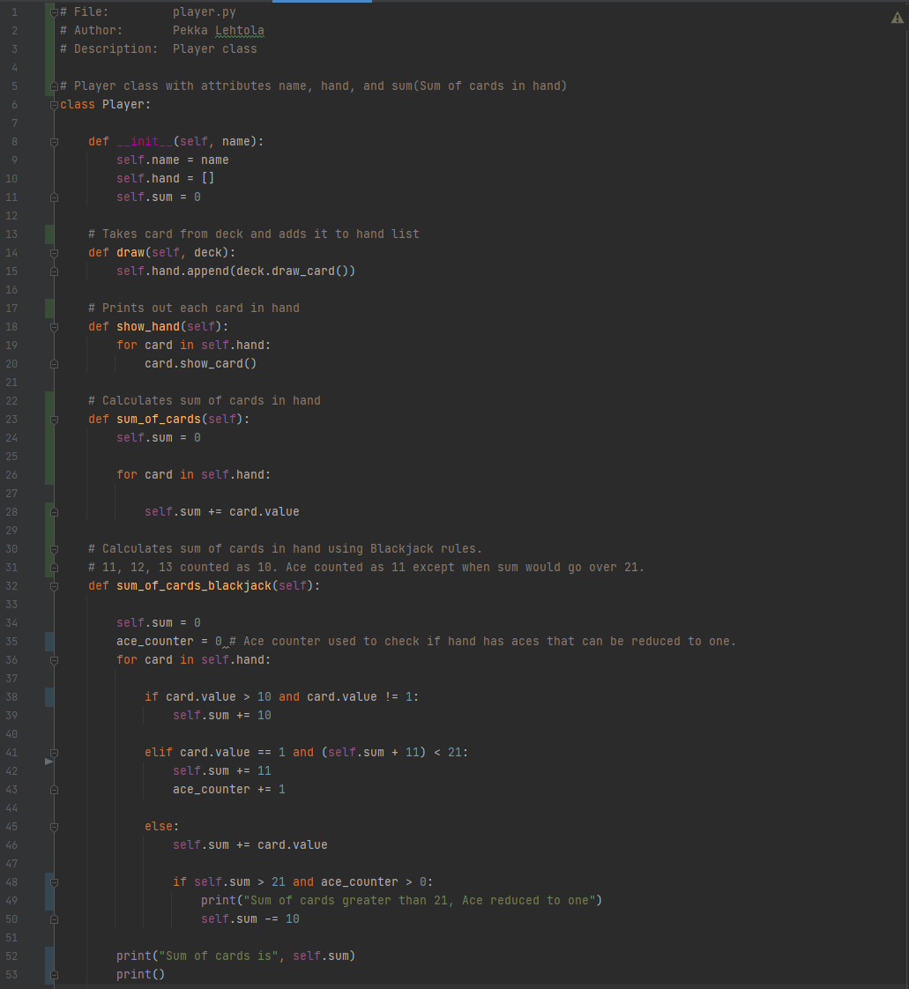

Main without game functions:

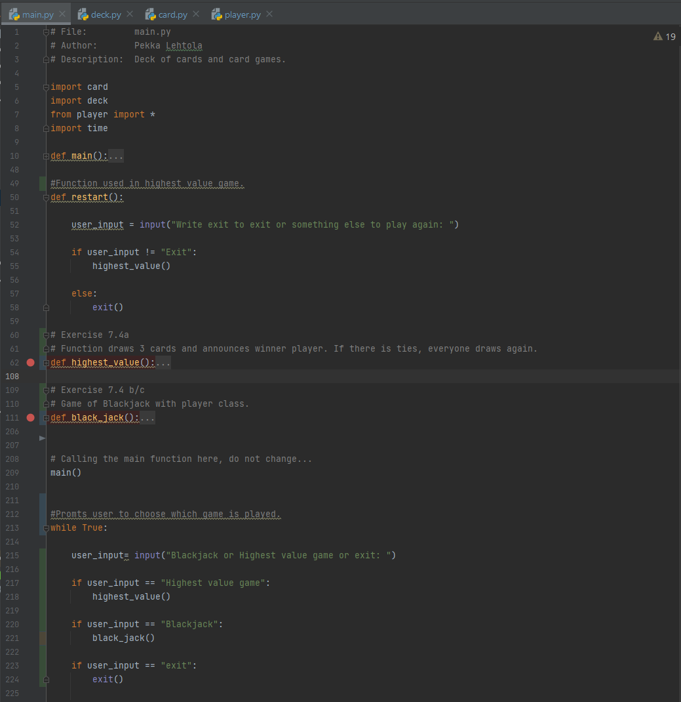

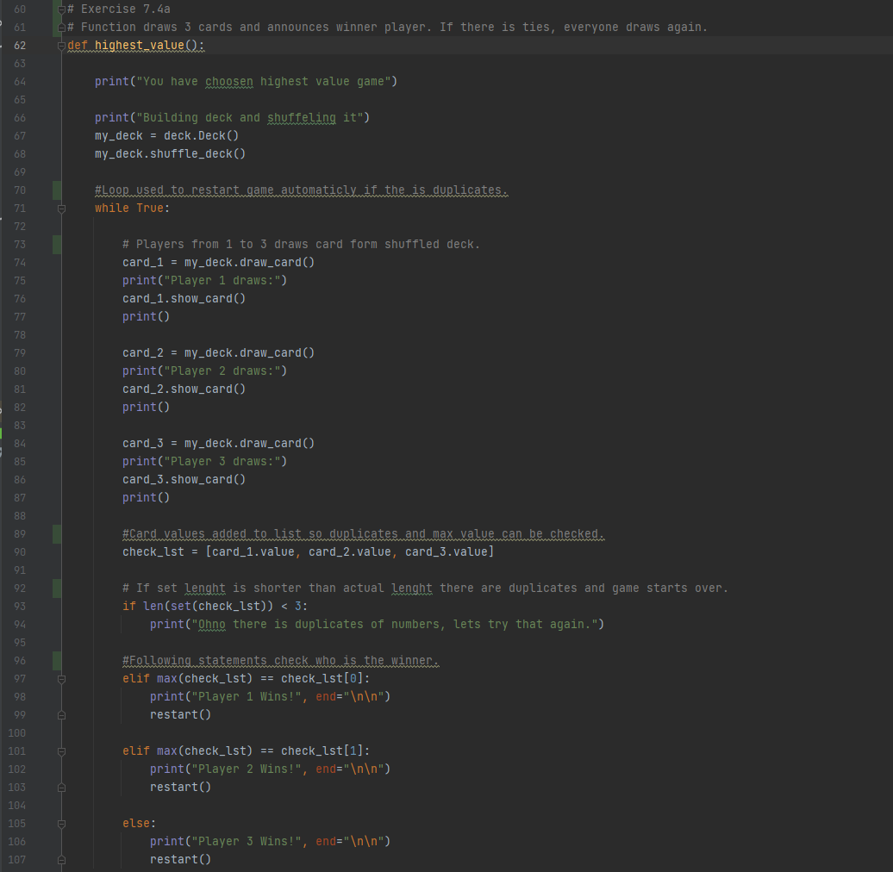Highest value game:

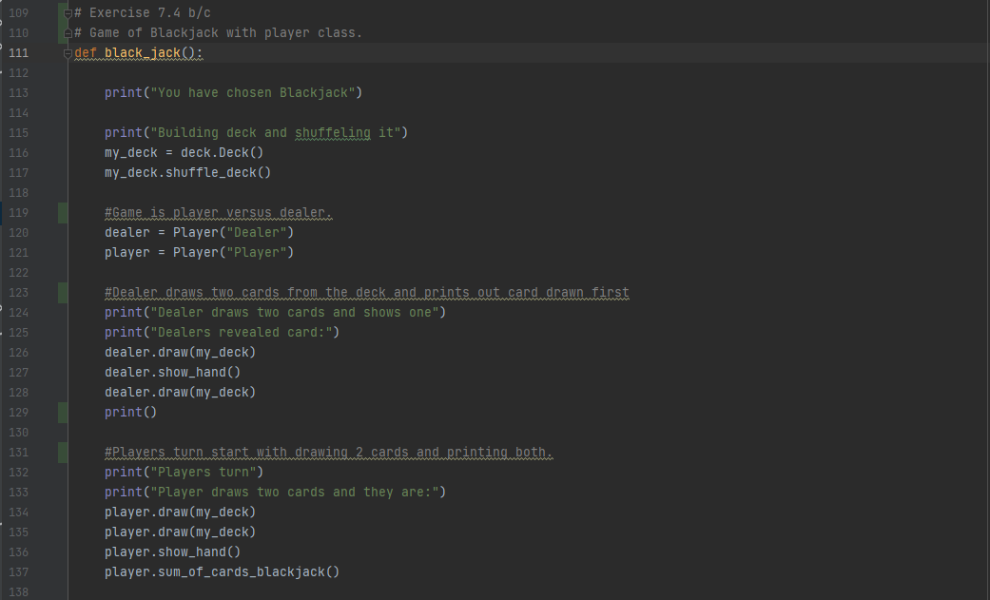Blackjack :

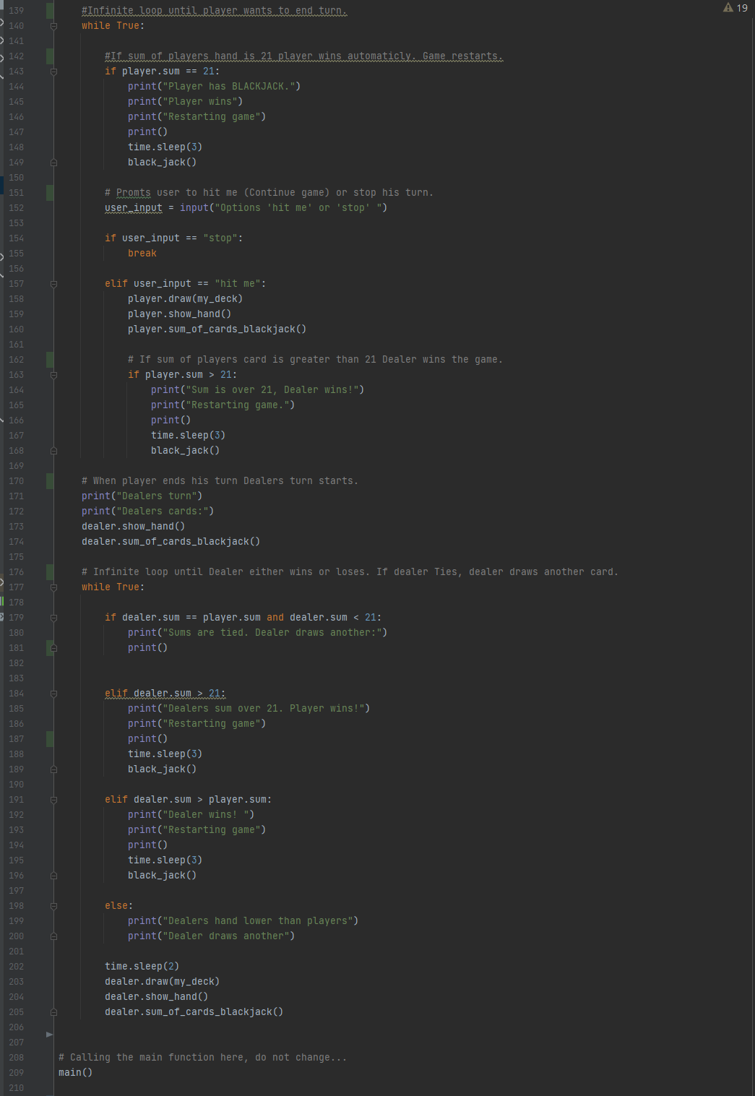

Screen capture of the output of Task 4

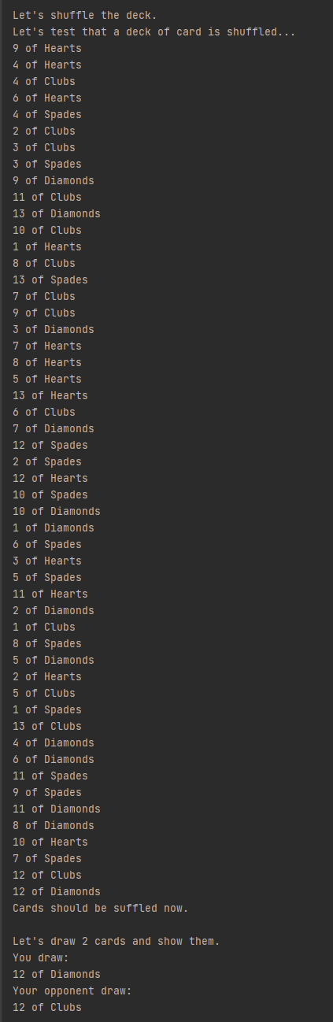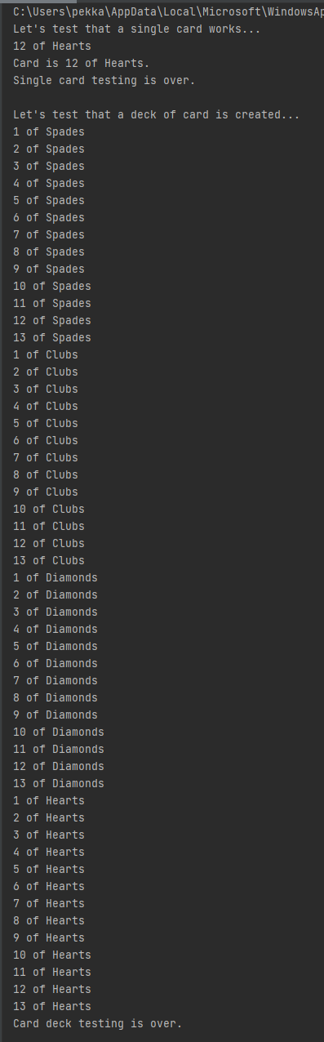Original output 1: Original output 2:

Highest value game output:

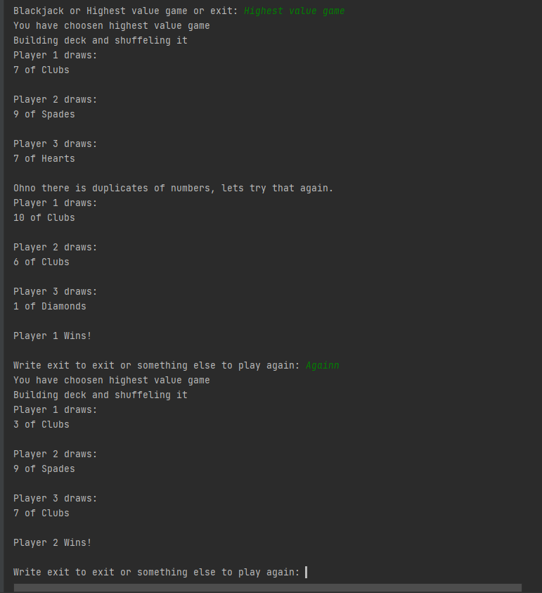

Blackjack output:

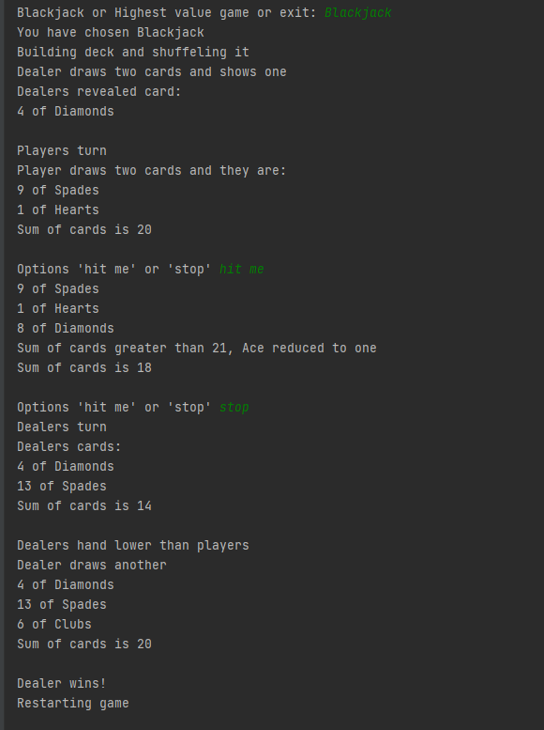

Screen capture of Task 5

Screen capture of the output of Task 5

Screen capture of Task 6

Screen capture of the output of Task 6

Screen capture of Task 7

Screen capture of the output of Task 7

Screen capture of Task 8

Screen capture of the output of Task 8

Screen capture of Task 9

Screen capture of the output of Task 9

Screen capture of Task 10

Screen capture of the output of Task 10

etc.

Screen capture of git log (showing that you made a commit after every task).

Self-assessment:

This exercise was easy/difficult/ok/etc. for me because…

Doing this exercise, I learned…

I am still wondering…

I understood/did not understand that… ; I did/did not know that… ; I did/did not manage to do…