**Exercise work**

**Name: Pekka Lehtola**

**Do you need help/comments:**

**-**

Topic:

Topic for exercise work is two player game called Indians vs. Cowboys.

Schedule:

* Week 1: Core game mechanics working.
* Week 2: UI
* Week 3: Random events.
* Final: Updated graphics.

How I achieve goals:

Working hard on the project and scour the internet about pygame library.

Weekly exercises:

I have done 100% of the weekly exercises.

Time spent on weekly exercises 8h/week.

Project work so far:

Players can move, reload, shoot multiple projectiles at once and characters can be hit.

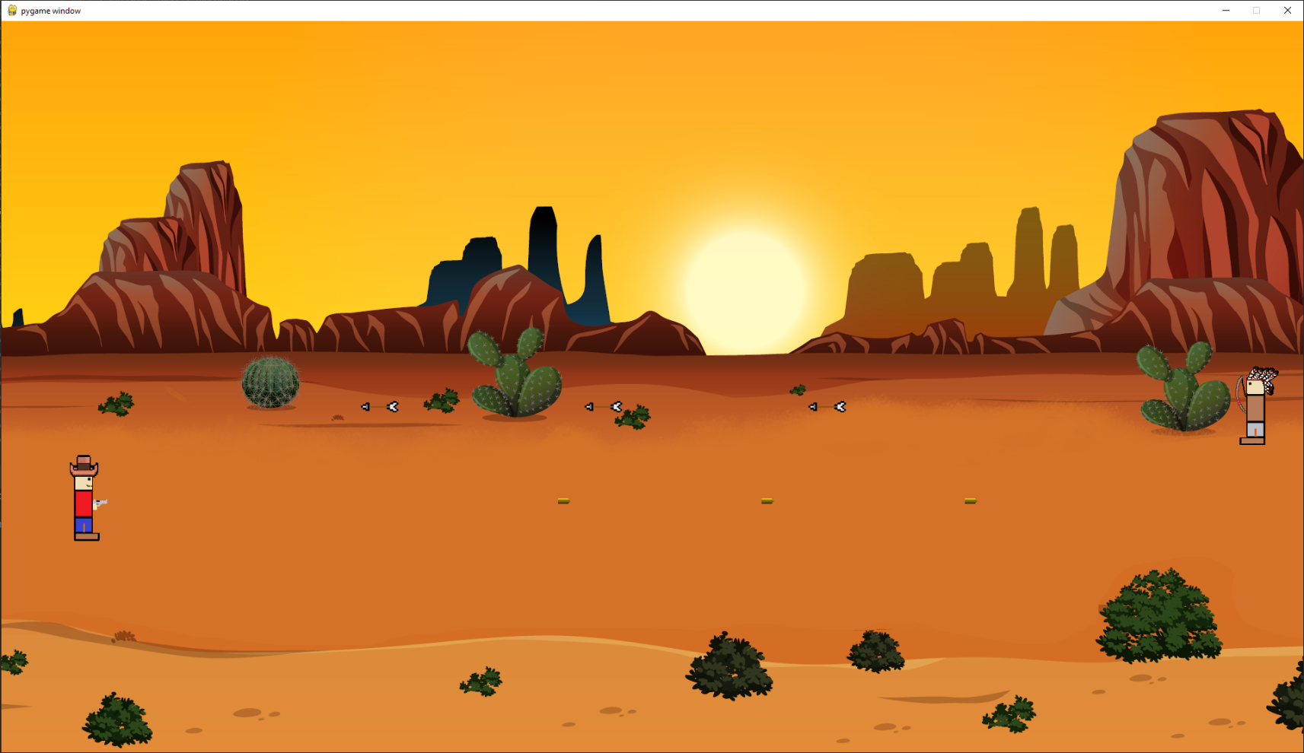

Screen capture of code:

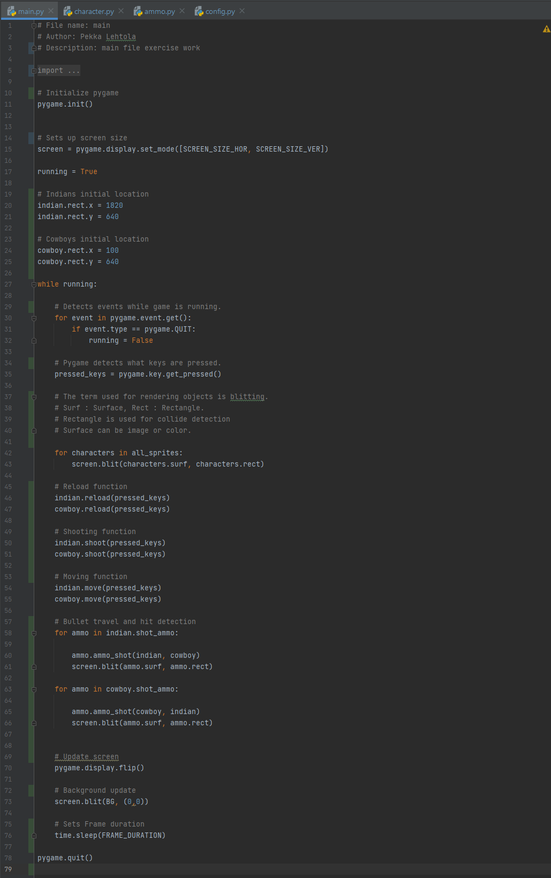Main:

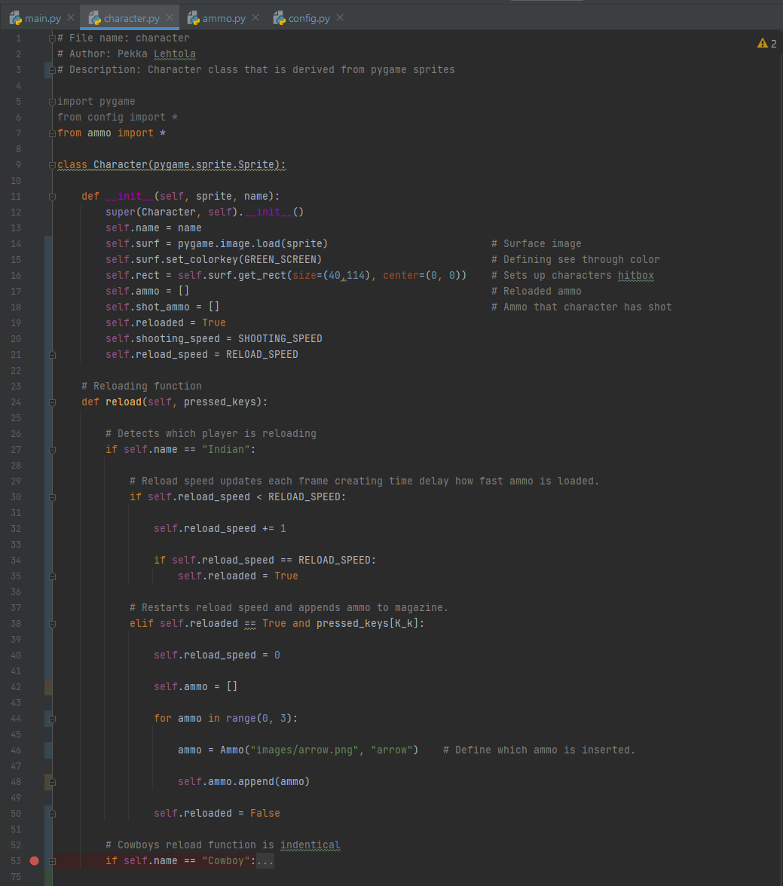Character 1/2:

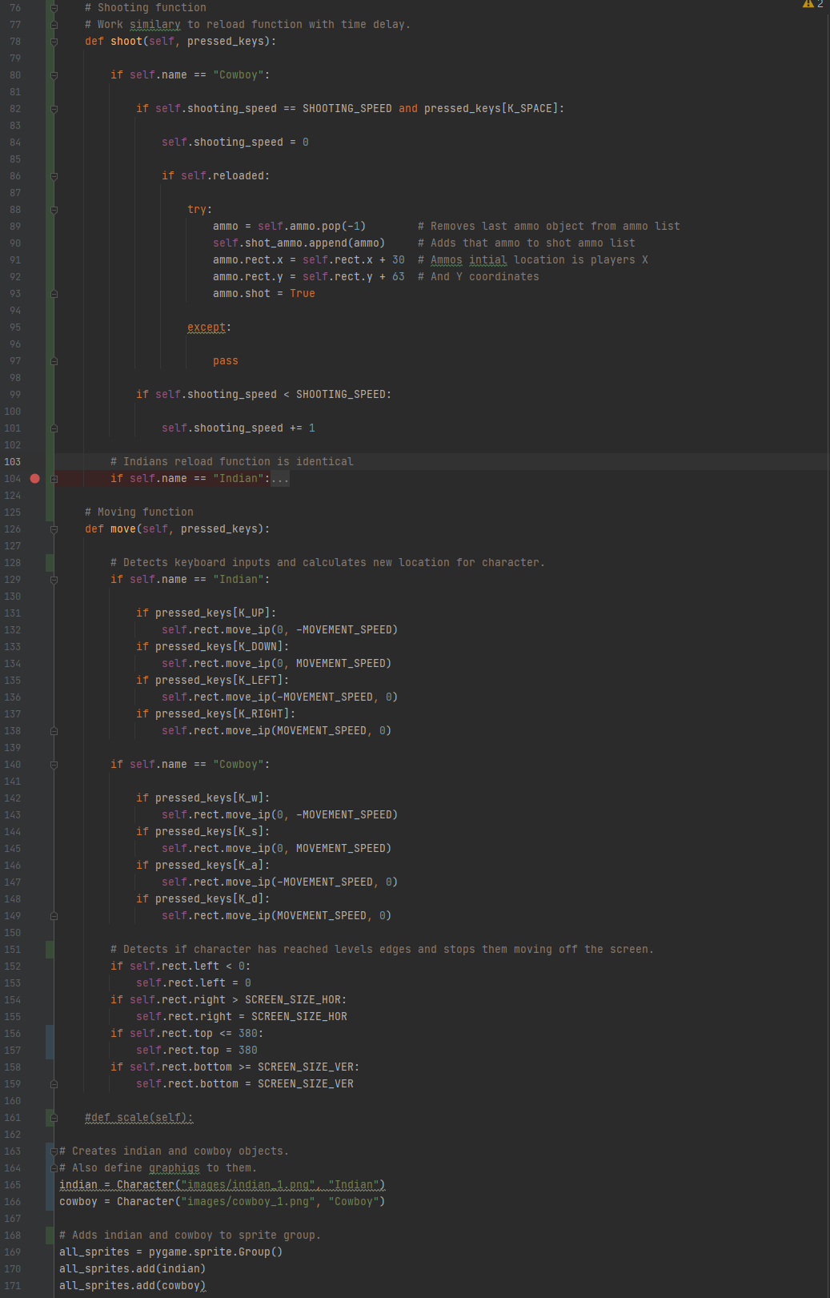Character 2/2:

Ammo:

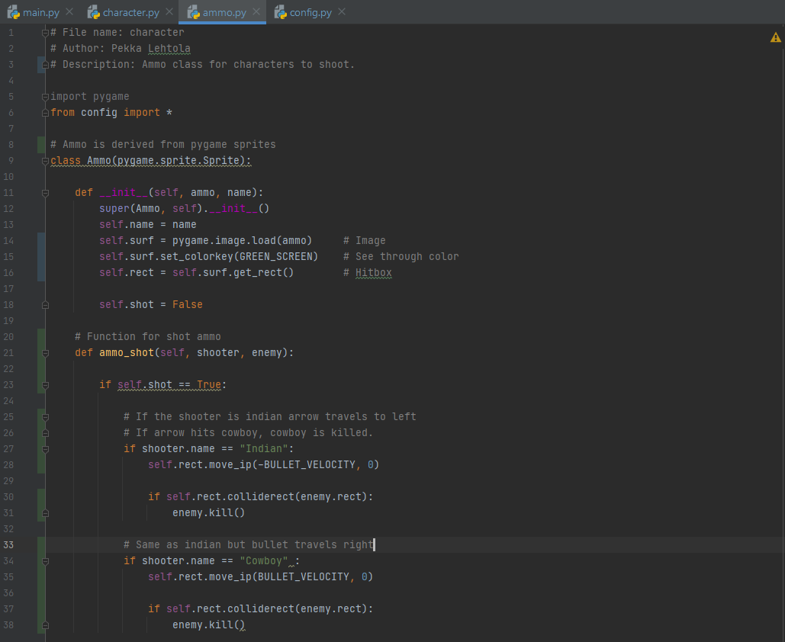

Config:

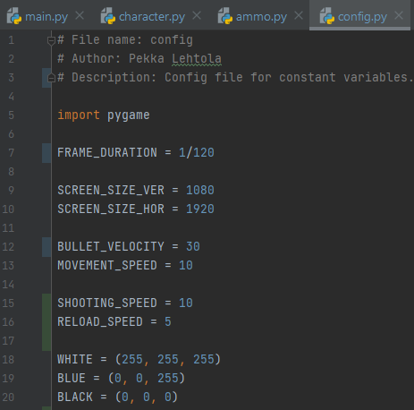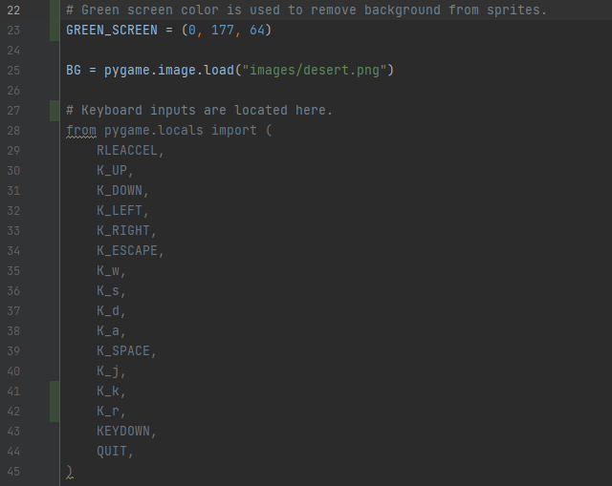

Screen capture of git log:

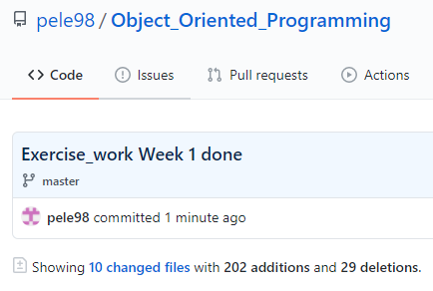

Work done this week: 8h

Self-assessment:

This exercise was easy/difficult/ok/etc. for me because…

Ok

Doing this exercise, I learned…

Oppisin käyttämään pygame kirjastoa hieman enemmän.

I am still wondering…

Pygame eventit eivät oikein vielä onnistuneet.

I understood/did not understand that… ; I did/did not know that… ; I did/did not manage to do…

-