**Exercise work 2**

**Name: Pekka Lehtola**

**Do you need help/comments:**

**UML Sequence diagram**

Schedule:

* Week 1: Core game mechanics working.
* Week 2: UI, UML diagrams, Flow chart
* Week 3: Random events, Inheritance, Polymorphism. Ui class separated to multiple classes
* Final: Updated graphics, UML diagrams and Flow chart final version.

Challenge goal:

Challenging (Grade 4-5)

Work done this week: 12h

What has been implemented / changed:

Ui module implemented.

Characters shooting and reloading updated to use seconds ( Previously used framerate)

Bug fixing.

Initial flow chart and UML diagrams created.

Flow chart and UML diagrams:

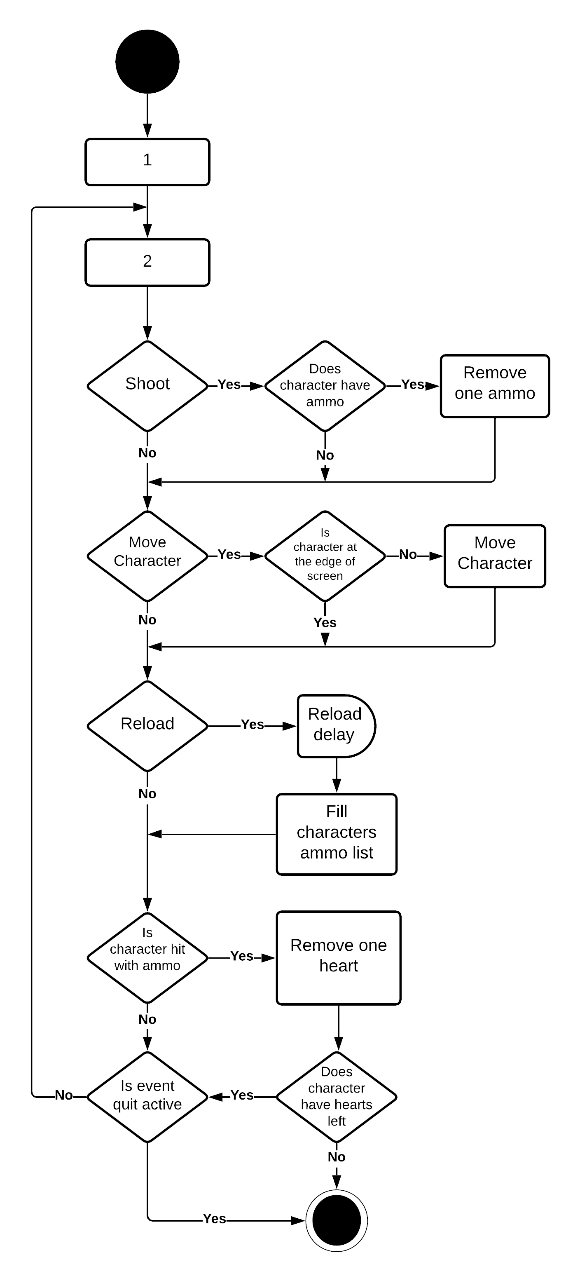Flow chart of main function:

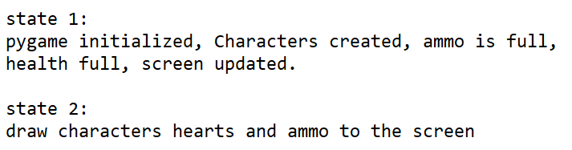

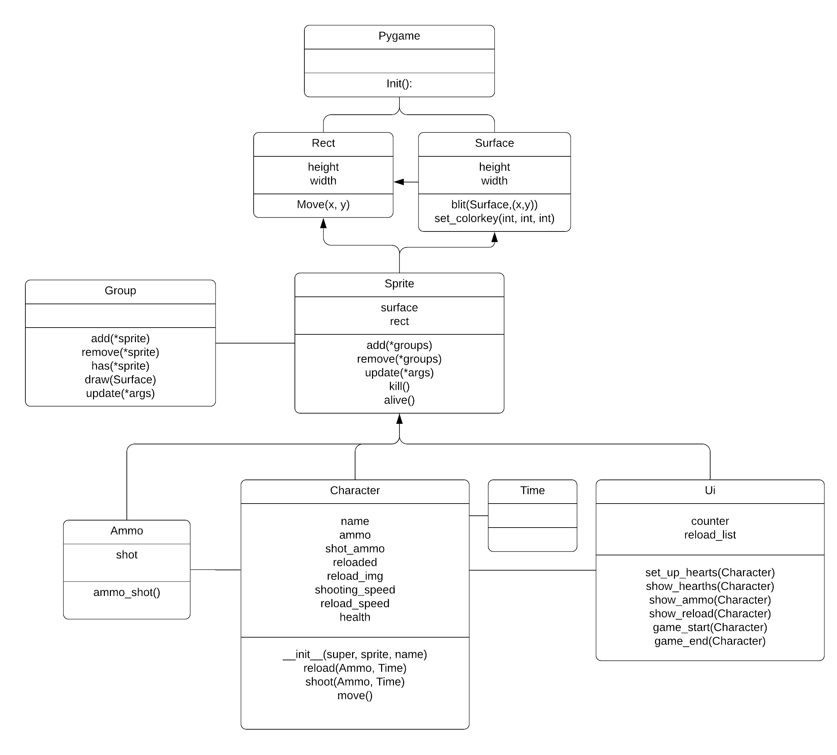Class diagram:

Sequence diagram

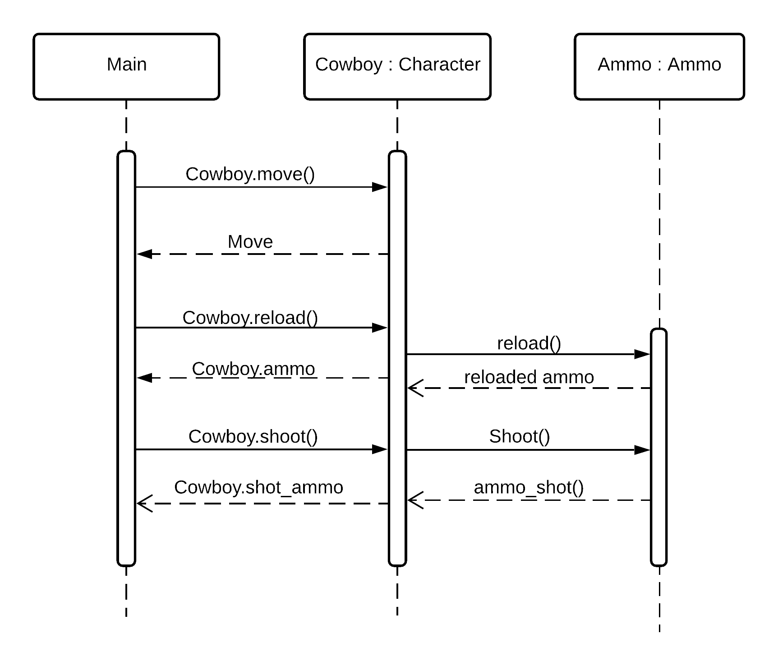

Code:

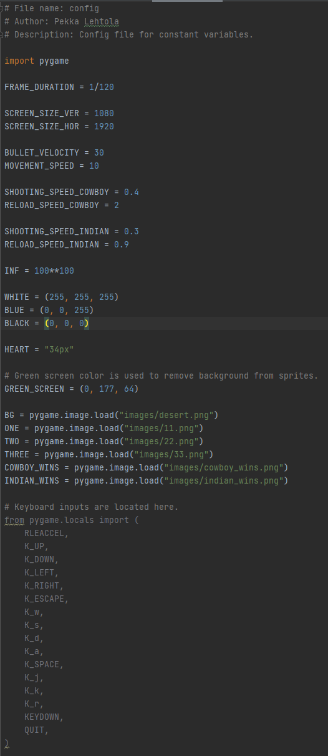Config: Ammo class:

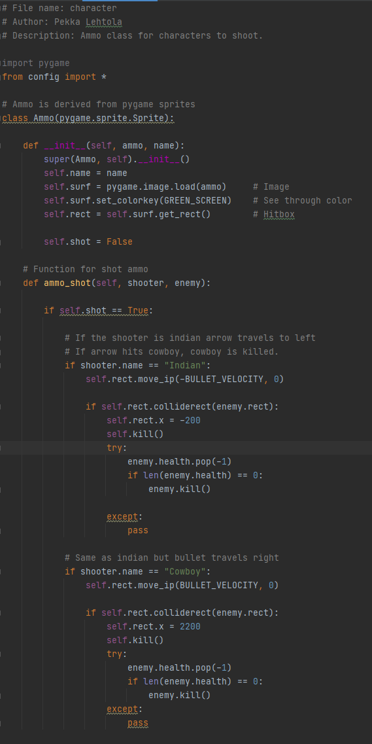

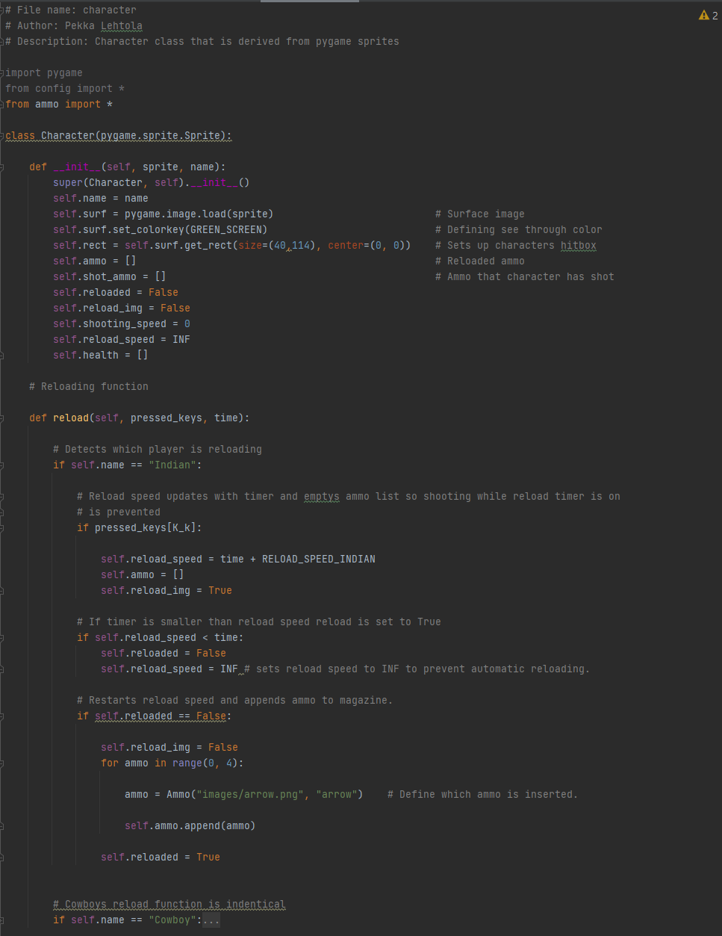Character class 1/2:

Character class 2/2 :

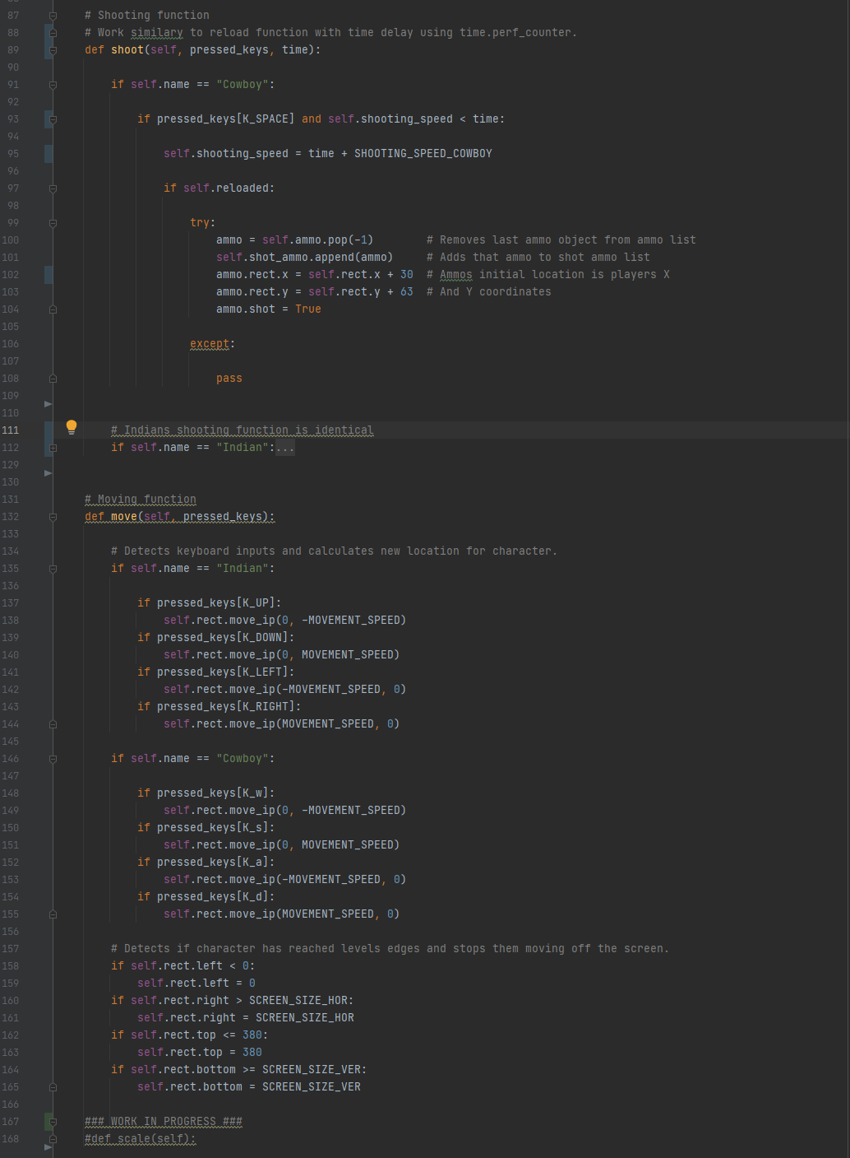

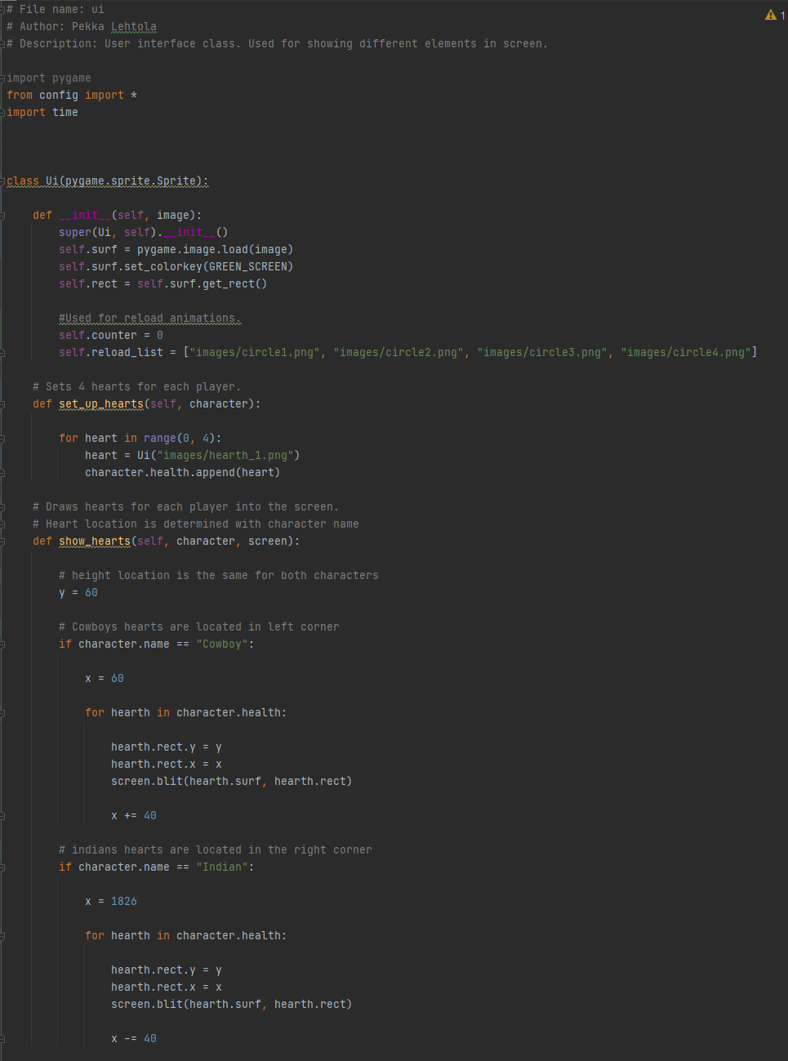Ui class 1/2:

Ui class 2/2:

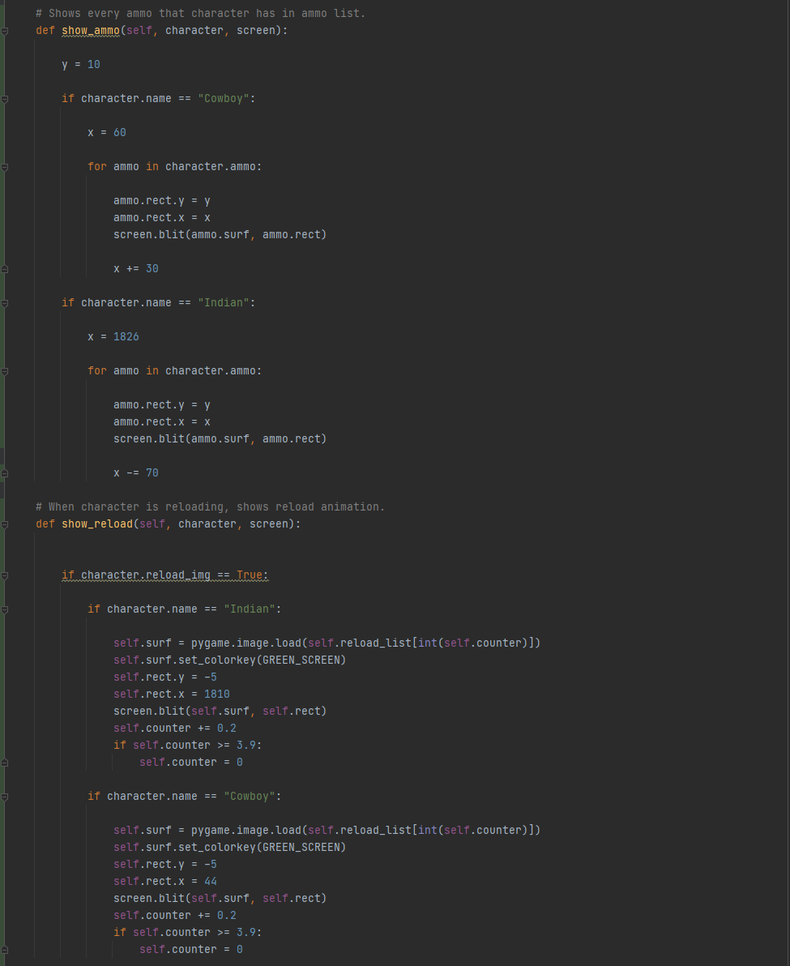

Ui class work in progress:

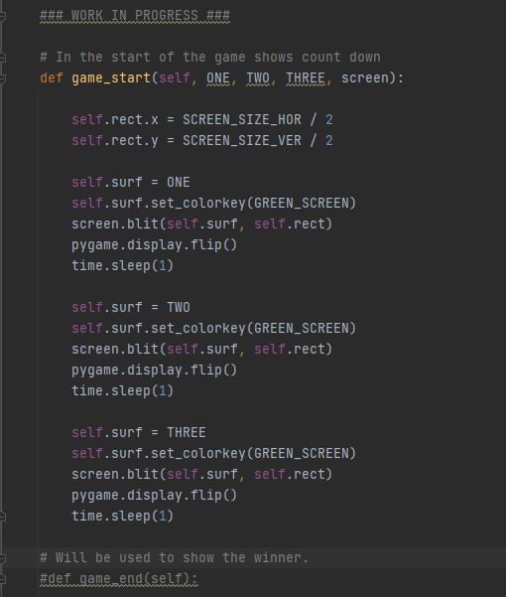

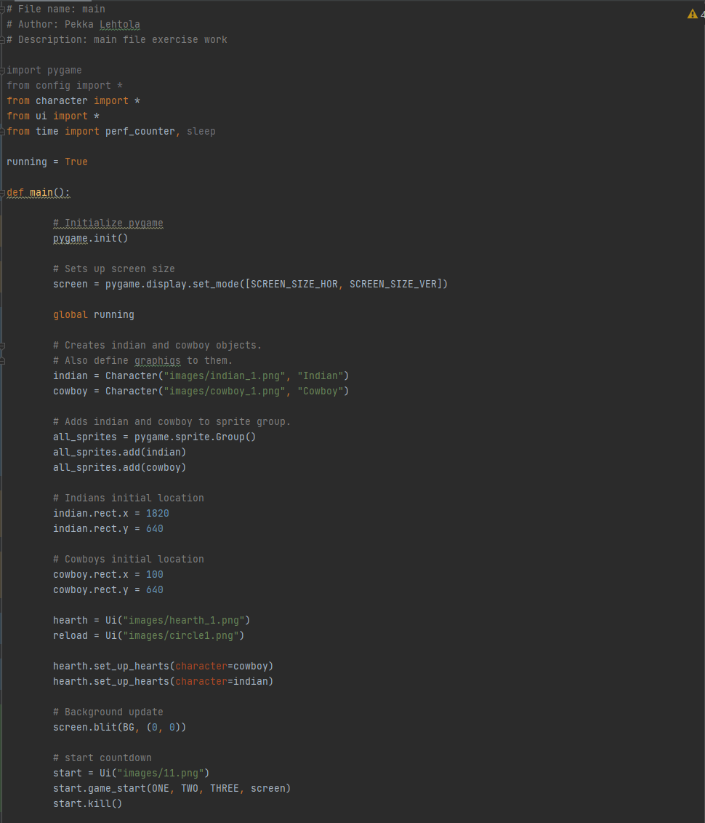Main 1/2:

Main 2/2:

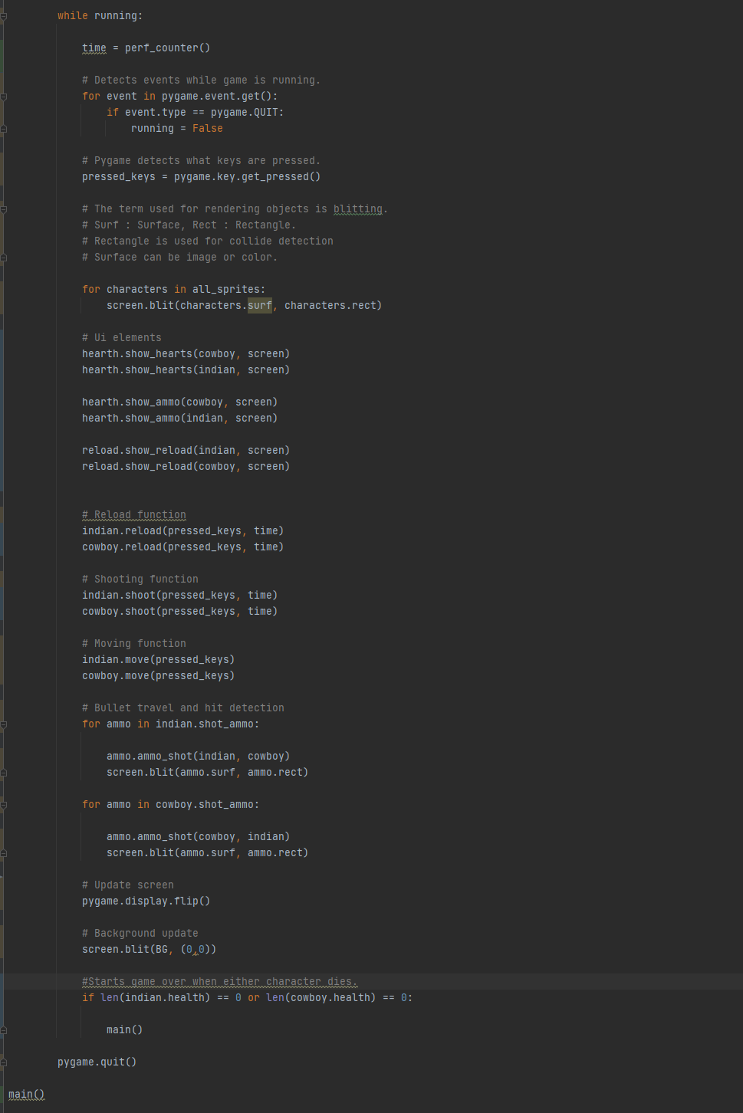

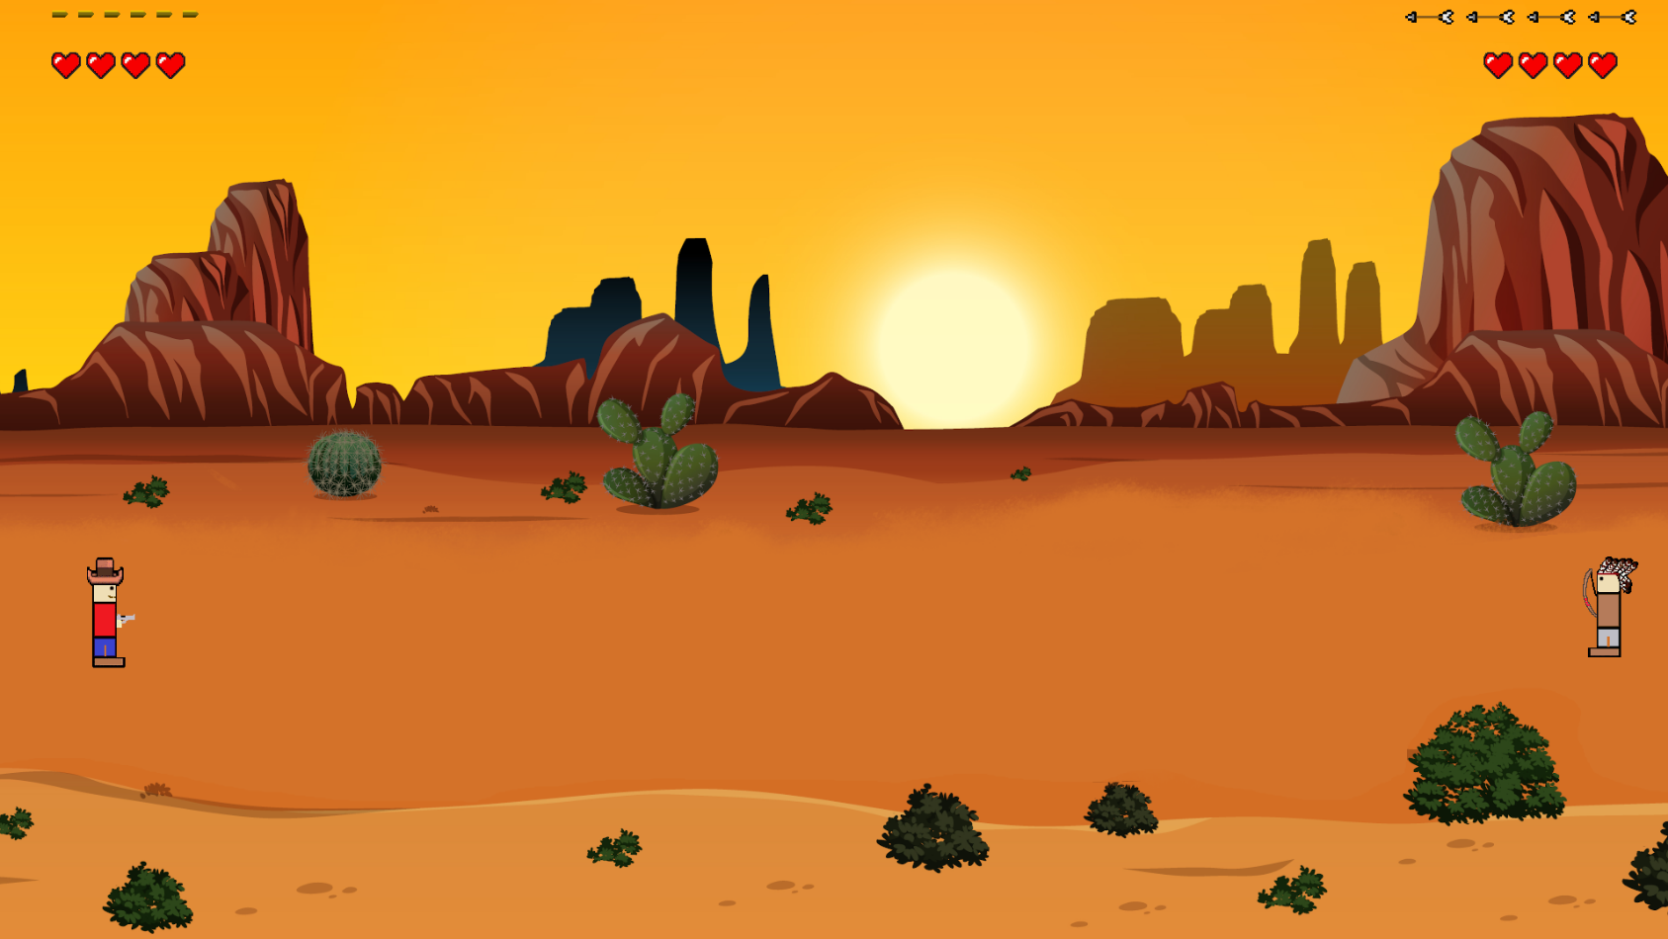Game:

Gameplay video (Sorry for the quality…):

**https://youtu.be/icjRZ-IOyUQ**

Screen capture of git log (showing that you made a commit after every task).

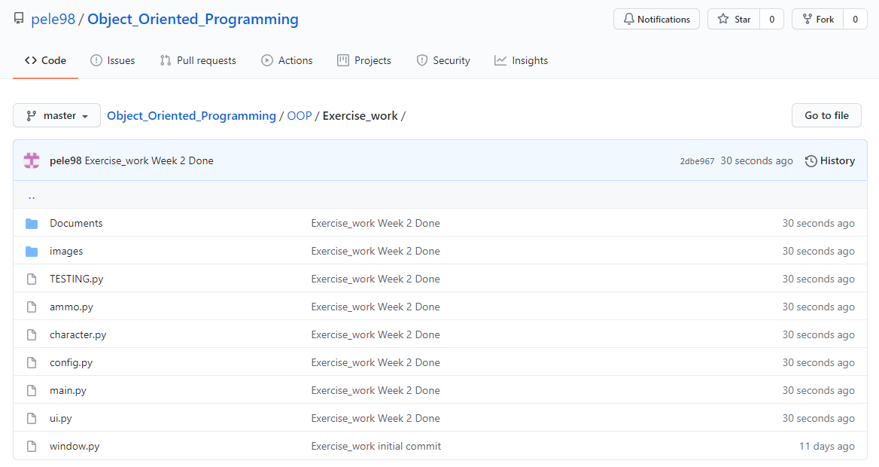

Self-assessment:

This exercise was easy/difficult/ok/etc. for me because…

Ok. Kuvien animointi toi tiettyjä haasteita ja UML diagrammien teko oli haastavaa. Muuten ohjelmointi sujui kuin rasvattu.

Doing this exercise, I learned…

Miten tehdä animaatioita.

I am still wondering…

-

I understood/did not understand that… ; I did/did not know that… ; I did/did not manage to do…

Sequence diagrammi omasta mielestä ei ole tarpeeksi hyvä.