## Task 1

The initial training for task 1 had the following results:  
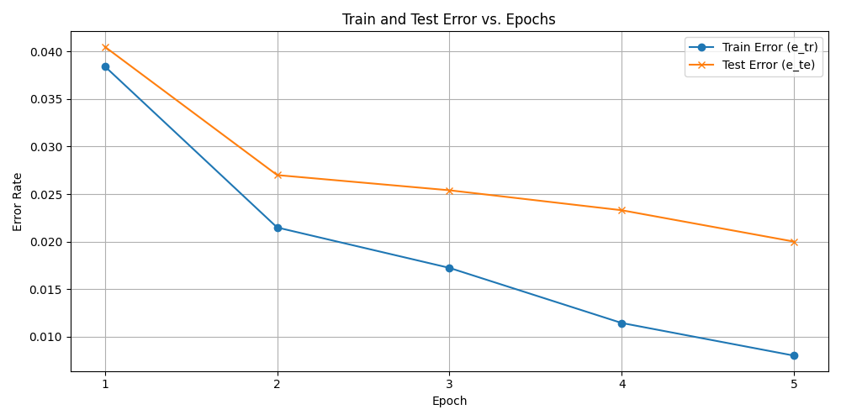

## Task 2

After setting the seed:  
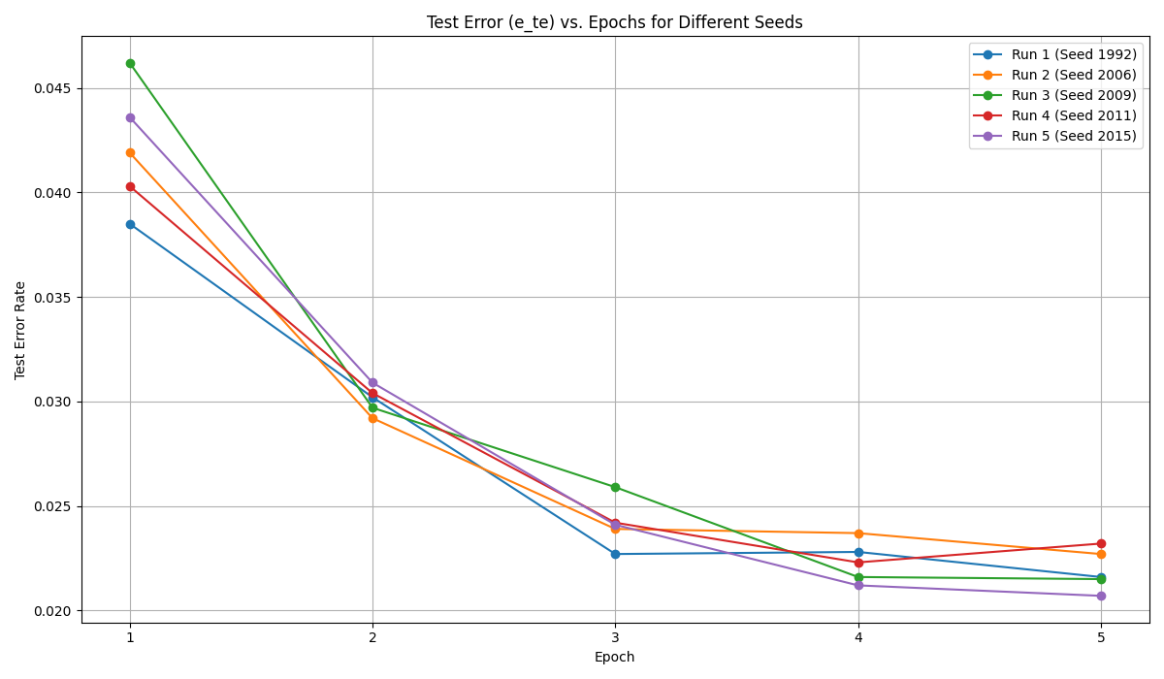

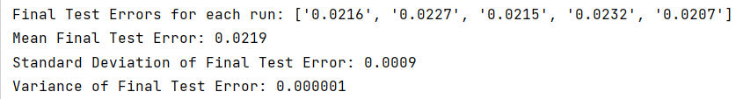

The variance of the test errors is very small, which means that the results were consistent across the different seeds. Therefore we can say that the model is ‘robust’ to the choice of the seed. (If the errors had a high variance, we would say that the model depends on the choice of the seed, but in our case the errors are rather similar).  
  
To support my claim we can refer to Omri’s comment in class – a random guesser would have a 10% success rate due to the 10 possible digits. In the initial example we had a 98.0% success rate on the test dataset, and here across the 5 different seeds we had a success rate varying between 97.7% and 97.9%. Comparing this to the baseline expected guess rate of 10%, I would say that the model is *robust*, i.e. agnostic to the choice of the seed.