**SciGuru**

**Application Design Document**

1. **D. D**

February, 2025

# **Table of content**

Contents

**Table of content** 2

**Chapter 1 : Introduction** 3

1.1 **Summary** 3

**1.2** **Related Researches** 4

**Chapter 2 : SciGURU Architecture** 6

**2.1 Supervised Fine Tuning (SFT)** 6

**2.1.1 Model Preparation** 6

**2.1.1.1 Base Model** 7

**2.1.1.2 Quantization** 8

**2.1.1.3 LoRA** 9

**2.1.2 Data Preparation** 10

**2.1.2.1 Picking The Right Dataset** 10

**2.1.2.2 Separation** 11

**2.1.2.3 Preprocessing** 12

**2.1.2.4 Tokenization** 13

**2.2 Reinforcement Learning (RL)** 14

**2.2.1 Proximal Policy Optimaztion (PPO)** 14

**2.2.1.1 PPO Preference Data** 15

**2.2.1.2 PPO Reward Model** 15

**2.2.2 Direct Policy Optimization (DPO)** 15

**Chapter 3 : Evaluation** 16

**3.1 SFT Evaluation** 16

**3.2 RL Evaluation** 18

**Chapter 4: Behavioral Analysis** 20

**4.1 Sequence Diagrams** 20

**4.1.1**  **Training:** 20

**4.1.2**  **Evaluation:** 21

**Chapter 5 : User Interface** 22

**Chapter 6 : Infrastructure** 23

**6.1 Resources** 23

**6.1 Folder Architecture** 24

**Bibliography** 25

# **Chapter 1 : Introduction**

## **Summary**

This research project focuses on training large language models (LLMs) to give better scientific explanations. By critically analyzing existing methodologies and leveraging state-of-the-art advancements, our goal is to fine-tune LLMs for improved precision and contextuality in scientific discourse.

Our approach integrates a blend of Supervised Fine Tuning (SFT) and different Reinforcement Learning (RL) methods, aiming to enhance the process of language modeling using up-to-date techniques.

We are creating and implementing an evaluation metric designed to measure the quality of scientific explanations. This metric enables us to gauge the success of our methods for enhancing the abilities of LLMs. Our goal is to fill a critical void regarding how LLMs function today, making them more useful for educational and research purposes. We're working towards enhancing how AI can help us understand and communicate scientific ideas, which could transform learning and discovery to be way easier in significant ways.

In addition to enhancing accuracy, we're placing significant emphasis on the quality of scientific explanations provided by LLMs. We aim to train a model that conveys complex scientific concepts in an engaging, clear, and contextually rich manner. Through this, we aspire to make science explanations more approachable and enjoyable for all.

## **Related Researches**

Our research aims to enhance LLMs capability to generate high-quality scientific explanations. While LLMs have demonstrated remarkable abilities across various tasks, their proficiency in providing clear, accurate, and pedagogically sound scientific explanations can still be improved.

The field of scientific explanation assessment has been extensively researched, providing us with established frameworks to evaluate and enhance explanation quality. We reviewed several key papers to ensure our approach aligns with state-of-the-art methodologies in this domain.

* + 1. **TAP : "The Uses of Argument" (1958)**

Toulmin's Argumentation Pattern (TAP), introduced by philosopher Stephen Toulmin, provides a structured approach to analyzing explanations through six key elements:

· ***Claim*** *- The main conclusion being presented*

· ***Data*** *- Supporting evidence and facts*

· ***Warrant*** *- Logical connection between data and claim*

· ***Backing*** *- Additional support for the warrant*

· ***Qualifier*** *- Conditions under which the claim holds true*

· ***Rebuttal*** *- Potential counterarguments or exceptions*

* + 1. **"An Instrument for Assessing Scientist's Written Skills in Public Communication of Science"**

The article presents a comprehensive evaluation framework that identifies five critical components of effective scientific communication:

· **Content Features**: Focuses on the selection and organization of scientific information, including decisions about what to include or omit.

· **Knowledge Organization**: Examines how information is structured and reinforced through repetition and logical flow.

· **Analogical Approaches**: Evaluates the use of analogies and metaphors to explain complex concepts through familiar references.

· **Narrative Elements**: Assesses the incorporation of storytelling techniques to make scientific concepts more engaging and memorable.

· **Dialogic Communication**: Measures how well the explanation facilitates understanding and engagement, particularly for complex or controversial topics.

* + 1. **"Analyzing how Scientists Explain their Research"**

Further insights come from the mentioned article, which presents rubric specifically designed for evaluating scientific explanations. This rubric emphasizes three key dimensions :

* **Pedagogical Knowledge** - Structure, Audience awareness, Language choice and Technical presentation skills
* **Content Knowledge** - Factual accuracy, Information organization, Knowledge transfer capabilities
* **Integration** - Contextual placement, Visual and mental imagery, Scaffolded learning approach  
    
  + 1. **Summary**

These frameworks provide our project with robust criteria for :

* Evaluating LLM-generated scientific explanations
* Developing effective training methodologies
* Creating comprehensive assessment metrics
* Guiding the fine-tuning process

By incorporating these established evaluation frameworks into our fine-tuning process, we aim to create a model that not only provides accurate scientific information but also presents it in a way that is pedagogically sound and accessible to diverse audiences. This approach ensures our work builds upon proven methodologies while advancing state-of-the-art AI-generated scientific explanations.

# **Chapter 2 : SciGURU Architecture**

## **2.1 Supervised Fine Tuning (SFT)**

The process of taking a **pre-trained LLM** and training it further on a **labeled dataset** to align its outputs with specific tasks or objectives. By providing input-output examples (such as questions paired with correct answers), the model learns patterns and nuances that improve its performance on that domain. This method leverages the broad linguistic knowledge already present in the foundational model, while focusing on a particular use case, whether that’s question answering, sentiment analysis, or any other NLP task.

## **2.1.1 Model Preparation**

Model preparation is the process of readying a foundational language model for specialized tasks by optimizing its performance and efficiency. At a high level, this involves selecting a robust, pre-trained model and then applying techniques to streamline its computational demands without sacrificing quality. While the foundational model provides broad language understanding, methods like quantization and LoRA are later used to fine-tune the model's efficiency and adaptability. Essentially, model preparation ensures that the model is in the best possible shape to undergo further task-specific fine-tuning and deployment.

### **2.1.1.1 Base Model**

**Role in Fine-Tuning**

Base model is a foundational, pre-trained Large Language Model (LLM) that has learned general language patterns from vast amounts of data. It serves as the starting point upon future fine-tuning.  
  
**Base Model in SciGURU**

The chosen foundational model is a powerful and versatile LLM, known for its efficiency and performance on various NLP tasks. We selected the falcon model after experimenting with multiple other open-source models and continued with the falcon mamba due to its balancing of capability and efficiency, maximizing resources utilization over 7B parameters.

**Other Base Models**

**T5_small** (70M parameters)

A compact encoder-decoder model that we tested initially. While efficient in terms of computational resources, its limited parameter count resulted in less sophisticated scientific explanations compared to larger models.   
  
Due to its lack of parameters amount, T5_small was a perfect fit for initializing the finetuning pipeline without the need for a heavy computation but ultimately wasn't selected as our primary model for scientific inference.

**T5_large** (770M parameters)

A larger version of T5 that showed improved performance over T5_small, but still fell short of the depth and nuance needed for complex scientific explanations.   
  
Similarly to T5_small this model also a step stone towards the goal by experiencing work on the BGU cluster as well as integration of the project with GPU , that said, experimentation showed it's parameter count still low and doesn't fit with our expectations.

**Llama_3.1** (8B parameters)

Meta's open-source model demonstrated strong performance but had licensing restrictions that could limit deployment options.

While it's size and performance managed to fit our starting expectations, the deployment did not go smooth as we thought it would and the deadline was too close to waste more time, that said, **Llama_3.1** is a good contestant for **Falcon_7B** and we might use it in future versions.

### **2.1.1.2 Quantization**

**Role in Fine – tuning**  
  
Quantization is used for optimization by reducing the memory and processing power required, it minimizes memory usage significantly and speeds up inference, making the model more lightweight and suitable for integration into scalable pipelines.  
 **Quantization in SciGURU**The Falcon-7b model undergoes 8-bit quantization, which reduces the model's precision to 8 bits while maintaining performance.

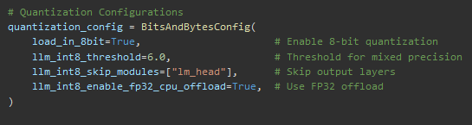

**load_in_8bit=True**  
Tells the library to load the model weights in 8-bit precision (instead of the usual 16-bit or 32-bit). This significantly reduces GPU memory usage and can speed up inference.

**llm_int8_threshold=6.0**  
Sets the threshold for outlier detection in quantization. If a weight matrix has values whose absolute magnitude exceeds this threshold, that particular matrix is left in higher precision instead of being forced into 8-bit. This helps maintain accuracy for “outlier” values that would degrade performance if quantized.

**llm_int8_skip_modules=["lm_head"]**  
Specifies which modules to exclude from 8-bit quantization. In this case, the lm_head (the final output layer in a language model) is skipped and remains in full precision. This is often done to preserve output quality.

**llm_int8_enable_fp32_cpu_offload=True**  
Enables offloading of certain calculations or parameters to CPU in 32-bit precision. This can help when GPU memory is limited, letting you keep some parameters in CPU RAM while still taking advantage of 8-bit quantization for the bulk of the model on the GPU.

### **2.1.1.3 LoRA**

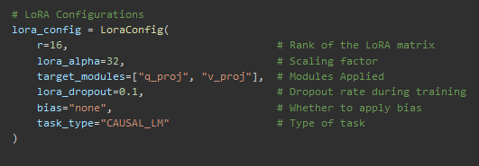 **Role in Fine – tuning**  
  
Low Rank Adaptation (LoRA) is applied to a model for efficient training and inference, instead of modifying the entire model parameters, LoRA adjusts smaller, low-rank matrices, reducing computational cost. LoRA allows the model to adapt to domain-specific tasks without needing extensive resources, ensuring efficient use of the pre-trained capabilities without causing catastrophic forgetting.  
  
**LoRA in SciGURU**

**r = 16**  
The rank of the low-rank matrices introduced by LoRA. This determines how many additional parameters get added during fine-tuning. A higher rank means more capacity (but also more parameters) for the LoRA adapters.

**lora_alpha = 32**  
A scaling factor for the LoRA weights. Typically, the effective learning rate for LoRA parameters is multiplied by (lora_alpha / r). This helps control the update magnitude applied by the LoRA layers.

**target_modules = ["q_proj", "v_proj"]**  
Specifies which model modules to apply LoRA to. In many transformer architectures, q_proj and v_proj are good choices because they significantly influence how attention is computed.

**lora_dropout = 0.1**  
The dropout rate for LoRA’s trainable params, can improve generalization and avoid overfitting.

**bias = "none"**  
Determines how bias terms are handled in the LoRA layers. "none" indicates no additional bias terms are used for these adapters. **task_type = "CAUSAL_LM"**  
Specifies the task type as causal language modeling. This helps ensure that the fine-tuning process aligns with a left-to-right (causal) language model setup.

## **2.1.2 Data Preparation**

Data preparation is the process of transforming raw text into a clean, structured, and consistent format that a model can effectively learn from. At a high level, this involves gathering and curating relevant data, cleaning it to remove noise or inconsistencies, and organizing it into a well-defined format. A key aspect of this process is tokenization—breaking down the text into units (words, subwords, or characters) that the model can understand. Essentially, effective data preparation lays the foundation for successful training by ensuring that the model receives high-quality, reliable input.

### **2.1.2.1 Picking The Right Dataset**

**Role in Fine-Tuning**

Choosing the right dataset is the first crucial step in data preparation. It involves selecting a collection of texts that are not only relevant to your task but also representative of the domain you’re targeting. For instance, if you're building a model for customer support, the dataset should include authentic customer interactions and responses. Factors such as data quality, diversity, and balance are essential - ensuring that the dataset has enough examples to capture the nuances of the language while avoiding biases. This careful curation lays a solid foundation, as the model’s performance is highly dependent on the quality and relevance of the data it learns from.

**Dataset in SciGURU**

The dataset we chose is **PubMedQA**, a high-quality question-answering dataset derived from peer-reviewed biomedical literature. It provides expert-annotated Q&A pairs that help SciGURU develop an understanding of specialized terminology, structured reasoning, and fact-based answering. Since scientific texts are often dense, PubMedQA enables the model to simplify complex concepts while maintaining accuracy.

1. **Domain-Specific Knowledge** – It is sourced from credible scientific literature, ensuring the model learns from high-quality, peer-reviewed research.
2. **Fact-Based Question Answering** – The dataset emphasizes objective, evidence-based responses, which align with producing clear and accurate scientific explanations.
3. **Generalization Potential** – The structured Q&A format can be extended beyond biomedicine to other scientific fields, making it a versatile resource for simplifying complex concepts across multiple disciplines.

**EXAMPLE**

**Question :** Do preoperative statins reduce atrial fibrillation after coronary artery bypass grafting?

**Context :** [Abstract discussing a study on the effects of preoperative statin therapy on postoperative atrial fibrillation rates.]

**Long Answer :** [Conclusion stating that preoperative statin use is associated with a significant reduction in postoperative atrial fibrillation.]

**Answer :** Yes

### **2.1.2.2 Separation**

**Role in Fine-Tuning**

Separation refers to the process of splitting your dataset into distinct subsets, typically training, validation, and test sets. This division is crucial for developing a robust NLP model, and key to reliable model assessment and successful deployment.

**Training Set** - used for the actual learning process, where the model adjusts its parameters based on the provided examples.

**Validation Set -** helps monitor performance during training, allowing for hyperparameter tuning and early stopping to prevent overfitting.

**Test Set -** offers an unbiased evaluation of the model's performance on unseen data, ensuring that the model generalizes well to real-world scenarios.

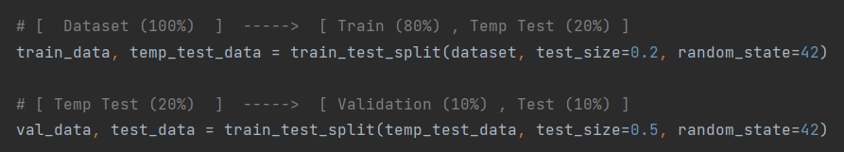**Separation in SciGURU Dataset**  
In SciGURU we have split our dataset into training set, validation set and test set in the following ratio (randomly, to reduce chance for examples relativity – meaning that the data split example distribution among the dataset is random) :  
  
Training Set – 80% (~2900 examples)  
Validation Set – 10% (~360 examples)  
Test Set – 10% (~360 examples)

### **2.1.2.3 Preprocessing**

**Role in Fine – tuning**  
  
Preprocessing transforms raw text into a cleaner, more consistent format, making it suitable for training. Preprocessing typically includes:

* **Cleaning the text** (removing special characters, punctuation, numbers, extra spaces, etc.)
* **Lowercasing** (optional, depending on the task)
* **Removing stop words** (for some tasks, but not always necessary)
* **Stemming/Lemmatization** (reducing words to their root form)

The goal of preprocessing is to eliminate inconsistencies and extraneous information that could confuse the model, ensuring that only valuable, structured information is fed into the system. Additionally, it often includes splitting the dataset into training, validation, and test sets to help evaluate model performance effectively.

**Preprocessing in SciGURU**

* Extracted **question-answer pairs** from the dataset.
* Formated them into a structured text prompt  
    
  A black background with white text

  AI-generated content may be incorrect.
* Used .strip() to remove extra spaces.
* Added \n\n for better separation and clarity.
* Processed data in **batches** using dataset.map().
* A computer screen shot of text

  AI-generated content may be incorrect.Removed original dataset columns after processing.

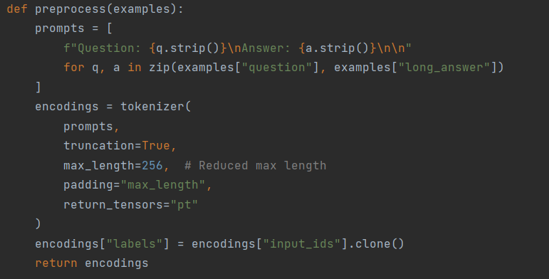

### **2.1.2.4 Tokenization**

**Role in Fine – tuning**

Tokenization is the critical process of breaking down text into smaller units called tokens, which are the basic elements that a model understands. Depending on the approach, tokens can be words, sub words, or even characters. Modern NLP methods often favor sub word tokenization techniques, which strike a balance between handling rare words and managing vocabulary size efficiently. Tokenization converts the cleaned text into numerical representations - typically sequences of integers that correspond to tokens in the model’s vocabulary - thereby bridging the gap between human-readable language and machine-readable data. This conversion is fundamental for model training, as it directly influences how the model perceives and processes the language.  
 **Tokenization in SciGURU**

* Used truncation (truncation=True) to limit sequences to 256 tokens.
* Applied padding (padding="max_length") to standardize input size.
* Converted the processed tokens into PyTorch tensors (return_tensors="pt").
* Duplicated input_ids as labels, meaning the model learns to predict the next token.
* 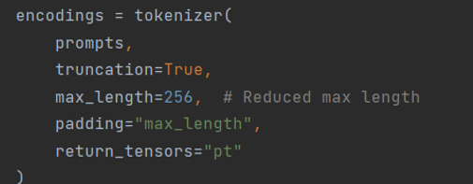Ensured the processed dataset is ready for model training.

## **2.2 Reinforcement Learning (RL)**

One of the project goals is to apply 4 different RL techinques to train the model and evaluate their effect on the explainablity of the model. The techniques we will apply are Direct Policy Optimization (DPO), Proximal Policy Optimization (PPO), Reinforcement Learning with Verifiable Rewards (RLVR), and classic reinfrocement learning using ChatGPT’s API (which we will refer to at (API RL).

Need to insert bibliography properly.(https://arxiv.org/abs/2406.09279, 2024)

https://arxiv.org/abs/2406.09279. (2024). Unpacking DPO and PPO: Disentangling Best Practices for Learning from Preference Feedback. *arxiv*, 3.

### **2.2.1 Proximal Policy Optimaztion (PPO)**

PPO is based on learning from preference feedback by first training a reward model on preference data, and then training a policy model by scoring responses produced by the policy model itself during training (“online” learning) as shown in Fig. 2. First, the policy model is prompted to generate responses, which are then scored with the reward model. These scores (i.e., scalar rewards) are then used to guide the optimization of the policy model, following the PPO algorithm. [https://arxiv.org/pdf/2406.09279v2]

We will base our work on the following papers - <https://arxiv.org/pdf/2305.18290>, <https://arxiv.org/pdf/2305.18290>  
We will use the same training data for PPO and DPO- the pubmedQA dataset.

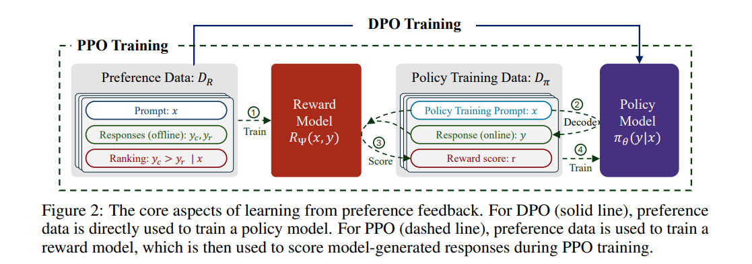  
This figure is refrenced from <https://arxiv.org/pdf/2406.09279v2>, Unpacking DPO and PPO: Disentangling Best Practices for Learning from Preference Feedback.

### **2.2.1.1 PPO Preference Data**

In PPO, a preference dataset is used for training a reward model, which consits of prompts, responses, and rankings. Each prompt $x$ comes with a pair of responses $y_{c}$, $y_{r}$, where $y_{c}$ denotes the chosen response and $y_{r}$ is the rejected response. As we need a pair of responses, we cannot use the same pubmedQA dataset. As learning directly from human feedback is infeasible for a 3-person project, we will use the AlpacaFarm framework (<https://github.com/tatsu-lab/alpaca_farm>, <https://arxiv.org/abs/2305.14387>). AlpacaFarm is a framework which can be used to generate human-like responses using an API to an LLM and an example response.  
We will use the same pubmedQA dataset as a question and answer example, ChatGPT’s API and AlpacaFarm to generate pairs of responses where one is labeled as the preferred and one as the rejected response.  
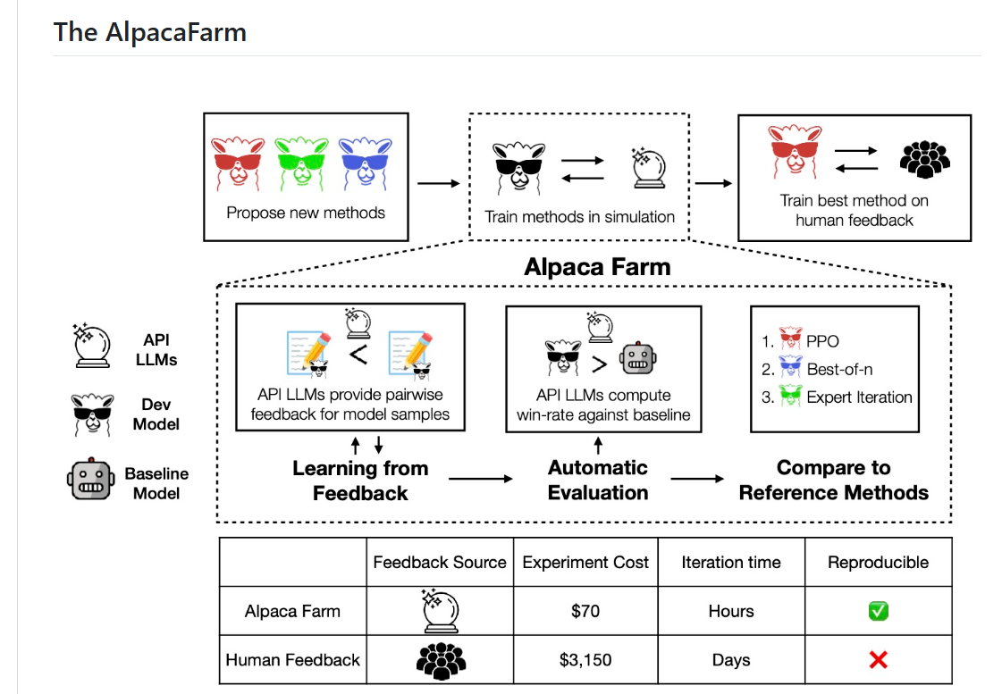

### **2.2.1.2 PPO Reward Model**

In our referenced work, the reward model is a scalar function, and can be parameterized with a transformer where a regression head replaces the language modeling head. The reward model is usually trained to minimize the following loss: wher

Where $x$ is the prompt, $y_{c}$ denotes the chosen response and $y_{r}$ is the rejected response.

### **2.2.2 Direct Policy Optimization (DPO)**

DPO is an offline RL approach for performing learning from preference feedback. It allows one to directly optimize the policy on preference data, without building reward models or needing to sample online from the active policy. As such, DPO is an offline training algorithm. In simple terms, DPO aims at increasing the margin between the log-likelihood of the chosen responses and the log-likelihood of the rejected ones, while ensuring the model does not stray far from the initial policy. (1)  
We will base our work on the following papers - <https://arxiv.org/pdf/2305.18290>, <https://arxiv.org/pdf/2305.18290>  
Our DPO will be based on the same labeled dataset of question, preferred answer and rejected answer that we used for the PPO.

### **2.2.3 Reinforcement Learning with Verifiable Rewards (RLVR)**

Ipsum upsum blah blah.

### **2.2.4 RL with the ChatGPT API**

Ipsum upsum blah blah.

# **Chapter 3 : Evaluation**

## **3.1 SFT Evaluation**

As mentioned before, the dataset was seperated into Training, Validation, Test sets.  
In order to evaluate the model performance after training (meaning that the model has only "seen" Training and Validation sets ), we have to use the test set (~3000 Q&A which the model has never seen or trained on) to test our current alpha model, the model responded to each question and its answer was compared to a suitable reference answer using predetermined quality metrics.  
  
**Quality Metrics**

**BLEU (Bilingual Evaluation Understudy):**

Measures how similar a generated text is to a reference text using n-gram overlap.  
Higher BLEU means better similarity to the reference text.  
Often used in machine translation.

**ROUGE (Recall-Oriented Understudy for Gisting Evaluation)**

Measures text overlap, especially useful for summarization tasks, when higher scores mean the generated text captures more key parts of the reference text.  
  
**ROUGE-1** Measures overlap of single words (unigrams).  
**ROUGE-2** Measures overlap of word pairs (bigrams).  
**ROUGE-L** Measures longest common subsequence (captures fluency and coherence).

**METEOR (Metric for Evaluation of Translation with Explicit Ordering)**

Improves BLEU by considering synonyms, stemming and word order, when a higher METEOR score means better alignment with the reference text.

**BERTScore**

Uses deep learning (BERT) to compare similarity at the meaning level, not just word overlap.Captures semantic similarity between words in context, when a higher BERTScore means the generated text conveys a similar meaning to the reference.

**Evaluation Results**

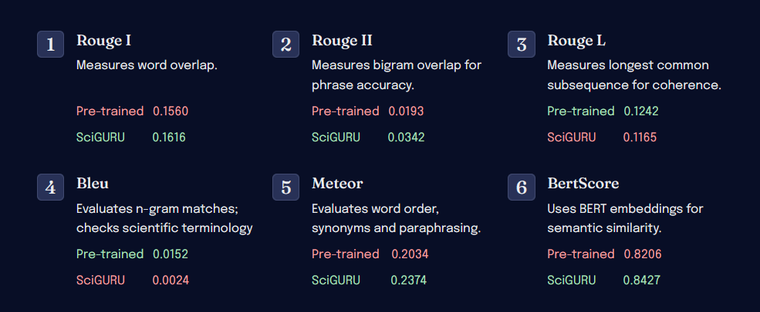

## **3.2 RL Evaluation**

# **Chapter 4: Behavioral Analysis**

## **4.1 Sequence Diagrams**

### **4.1.1 Training:**

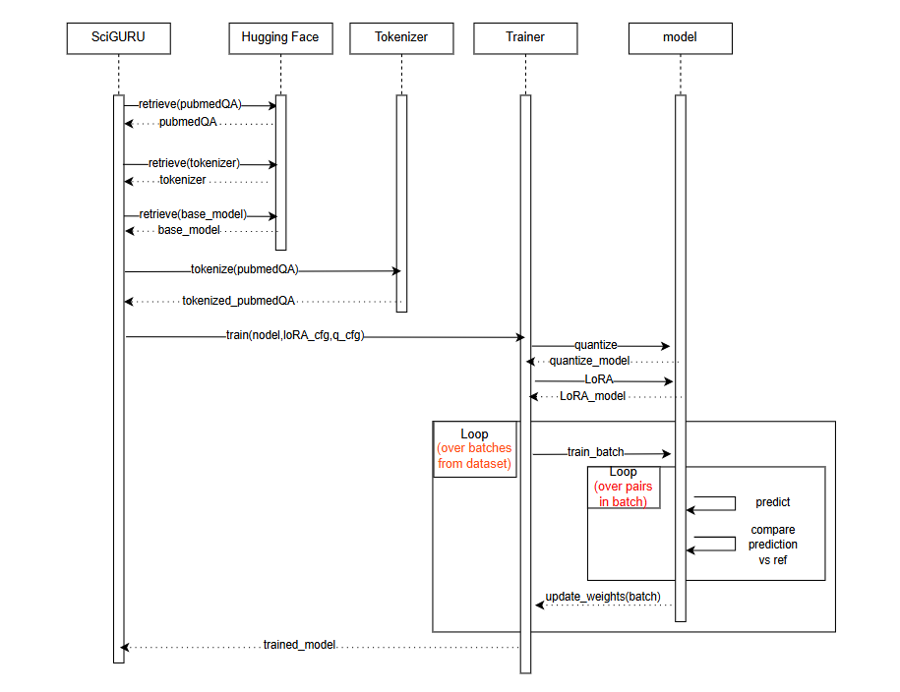

The diagram illustrates our SFT training pipeline. We begin with SciGuru, the main orchestrator, retrieving the PubMedQA dataset, tokenizer, and base model from Hugging Face. After tokenizing the PubMedQA data, SciGURU initiates our training process with specific LoRA configurations. Then, the Trainer component applies 4-bit quantization to the model and implements the LoRA adaptations. The core training loop processes batches of data, where the model makes predictions and compares them against our reference answers. After each batch, the weights are updated accordingly. This iterative process continues for all pairs within each batch until the training is complete, ultimately producing a trained model that's returned to SciGURU.

### **4.1.2 Evaluation:**

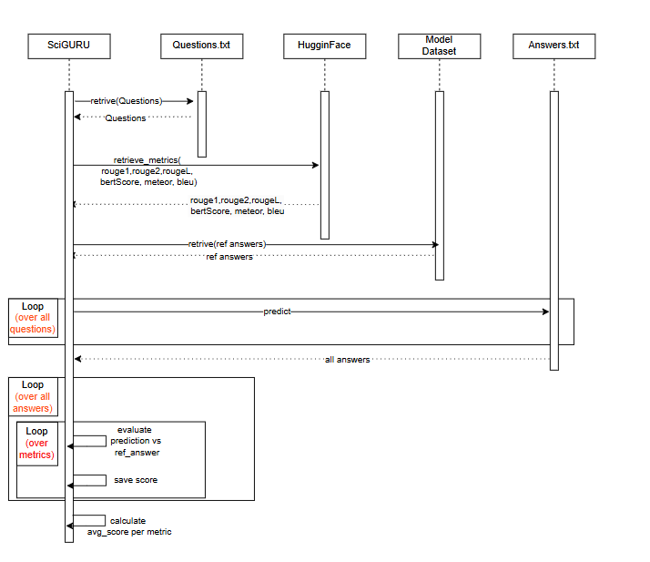

The diagram depicts the evaluation process for assessing the trained model’s explanation quality. The flow begins with SciGURU retrieving test questions from a Questions.txt file, followed by loading multiple evaluation metrics including ROUGE-1, ROUGE-2, ROUGE-L, BERT Score, METEOR, and BLEU from Hugging Face. SciGURU then retrieves reference answers from our Model’s Dataset. The process enters three loops: first, it iterates through all questions, generating predictions which are stored in Answers.txt. Then, all answers are processed, and the innermost loop evaluates each metric by comparing predictions against reference answers. Finally, scores are saved and averaged per metric to produce the final evaluation results. This evaluation framework allows us a systematic assessment of the model's performance in generating scientific explanations across multiple quality dimensions.

# **Chapter 5 : User Interface**

Currently, the only way to interact with our model is using MobaXtrem, where our project lies.  
there are 2 text files : Questions.txt and Answers.txt.  
  
To ask the model a question (or several questions) the user must follow the following steps:  
  
1. Open Questions.txt file and type in the questions that he wish to ask SciGURU.  
  
2. Run a sbatch script, which runs SciGURU inference on Questions.txt and outputs to Answers.txt.

3. Open Answers.txt to watch the model's response

Safe to say that this is the way its done right now, but SciGURU's future plans are to build a UI in which the user could interactively ask the model questions and get an instant response.

# **Chapter 6 : Infrastructure**

SciGURU is built on a robust computational infrastructure designed for efficient execution and development. The project operates on a **cluster-based system**, leveraging **RTX 4090 / RTX 3090 GPUs** (one per sbatch script) to manage workload distribution effectively. The development workflow follows the **SCRUM methodology**, ensuring iterative improvements and streamlined collaboration.

## **6.1 Resources**

**Computational Infrastructure**

* Runs on a high-performance computing cluster with allocated **RTX 4090 / 3090 GPUs**.
* Workload distribution and model training are managed using **sbatch scripts**.

**Development Methodology**

* + Uses **SCRUM** for agile development and continuous iteration.
  + Organized in structured sprints to improve model performance and efficiency.
  + Version-controlled updates ensure reproducibility and tracking of enhancements.

**Execution and Deployment**

* + Fully script-based execution model.
  + Automated data processing, training, and evaluation workflows.
  + Logging and monitoring ensure stable and trackable model iterations.

## **6.1 Folder Architecture**

**Log**

* Stores all **runtime logs**, capturing details of model training, execution, and debug information.
* Logs are structured for easy tracing of issues and performance evaluation.
* Helps maintain a history of all major training runs and parameter configurations.

**Utils**

* API keys and authentication tokens.
* Environment setup files (requirements.txt, .env configurations).
* Helper scripts for debugging and monitoring system performance.

**Versions**

* Contains all **trained versions** of SciGURU, allowing for comparison and iteration.
* Includes metadata on hyperparameters and training configurations for reproducibility.
* Ensures past versions can be reloaded and used for further fine-tuning or evaluation.

**Finetuning**

* Houses datasets, python files related to the **fine-tuning process**.
* Supports different models and dataset variations for experimentation.

**Scripts**

* **Fine-tuning** the model using predefined training configurations.
* **Resource loading**, loading hugging face models, tokenizers and datasets.
* **Environment setup** for configuring dependencies and initializing the system.
* **Environment reset** scripts for restoring a clean working state when needed.

By structuring the project in this way, SciGURU ensures **scalability, efficiency, and organization**, facilitating seamless collaboration and continuous improvements in model performance.

# **Bibliography**

Osborne, J., Erduran, S., & Simon, S. (2004). Enhancing the quality of argumentation in school science. Journal of Research in Science Teaching, 41(10

https://arxiv.org/abs/2406.09279. (2024). Unpacking DPO and PPO: Disentangling Best Practices for Learning from Preference Feedback. *arxiv*, 3.

), 994–1020.<https://doi.org/10.1002/tea.20035>

Toulmin, S. E. (2003). The Uses of Argument (2nd ed.). Cambridge: Cambridge University Press.

Baram-Tsabari, A., & Lewenstein, B. V. (2013). An Instrument for Assessing Scientists’ Written Skills in Public Communication of Science. Science Communication, 35(1), 56–85.<https://doi.org/10.1177/1075547012440634>

Sevian, H., & Gonsalves, L. (2008). Analysing how Scientists Explain their Research: A rubric for measuring the effectiveness of scientific explanations. International Journal of Science Education, 30(11), 1441–1467.<https://doi.org/10.1080/09500690802267579>

Wei, J., Wang, X., Schuurmans, D., Bosma, M., Xia, F., Chi, E., ... & Zhou, D. (2022). Chain-of-thought prompting elicits reasoning in large language models. Advances in Neural Information Processing Systems.<https://arxiv.org/abs/2307.09288>

Ouyang, L., Wu, J., Jiang, X., Almeida, D., Wainwright, C., Mishkin, P., ... & Lowe, R. (2022). Training language models to follow instructions with human feedback. Advances in Neural Information Processing Systems, 35, 27730-27744. [arXiv:2203.02155](https://www.google.com/search?q=Constitutional+ai%3A+Harmlessness+from+ai+feedback&oq=Constitutional+ai%3A+Harmlessness+from+ai+feedback&gs_lcrp=EgZjaHJvbWUyBggAEEUYOTIGCAEQRRg7MgYIAhBFGD3SAQgxNDQ4ajBqNKgCALACAA&sourceid=chrome&ie=UTF-8)

Bai, Y., Kadavath, S., Kundu, S., Askell, A., Kernion, J., Jones, A., ... & Kaplan, J. (2022). Constitutional ai: Harmlessness from ai feedback. arXiv preprint [arXiv:2212.08073](https://arxiv.org/abs/2204.05862).

Schulman, John, et al. "Proximal policy optimization algorithms." arXiv preprint [arXiv:1707.06347](https://arxiv.org/abs/1707.06347) (2017)

Kojima, T., Gu, S. S., Reid, M., Matsuo, Y., & Iwasawa, Y. (2022). Large language models are zero-shot reasoners. Advances in neural information processing systems, 35, 22199-22213. [arXiv:2205.11916](https://arxiv.org/abs/2205.11916)