Phase 1 - Requirements & Stakeholder Analysis

Digital Design Team-
My Questions:
- How is the internal counter implemented (e.g., synchronous reset)?
- What is the expected behavior regarding metastability on the reset_n signal, since it is implemented as asynchronous but defined as synchronous in the spec?
- Can we see the internal state machine (if one exists) for the countdown logic to ensure 100% FSM coverage?

Firmware/Software Team-
My Question:
- Since STATUS.EXPIRED is cleared on read or by CLR_STATUS (WIC), what is the primary software usage model for clearing the flag (Read or Write)? -corner cases
- What is the maximum acceptable delay variability when running in Auto-Reload mode? See Auto-reload functionality

System Architect-
My Question:
- Why was a max GNT latency of 3>=cycles chosen, and what system performance is dependent on meeting this bus requirement?
- What is the expected behavior for the "Undefined" Misaligned Address Access? Should we inject these errors?

Board Design Team-
My Question:
- Are there any specific loading or electrical requirements for the output signals (gnt, rdata)?
- Is the reset_n signal shared with other asynchronous components on the board?

Phase 2 - Verification Plan (vPlan) Development

Section 1 - Scope
IN SCOPE:
Full functional verification of all Timer operating modes (One-shot and Auto-reload). Complete verification of the REQ/GNT bus handshake protocol, including the 3>=cycle GNT latency requirement. All register access types: RW, W (Self-clearing), RC, and WIC. Error handling for LOAD=0 (must be treated as 1) and unmapped addresses.
OUT OF SCOPE:
Misaligned address access (behavior is undefined and requires error injection only). Interrupt generation, Prescaler, Multi-channel, and PWM (features planned for future expansion using reserved bits). Verification of multiple bus masters (Spec assumes single master).

Section 2 – Verification Strategy
- Methodology:
UVM (Universal Verification Methodology) using System-Verilog to enable reusability and scalability.
- Stimulus Strategy:
Constrained Random Verification (CRV) for bus transactions (read/write to all registers) and a Directed Test approach for critical state changes (e.g., starting the timer, testing expiry, and reset).
- Checking Strategy:
Reference Model (Predictor) based Scoreboard. A behavioral System-Verilog model will track the internal counter value and predict the exact clock cycle for the EXPIRED flag to be set, comparing this prediction against the DUT's STATUS register.
- Coverage Strategy:
Combination of Code Coverage (for all RTL lines and branches) and Functional Coverage (Cover-groups).

Section 3 - Metrics for Success (Exit Criteria)
- 100% of Functional Coverage targets met.
- 100% of Code Coverage targets met.
- For more refer to Phase 6 for the detailed Sign-off Criteria.

Phase 3 - Testbench Architecture

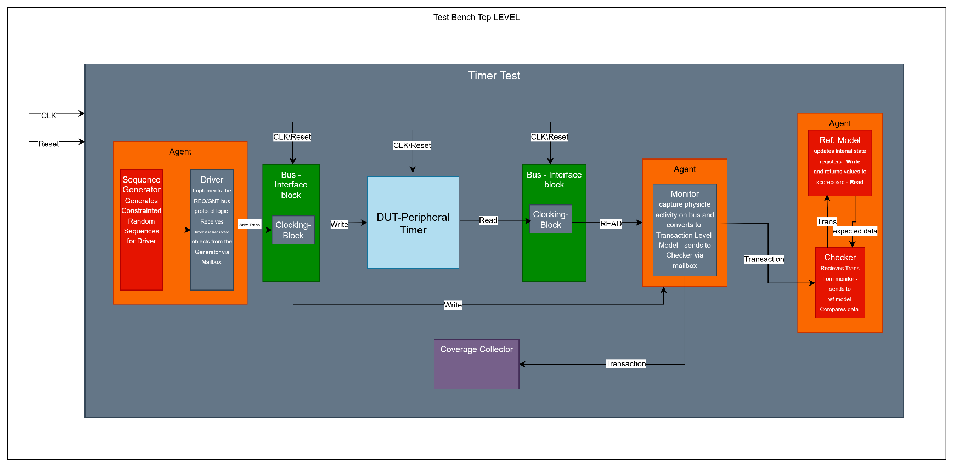
Diagram

Transaction
timer_bus_transaction: Defines a single bus access (Read/Write) containing addr, wdata, rdata, and write_en

Test Scenario
A UVM sequence (e.g., one_shot_test_seq) that drives a series of transactions: Write to LOAD, Write to CONTROL (START=1), Wait for Expiration, Read STATUS.

Components
timer_if- Contains the req/gnt bus signals and the bus_cb Clocking Block for clean, race-free synchronous signal sampling.
Monitor – Observes req, gnt, addr, write_en, wdata, and rdata from the DUT side. Converts physical pin activity into timer_bus_transaction objects and sends them to the Scoreboard. Checks bus timing (e.g., GNT latency).
Driver – Translates timer_bus_transaction objects received from the Sequencer into physical pin activity on the timer_if.bus_cb.
Implements the full REQ/GNT handshake protocol and bus timing requirements.

Phase 4 - Coverage Plan Development

Timer-State
# | Name | Covergroup/Coverpoint | Definition
1 | cg_timer_state | Cover group | Captures key operational states of the timer in conjunction with RELOAD_EN
2 | cp_reload_en | Cover point | Bin for RELOAD_EN = 0 (One-Shot) and RELOAD_EN = 1 (Auto-Reload).
3 | cp_expired_status | Cover point | Bin for STATUS.EXPIRED transitions (0 to 1).

Timer -commands
# | Name | Covergroup/Coverpoint | Definition
1 | cg_timer_commands | Cover group | Captures all valid commands
2 | cp_start | Cover point | Transition: Timer Idle -> Write CONTROL.START=1
3 | cp_load_val | Cover point | Bins for small (1-10), mid (100-1000), max (65535) LOAD_VAL and the corner case: LOAD_VAL = 0 (treated as 1)
4 | cp_flag_clear | Cover point | Bins for clearing EXPIRED via Read (RC) AND clearing EXPIRED via Write (CLR_STATUS=1, WIC)

Cross Coverage
cross_mode_and_clear: cross cp_reload_en, cp_flag_clear; – Ensure we clear the flag using both methods (RC/WIC) in both One-Shot and Auto-Reload modes.

Phase 5 - Detailed Test Case Design

Test 1: One-Shot Cycle
Basic Functionality: One-Shot Cycle
Goal: Verify the standard non-recurring operation.
Steps:
1. Write 5 to LOAD.
2. Write START=1.
3. Wait 5 cycles.
4. Verify STATUS.EXPIRED=1.
5. Read STATUS (verify data and check flag is cleared).

Test 2: Auto-Reload
Corner Case: Auto-Reload with LOAD=0
Goal: Verify the LOAD=0 exception and continuous running mode.
Steps:
1. Write 0 to LOAD (system treats it as 1).
2. Write RELOAD_EN=1.
3. Write START=1.
4. Wait 10 cycles.
5. Verify STATUS.EXPIRED=1 (it should have expired 10 times) and the timer is still running.

Test 3: Immediate Restart and Capture Timing
Goal: Verify that a new START takes immediate effect and uses the current LOAD_VAL.
Steps: 1. Write 1000 to LOAD.
2. Write START=1.
3. Wait 5 cycles.
4. While running: Write 5 to LOAD.
5. Write START=1
6. Verify the timer expires exactly 5 cycles later, proving the previous countdown was abandoned and the new LOAD_VAL=5 was captured immediately.

Phase 6 - Closure & Reporting Strategy

KPIs definition
- Functional Coverage Hit Rate – Overall percentage of the functional coverage goals. Target: >=98%
- Bug Trend – Rate of bug identify and closure.
Critical Bugs:
  - Any bug that violates the REQ/GNT protocol timing. (Slides 11-13)
  - Functional failure. (Slide 10)
Major Bugs:
- Any failure of secondary register access.
- Error handling
- Scoreboard Mismatch Rate – overall parentage of failed tests because of mismatch by input and output.
Target: <=1 of all regression tests due to environment issues

Verification sign-off Criteria
- All critical and major bus fixed.
- Functional and code coverage targets met – 100%.
- Formal Verification Sign-off on all critical properties –
No unintended state changes during reset. Data integrity (ensuring the counter decrements correctly).
Bus Protocol: GNT latency requirement is formally proven.

