Feature Request: Autosuggest + Song Preview

**July 31st 2018**

# OBJECTIVE

Searches have a live feed of auto suggested results and an option to preview the song audio to enhance the end user experience.

# BACKGROUND

When Jammming makes a request to the Spotify Search API endpoint the response includes additional data *cover* and *preview_url* keys which were not used in the current development cycle. With the search bar being one of the core interaction areas for end users it is vital to ensure that finding the correct Song, Artist or Album is efficient and user friendly. Even with the larger screen space on mobile devices today, screen space is still a valuable asset that should be carefully considered in the design of any future application.

The feature(s) described in the objective accomplish the following:

* Displays a list of fuzzy potential matches (swipe/scrollable) below the search bar as the user types in any [complete/incomplete] term/keyword. This list will remain until the term is cleared.
* Allows users to directly interact with the auto suggested list and play the songs preview audio clip (if available)
* If the user finds a match. Allow them to quickly add to “active” playlist.

# TECHNICAL DESIGN

# Retrieve and Display Live Search

The current SearchBar, will need to be modified to include a more sophisticated handler for keystroke event. The handler will record each keystroke and make a separate Spotify Search API request while presenting those updated responses to SearchResults.

The SearchResults component will be responsible for displaying and filtering the tracks from the responses from each GET request. An additional step of filtering songs already added to the current “active” playlist will be implemented to reduce redundant results.

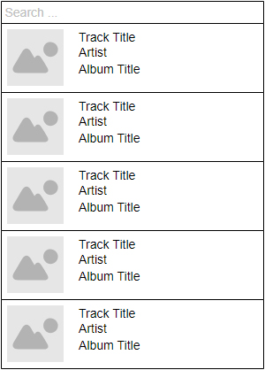

**Add Preview Audio Player**

Modify the Tracks component to include a child component “AudioPlayer” which handles the playback of the track preview audio clips. AudioPlayer will create a small audio control overlay over the cover image to allow simultaneous play and paus functionality. Controls will be hidden if the preview clips (Spotify preview_url) is unavailable and a dummy cover album will be used where the album cover is not available.

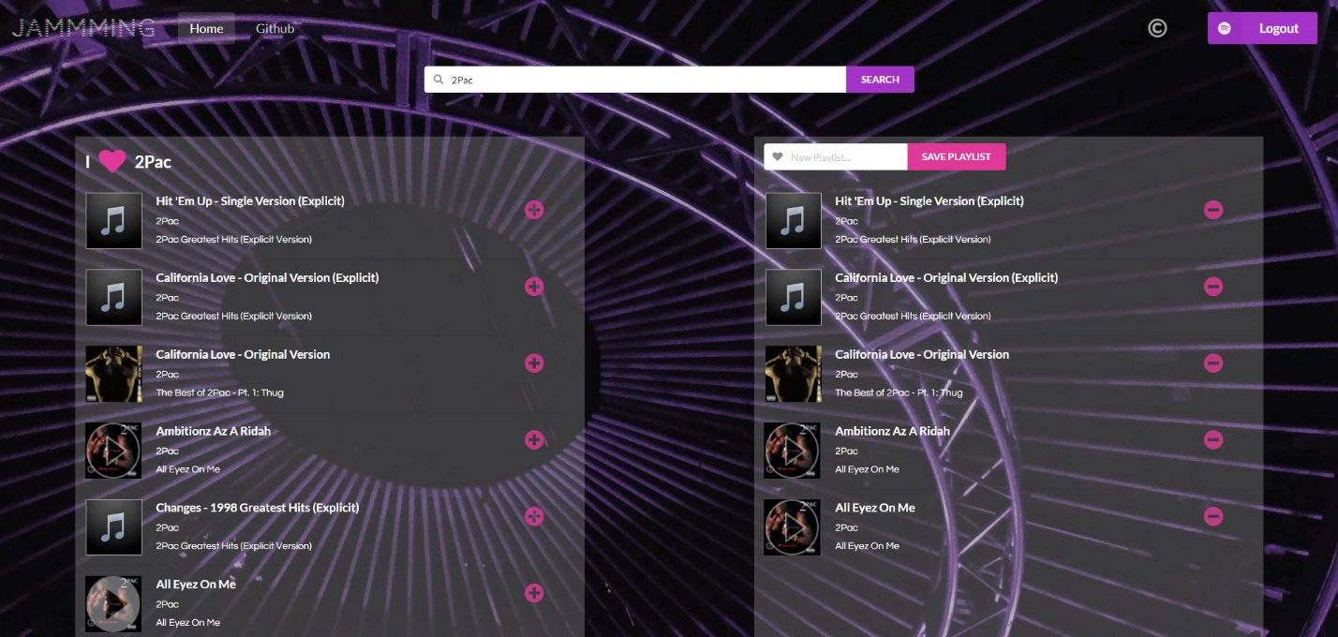

# CAVEATS

# Missing Preview Clips and Album Cover Images

Based on our preliminary experience with Spotify Search API responses, not all tracks have a cover album and/or audio preview clip. This requires that the app “fill in” the missing information when presenting the data to the user either through another resource (separate API) or by creating dummy objects in their place.

**Excessive Requests to the Spotify Search API Endpoint**

There is a risk of abuse with the number searches with each keystroke that may result in the throttling the Spotify Search API as well as the general responsiveness of the interface. This may be handled better in the future by adding an additional layer in the search that prioritizes popular searches or even user preferences prior to passing on a request to Spotify. This can be done more efficiently using their graphql API endpoint.