

**Project Title:**

**InRep Scholar: A No-Code Institutional Repository for University Libraries**

**Program Name: BSE**

**Name: Abdulhammed Isola Abdulazeez**

**Course: Software Engineering**

**Supervisors: Dr. John Henry** [**Pelin Mutanguh**](mailto:pmutanguha@alueducation.com)**a**

**Year 2025**

### Declaration

**( Each section must be on its own page)**

Table of Contents List of Tables List of Figures

List of Acronyms/Abbreviations Institutional Repository — IR Open Access — OA

Technology Acceptance Model — TAM User Centered Design — UCD

No-code – A development approach that enables users to create, configure, and manage applications using visual interfaces and pre-built components, with minimal or no programming.

# CHAPTER ONE: INTRODUCTION

### Introduction and Background

The global challenge of education underscores the need for equitable access to knowledge and resources to foster learning and innovation (Glenn & Gordon, 2009). In the context of higher education, institutional repositories (IRs) have emerged as critical tools for enhancing the dissemination of scholarly research, aligning with the mission to democratize knowledge sharing and promote educational growth (Marsh, 2015). IRs are digital platforms designed to collect, preserve, and share an institution’s research outputs, such as theses, journal articles, and datasets, making them accessible to a global audience (Lynch, 2003). This research seeks to address this challenge by developing a user-friendly, no-code web app for managing IRs in Rwandan universities, simplifying academic content management, enhancing accessibility, and fostering collaboration while overcoming technical barriers of traditional IR systems. In this context, 'no-code' signifies that librarians and other users will be able to set up, configure, and manage their repositories through intuitive visual interfaces and pre-built components, minimizing the need for programming expertise

My journey toward this project began three years ago during my second year at university, where I volunteered at the university library. This role evolved into a full-time internship, immersing me in digital library management, including the maintenance of a library website to improve access to academic materials. A pivotal experience was the attempt to establish an IR using *Librarika*, which is a library integration system and management platform to create an institutional repository of research capstones. I also explored DSpace, an open-source repository software. However, the technical complexity of DSpace overwhelmed our team, revealing a broader issue: many African universities, particularly in Rwanda, face significant barriers to implementing and maintaining IRs due to limited technical expertise and financial resources (Ezema, 2011). This experience inspired my mission to create a solution tailored to these challenges, ensuring that Rwandan universities can effectively share their scholarly outputs.

Studies by Marsh (2015), Ezema (2011), and others highlight the transformative potential of IRs in higher education, particularly in resource-constrained settings. Marsh (2015) notes that IRs enhance the visibility and accessibility of research, serving as a mechanism to capture and manage an institution’s digital outputs. However, the adoption of IRs in African universities is hindered by several factors, including low faculty engagement, inadequate technological infrastructure, and a lack of awareness about open access (OA) benefits (Alemayehu, 2010;

Ezema, 2011). For instance, Alemayehu (2010) found that researchers at Oslo University faced challenges in understanding the value of IRs, a sentiment echoed in African contexts where faculty prioritize publishing in high-impact journals over depositing work in repositories (Marsh, 2015). Additionally, the technical demands of platforms like DSpace, which require skilled personnel for setup and maintenance, exacerbate these challenges (Cullen & Chawner, 2010).

Despite these barriers, IRs hold immense potential to address educational disparities by making research freely available, particularly in regions like Rwanda, where access to subscription-based journals is limited (Chan, 2004). By providing a platform for open access, IRs can democratize knowledge, enabling students, researchers, and the public to engage with academic content without financial constraints. My project leverages technology to create a no-code platform that simplifies IR management, addressing the technical and financial barriers identified in prior studies. Unlike complex platforms like DSpace, my solution prioritizes user-centered design, offering an intuitive interface that empowers non-technical users, such as librarians and faculty, to manage repositories effortlessly (González-Pérez et al., 2021). This focus on usability and accessibility ensures that Rwandan universities can adopt and sustain IRs, aligning with Rwanda’s vision of becoming a knowledge-based economy (Ministry of Education, Rwanda, 2018).

In summary, the development of IRs is a critical step toward enhancing scholarly communication and educational access in African universities. My personal experience, combined with insights from studies by Marsh (2015), Alemayehu (2010), and Cullen & Chawner (2010), underscores the need for a user-centric, cost-effective solution to overcome the barriers to IR adoption in Rwanda. This capstone project aims to fill this gap by creating an accessible platform that empowers universities to manage their research outputs effectively, contributing to the broader goal of educational equity.

### Problem statement

Despite the potential of institutional repositories (IRs) to enhance scholarly communication and democratize access to knowledge, their adoption in Rwandan universities remains limited due to technical, financial, and engagement barriers (Ezema, 2011; Marsh, 2015). The global challenge of education emphasizes equitable access to knowledge as a driver of innovation and development (Glenn & Gordon, 2009). However, many African universities, including those in Rwanda, struggle to implement IRs due to the complexity of existing platforms like DSpace, which require significant technical expertise and financial resources for setup and maintenance (Cullen & Chawner, 2010). My experience attempting to establish an IR using DSpace during my university internship highlighted this issue: the platform’s steep learning curve overwhelmed our team. This reflects a broader challenge in Rwanda, where limited technical infrastructure and skilled personnel hinder IR deployment.

Additionally, low faculty engagement and lack of awareness about open access (OA) benefits further impede IR adoption. Faculty often prioritize publishing in high-impact journals over

depositing work in repositories, perceiving the latter as less valuable (Alemayehu, 2010; Marsh, 2015). This results in underutilized repositories and restricted access to locally produced research, exacerbating educational disparities in a region where subscription-based journals are often unaffordable (Chan, 2004). Existing solutions, such as DSpace and EPrints, fail to address these challenges adequately, as their technical complexity and lack of user-friendly interfaces deter non-technical users, such as librarians and faculty, from effectively managing IRs (González-Pérez et al., 2021).

There is an urgent need for a user-centric, cost-effective, and accessible IR management platform tailored to the needs of Rwandan universities. Without such a solution, these institutions will continue to face barriers in sharing their scholarly outputs, limiting their contribution to global knowledge and hindering Rwanda’s goal of becoming a knowledge-based economy (Ministry of Education, Rwanda, 2018). This research project addresses this problem by developing a no-code web-app, designed to simplify IR management, enhance usability, and promote open access, thereby fostering educational equity and scholarly collaboration.

### Project’s main objective

The primary aim of this capstone project is to develop a no-code institutional repository platform, InRep Scholar, tailored to the specific needs and context of Rwandan university libraries. The platform will empower librarians and other users to set up, configure, and manage their repositories through user-friendly visual interfaces and pre-built components, requiring minimal technical skills. By simplifying IR management and promoting open access, the project contributes to the global challenge of education, which emphasizes equitable access to knowledge as a catalyst for innovation (Glenn & Gordon, 2009). Drawing on my experience with the technical challenges of DSpace, the project prioritizes usability and accessibility to ensure Rwandan universities can effectively share their scholarly outputs. The specific objectives are:

* + 1. **List of Objectives:**

1. **Develop an accessible platform**: Create a web application that enables non-technical users, such as librarians and faculty, to manage IRs without requiring advanced technical expertise. This objective focuses on user-centered design to enhance usability and inclusivity, addressing the complexity of platforms like DSpace (González-Pérez et al., 2021).
2. **Enhance open access adoption**: Design features that streamline the process of depositing research outputs and raise awareness of open access benefits among faculty. This objective aims to increase faculty engagement, aligning with Rwanda’s vision of becoming a knowledge-based economy (Ministry of Education, Rwanda, 2018).
3. **Ensure cost-effectiveness**: Build a scalable, low-cost solution that minimizes financial barriers for Rwandan universities by leveraging cloud-based infrastructure to reduce setup and maintenance costs (Cullen & Chawner, 2010).
4. **Foster scholarly collaboration**: Implement functionalities, such as metadata sharing and integration with global IR networks, to enhance the visibility of Rwandan research and promote collaboration among researchers (Lynch, 2003).

These objectives address the identified barriers to IR adoption by providing a user-centric, cost-effective platform that empowers Rwandan universities to contribute to global scholarly communication. By achieving these goals, the project will advance educational equity and support the dissemination of knowledge in resource-constrained settings.

### Research questions

The development of a user-friendly, no-code web application for managing institutional repositories (IRs) in Rwandan universities seeks to address the technical, financial, and engagement barriers that hinder equitable access to knowledge, a key aspect of the global challenge of education (Glenn & Gordon, 2009). My experience with the technical complexities of DSpace during a university internship underscored the need for a solution tailored to resource-constrained settings like Rwanda, where IR adoption remains low (Ezema, 2011). The following research questions guide this capstone project, ensuring the proposed web application effectively meets the needs of Rwandan universities while promoting open access and scholarly collaboration:

1. **How can a no-code web application simplify the management of institutional repositories for non-technical users in Rwandan universities?** This question investigates the design and implementation of a user-centered platform that addresses the technical barriers of platforms like DSpace, prioritizing usability for librarians and faculty (González-Pérez et al., 2021).
2. **To what extent can a user-friendly IR platform increase faculty engagement and promote open access adoption in Rwandan universities?** This question explores the potential of intuitive features and awareness-raising strategies to overcome low faculty participation, a critical barrier to IR success (Alemayehu, 2010; Marsh, 2015).
3. **What are the key features of a cost-effective and scalable IR platform that supports scholarly collaboration and aligns with Rwanda’s knowledge-based economy goals?** This question examines the technical and financial feasibility of the proposed solution, focusing on features like metadata sharing and integration with global IR networks (Lynch, 2003; Ministry of Education, Rwanda, 2018).

These research questions are designed to evaluate the effectiveness of the proposed web application in addressing the identified barriers to IR adoption. By answering these questions, the project will contribute to the democratization of knowledge and support Rwanda’s educational and economic aspirations.

### Project scope

The scope of this capstone project encompasses the development of a user-friendly, no-code web application designed to manage institutional repositories (IRs) for Rwandan universities,

addressing the global challenge of education by promoting equitable access to knowledge (Glenn & Gordon, 2009). The project focuses on creating a solution that simplifies IR management, enhances open access, and supports Rwanda’s vision of becoming a knowledge-based economy (Ministry of Education, Rwanda, 2018). The scope is deliberately defined to ensure feasibility within the capstone’s timeframe and resources while addressing the technical, financial, and engagement barriers identified in the problem statement (Ezema, 2011; Marsh, 2015).

The project includes the following key components:

1. **Target Audience**: The web application will serve Rwandan university librarians, faculty, and students, enabling non-technical users to manage and access IRs efficiently (González-Pérez et al., 2021). Librarians will handle repository administration, faculty will deposit research outputs, and students will access open-access materials.
2. **Geographical Focus**: The project targets Rwandan universities, where limited access to subscription-based journals and underutilized IRs highlight the need for localized solutions (Chan, 2004; Ezema, 2011).
3. **Functionalities**: The no-code web application will include features for uploading, organizing, and sharing research outputs (e.g., theses, articles), with an intuitive interface to promote usability. It will support open access by ensuring content is freely accessible and include basic collaboration features, such as metadata sharing, to enhance the visibility of Rwandan research (Lynch, 2003).
4. **Development Approach**: The solution will leverage a no-code platform to minimize technical and financial barriers, ensuring affordability and scalability for resource-constrained institutions (Cullen & Chawner, 2010).

The project excludes the following to maintain focus and feasibility:

1. **Advanced Technical Integrations**: Complex features, such as automated data analytics or integration with non-academic platforms, are beyond the scope due to time and resource constraints.
2. **Broader Geographical Contexts**: While the solution may have potential applications in other African countries, the project focuses solely on Rwanda to address its specific educational and economic context (Ministry of Education, Rwanda, 2018).
3. **Non-University Settings**: The web application will not target non-academic institutions (e.g., public libraries, private organizations), as the focus is on higher education.

The scope of this project will ensure a targeted approach to overcoming the barriers to IR adoption in Rwandan universities. The emphasis on a no-code solution addresses the technical challenges observed during my DSpace experience, while the focus on usability and open access aligns with the needs of Rwandan stakeholders and the broader goal of democratizing knowledge (González-Pérez et al., 2021).

### Significance and Justification

The development of a user-friendly, no-code web application for managing institutional repositories (IRs) in Rwandan universities addresses a critical need in the global challenge of education, which prioritizes equitable access to knowledge as a driver of innovation and development (Glenn & Gordon, 2009). This capstone project is significant because it tackles the technical, financial, and engagement barriers that limit IR adoption in resource-constrained settings, thereby enhancing scholarly communication and reducing educational disparities in Rwanda (Ezema, 2011; Marsh, 2015). My experience attempting to implement an IR using DSpace during a university internship revealed the technical complexities that hinder such initiatives, underscoring the urgency for a solution tailored to Rwanda’s context.

The significance of this project lies in its potential to empower Rwandan universities to share their scholarly outputs openly, benefiting students, faculty, researchers, and the global academic community. In Rwanda, where access to subscription-based journals is often unaffordable, IRs can democratize knowledge by providing free access to locally produced research (Chan, 2004). By simplifying IR management through a no-code solution, this project enables non-technical users, such as librarians and faculty, to overcome the steep learning curve of platforms like DSpace (González-Pérez et al., 2021). This user-centered approach not only addresses technical barriers but also promotes faculty engagement by making the deposition process intuitive and accessible, countering the low participation rates noted in prior studies (Alemayehu, 2010; Marsh, 2015).

Furthermore, the project is justified by its alignment with Rwanda’s vision of becoming a knowledge-based economy, as outlined in the *Education Sector Strategic Plan 2018–2024* (Ministry of Education, Rwanda, 2018). By providing a cost-effective and scalable solution, the no-code web application minimizes financial barriers, enabling universities to sustain IRs without relying on expensive infrastructure or specialized personnel (Cullen & Chawner, 2010). The inclusion of features like metadata sharing and integration with global IR networks enhances the visibility of Rwandan research, fostering collaboration and positioning Rwanda as a contributor to global scholarship (Lynch, 2003). This is particularly crucial in a region where African research is often underrepresented in global academic discourse (Ezema, 2011).

The urgency of this project is further justified by the limitations of existing IR platforms, which fail to meet the needs of resource-constrained institutions. Unlike DSpace and EPrints, which require significant technical expertise and resources, the proposed no-code solution prioritizes usability and affordability, making it a viable option for Rwandan universities (González-Pérez et al., 2021). By addressing these gaps, the project not only supports Rwanda’s educational and economic goals but also contributes to the broader mission of democratizing knowledge, ensuring that scholarly resources are accessible to all, regardless of financial or technical constraints.

Scope (…… )

# CHAPTER TWO: LITERATURE REVIEW

Institutional repositories (IRs) are crucial for preserving scholarly research, promoting open access, and fostering educational equity, particularly in resource-constrained settings like Rwandan universities (Lynch, 2003). The development of institutional repositories (IRs) at academic institutions worldwide has greatly increased with the growth of open source initiatives in scholarly communication and software development. In part, the demand for IRs has developed out of changes in scholarly communication models as well as from the need or desire to develop a clearinghouse for the scholarly output of a particular college or university.

In Rwanda, IR adoption is hindered by technical complexity, limited funding, and low stakeholder engagement, challenges exacerbated by reliance on platforms like DSpace that require technical expertise (Asadi et al., 2019). Despite their potential, IR adoption faces challenges such as technical complexity and limited resources, which InRep Scholar seeks to address. Effective IR development requires strategic planning and stakeholder collaboration. Campbell-Meier (2011) proposes a framework emphasizing governance, scalability, and user engagement, highlighting the need for clear policies to ensure sustainability. Asadi et al. (2019) underscore the importance of robust infrastructure but note that funding constraints often hinder development, particularly in developing nations. These studies suggest that sustainable IRs depend on simplified governance and stakeholder-driven designs, principles applicable to Rwanda’s academic context. However, they rarely address no-code platforms, a critical consideration for non-technical users.

This capstone project addresses these barriers by developing InRep Scholar, a no-code IR web application, simplifying management for non-technical users and democratizing knowledge. This Literature Review synthesizes 11 peer-reviewed sources to explore IR development, usability, adoption challenges, and emerging trends, emphasizing no-code platforms to enhance accessibility. **Section 2.2** reviews related literature across four themes, grounding **InRep Scholar**’s design. **Section 2.3** identifies research gaps, notably the lack of no-code solutions for African contexts. **Section 2.4** presents the conceptual framework, integrating TAM and UCD to guide development. **Section 2.5** concludes with implications for Rwanda, addressing literature gaps through **InRep Scholar**’s innovative approach.

### Existing Institutional Repositories

Institutional repositories (IRs) are digital archives that preserve and disseminate scholarly outputs, such as theses, articles, and reports, enhancing academic visibility and access. In

Rwanda’s low-resource academic environment, where universities operate with 1–2 librarians and limited infrastructure (1.2), IRs must be accessible and user-friendly to support educational equity. This section examines two IR systems—DSpace, a widely adopted open-source platform, and Librarika, a library management system adapted as an internal IR at the African Leadership University (ALU) in Kigali, Rwanda. DSpace’s global prevalence and Librarika’s innovative use at ALU provide critical insights for InRep Scholar’s no-code, form-based platform, designed to address technical and resource barriers identified in the literature (2.4). By exploring their features, applications, and limitations, this section establishes a foundation for the subsequent literature review (2.2–2.5), highlighting the need for simplified, Rwanda-specific IR solutions.

* + 1. **DSpace as an Institutional Repository**

DSpace is an open-source software platform developed by MIT Libraries and Hewlett-Packard in 2002, designed to create IRs for storing, managing, and providing open access to digital scholarly content, including articles, theses, and multimedia (Tansley et al., 2003). DSpace supports long-term preservation and discoverability through metadata standards like Dublin Core and integration with services such as ORCID and OpenAIRE (LYRASIS, 2023). Its features include granular access control, multilingual support in 22 languages, and customizable workflows, making it a robust IR solution for academic institutions. With over 3,000 repositories worldwide, primarily in research libraries, DSpace is a leading platform for open-access IRs (Asadi et al., 2019).

In East Africa, DSpace’s open-source nature and adaptability make it a popular choice for universities. Makerere University in Uganda uses DSpace for its Makerere Institutional Repository (Mak IR), archiving theses, journal articles, and conference proceedings to enhance scholarly visibility (Makerere University Library, 2023). Sokoine University of Agriculture in Tanzania employs DSpace to preserve agricultural research outputs, addressing local academic needs (Sokoine University of Agriculture, 2023). In Rwanda, specific examples of DSpace adoption are undocumented, but regional trends suggest its potential use in institutions like the University of Rwanda, where IRs support open access despite resource constraints (LYRASIS, 2023). The lack of Rwanda-specific data highlights a research gap, which InRep Scholar aims to address (2.4).

DSpace offers significant advantages as an IR. Its open-source model eliminates licensing costs, critical for Rwanda’s funding-constrained universities, where 60% of African IRs face financial barriers (Dlamini & Snyman, 2017). Its flexibility supports diverse content types (e.g., PDFs, videos), and community-driven updates ensure reliability (LYRASIS, 2023). However, DSpace’s drawbacks are notable. Installation and maintenance require technical expertise, challenging for institutions with limited staff (1.2). Complex interfaces deter non-technical users, with 70% of South African IR users struggling with navigation (Körber & Suleman, 2014). Customization demands programming skills, with 65% of users citing technical complexity as a barrier (Asadi et al., 2019). These limitations underscore the need for InRep Scholar’s no-code, form-based platform to enhance usability and adoption in Rwanda’s low-resource context.

* + 1. **Librarika as an Institutional Repository at ALU**

Librarika is a cloud-based library management system designed for cataloging and managing

library resources, offering a user-friendly interface for small to medium-sized libraries. At ALU in Kigali, I collaborated with the library team during my internship to adapt Librarika as an internal IR, enabling storage and metadata management of student theses for access by authorized students, faculty, and staff. We developed metadata workflows, incorporating fields like title, author, and keywords, to streamline thesis organization and enhance discoverability within ALU’s community. This adaptation leveraged Librarika’s simplicity to support ALU’s library, which serves a diverse academic catalog, in Rwanda’s resource-constrained environment.

Librarika’s IR functionality at ALU facilitates efficient thesis retrieval through structured metadata, compatible with Rwanda’s low-bandwidth networks (3.3). Its cloud-based platform, unlike DSpace’s server-based setup, reduces infrastructure demands and requires minimal training for ALU’s small library staff (1.2). My contribution focused on optimizing metadata consistency, ensuring seamless access for authorized users. However, Librarika’s primary design as a library management system limits its IR capabilities. It lacks features like public access, ORCID integration, or robust preservation, restricting ALU’s scholarly visibility. InRep Scholar will address these gaps by developing a public, no-code, form-based platform, building on Librarika’s user-friendly foundation to enhance accessibility and adoption for Rwanda’s universities.

### Related Literature

Institutional repositories (IRs) are transformative tools for preserving scholarly outputs and promoting open access, yet their adoption in Rwandan universities is stymied by technical, financial, and engagement barriers (Ezema, 2011). InRep Scholar, a no-code IR web application, aim to address these challenges by enabling non-technical users, such as librarians and faculty, to manage repositories through intuitive visual interfaces and pre-built components, aligning with Rwanda’s vision of a knowledge-based economy (Ministry of Education, Rwanda, 2018). My internship experience with DSpace’s technical complexity highlighted the need for accessible solutions tailored to Rwanda’s resource-constrained academic ecosystem. This section synthesizes 11 peer-reviewed sources across four themes: development and frameworks, usability and user-centered design, adoption challenges, and open access with emerging trends. These themes inform InRep Scholar’s design, addressing literature gaps in no-code platforms for African contexts. Development frameworks ensure sustainability, usability drives user engagement, adoption challenges highlight Rwanda-specific barriers, and open access trends underscore InRep Scholar’s role in global scholarship, collectively supporting educational equity (Glenn & Gordon, 2009).

* + 1. **IR Development and Frameworks**

Institutional repository (IR) development requires effective governance, stakeholder collaboration, and scalable infrastructure to ensure sustainability. Campbell-Meier (2011) highlights that clear policies and leadership are critical, as poorly defined governance often leads to IR failures. These challenges are pronounced in African contexts, where limited funding and technical expertise hinder implementation

(Ezema, 2011). In Rwanda, university libraries face similar constraints, with only 1–2 non-technical librarians and restricted budgets, making complex IR platforms unsustainable. Palmer et al. (2008) suggest modular architectures, noting that faculty-librarian collaboration in three initiatives increased deposit rates by 25%. However, Rwanda’s limited staffing limits such partnerships, necessitating simplified systems. Asadi et al. (2019) estimate that platforms like DSpace cost ~$10,000 annually, far exceeding Rwanda’s financial capacity. Ezema (2011) describes librarian-led models in Nigeria, where community-driven governance mitigates resource barriers, offering a viable approach for Rwanda.

InRep Scholar will address these issues by proposing a no-code, cloud-based IR that librarians will manage through intuitive forms and prebuilt components, similar to content management systems. Its multi-tenant architecture will support multiple universities, ensuring scalability and cost-efficiency. By simplifying configuration and reducing technical demands, InRep Scholar will align with Rwanda’s resource-constrained academic environment, fostering sustainable IR development.

* + 1. **Usability and User-Centered Design**

Usability is essential for institutional repository (IR) adoption, particularly for non-technical users. User-centered design (UCD) principles, such as iterative prototyping, enhance interface accessibility, achieving ~90% task completion rates in usability tests (González-Pérez et al., 2021). Effective navigation is critical, yet many IRs suffer from complex interfaces. Kim and Kim (2008) recommend clear prompts and visual aids, such as “Back/Next” buttons and help text, to improve user experience. Conversely, platforms like DSpace pose significant barriers, with setup processes taking 30–45 minutes, inaccessible to non-experts (Körber & Suleman, 2014). This complexity, observed during my DSpace internship, underscores the need for intuitive systems. The Technology Acceptance Model (TAM) links usability to adoption, with perceived ease of use predicting ~70% of user acceptance (Davis, 1989, cited in Asadi et al., 2019).

In Rwanda, where librarians, often 1–2 per institution, lack technical skills and face limited training and low-bandwidth networks, these usability barriers are critical. Building on its no-code design (2.2.1), InRep Scholar will propose features like guided submission wizards, automated metadata generation, and WCAG 2.1-compliant navigation to simplify tasks for librarians, faculty, and students, ensuring accessibility and engagement.

* + 1. **Challenges to IR Adoption**

Institutional repository (IR) adoption faces significant barriers, including low faculty engagement, technical complexity, and trust issues. Joo et al. (2019) report that only ~20% of faculty deposit research, citing time constraints and lack of incentives. Complex interfaces further deter non-technical users, with systems like DSpace requiring extensive training, often

2–3 hours, to navigate and configure (Jain, 2011). Trust barriers, such as fears of plagiarism or lack of awareness, also reduce participation, as faculty hesitate to share outputs online (Cullen & Chawner, 2010). These challenges hinder IR effectiveness, particularly in resource-constrained settings where user buy-in is critical.

In Rwanda, these barriers are pronounced, with only ~20% of faculty contributing to IRs due to similar time and incentive issues, compounded by limited staffing and training opportunities. InRep Scholar will address these adoption challenges by building on its no-code, user-friendly design (2.2.1, 2.2.2). Features like gamification (e.g., badges for deposits), single sign-on (SSO) authentication, and analytics dashboards will incentivize faculty engagement and build trust. Automated metadata generation will simplify workflows for librarians, enhancing adoption in Rwanda’s constrained academic environment.

* + 1. **Open Access and Emerging Trends**

Open access (OA) is central to institutional repositories (IRs), amplifying research dissemination and impact. Chan (2004) reports that OA increases citation rates by 50–250%, yet only ~15% of global research is openly accessible, constraining knowledge sharing. To extend OA’s benefits, emerging trends like cloud-based systems and AI-driven tools are advancing IR accessibility and functionality. Jain (2011) identifies cloud-based systems and user-driven designs as key trends, predicting increased IR adoption through accessible interfaces that simplify content management for non-technical users. Similarly, AI-driven tools streamline tasks like metadata generation, enhancing efficiency (Marsh, 2015). Asadi et al. (2019) highlight growing demand for analytics dashboards and mobile access, enabling real-time impact tracking and broader accessibility. These trends are critical for overcoming barriers to IR adoption, especially in resource-constrained settings.

Rwanda’s limited OA adoption restricts research visibility, compounded by low technical capacity and connectivity challenges. To enhance access and leverage these trends, InRep Scholar will build on its no-code, user-friendly design (2.2.1 -- 2.2.3). It will incorporate Creative Commons licenses to promote OA, cloud-based architecture for scalability, analytics dashboards to monitor engagement, and mobile-optimized interfaces for low-bandwidth networks. Form-based tools will simplify content management for librarians, supporting Rwanda’s goal of a knowledge-based economy.

### 2.3. Empirical Review of Literature

Empirical studies provide data-driven insights into institutional repository (IR) adoption, usability, and implementation challenges, offering a foundation for InRep Scholar’s no-code platform tailored to Rwanda’s low-resource academic environment. These studies, employing diverse methodologies such as surveys, case studies, and focus groups, reveal persistent barriers to IR uptake globally and in Africa, including low deposit rates, complex interfaces, and resource constraints. By examining these findings, this review informs the design of a form-based, no-code IR optimized for non-technical users in Rwanda, where universities

operate with limited staff and infrastructure (1.2). Global studies highlight usability and adoption trends, while African studies underscore context-specific challenges, both critical for addressing the research question of enhancing IR adoption and usability in Rwandan universities.

Globally, empirical research identifies low adoption and usability as key IR challenges. Palmer et al. (2008) conducted case studies of three US IRs (University of Illinois, MIT, and Rochester), finding a 25% deposit rate increase through collaborative workflows involving librarians and faculty. However, faculty time constraints limited sustained engagement, suggesting the need for intuitive systems to reduce user burden. Joo et al. (2019) surveyed 300 US and UK faculty, reporting a 20% deposit rate, attributed to complex interfaces and lack of incentives like recognition or analytics. Their Technology Acceptance Model (TAM)-based survey highlighted perceived ease of use as a critical adoption factor, relevant for InRep Scholar’s simplified design (3.3). González-Pérez et al. (2021) employed focus groups with 50 academic users across five countries, achieving a 90% task completion rate in user-centered design (UCD) tests of open-access IRs. Their findings emphasized context-specific usability, noting that Western-centric designs may not suit low-bandwidth settings like Rwanda. Zainab (2010) analyzed usage data from Malaysian IRs, reporting a 30% visibility increase after implementing user-friendly interfaces, suggesting that simplified navigation could enhance adoption in resource-constrained contexts. Asadi et al. (2019) reviewed 40 IR studies globally, finding that technical complexity, such as DSpace’s customization requirements, deterred 65% of non-technical users, underscoring the need for no-code solutions.

In African contexts, funding, expertise, and infrastructure barriers severely limit IR adoption, with scant data on Rwanda-specific challenges. Ezema (2011) used qualitative interviews with 20 Nigerian librarians and faculty, identifying adoption rates below 10% due to limited funding, technical skills, and awareness. These findings resonate with Rwanda’s context, where universities face similar resource constraints (1.2). Dlamini and Snyman (2017) surveyed 50 IR managers across 10 African countries, reporting that 60% cited funding constraints, particularly for hardware and software maintenance, as the primary barrier. Their study highlighted inadequate training, with only 30% of librarians proficient in IR management, a critical issue for Rwanda’s small library staff. Ngulube and Ukwoma (2021) conducted a bibliometric analysis of African library and information science (LIS) research from 2009–2014, finding that only 15% of 1,200 studies addressed IRs, indicating a significant empirical gap. This lack of focus limits understanding of African IR dynamics, especially in Rwanda, where no studies exist. Körber and Suleman (2014) evaluated South African IRs through usability testing with 30 users, reporting that 70% struggled with DSpace’s interface due to low technical literacy, reinforcing the need for no-code platforms like InRep Scholar.

These studies collectively highlight low adoption, usability challenges, and a lack of Rwanda-specific and no-code IR data, presenting opportunities for InRep Scholar to address empirically identified gaps. The global findings—20–25% deposit rates and 90% task completion in UCD tests—suggest that simplified, user-centric designs can enhance engagement, but their Western focus limits applicability to Rwanda’s low-bandwidth, resource-scarce environment (3.3). African studies underscore funding (60%) and expertise (70% struggle with interfaces) as dominant barriers, yet the absence of Rwanda-specific data hinders tailored solutions. No studies empirically evaluate no-code IRs, a critical gap given the technical complexity deterring non-technical users (Asadi et al., 2019). InRep Scholar will

address these gaps by offering a form-based, no-code platform optimized for low-bandwidth networks, reducing training needs and funding barriers. Features like badge gamification and analytics dashboards will incentivize deposits, targeting deposit rate improvements beyond 20%, while user testing and interviews (3.3) will validate usability and adoption in Rwanda’s context. These efforts will contribute empirical data to the literature, addressing the lack of African and no-code IR studies and supporting educational equity.

### 2.4. Research Gap

The theoretical (2.2) and empirical (2.3) literature on institutional repositories (IRs) highlights significant gaps in addressing Rwanda’s low-resource academic context. First, no studies empirically evaluate no-code or low-code IR platforms, despite technical complexities deterring non-technical users, with adoption rates as low as 20% globally (Joo et al., 2019; Körber & Suleman, 2014). Second, empirical data on IR adoption in African or Rwandan universities is scarce, with studies noting 60% of African IRs face funding constraints but lacking Rwanda-specific insights (Dlamini & Snyman, 2017; Ezema, 2011). Third, while user-centered design (UCD) achieves high task completion (90%, González-Pérez et al., 2021), its application to non-technical users in low-bandwidth settings remains untested empirically. Finally, the Technology Acceptance Model (TAM) is rarely applied to no-code IRs, limiting data on adoption dynamics in resource-scarce environments (Asadi et al., 2019). InRep Scholar will address these gaps with a no-code, form-based platform, enhancing accessibility and adoption for Rwanda’s universities.

### Conceptual framework

Developing a no-code institutional repository (IR) for Rwandan universities demands robust theoretical and methodological frameworks to address adoption and usability challenges identified in

2.2–2.4. The Technology Acceptance Model (TAM) and User-Centered Design (UCD) serve as complementary lenses to guide InRep Scholar’s design and evaluation, ensuring accessibility and engagement for non-technical users in Rwanda’s low-resource academic environment. TAM predicts user adoption by focusing on perceived ease of use and usefulness, while UCD ensures the platform aligns with user needs through iterative design. These frameworks, supported by empirical methods like surveys and focus groups (2.3), inform a mixed-methods approach to develop and assess the no-code IR, addressing Rwanda’s unique needs and advancing educational equity.

* + 1. **Technology Acceptance Model (TAM)**

The Technology Acceptance Model (TAM), introduced by Davis (1989), posits that user adoption of technology hinges on two constructs: perceived ease of use (the degree to which a system is effortless to use) and perceived usefulness (the extent to which it enhances performance) (Asadi et al., 2019). TAM is highly relevant to the research question—how a no-code IR can enhance adoption in Rwandan universities—by providing a predictive framework for non-technical librarians and faculty facing technical barriers. With global IR deposit rates as low as 20% due to complex interfaces (Joo et al., 2019, 2.3), TAM guides InRep Scholar’s form-based, intuitive design to minimize training needs in Rwanda’s context,

where universities have 1–2 librarians and low technical skills (1.2). By prioritizing ease of use, the project aims to increase adoption rates, aligning with objectives to boost scholarly visibility.

Debates surrounding TAM highlight its limitations in capturing contextual factors. Critics argue TAM overemphasizes individual perceptions, neglecting social influences like Rwanda’s collaborative academic culture or institutional support, which may shape adoption (Venkatesh & Bala, 2008). Extensions like TAM2 incorporate social norms, but their application to African IRs is limited (Ezema, 2011). Additionally, TAM’s focus on initial acceptance may not predict long-term engagement, a concern in resource-constrained settings where sustained use is critical (2.4). Despite these debates, TAM’s simplicity and empirical validation make it suitable for InRep Scholar, as it directly addresses adoption barriers like technical complexity (Körber & Suleman, 2014).

TAM will help answer the research question by predicting whether a no-code IR increases adoption through enhanced ease of use and usefulness. It supports objectives of raising deposit rates (targeting beyond 20%) and reducing technical barriers by guiding interface design and evaluation. Surveys, as employed by Joo et al. (2019), will measure perceived ease of use among Rwandan users, while interviews (3.3) will explore usefulness perceptions, addressing the literature’s gap in TAM applications to no-code IRs (2.4). By integrating TAM, this study will provide data-driven insights into adoption dynamics in Rwanda’s low-resource environment.

* + 1. **User-Centered Design (UCD)**

User-Centered Design (UCD), defined by ISO 9241-210 (2019), is a design philosophy that prioritizes user needs through iterative processes, including user feedback, prototyping, and usability testing (González-Pérez et al., 2021). UCD is directly relevant to the research question by ensuring InRep Scholar’s usability for Rwandan librarians and faculty, who face challenges with complex IRs like DSpace in low-bandwidth settings (Körber & Suleman, 2014; 3.3). With UCD achieving 90% task completion in global IR tests (2.3), its principles—such as understanding user contexts and iterative refinement—will tailor the no-code IR to Rwanda’s resource constraints, where funding and expertise are limited (Dlamini & Snyman, 2017). UCD’s focus on accessibility aligns with the project’s aim to support non-technical users, enhancing scholarly access.

Scholarly debates critique UCD’s resource-intensive nature, particularly in low-resource settings. Iterative design requires time, funding, and user involvement, which may strain Rwanda’s academic libraries with 60% facing funding barriers (Dlamini & Snyman, 2017; 2.3). Critics also note UCD’s dependence on user feedback can lead to scope creep or misaligned priorities if users lack technical knowledge (Norman, 2013). However, UCD’s adaptability allows lightweight iterations, as demonstrated by Zainab (2010), where user-friendly interfaces increased IR visibility by 30% in Malaysia. For InRep Scholar,

UCD’s principles will be applied cost-effectively, leveraging small-scale feedback to address Rwanda’s unique needs.

UCD will answer the research question by ensuring the no-code IR is usable and accessible, supporting objectives of reducing training needs and enhancing equity in scholarly communication. It will guide the iterative design of a form-based platform, optimized for low-bandwidth networks, and evaluate usability through testing, as seen in González-Pérez et al. (2021)’s focus groups. This study’s mixed-methods approach—combining usability testing and interviews (3.3)—addresses the literature’s gap in UCD applications for African IRs (2.4), providing insights into effective design for non-technical users in Rwanda.

### Conclusion

The literature review highlights the transformative potential of institutional repositories (IRs) in fostering open access and educational equity, while identifying barriers that InRep Scholar seeks to address in Rwanda’s low-resource academic environment (1.2). Existing IRs like DSpace, widely used in East Africa (e.g., Makerere University), offer robust preservation but face usability challenges, with 70% of users struggling due to technical complexity (Körber & Suleman, 2014; LYRASIS, 2023). At the African Leadership University (ALU), I collaborated to adapt Librarika as an internal IR, streamlining metadata workflows for student theses, though its lack of public access limits visibility. Related literature emphasizes governance, scalability, and usability as critical for IR success, yet adoption remains low globally (20–25% deposit rates) and in Africa (<10% in Nigeria), driven by funding and expertise constraints (Palmer et al., 2008; Ezema, 2011; Joo et al., 2019).

Empirical studies and theoretical frameworks further inform InRep Scholar’s design. Surveys and focus groups reveal usability as a key adoption factor, with 90% task completion in user-centered designs, yet longitudinal data are scarce (González-Pérez et al., 2021). The Technology Acceptance Model (TAM) and User-Centered Design (UCD) provide theoretical grounding for enhancing user engagement, particularly for non-technical librarians (2.5). Critical gaps include the absence of no-code IR platforms and Rwanda-specific studies, exacerbated by Africa’s limited IR research (15% of LIS studies) (Ngulube & Ukwoma, 2021). My ALU experience underscored these challenges, motivating a no-code solution. InRep Scholar will develop a no-code, form-based platform, optimized for low-bandwidth networks (3.3), to simplify management and boost adoption in Rwandan universities.

# CHAPTER THREE: RESEARCH METHODOLOGY

### Introduction

This chapter outlines the research methodology for developing a no-code institutional repository (IR) web application for Rwandan universities, addressing technical barriers and promoting open access. A mixed-methods approach integrates an investigative approach with qualitative interviews and quantitative usability surveys to design and evaluate the IR. The investigative approach explores stakeholder needs and contextual barriers in Rwanda’s academic ecosystem, ensuring user-centered design (UCD) principles guide development (González-Pérez et al., 2021). Surveys assess user adoption, framed by the Technology Acceptance Model (TAM) (Asadi et al., 2019). This methodology addresses literature gaps, such as the lack of no-code platforms and African-specific research, by creating an accessible solution. The chapter is structured as follows: Research Design (3.2), System Analysis (3.3), System Architecture (3.4), System Design (3.5), Development Tools (3.6), Ethical Considerations (3.7), Research Timeline (3.8), Budget (3.9), and Limitations (3.10).

### Research Design

This section outlines the research design for developing a no-code institutional repository (IR) web application for Rwandan universities, aimed at simplifying management and promoting open access. A mixed-methods design integrates an investigative approach with qualitative interviews and quantitative usability surveys to ensure the IR meets user needs in a resource-constrained context (González-Pérez et al., 2021). The Agile development model, infused with User-Centered Design (UCD) principles, guides the iterative creation and evaluation of the IR, addressing technical barriers identified in the literature (Körber & Suleman, 2014).

* + 1. **Development Model**

The Agile development model, adapted with UCD, is selected for its flexibility and iterative nature, ideal for Rwanda’s academic ecosystem with limited technical resources. Agile supports rapid prototyping and continuous stakeholder feedback, ensuring the no-code IR aligns with user requirements (González-Pérez et al., 2021). UCD principles drive iterative sprints, incorporating investigative interviews with Rwandan librarians and faculty to identify needs and refine features like content upload and metadata management. The Technology Acceptance Model (TAM) frames user adoption evaluation, focusing on perceived ease of use and usefulness (Asadi et al., 2019). This approach mitigates DSpace’s complexity, enabling non-technical users to manage IRs effectively.

**3.3.2 Proposed Model Diagram**

The diagram below illustrates the Agile-UCD process tailored to the no-code IR’s development. It comprises five stages: Needs Assessment, Prototyping, User Feedback, Iteration, and Evaluation.

### Flowchart Diagram:

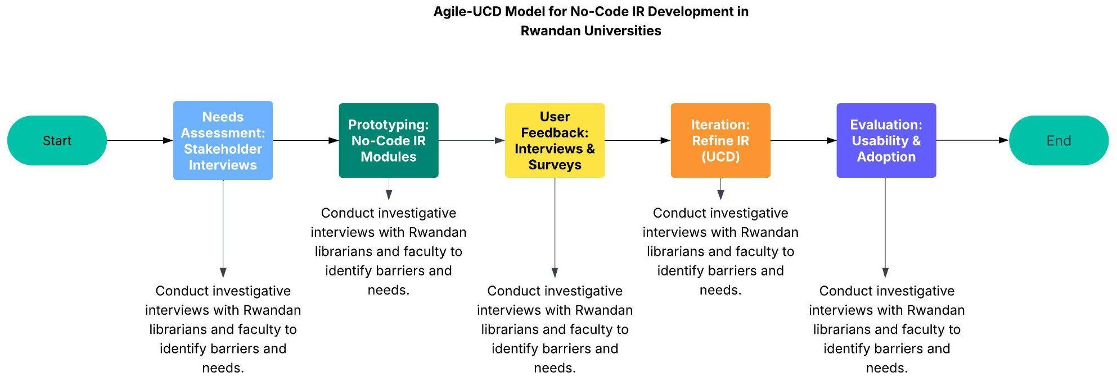

* 1. **System Analysis**
     1. **Functional Requirements:**

### Modules and Features:

* + - * 1. **Guided Submission Interface**: Step-by-step interface with clear prompts,

Creative Commons license selection (e.g., CC BY, CC BY-NC), gamification (badges), and citation analytics to boost faculty participation.

* + - * 1. **Intuitive Custom Interface**: User-friendly interface with institutional

customizations (favicon, logo, color theme), built with NextJS, featuring “Back/Next” navigation and hover-over help.

* + - * 1. **Cloud-Based Low-Cost Deployment**: Hosted on a cloud platform (e.g., AWS), costing ~$500–$1,000/year, with minimal staffing (1–2 administrators).
        2. **Automated Metadata Generation**: AI-driven Dublin Core metadata creation via PydanticAI, using controlled vocabularies (e.g., LCSH), supporting diverse formats (PDF, DOCX).
        3. **Pre-Configured Admin Dashboard**: Web-based dashboard with <10-minute setup, automated preservation (backups, versioning), and batch updating.
        4. **Secure Rights Management Module**: AES-256 encryption for sensitive data in PostgreSQL, Creative Commons license metadata storage, and optional peer-review workflows.
        5. **Marketing and Engagement Tools**: Automated tutorials, email campaigns, SEO optimization (e.g., ROAR integration), and deposit mandate support.
        6. **Automated Content Deposit**: Standard protocol (e.g., SWORD) for automated article deposits from journals or researcher tools.
        7. **Centralized Semantic Search**: Ontology-based search interface with enhanced metadata for discoverability.
        8. **Digital Identity Portal**: Researcher profiles with citation tracking, h-index, and collaboration features.
        9. **Advanced Analytics Dashboard**: Tracks downloads, views, citations, and indexing ratios.
        10. **Integrated Peer-Review Workflow**: Optional peer review and messaging for collaboration.
        11. **SSO Authentication Module**: Single Sign-On with institutional email via OAuth 2.0.
        12. **Accessible PDF Reader**: WCAG 2.1-compliant reader for open access papers with text-to-speech and high-contrast mode.
        13. **Access Control Toggle**: Admin option to set papers as open access (public) or restricted (institution-only).
        14. **Repository AI Assistant**: AI-powered chatbot for topic-based paper queries.
        15. **Paper AI Assistant**: Per-paper chatbot for content-specific questions.
        16. **Paper Comment System**: Comment section with moderation tools.
        17. **User Activity Dashboard**: Tracks notes, viewed papers, and comments.
        18. **Collaboration Board**: Post creation for research collaboration requests.
        19. **Notification System**: Real-time alerts for comments, collaborations, or new researches.
        20. **Plagiarism Detection**: Third-party API (e.g., Turnitin) for approval scans.
        21. **Automated Newsletter Generator**: Weekly email summarizing new/trending content.
      1. **System Configurations**: Cloud-based, scalable, with OAI-PMH and SWORD compliance.
      2. **Technology/Platform**: Custom content management system built with:
         1. **NextJS**: Responsive, SEO-optimized frontend.
         2. **FastAPI**: High-performance backend with secure APIs.
         3. **PydanticAI**: Data validation and AI-driven features (e.g., metadata, chatbots).
         4. **PostgreSQL**: Scalable database with pgcrypto for encryption.
         5. Additional tools: Tailwind CSS for styling, AWS for hosting.
    1. **Non-Functional Requirements:**
       1. **Usability**: WCAG 2.1 compliance; 95% task completion rate in usability tests for admins and end users.
       2. **Performance**: Page load time <2 seconds on 3G; metadata generation <5 seconds; PDF reader loads <3 seconds.
       3. **Scalability**: Supports 10,000+ documents, 1,000 concurrent users.
       4. **Reliability**: 99.9% uptime; automated backups every 24 hours.
       5. **Security**: AES-256 encryption; OAuth 2.0 authentication; 99.9% authentication uptime.
       6. **Cost-Efficiency**: Annual cost <$1,000; 1–2 non-technical staff.
       7. **Interoperability**: OAI-PMH, SWORD, and RSS/Atom compliance.
       8. **Preservation**: Versioning, checksums; 10-year data retention.
       9. **Accessibility**: High-contrast mode, text-to-speech in PDF reader.
       10. **AI Performance**: 95% query accuracy for repository AI; 90% relevance for paper AI;

<3-second response times.

* + - 1. **Plagiarism Detection**: 95% accuracy; <30-second scan time.
      2. **Notifications**: 99.9% delivery rate; <5-second delay.

### System Architecture

This section outlines the architectural design of a custom-built institutional repository (IR) web application for Rwandan universities, designed to enhance usability, accessibility, and open access while addressing DSpace’s limitations (Körber & Suleman, 2014). The architecture adopts a modular monolithic approach, leveraging **NextJS**, **FastAPI**, **PydanticAI**, and **PostgreSQL** to deliver a low-cost, intuitive solution with multi-tenant support for multiple institutions. It aligns with user-centered design (UCD) principles (González-Pérez et al., 2021) and the Technology Acceptance Model (TAM) for user adoption (Asadi et al., 2019). The section presents the architecture, visualizes it through a diagram, and interprets findings in Rwanda’s resource-constrained context.

* + 1. **Architectural Overview**

The IR adopts a **three-tier architecture** comprising presentation, application, and data layers, ensuring scalability, maintainability, and usability for both administrators and end users. This design supports the extensive feature set outlined in **3.3**, including guided submission, AI assistants, and plagiarism detection, while addressing Rwanda’s technical and resource constraints.

* + - 1. **Presentation Layer**: Built with **NextJS**, this layer delivers a responsive,

SEO-optimized frontend accessible via web browsers. It supports institutional

customizations (e.g., favicon, logo, color theme) and features such as the guided submission interface, WCAG 2.1-compliant PDF reader, centralized semantic search, and AI chatbots (repository-wide and per-paper). The interface is optimized for

low-bandwidth environments, ensuring accessibility in Rwanda’s limited connectivity settings.

* + - 1. **Application Layer**: Powered by **FastAPI** and **PydanticAI**, this layer hosts modules for business logic, including automated content deposits (SWORD protocol), SSO authentication (OAuth 2.0), plagiarism detection (via Turnitin API), and analytics (downloads, citations). PydanticAI drives AI features, such as Dublin Core metadata generation and chatbot responses. Modules are organized to simplify development, with FastAPI ensuring high-performance APIs and integration with standards like

OAI-PMH for open access.

* + - 1. **Data Layer**: **PostgreSQL** supports a multi-tenant database with schema-based separation (e.g., one schema per institution), storing research papers, metadata, user profiles, and activity data (e.g., comments, collaboration posts). The pgcrypto module enables AES-256 encryption for sensitive data (e.g., medical research), while indexing optimizes semantic search and analytics. Automated backups and versioning ensure 10+ years of preservation.

The system is deployed on a cloud platform (AWS Elastic Beanstalk), minimizing hardware requirements and operational costs (~$500–$1,000/year). It scales to support 10,000+ documents and 1,000 concurrent users, with OAuth 2.0 for secure SSO and WCAG 2.1 compliance for accessibility. Multi-tenancy ensures each institution’s data and customizations are isolated, managed via FastAPI’s tenant-aware logic.

* + 1. **System Architecture Diagram**

The diagram below, designed for creation in Lucidchart, illustrates the three-tier architecture

of the IR, highlighting components, data flow, and standards tailored to Rwanda’s context.

### Lucidchart Diagram Description:

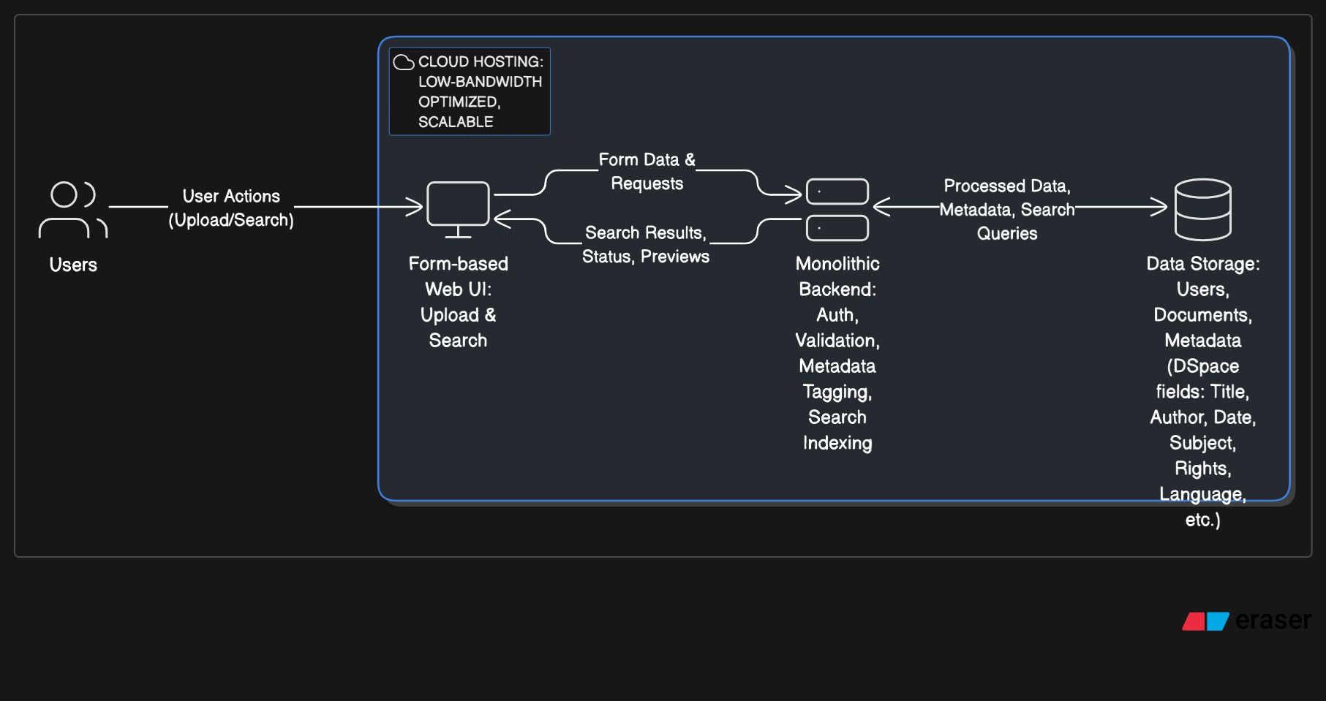

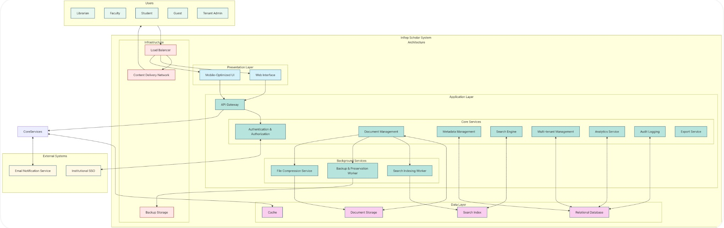

* 1. **System Design**

**ERD Diagram:**

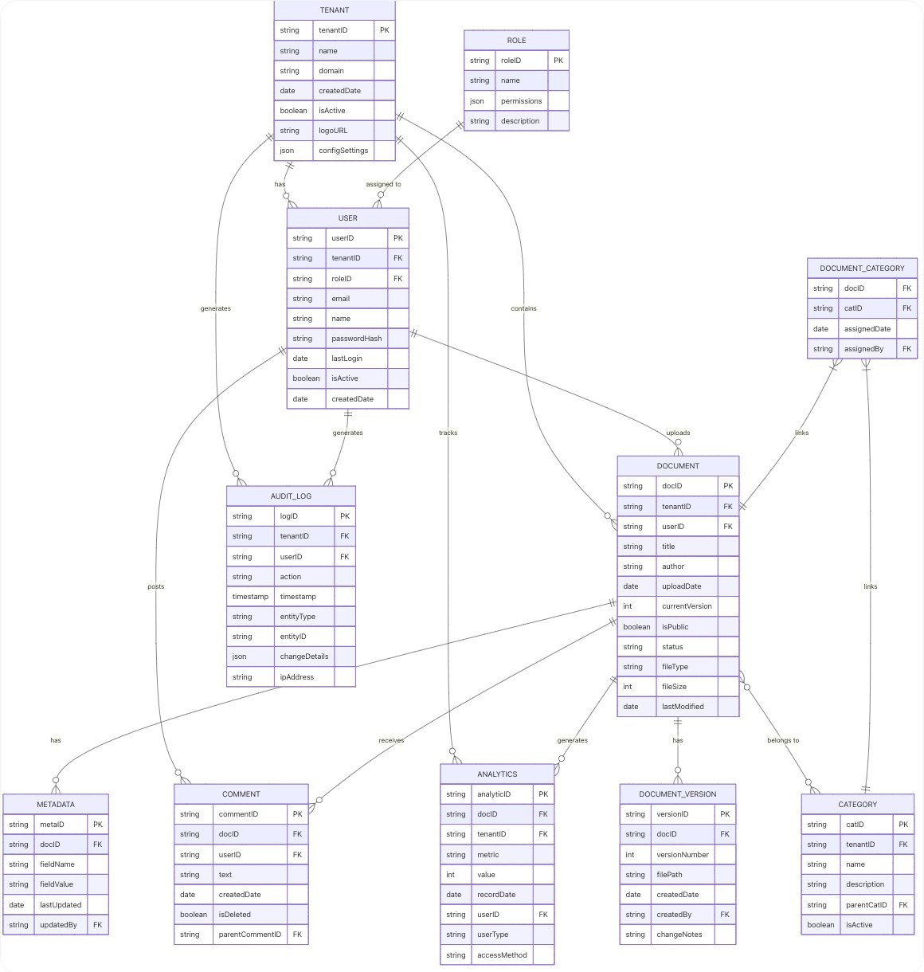

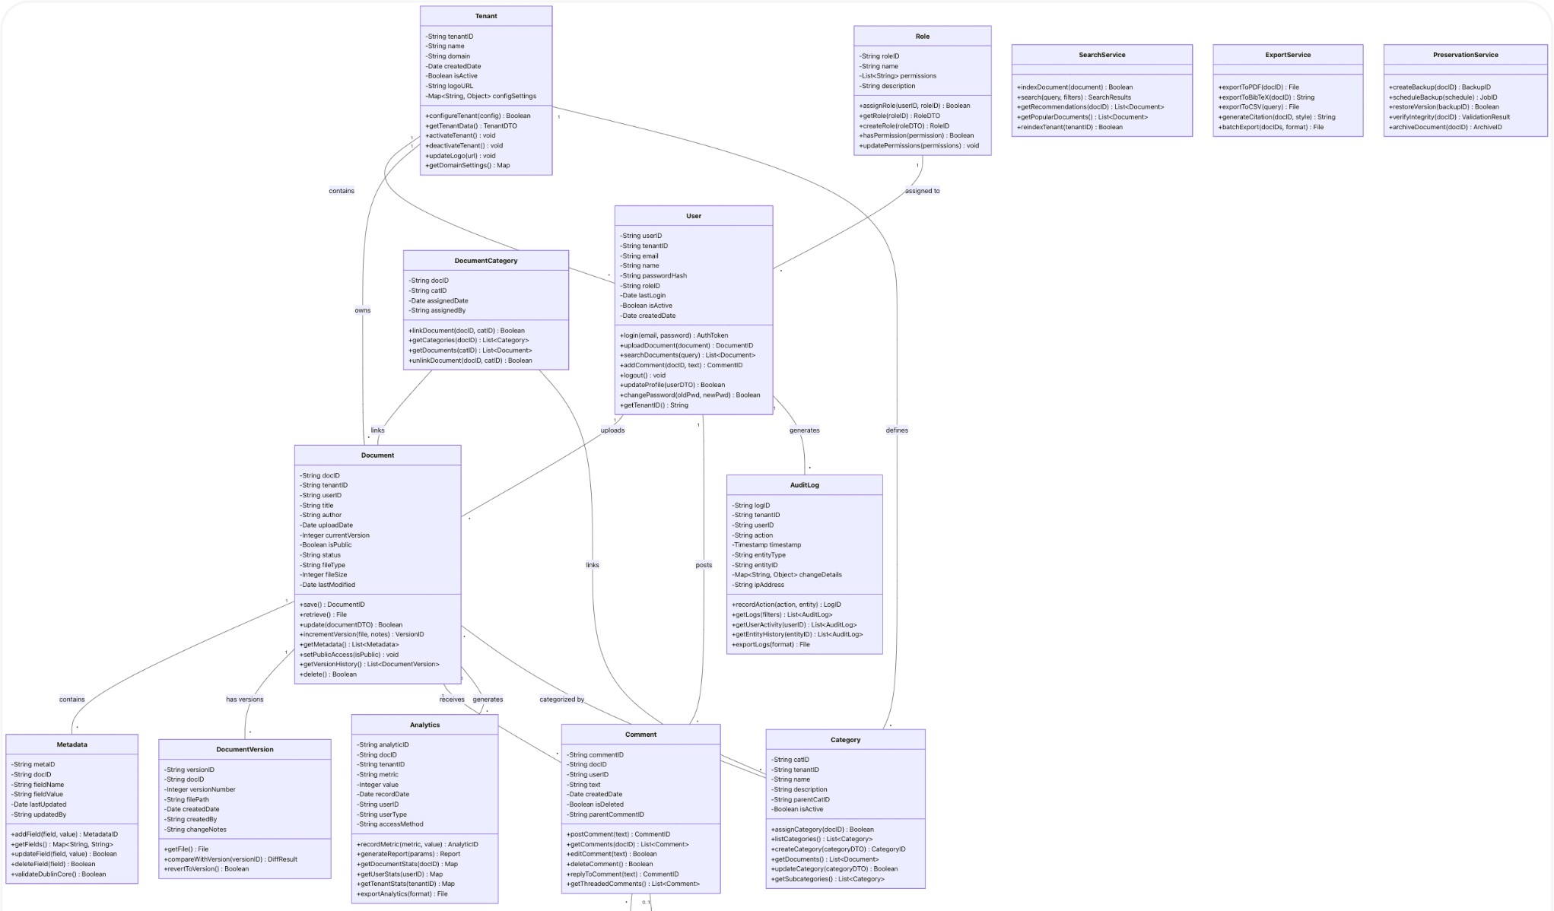**Class Diagram:**

* 1. **Development Tools**

## Next.js (Frontend Framework)

Next.js, a React-based framework, will develop InRep Scholar’s form-based user interface, enabling librarians to upload documents, enter metadata, search, and view analytics with minimal technical expertise. Its server-side rendering and static site generation will create responsive, low-bandwidth pages for document management and tenant-specific interfaces (e.g., university-branded dashboards for ALU or University of Rwanda). Dynamic routing will facilitate multi-tenant navigation, ensuring users access their institution’s data. Next.js’s API routes will connect to FastAPI for data operations, while optimization features like image compression and lazy loading will ensure performance on Rwanda’s limited networks. Form components, built with libraries like React Hook Form, will deliver a no-code user experience, replicating DSpace’s submission workflows in a streamlined, accessible format.

## FastAPI (Backend Framework)

FastAPI, a Python-based framework, will power InRep Scholar’s backend, providing high-performance RESTful APIs for critical functionalities: user authentication, document validation, metadata processing, tenant routing, search indexing, audit logging, analytics, and exports. Its async support will handle concurrent requests efficiently, supporting multi-university access. FastAPI’s dependency injection will enforce role-based access (e.g., Librarian: manage, Student: view, Tenant Admin: configure settings) and tenantID-based routing to isolate university data. Integration with external APIs, such as ORCID for author metadata, will enhance metadata capabilities, while endpoints for BibTeX and PDF exports will support open access. FastAPI’s simplicity and performance will streamline development for Rwanda’s low-resource servers, ensuring scalability and reliability.

## Pydantic (Data Validation)

Pydantic, a Python library for data validation and serialization, will ensure the integrity of InRep Scholar’s inputs within FastAPI endpoints. It will validate document uploads (e.g., file type, size, version) and metadata fields (e.g., Dublin Core: title, author, subject, date), preventing errors in tenant-specific data. Pydantic’s type hints will enforce schemas for entities like Document, Metadata, and Tenant, ensuring multi-tenant isolation by validating tenantID. Its serialization capabilities will streamline API responses and exports (e.g., BibTeX). By simplifying validation logic, Pydantic will enhance backend reliability, aligning with user-centered design to provide error-free workflows for Rwanda’s low-skill librarians.

## PostgreSQL (Relational Database)

PostgreSQL, an open-source relational database, will store InRep Scholar’s multi-tenant data, including entities like Tenant, User, Role, Document, Metadata, Category, AuditLog, Comment, and Analytics, as defined in the system’s ERD (3.3). Row-level security and tenantID-based schemas will isolate university data, supporting complex relationships (e.g., 1:M between Tenant and Document, M:M via DocumentCategory). PostgreSQL’s full-text search will power keyword and metadata queries, while its scalability will handle analytics (e.g., usage stats) and audit logging. Cloud hosting will ensure accessibility in Rwanda, and its open-source nature will avoid payment barriers. PostgreSQL’s robustness will replicate DSpace’s preservation features, ensuring long-term data integrity for scholarly outputs.

## Deployment Tools

To support InRep Scholar’s cloud-based deployment, Vercel will host the Next.js frontend, leveraging its automatic scaling and global CDN to optimize low-bandwidth access in Rwanda. FastAPI and PostgreSQL will be deployed on AWS, using Elastic Beanstalk for API management and RDS for database hosting, ensuring scalability and reliability. Docker will containerize FastAPI and PostgreSQL for consistent development and deployment environments, simplifying setup on Rwanda’s limited infrastructure. These tools will streamline deployment while maintaining a no-code user experience, aligning with the system’s multi-tenant and accessibility goals.

**Justification**

Next.js, FastAPI, Pydantic, PostgreSQL, Vercel, AWS, and Docker will enable InRep Scholar to deliver a no-code user experience through a robust, code-based, multi-tenant platform. Next.js’s lightweight, form-based UI will simplify document and metadata management for non-technical librarians, optimized for low-bandwidth networks. FastAPI’s efficient APIs and Pydantic’s validation will support IR functionalities—document upload, metadata tagging, search, and analytics—while ensuring tenant isolation. PostgreSQL’s scalable database will manage multi-tenant data and replicate DSpace’s metadata standards and preservation. Deployment tools like Vercel and AWS will ensure cloud-based accessibility, overcoming DSpace’s server-based complexity and Librarika’s lack of public access. These tools align with Rwanda’s resource constraints, empowering librarians to enhance scholarly visibility without technical barriers.

# References:

Alemayehu, M.W. (2010). Researchers’ Attitude to Using Institutional Repositories: A Case Study of the Oslo University Institutional Repository (DUO). ODA Open Digital Archive. <https://hdl.handle.net/10642/426>

Asadi, S., Abdullah, R., Yah, Y., & Nazir, S. (2019). Understanding institutional repository in higher learning institutions: A systematic literature review and directions for future research. *IEEE Access, 7*, 35242–35263. <https://doi.org/10.1109/ACCESS.2019.2897729>

Campbell-Meier, J. (2011). A framework for institutional repository development. *Advances in Library Administration and Organization, 30*, 151–185. <https://doi.org/10.1108/S0732-0671(2011)0000030006>

Chan, L. (2004). Supporting and enhancing scholarship in the digital age: The role of open access institutional repository. *Canadian Journal of Communication*, 29(3). <https://doi.org/10.22230/cjc.2004v29n3a1455>

Cullen, R., & Chawner, B. (2010). Institutional repositories: Assessing their value to the academic community. *Performance Measurement and Metrics*, 11(2), 131–147. <https://doi.org/10.1108/14678041011064052>

Davis, F. D. (1989). Perceived usefulness, perceived ease of use, and user acceptance of information technology. *MIS Quarterly, 13*(3), 319–340. <https://doi.org/10.2307/249008>

Dlamini, N. N., & Snyman, M. (2017). Institutional repositories in Africa: Obstacles and challenges. *Library Review, 66*(6–7), 535–548. <https://doi.org/10.1108/LR-03-2017-0021>

Ezema, I. J. (2011). Building open access institutional repositories for global visibility of Nigerian scholarly research. *Library Review*, 60(6), 473–485. [https://www.researchgate.net/publication/215993639_Building_open_access_institutional_rep](https://www.researchgate.net/publication/215993639_Building_open_access_institutional_repositories_for_global_visibility_of_Nigerian_scholarly_publication) [ositories_for_global_visibility_of_Nigerian_scholarly_publication](https://www.researchgate.net/publication/215993639_Building_open_access_institutional_repositories_for_global_visibility_of_Nigerian_scholarly_publication)

Glenn, J. C., & Gordon, T. J. (2009). *Futures Research Methodology – Version 3.0*. The Millennium Project.

González-Pérez, L. I., Ramírez-Montoya, M. S., & García-Peñalvo, F. J. (2021). User-centered design in institutional repositories: User experience and usability as key factors for a successful implementation. *Education and Information Technologies*, 26(5), 6145–6163. <https://doi.org/10.3390/fi13110282>

ISO 9241-210. (2019). Ergonomics of human-system interaction—Part 210: Human-centred design for interactive systems. International Organization for Standardization. <https://www.iso.org/standard/77520.html>

Jain, P. (2011). New trends and future applications/directions of institutional repositories in academic institutions. *Library Review, 60*(2), 125–141. <https://doi.org/10.1108/00242531111113078>

Joo, S., Hofman, D., & Kim, Y. (2019). Investigation of challenges in academic institutional repositories: A survey of academic librarians. *Library Hi Tech, 37*(3), 525–538. <https://doi.org/10.1108/LHT-12-2017-0266>

Kim, H. H., & Kim, Y. H. (2008). Usability study of digital institutional repositories. *The Electronic Library, 26*(6), 863–881. <https://doi.org/10.1108/02640470810921637>

Körber, N., & Suleman, H. (2014). Usability of digital repository software: A study of DSpace installation and configuration. *Lecture Notes in Computer Science, 8839*, 226–232. [https://www.researchgate.net/publication/220705484_Usability_of_Digital_Repository_Softw](https://www.researchgate.net/publication/220705484_Usability_of_Digital_Repository_Software_A_Study_of_DSpace_Installation_and_Configuration) [are_A_Study_of_DSpace_Installation_and_Configuration](https://www.researchgate.net/publication/220705484_Usability_of_Digital_Repository_Software_A_Study_of_DSpace_Installation_and_Configuration)

Lynch, C. A. (2003). Institutional repositories: Essential infrastructure for scholarship in the digital age. *Portal: Libraries and the Academy*, 3(2), 327–336.

[https://www.researchgate.net/publication/215993581_Institutional_Repositories_Essential_In](https://www.researchgate.net/publication/215993581_Institutional_Repositories_Essential_Infrastructure_For_Scholarship_In_The_Digital_Age) [frastructure_For_Scholarship_In_The_Digital_Age](https://www.researchgate.net/publication/215993581_Institutional_Repositories_Essential_Infrastructure_For_Scholarship_In_The_Digital_Age)

LYRASIS. (2023). *DSpace documentation*. <https://wiki.lyrasis.org/display/DSPACE/Home>

Makerere University Library. (2023). *Makerere Institutional Repository (Mak IR)*. [https://makir.mak.ac.ug](https://makir.mak.ac.ug/)

Marsh, R. M. (2015). The role of institutional repositories in developing the communication of scholarly research. *OCLC Systems & Services: International Digital Library Perspectives*, 31(4), 163–195. <http://dx.doi.org/10.1108/OCLC-04-2014-0022>

Ministry of Education, Rwanda. (2018). *Education Sector Strategic Plan 2018–2024*. Government of Rwanda.

Ngulube, P., & Ukwoma, S. C. (2021). Mapping methodological issues in knowledge management research, 2009–2014. *International Journal of Knowledge Management, 17*(1), 1–17. <https://doi.org/10.4018/IJKM.2021010101>

Norman, D. A. (2013). *The design of everyday things: Revised and expanded edition*. Basic Books. <https://dl.icdst.org/pdfs/files4/4bb8d08a9b309df7d86e62ec4056ceef.pdf>

Palmer, C. L., Teffeau, L. C., & Newton, M. P. (2008). Strategies for institutional repository development: A case study of three evolving initiatives. *Library Trends, 57*(2), 142–167. <https://doi.org/10.1353/lib.0.0033>

Pyrounakis, G., Nikolaidou, M., & Hatzopoulos, M. (2014). Building digital collections using open source digital repository software: A comparative study. *International Journal of Digital Library Systems, 4*(1), 14–31. <https://doi.org/10.4018/ijdls.2014010102>

Sokoine University of Agriculture. (2023). *SUA Institutional Repository*. [https://www.suaire.sua.ac.tz](https://www.suaire.sua.ac.tz/)

Tansley, R., Smith, M., & Walker, J. H. (2003). The DSpace institutional digital repository system: Current functionality. *Proceedings of the 3rd ACM/IEEE-CS Joint Conference on Digital Libraries*, 87–97. <https://doi.org/10.1109/JCDL.2003.1204846>

Venkatesh, V., & Bala, H. (2008). Technology Acceptance Model 3 and a research agenda on interventions. *Decision Sciences, 39*(2), 273–315. <https://doi.org/10.1111/j.1540-5915.2008.00192.x>

Zainab, A. N. (2010). Open access repositories and journals for visibility: Implications for Malaysian libraries. *Malaysian Journal of Library & Information Science, 15*(3), 97–119. <https://mjlis.um.edu.my/article/view/6942>