- Plot the data. Construct a time series plot of the data.

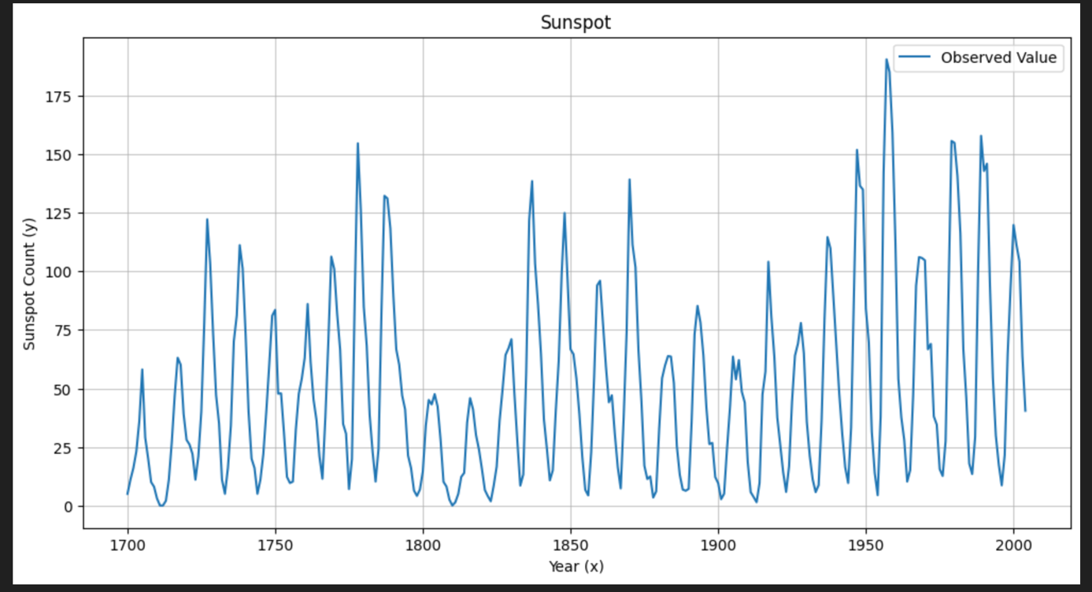

b) Use simple exponential smoothing with the optimal value of 𝜆 to smooth the data (you
can find the optimal value from either Minitab or R). How well does this smoothing procedure
work? Do you think that simple exponential smoothing should be used to forecast this data?

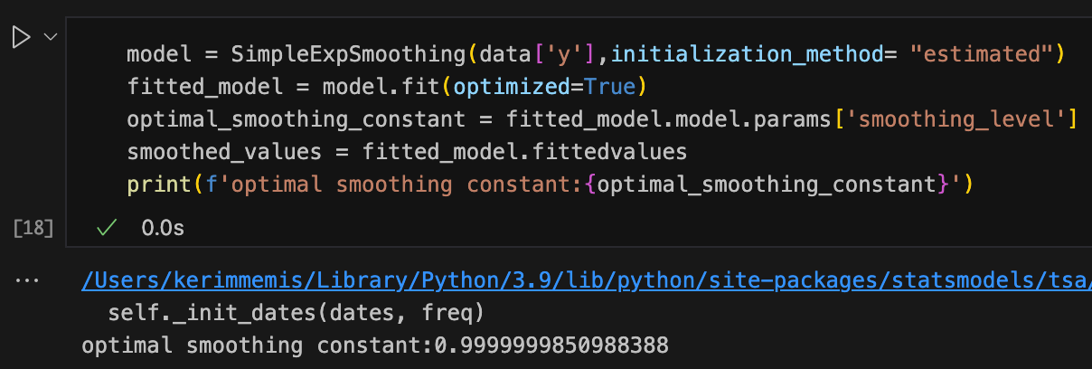

Using an optimization procedure in python,the optimal smoothing parameter was found as approximately 0.9995.
If we want to talk about smoothing procedure,there will be a almost no smoothing. A λ value very close to 1 means the model provides almost no smoothing of the noise.
It effectively ignores the historical average and places all its weight on the most recent observation.Visually, the fitted line tracks the actual data, but with a noticeable one-step lag. The model acts as a "Naive Model," essentially predicting that the value next year will simply be the same as the value this year.
While this minimizes the error mathematically for this specific method, it fails to capture the true cyclic structure of the data. It doesn't predict the changes; it just reacts to them after they happen.

